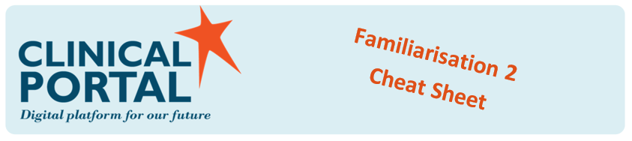

* **User Settings – Personalise your profile**

Filter information so you only see what you choose to on your Clinician Homepage. Align yourself to a ward or clinician, add your ED Location and associate yourself with OP Clinics:

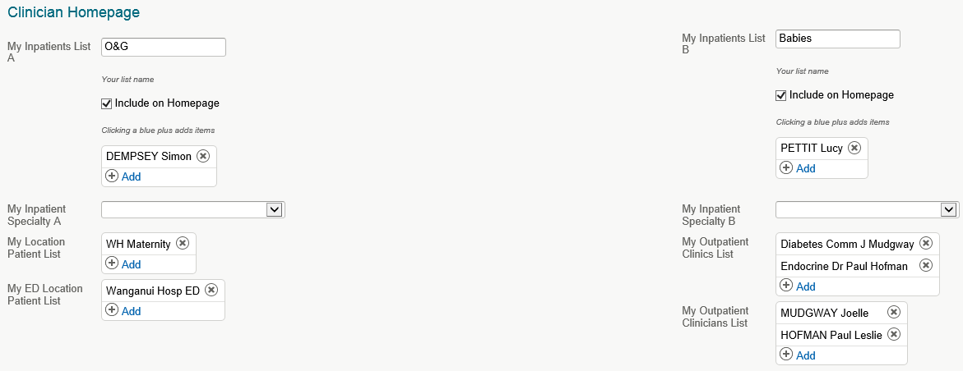

By defining your User Settings, your homepage can be configured to match your workflow:

* Inpatient lists
* My Location List
* Unapproved Document Count
* Unsigned Results Count

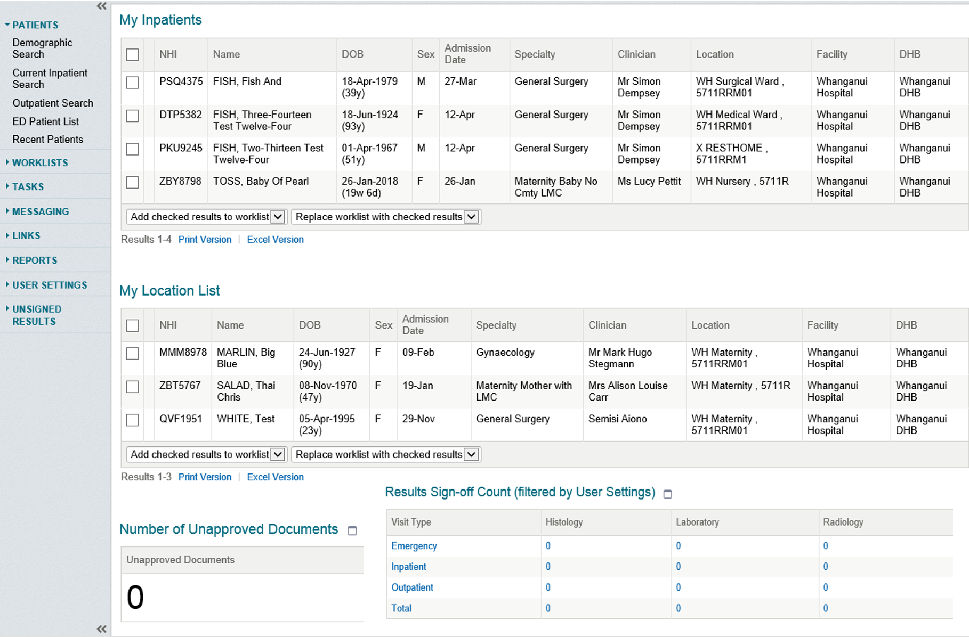

V1.0 15-6-18

* **Viewing Laboratory Results**

Results display differently in Clinical Portal, which will mean a change in the way we interpret results. Results will now be read right to left. This change is in line with the region and national standards.

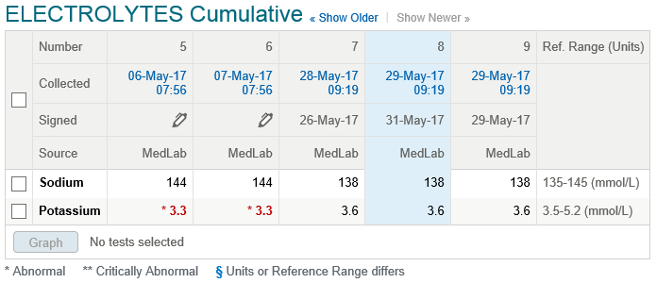

* **Security Visibility**

The Summary tab displays a Patient Access Summary showing the currently logged in user and the last five users to have assessed the patient record. The currently logged in user shows twice, as current and as one of the most recent five. A more detailed history is available in the Access tab.

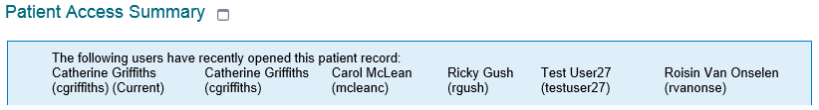

The Access tab displays a list of users who have accessed the patient’s record within the last 30 days. Each users name is only added once each day they access the record:

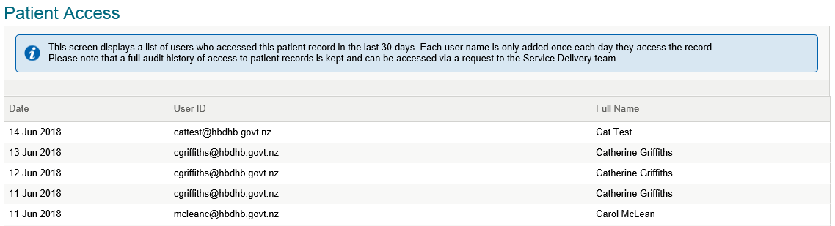

If you have any questions please email [clinicalportal@hawkesbaydhb.govt.nz](mailto:clinicalportal@hawkesbaydhb.govt.nz), we are more than happy to help.

*Visit the Clinical Portal homepage on* ***Our Hub*** *under* ***Our Place.***

**More Information:**