Residential
Care
Plan

Guidelines for the Prevention, Control and Management of Influenza Outbreaks
OVERVIEW
Preface: Our residents are vulnerable to influenza-like illness due to co-morbidities, advanced age and the environment of communal living which facilitates the spread of respiratory agents.

The purpose of this document: is to provide evidence based best practice guidelines for preparing, preventing, identifying and managing outbreaks of influenza.

Note: in a pandemic period, outbreak control will be determined by Te Whatu Ora Hawke’s Bay.

INTRODUCTION
As at 30 September 2011 there were 35,000 residents across the Aged Residential Care (ARC) sector of New Zealand. Of these ARC residents nearly two thirds (57 percent) required one of the higher levels of care (hospital, dementia, or psychogeriatric) this requires highly specialised care by registered nurses (RN) and caregivers/healthcare assistants (HCAs). (New Zealand Aged Care Association, 2021-2022).
During the 2020-2023 SARS-CoV-2 (COVID-19) pandemic, ARC facilities were where some of the first clusters or outbreaks occurred, impacting on the health and wellbeing of residents and diminishing an already compromised workforce. The pandemic affected older people disproportionately, especially those living in ARC facilities. The World Health Organisation sited evidence that indicated more than 40% of COVID-10 related deaths were linked to long-term care facilities which made them high risk, often due to low preventative measures and inadequate resources to enable recovery. (WHO, 2019) New Zealand data from stats.govt.nz indicated the elderly population were at greater risk of morbidity due to age and pre-existing medical conditions. These rates declined significantly for younger persons.
A pandemic outbreak of any kind in an ARC facility will require a swift and well-co-ordinated response from key stakeholders across different organisations. Te Whatu Ora localities, hospitals PHU and community hubs will need to work collaboratively with the ARC facility to contain the outbreak and minimise the impact.

CONTENTS
 | Introduction |  | 1
Section 1 | General Information |  | 3
Section 2 | Clinical | Signs and symptoms | 4
Section 3 | Recognising | Recognising influenza-like illness and outbreaks | 5
 |  | Influenza surveillance | 5
 |  | Response to a single case of ILI in a resident | 5
Section 4 | Testing of Residents | Testing of residents | 6
 |  | Antiviral medication | 6
Section 5 | Infection Control | Key elements for staff in controlling influenza | 7
 |  | Visitor restriction and signage | 7
 |  | Transmission based precautions | 8
Section 6 | Staffing | Allocation of staff | 10
Section 7 | Monitoring | Effective outbreak management | 11
 |  | Monitoring the outbreak | 11
 |  | Ongoing surveillance | 11
Appendix 1 |  | What to do when a suspected outbreak occurs | 13
Appendix 2 |  | Resident Transfer Advice Form | 14
Appendix 3 |  | Signage | 15
Appendix 4 | Environmental Cleaning |  | 24
Appendix 5 | Testing for Influenza |  | 26
Appendix 6 | Management | Outbreak management team tasks | 29
 |  | Outbreak planning | 31
 |  | Infection control checklist for outbreaks | 33
 |  | Resident illness report | 38
 |  | Outbreak reporting | 40

SECTION 1 GENERAL INFORMATION
Influenza
- Influenza is a virus that spreads quickly from person to person with the ability to cause respiratory infections which can result in serious illness.
- Influenza viruses A, B, C and D represent the four antigenic types of influenza viruses. Of the four types, influenza A is the most severe, influenza B virus is less severe but can still cause outbreaks, and influenza C virus is usually only associated with minor symptoms.
Transmission, incubation and communicability
- Large droplets are the primary mode of transmission for influenza viruses, these droplets are produced when infected individuals cough or sneeze
- Influenza can also be transmitted by direct contact with respiratory secretions, such as from hard surfaces where influenza viruses can persist
The incubation period for influenza is short, on average 2 days (range 1-4 days). People infected with influenza are considered infectious from 1 day before onset of symptoms and viral shedding is greatest in the first 3-5 days of illness.
Vaccination is the single most important means for preventing influenza. In each facility we should aim for coverage of 95%.

SECTION TWO CLINICAL
Symptoms and signs
Influenza can be difficult to distinguish from other viral respiratory tract infections on clinical signs alone. Symptoms and signs of influenza may include the following:
- Sudden onset of fever (≥38°C). Of note, elderly residents may not necessarily have an elevated temperature with influenza, due to medical conditions or medications masking rises in temperature.
- Respiratory symptoms
  - New or worsening cough
  - Shortness of breath
  - Sore throat
- Systemic symptoms
  - Headache
  - Myalgia (muscle soreness)
  - Malaise
In the elderly, symptoms may also include:
- Onset of, or increase in, confusion
• Worsening of underlying conditions, for example: exacerbation of chronic obstructive pulmonary disease or congestive heart failure

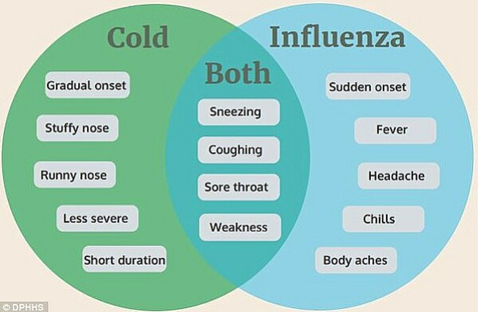

Complications include
- primary viral and secondary bacterial pneumonia | - exacerbations of chronic conditions
- sinusitis, otitis media | - febrile seizures
- encephalitis | - myositis
- Reye’s syndrome when salicylates such as aspirin are used

- increased number of deaths | - increased rates of hospitalisation

SECTION 3 RECOGNISING
Recognising influenza-like illness and outbreaks
- Three or more people (residents or staff) with influenza-like illness (ILI) within the same 3 days (72 hour period) indicates a potential influenza outbreak.

Influenza Surveillance
The aim of ILI surveillance is to ensure early identification of symptoms in residents and staff that may precede, or indicate early stages of an outbreak.
Prompt detection of outbreaks allows early implementation of control measures.
Early implementation of control measures and notification has been associated with shorter duration of outbreaks.
Response to a Single Case of Influenza-like Illness in a Resident
- Hydration
- Isolate ill resident or cohort and minimise interaction with other residents
- If admission/transfer is required to Hawke’s Bay Hospital inform in advance that the resident is being transferred and there is potential or confirmed influenza. Refer to Appendix 3 for a sample transfer advice form (ISBAR).

SECTION 4 TESTING OF RESIDENTS
Testing of residents
- In an outbreak, a sample of people meeting the ILI case definition should be tested, usually 4 to 6, be advised by the Public Health Unit (refer to Appendix 2)
- Nose or throat swabs are collected for influenza testing once three or more cases of ILI occur within 3 days, and at least one has a positive laboratory test for influenza, the outbreak is confirmed
- Further cases of ILI are assumed to be due to influenza and should be treated as such
Antiviral medication during an outbreak – on advice from Public Health
- GPs are responsible for prescribing antiviral medications.
- Early initiation of antiviral treatment (within 48 hours of symptom onset) in adults with confirmed influenza reduces the risk of secondary complications requiring antibiotic therapy, and hospitalisation.
Antiviral use for prophylaxis – advice from Public Health
- The widespread use of antivirals in facilities that house residents at high risk of severe disease and death from influenza is supported by observational cohort studies and one randomised controlled trial.
- During an outbreak, other facility residents will have been, or may become, exposed to infectious residents.
- The provision of antivirals works as early treatment for those incubating disease and reduces shedding in those infected.
- Antiviral prophylaxis should only be used in addition to other outbreak control measures.
- If recommended, to optimise the chances of reducing transmission and bring the outbreak under control, antiviral prophylaxis should be given to ALL asymptomatic residents (regardless of vaccination status) and ALL unvaccinated staff as long as there are no contraindications.
- Ideally, antivirals should be commenced by all targeted residents and staff within 24 hours, medicine safety issues, including renal function/renal insufficiency, must be appropriately considered during the prescribing phase.
- Staff need to be aware of the most common side effects, e.g. nausea and vomiting.

SECTION 5 INFECTION PREVENTION AND CONTROL/TRANSMISSION
Key elements for staff in controlling influenza:
- staff and resident vaccination rates
- hand hygiene as per the 5 moments of hand hygiene
- use of appropriate personal protective equipment (PPE)
- regular cleaning of the environment
- increased cleaning of shared equipment and high touch surfaces
- infected resident placement - isolation and cohorting
- minimising resident transfer or transport
- ventilation and opening of windows
- encouraging good respiratory hygiene (coughing into sleeves/tissues)
Transmission-based precautions are essential work practices in addition to the above (refer to Appendix 5).
Depending upon the extent of the outbreak and the physical layout of the building, a restriction on admissions might be applied.
If transfer to hospital is required, notify the ambulance service and receiving hospital of the outbreak and the suspected or confirmed diagnosis. A template for resident transfer refer to Appendix 3.
Re-admission of residents, who have had influenza and were transferred to hospital or another facility, requires the provision of appropriate accommodation, care and infection prevention and control. The re-admission of residents who have not had suspected or confirmed influenza in the outbreak (i.e. who are not known cases) is generally not recommended during an outbreak.
Visitor restriction and signage
During an outbreak, preferably, minimize the movement of visitors into and within the facility. If recommended by the outbreak management team:
- Suspend group social activities that involve visitors such as musicians
- Postpone visits from non-essential external providers
- Inform regular visitors and families of residents of the outbreak of influenza and request they only undertake essential visits; discourage unnecessary visitors
- Ask those who do visit an unwell resident, to:
  - Visit only one resident
  - Enter and leave directly without spending time in communal areas
  - Use an alcohol based hand rub or wash their hands before and after visiting
  - If giving direct care, use PPE as directed by staff
  - Initiate passive screening for respiratory symptoms using “Attention Visitors” signage (refer to Appendix 4) and reminding visitors:
    - Not to visit if unwell
    - To follow signs for the use of PPE, as indicated
    - To practice hand hygiene and respiratory hygiene/cough etiquette
    - Post “Attention Visitors” signs at the entrance(s) and other strategic locations in the facility (refer to Appendix 4)
    - Initiate active screening (incoming visitors report to the desk) as required
Transmission-based precautions are essential work practices
- Use of PPE and, where possible maintain a 1 metre distance between the infected resident and others
- Staff must change their PPE after every contact with an ill resident, when moving from one room to another or from one resident care area to another
- All staff must perform:
  - hand hygiene after every contact with an unwell resident
  - after being in contact with contaminated surfaces
  - whether or not gloves are worn - when visibly soiled with body fluids and/or substances, use water and liquid soap for hand washing
- Single-use surgical face masks should be worn by staff when exposure to respiratory droplets is likely, that is, when within 1m of an affected resident:
  - The mask should be put on when entering the room
  - Remove the mask after leaving the room, handling only by the tapes/elastic, and place in a clinical waste bin
  - Perform hand hygiene after disposing of the mask
  - Never re-use masks
  - When undertaking activities that require an infected resident to leave their room, the resident should wear a mask if tolerated
- Encourage good cough etiquette
- Eye protection includes the use of safety glasses, goggles or face shields but does not include personal eye glasses.
  - Protective eyewear must be disposed of, or where approved for re-use, cleaned after use
  - Eyes should be protected where there is potential for splattering or spraying of blood, body fluids, secretions or excretions, including coughing
- Use resident-dedicated equipment where possible
  - Ideally, any care equipment should be dedicated for the use of an individual resident. If resident care equipment must be shared, the items must be cleaned and disinfected between each resident use.
- Allocate ill residents to single rooms
- Enhanced cleaning and disinfection of the ill resident’s environment
  - Influenza viruses can persist on hard surfaces and remain viable for up to 24 hours on hard, non-porous surfaces.
  - Infectious influenza virus can be transferred to hands from these surfaces for at least 2 – 8 hours after contamination of the surface
  - Frequently touched surfaces are those closest to the resident, and should be cleaned more often (for example - bedrails, bedside tables, commodes, doorknobs, sinks, surfaces and equipment close to the resident), use sodium hypochlorite 100mL in 1L of water (1:10 solution)
- Linen should be laundered using hot water and detergent
  - Linen should be dried on a hot setting in a dryer
  - There is no need to separate the linen of ill residents from that of other residents
  - Appropriate PPE should be used when handling soiled linen.
- Crockery and cutlery should be washed in a dishwasher

PPE is an important element of standard precautions
- Explain to residents that PPE is used for everybody’s safety!
- PPE for resident care staff during an influenza outbreak includes the following:
  - Gown
  - Disposable gloves
  - Surgical facemask
  - Eye protection (if there is potential for mucous membranes to come into contact with body fluids, for example a coughing person)
Donning and doffing areas must be identified. The doffing area must include hand hygiene products, waste receptacles and signage.
The use of PPE alone is not enough— YOU MUST perform hand hygiene before putting on and after removing the protective item.
Hand hygiene
- A most important key to prevention and further spread of infection is good hand hygiene
- Hand hygiene means rubbing hands with an alcohol based hand rub or washing then with liquid soap and water and drying with a single-use towel

Hand hygiene will NOT be effective if any of the following are present:
- Skin with cracks, cuts or dermatitis – cover all cuts or abrasions
- Hand and arm jewellery
- Nails longer than 3-4mm, or with chipped or worn nail polish, or artificial nails, or nail enhancements

Hand hygiene must be performed regardless of whether gloves are used. Note: staff must perform hand hygiene before applying gloves and after removing gloves as the removal process can cause contamination resulting in further infections.

SECTION 6 STAFFING
Allocation of staff
- Once resident isolation measures are in place, to further reduce the risk of transmission, it is preferable to allocate specific (vaccinated) staff to the care of residents
- These staff members should not move between their section and other areas of the facility, or care for other residents
- Staff members should self-monitor for signs and symptoms of respiratory illness and self-exclude from work if unwell
- When ILI is apparent, influenza can be spread within the facility by staff, who should work only if well and wearing a mask

SECTION 7 MONITORING
Effective outbreak management has four phases:
Prevent and Prepare phase:
Maintain vigilance to reduce the risk of the virus entering the ARC facility. Prepare for different outbreak scenarios and check policies and protocols are up-to-date.
- Keep up-to-date on the latest Ministry guidelines for ARC providers.
- Establish and maintain links with ARC OMT. Work collaboratively and know who to contact, when and why.
- Understand ARC facility role and responsibility in ARC OMT.
- Localise national guidance so it works for the ARC facility.
- Develop an Outbreak Management Plan. Ensure this addresses psychosocial welfare of health care and support workers and residents and their whanau.
- Specify who will hold key roles and responsibilities within the ARC facility during an outbreak.
- Ensure resident’s care plans and photo identification are up-to-date. Monitor medicines expiry dates.
- Strengthen relationships with iwi and Maori to support outbreak preparedness.
- Establish training and education plan for health care and support workers and visitors.
- Develop communication plan for residents and their whanau, health care and support workers, and visitors.
- Practice scenario training with Te Whatu Ora Hawke’s Bay, PHU and other local stakeholders.
- Undertake preparedness assessment as requested by Te Whatu Ora Hawke’s Bay.
- Ensure measures are being taken to prevent infection from being introduced into ARC facility.
Standby phase: Possible cases in the ARC facility
A person in the ARC facility is considered a potential case of the virus and is being tested.
- Support early case recognition through early identification of symptoms.
- Support people in ARC to be tested as quickly as possible.
- Get residents tested by GP/NP, notify PHU, and highlight to laboratory to prioritise the test.
- Isolate cases under investigation.
- Begin close contact tracing of those under investigation.
- Increase IPC protocols
- Contact Te Whatu Ora Hawke’s Bay if concerned about ARC facility’s ability to respond.
- As appropriate, liaise with Maori NGOs or other providers to provide additional support to residents and their whanau.
Outbreak phase: One or more active cases within the ARC facility
A resident, a healthcare or support worker, or a visitor who has been at the ARC facility during their infectious period is determined to be a case. The ARC OMT is convened.
- Participate in daily ARC OMT meetings.
- Notify GP/NP of residents of positive test.
- Complete and submit ‘ARC Facility Outbreak Investigation Information for PHU’ to PHU.
- Tailor and implement the Outbreak Response Plan.
- Establish and maintain Daily ARC Facility Situation Report.
- Identify and manage close contacts of cases within the ARC facility.
- Appoint GP/NP to work with PHU to develop testing plan.
- GP/NP or PHU to highlight to laboratory to prioritise tests.
- Implement strengthened IPC measures, including PPE retraining.
- Implement alternative rostering arrangements to minimise transmission.
- Implement surge staffing plan.
- As appropriate, liaise with Maori NGOs or other providers to provide additional support to residents and their whanau. Consider how to cohort health care and support workers to look after specific groups of patients and minimise movement within ARC facility.
- Consider how rosters may be managed to reduce the number of sites or facilities health care and support workers are working across (including GP/NP).
- Screen healthcare and support workers at the start of each shift, and implement ongoing self-monitoring for symptoms.
- Implement physical distancing.
- Review roles and responsibilities of vulnerable health care and support workers.
- Maintain clinical monitoring, assessment, and testing of residents and on-site health care and support workers.
- Monitor residents for acute respiratory symptoms, fever, or other deterioration. Notify GP/NP as required and place in isolation.
- Communicate with residents and their whanau any changes to visiting requirements.
- Implement detailed visiting policies and protocols.
Review phase: After the outbreak
The PHU has declared the outbreak over, and the outbreak response is reviewed by the ARC OMT. The ARC facility returns to the Prevent and Prepare phase.
- Participate in ARC OMT debrief and review meetings.
- Record learnings. Anonymise and share learnings with other ARC facilities.
Monitoring the outbreak
- Management and Administration should update listing with new information daily, by midday (or another agreed time), or more frequently if major changes occur, and communicate this to the PHU each day (as arranged, by email (preferred), fax or telephone).
Ongoing resident surveillance should include the following
- Monitoring residents for ILI symptoms
- Addition of all new cases to resident list
- Updating the status of symptomatic residents: hospitalised, recovered, deceased
- Recording the use of antiviral prophylactic medication and any adverse reactions to or cessation of any prescribed antiviral medication
Ongoing staff surveillance should include all the following:
- Addition of all new staff cases to the staff list
- Identification of staff who have recovered, and confirmation with the PHU of their return to work date
APPENDIX 1 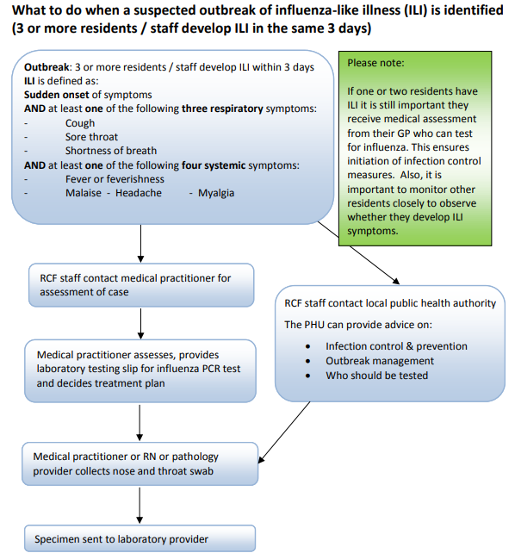 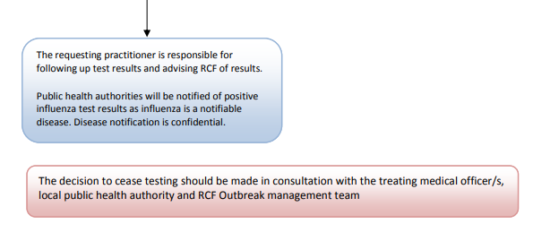

APPENDIX 2
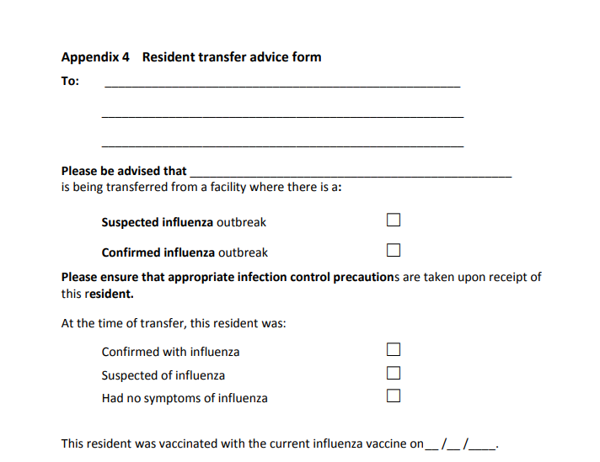

APPENDIX 3
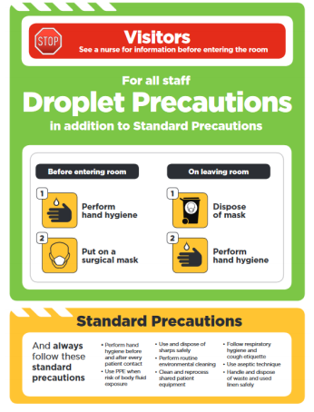

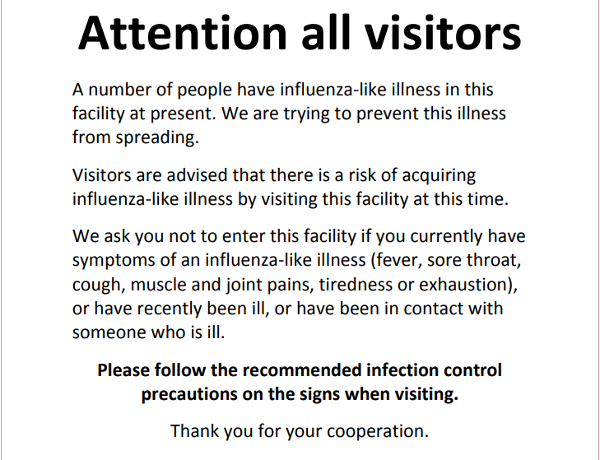
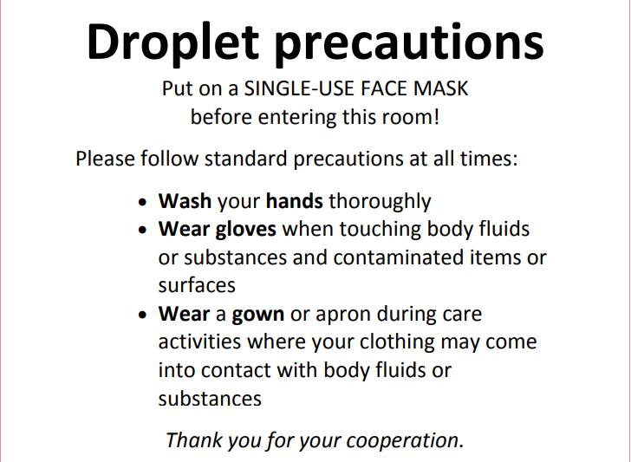

The 5 moments of hand hygiene

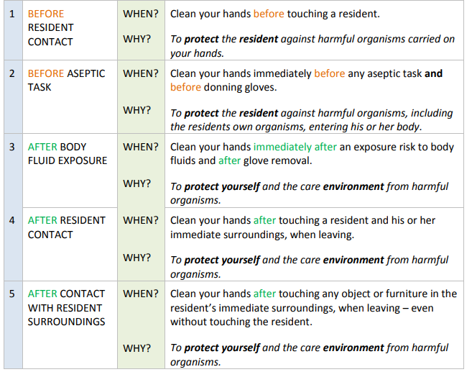
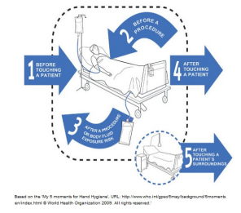
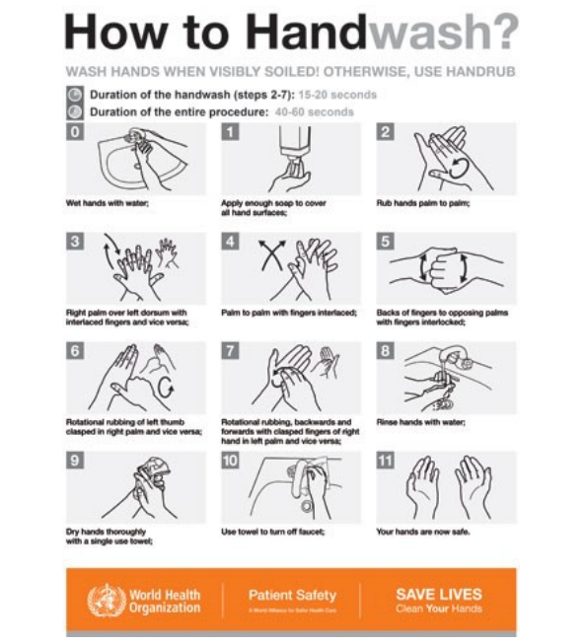
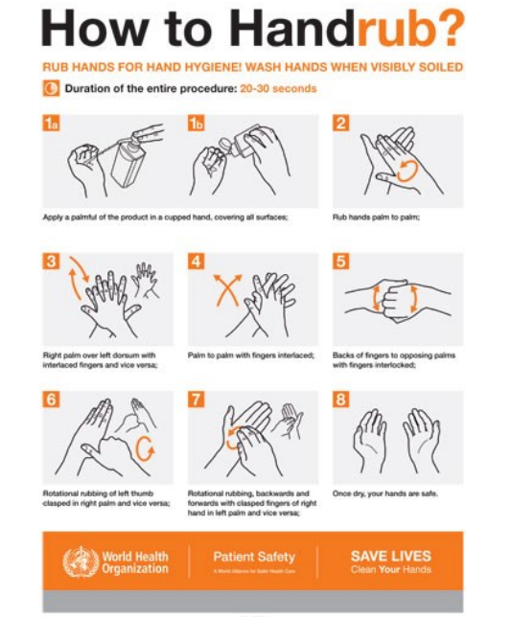

Respiratory Hygiene Information
- Respiratory hygiene and cough etiquette is one element of standard precautions.
- Covering sneezes and coughs can minimise or prevent infected persons from dispersing respiratory secretions into the air.
- Large droplets are believed to be the primary mode of transmission for influenza viruses and these occur when infected individuals cough or sneeze.
- The droplets do not remain suspended in the air and generally travel short distances (up to 1 metre).
- Hands should be washed with soap and water or alcohol hand rub after coughing, sneezing, using tissues, or after contact with respiratory secretions or objects contaminated by these secretions. It is important to keep contaminated hands away from the mucous membranes of the eyes and nose.
Cough Etiquette
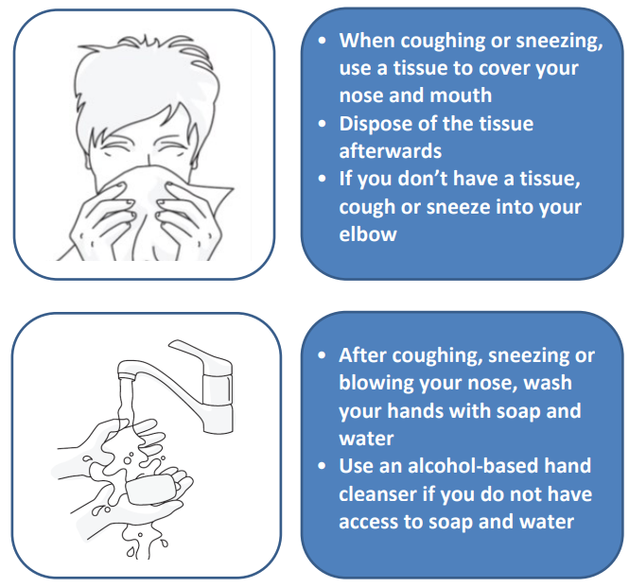
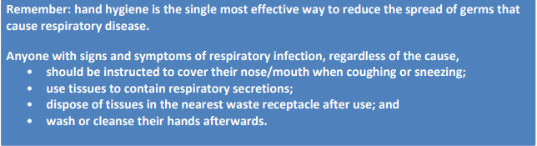

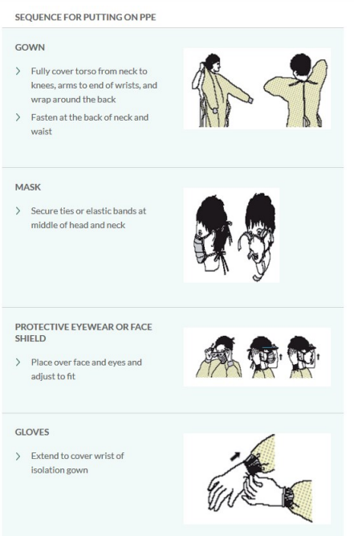
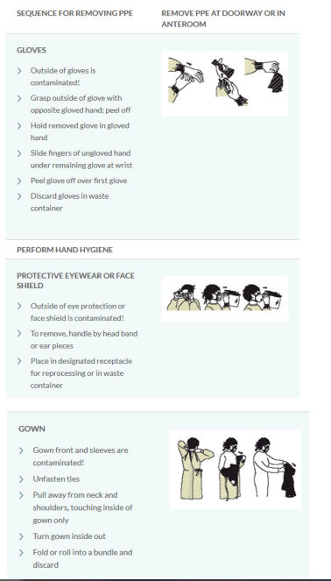
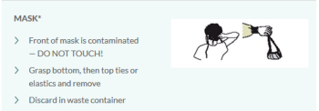
APPENDIX 4
Environmental Cleaning
Step 1: Cleaning
Note: rooms of well residents should be cleaned first.
- Use warm water with a neutral detergent
- Note: some chlorine/detergent products with 1000ppm sodium hypochlorite can be used as a one-step cleaning/disinfection process i.e. environmental wipes
- Cleaning staff must wear PPE
- Cleaning cloths should be disposed of in a biohazard bag
Step 2: Disinfect
- A general recommendation is to use either a neutral detergent followed by 1000ppm sodium hypochlorite, or
- A one-step product with 1000ppm sodium hypochlorite (more practical)
- Disinfection is an additional step to cleaning and does not replace cleaning
- Use either chlorine disinfectant or alternatively, alcohol
- Disinfect all:
  - Horizontal surfaces
  - Bedside table – over bed table
  - Chairs
  - Commodes
  - Doorknobs
  - Toilet flushers
  - Taps
  - Handrails
  - Basins
  - Walking frames
  - Note: Floors require cleaning with warm water and neutral detergent
  - Clothes and bed linen can be laundered as usual
Step 3: Chlorine solutions
- If using chlorine solution, leave on for 10 minutes then rinse off with hot or cold water
- Preparing chlorine solutions at concentrations required for disinfection
  - Chlorine solutions must be freshly made up and used within 24 hours, as chlorine deteriorates over time.
  - A general recommendation for the use of a sodium hypochlorite solution is a concentration of 1000ppm, 100mL in 1L of water (1:10 solution)
  - At this strength, in a one-step product, it is not necessary to rinse off
  - Follow the manufacturer’s instructions for use of this product
Step 3: Alcohol disinfectant
- Use on surfaces not suitable for chlorine disinfectants
- Do not dilute
- Do not rinse off
- Not particularly practical for large areas
- Flammable, toxic, avoid inhalation, use in well ventilated area, keep away from heat sources, flames, electrical equipment and hot surfaces

APPENDIX 5
Testing for Influenza
Why test for influenza viruses during flu season?
- It is important to identify the pathogen causing illness to determine whether there is an outbreak of influenza in a facility, as many respiratory illnesses have similar signs
- Confirmation of influenza helps clinicians make appropriate clinical decisions about treatment of those who are sick, and reduces inappropriate use of antimicrobials
- Knowing the infectious agent helps the public health authority advise and assist in managing the outbreak, control the spread of the illness, and prevent further cases
- Specialised testing provides important information on the types of influenza viruses circulating in the community, and contributes to assessing how effective current vaccines are and in developing new vaccines
When should you test and who should be tested?
- When an outbreak of influenza-like illness (ILI) occurs, that is, if three or more residents or staff develop symptoms of ILI during the same 3-day time period
- If a resident has symptoms of an influenza-like illness (ILI) including:
  - Sudden onset of fever, chills, myalgia or clinically documented temperature of > 38⁰C PLUS two or more of the following
    - Headache
    - Malaise
    - Cough
    - Sore throat
- The resident’s GP can assess the ILI and request a test for influenza and other pathogens
- Testing should be performed as soon as possible after the onset of ILI symptoms
- During an outbreak, a sample of people with ILI should be tested (usually 4-6 people with ILI)
- Rapid antigen testing is carried out at the Laboratory at Hawke’s Bay Hospital. The decision to send for PCR testing lies with the Medical Officer of Health.
- The most definitive test is a reverse transcription Nucleic Acid Amplification Test (NAAT or NAT). This is also known as a Polymerase Chain Reaction (PCR) test. This test is used because:
  - It is the most sensitive (best able to correctly identify patients who have influenza)
  - It is the most specific (best able to correctly identify people who don’t have influenza)
  - It is relatively rapid
  - It enables us to differentiate

Swab collection procedure
- Before performing swab
- Obtain required materials:
  - Personal protective equipment (PPE) for the health care worker taking the swab, including gown, gloves, eye protection (goggles or face shield), and surgical mask.
  - One dry, sterile, flocked swab.
  - One viral culture swab with viral culture medium. IMPORTANT NOTE: Contact laboratory for current local advice about swabs.
- Swabs should only be collected from residents or staff with acute symptoms (onset within the preceding 3 days, i.e. 72 hours).
- Performing the swabs
- Preparation:
  - Perform hand hygiene
  - Don PPE in the order of gown, surgical mask, eye protection, and gloves
- Explain the procedure to the resident and obtain consent

Throat swab procedure:
- Stand at the side of the resident’s head and ensure their head is resting against a wall or supporting surface
- Place your non-dominant hand on the patient’s forehead
- Ask the resident to open his/her mouth widely and say “aaah”
- Use a wooden spatula to press the tongue downward to the floor of the mouth, this will avoid contamination of the swab with saliva
- Using the viral culture swab, insert the swab into the mouth, avoiding any saliva
- Place lateral pressure on the swab to collect cells from the tonsillar fossa at the side of the pharynx
- Rotate the swab twice (2 x 360 degree turns) against the tonsillar fossa to ensure the swab contains epithelial cells (not mucus)
- Remove the swab, and place directly into its labelled tube or bottle
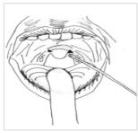
- IMPORTANT NOTES
  - Choose an area for the procedure where the resident can rest their head against a wall or on a high-backed chair with room for you to stand beside (not in front of) the patient
  - Ensure the area is well lit, with hand washing and infectious waste disposal facilities
  - Remember to WASH AND DRY HANDS before and after the procedure!
  - Gloves, respiratory protection and eye protection MUST be worn when collecting nose and throat swabs
  - Masks should NOT be touched during wear and should NOT be worn around the neck at any time
  - When removed, handle the mask by the ties of the mask only.
- After performing the swab labelling and storage of specimen
  - Label the tube or bottle containing the swabs with the resident’s full name, date of birth, specimen type and date of collection
  - The accompanying request form should include the ARC facility name
  - Remove PPE safely (remove gloves, perform hand hygiene, remove goggles or face shield, gown and mask and perform hand hygiene again)
  - Specimens should be sent on the day of collection, or at worst, the following day, refrigerate the specimen until it is sent to the laboratory (do NOT freeze the specimen)
  - IMPORTANT NOTE: Dispose of gloves, gowns and masks in an infectious waste bag

APPENDIX 6 MANAGEMENT
Outbreak Management Team tasks during an influenza outbreak
Outbreak Management Team (OMT) comprises of:
- Clinical Manager
- Quality Co-Ordinator
- Clinical Co-ordinators
- Nominated Infection Prevention and Control Representatives of each Facility
Key areas
- Quality Co-Ordinator
  - Decide on and organise ongoing OMT meetings and location
  - Arrange and undertake a debrief at the conclusion of the outbreak
  - Public health authority liaison (HBDHB), ensure that telephone contact numbers for the PHU (including out-of-hours) are available to facility staff
  - Inform the PHU immediately by phone of hospitalisations or deaths in residents or staff
  - Confirm the implementation of the exclusion policy for staff who refuse vaccination or antiviral medications
  - Communication - prepare and implement a communication plan, including a draft media release if required
  - Prepare internal communications for resident, family and staff groups
- Clinical Director/Clinical Co-Ordinators
  - Update the list daily and communicate
  - Liaise daily with the PHU to discuss results of testing, and for advice on infection prevention and control measures, as needed
  - Infection prevention and control within Facility
    - Ensure staff have adequate training and equipment for infection prevention and control measures
    - Manage resident movement within the Facility, including isolation and cohorting, restrict group activities for residents, and defer transfers out, and new admissions into
    - Review the vaccination status of staff and residents and recommend/offer vaccination to those who are unimmunised
    - Implement contingency plans for staffing
    - Placement of signs
    - Update staff regularly on outbreak management and control measures and progress
    - Communicate, as needed, with GPs on individual resident results (where testing was requested by the PHU) and the outbreak in general
  - Vaccination. In consultation and with advice from appropriate local medical practitioners, determine if influenza vaccination clinics are required for unvaccinated residents or unvaccinated staff and if needed, how they will be arranged. PHUs may be able to assist in some circumstances.
  - Antiviral medication for treatment or prophylaxis
    - In consultation with and advice from GPs, arrange antiviral medications for treatment of ill residents and staff, as appropriate
    - When recommended by the PHU, consult with GPs of residents and arrange antiviral prophylaxis, as prescribed by GPs, for (preferably) all asymptomatic residents and unvaccinated staff

Planning actions:
Outbreak Planning
1. |  | Do you have an influenza/respiratory infection outbreak plan?  *Make sure it covers all the areas identified below
2. |  | Have you updated the influenza/respiratory infection outbreak plan this year?
3. |  | Have the relevant healthcare providers/organisations in the community (e.g. associated GPs) been involved in the planning process?
4. |  | Does the plan contain an agreement between your facility and associated GPs to provide medical care during weekends and public holidays?
5. |  | Are facility staff aware of the plan and their roles and responsibilities?
Vaccination actions:
6. |  | Does you facility achieve a high (>90%) rate of annual vaccination of both staff and residents?
7. |  | Does your facility have an up-to-date consolidated line listing of all residents’ influenza, pneumococcal and COVID-19 vaccination status?
8. |  | Does your facility have up-to-date (at mid-April) consolidated listing of all staff members’ influenza and COVID-19 vaccination status?
Outbreak recognition actions:
9. |  | Does your facility routinely assess residents for influenza-like illness from April to October?
10. |  | Does your facility encourage staff to report influenza-like illness symptoms from April to October?
11. |  | Does a process exist to notify the Clinical Director and Outbreak Co-coordinator (infection prevention and control practitioner) and public health unit as soon as practicable and within 24 hours of when outbreak is suspected?
Antiviral actions:
12. |  | Have you consulted with visiting GPs to develop the antiviral component of the plan?
13. |  | Are mechanisms for prescribing antivirals for treatment and prophylaxis in a timely manner identified?
Staffing actions:
14. |  | Do you have a staffing contingency plan in case 20% - 30% of staff fall ill and are excluded for 5 -6 working days?
15. |  | Have you developed a plan for cohorting staff in an outbreak (well unvaccinated staff only working in areas with no resident cases)?
16. |  | Have you developed plans to support staff during an outbreak, such as through provision of antiviral treatment or prophylaxis?
Planning actions:
Communication actions:
17. |  | Do you have a contact number for the public health unit?
18. |  | Do you have a plan for communicating with staff, residents, volunteers an family members during an outbreak?
19. |  | Have key personnel been designated to manage the needs of media e.g. by preparing draft media releases?
Resident management actions:
20. |  | Have you considered the need for restriction of movement, and, access to group/communal living areas, as well as external transfers?
Visitor actions:
21. |  | Do you have a contact list for regular visitors including residents’ families, allied health, and service providers such as hairdressers?
22. |  | Do you plan to discourage visitors with ILI from entering the facility during an outbreak, as well as external transfers?
23. |  | Have facility personnel been designated to control and respond to issues that arise due to visitors?
Training:
24. |  | Does your outbreak plan include appropriate training for staff? For example – caring for self, hand hygiene, PPE use, contact/isolation precautions
25. |  | Do you provide outbreak education material at staff orientation to raise staff awareness?
Cleaning:
26. | Does the plan identify who is responsible for overseeing increased frequency of cleaning, liaison with contractors or hiring extra cleaners as necessary?
27. | Does the plan include arrangements for increased of emptying bins?
Infection control checklist for outbreaks in facility | Task
Do we have an outbreak?  “3 or more residents/staff fall ill with influenza-like illness within 3 days” | If yes: Activate Influenza management plan by following the steps listed below:
 | Inform most senior Facility management staff on duty
 | Access Influenza outbreak stores
Notifications  Inform staff, residents, public health authorities, doctors of ill residents, and visitors | Inform all staff of potential outbreak and advise of increased hygiene measures
 | Inform all residents of possible outbreak of ILI; provide information, including symptoms and hygiene measures.
Notify the Public Health Unit (PHU).
- Email (preferred) or fax a list of current unwell residents/staff to PHU (update daily).
- Ensure onset-of-illness dates are recorded for each ill resident.
- Notify PHU within 24 hours of deaths or hospitalisations (and record these on the list)
- Once a pandemic is established daily reporting is required to the Emergency Operations Centre at Hawke’s Bay Hospital (see page 42)
Advise resident’s GPs of the possible outbreak.
- Unwell residents should be reviewed by their GPs
 | Inform visitors by notices in facility; provide information on influenza, discourage non-essential visits
Infection control  Implement additional infection control measures | Isolate/cohort ill residents in one area; separate infected from uninfected residents, where possible
Restrict infected (ill) residents to their room.
- Ensure signage is posted outside ill residents rooms
Ensure adequate supplies
- Ensure supplies of liquid soap, paper towels, alcohol gel or hand rub
- Ensure adequate supplies of person protective equipment (PPE) – masks, gloves, gowns
Implement enhanced infection and prevention controls.
- Increase hygiene measures for all staff – standard hygiene plus additional measures
- Instruct cleaning staff in regards to extra cleaning
Infection Control  Cont… | Restrict visitors:  - Place signs on facility entrance door to restrict visitors to a minimum  - Ensure those with weakened immune systems are discouraged from visiting the facility, where practicable. (Particularly young children & people with compromised immune systems, e.g. people with HIV, major illness and those taking immunosuppressant drugs)  - Restrict the movement of visitors within the facility  - Ensure visitors practice hand hygiene  - Exclude visitors with influenza-like illness for at least 5 days after last symptoms
Confirm the cause of outbreak  i.e. arrange collection of appropriate laboratory samples | Through residents’ GPs, arrange nose and throat swabs for respiratory PCR testing from four to six cases with acute symptoms (ideally within 48 hours of onset of symptoms)
 | Liaise with the Public Health Unit about sending the swabs to the laboratory, if needed
 | Record on the list residents who have swabs taken, update with results when available and email to public health unit
Manage Staff | Only vaccinated staff should care for residents with respiratory illness, where possible
 | Exclude infected staff from work for 5 days from onset of illness, or 24 hours after resolution of fever
Unvaccinated staff should be excluded from work unless they are asymptomatic and wearing a mask, or asymptomatic and taking appropriate antiviral prophylaxis
(Unvaccinated staff are recommended to only work if asymptomatic; AND taking prophylaxis or using PPE.)
Vaccination | Offer influenza vaccinations for all well, unvaccinated staff and residents, if appropriate.

*This checklist is designed for the review of infection prevention and control procedures by the outbreak coordinator and to prompt other actions to optimize infection
Name of facility: Date: / / Contact details /Contact person: _________
Y/N |  | Questions/Prompt |  | Comments
Facility Information:
 |  | Total number of residents at the facility
 |  | Total number of staff at the facility
 |  | Date of onset of first illness
 |  | Number/locations of ill residents
 |  | Number/work location of ill staff
Dementia unit:
- Is there a dementia unit at the facility?
- Does the outbreak involve dementia patients?
- Can the unit be isolated?
Restriction of non-essential visitors:
- For example, hairdressers
Restrict transfer of residents to other facilities:
- Advice: The facility should notify hospital and ambulance service of the outbreak, if residents require hospitalisation
- Preferably, do not admit people for respite care until the outbreak is over (or discuss with family re risk)
Restrict movement of residents:
- Suspend communal resident group activities
- If possible, minimize movement of residents within facility
Notification:
- Notify Public Health Unit re outbreak, hospital transfers, deaths, additional cases
Signage:
- Advice: Consider warning signage
- At entry to the facility
- At entry to ill residents’ room
- Hand hygiene signs
Resources:
- Fact sheets for visitors/families
Y/N | Questions/Prompt |  |  | Comments
Staff:
 | Stress the importance of hand hygiene
Advice re exclusion of ill staff:
- Staff should monitor their health during the course of the outbreak
- If symptoms of influenza are experienced, the staff member should not attend work until 5 days after the onset of illness or until symptoms have completely resolved (whichever is longer)
Restrict movement of staff:
- Staff working in the affected area should not work in other areas of the facility during the outbreak
- If possible, designated vaccinated staff should care for ill residents
- Staff should not work at other facilities during the outbreak
Agency staff:
- Are agency staff employed at the facility?
- Are agency staff also employed at other facilities?
- Recommend that agency staff employed at the facility not work at other facilities during the outbreak
Isolate/cohort ill residents:
- Do ill residents have single rooms with ensuites?
- If no ensuite, can ill residents share a bathroom with other ill residents?
- Advice: Ill residents should be isolated in their rooms until 5 days after the onset of acute illness or until symptoms have completely resolved (whichever is longer)
Hand Washing Facilities:
- Stress importance of handwashing
- Are liquid soap and paper towels available?
- Where are they located?
- Advise: Use of alcohol hand rub
  - Staff
  - Residents - e.g. in dining room; at bedside if practicing respiratory hygiene and cognitively able to use hand rub
  - Visitors - On entry and departure to the facility
Personal Protective Equipment (PPE):
- Should be readily accessible; location outside ill resident’s rooms
- Dispose of used PPE into yellow infectious waste bags
- Gloves, long sleeve gowns, masks- to be worn by:
  - Staff or visitors caring for ill residents
  - Staff cleaning ill resident’s rooms/bathrooms
Y/N | Questions/Prompt |  | Comments
Cleaning:
- Are cleaners wearing appropriate PPE?
- Are they cleaning with correct detergent and water?
- Increase frequency of wiping frequently touched surfaces with detergent and water, e.g. hand rails, door handles, counter tops
- Are cleaners moving FROM clean to ‘dirty’ areas?
- Segregate equipment used for cleaning ill resident’s rooms from other cleaning equipment
Laundry:
- Is the laundry cleaned on site?
- Are laundry staff wearing appropriate PPE?
- Are there handwashing facilities in the laundry?
- Washing of resident’s personal items requires an appropriate detergent and hot water
- NB Contaminated linen does not need to be held or transported separately from other laundry
Infectious Waste:
 | - Where is it stored?

Resident Illness report and Tracking form
*Update daily and email or FAX each weekday to Public Health Unit.
Table A13.2 Resident illness report – example line list
FACILITY NAME: |  |  |  |  | RESIDENT illness |  |  |  |  |  |  |  | DATE PUBLIC HEALTH NOTIFIED:  TIME PUBLIC HEALTH NOTIFIED:
TELEPHONE: AFTER HOURS CONTACT:
FAX:
EMAIL:
FORM COMPLETED BY:
FACILTY AREA(S): |  |  | DATE: |  |  |  |  |  |  | DATE OUTBREAK DECLARED: |  |  |  |  | DATE OUTBREAK DECLARED OVER:
Name of resident  (Surname, Initial) | Sex | D.O.B | New or worse cough  Y/N | Fever  Y/N |  | Sore Throat  Y/N | Joint Pain or Muscle Ache  Y/N | Extreme Fatigue  Y/N | Runny Nose  Y/N | Other Symptom  Specify or put NONE Or no other sx | Date First Onset of symptom  DD/MM/YY | Date Swab Test Taken  DD/MM/YY | Result Flu A, B, RSV etc. | Date of Last Flu Vaccine  MM/YY | Date Antiviral Started  DD/MM | Date of Recovery  DD/MM | Date of resident Hospital admission  DD/MM | Resident Date of Death  DD/MM
Staff Illness Report and Tracking Form (Example) - Update daily and email or FAX each weekday to Public Health Unit.

FACILITY NAME: |  |  |  |  | STAFF ILLNESS |  |  |  |  |  |  |  | DATE PUBLIC HEALTH NOTIFIED:  TIME PUBLIC HEALTH NOTIFIED:
TELEPHONE: AFTER HOURS CONTACT:
EMAIL: |  |  |  |  |  |  |  |  |  | FAX:
FORM COMPLETED BY:
FACILTY AREA(S): |  |  | DATE: |  |  |  |  |  |  | DATE OUTBREAK DECLARED: |  |  |  |  |  |  | DATE OUTBREAK DECLARED OVER:
Name of Staff Member  (Surname, Initial) | Sex | D.O.B | New or worse cough  Y/N | Fever  Temp  Y/N |  | Sore Throat  Y/N | Joint Pain or Muscle Ache  Y/N | Extreme Fatigue  Y/N | Runny Nose  Y/N | Other Symptom  Specify or put NONE Or no other sx | Date First Onset of symptom  DD/MM/YY | Date Swab Test Taken  DD/MM/YY | Result Flu A, B, RSV etc. | Date of Last Flu Vaccine  MM/YY | Date Antiviral Started  DD/MM | Date of Recovery  DD/MM |  | Date last worked at RC?  DD/MM | Date returned to work at facility  DD/MM | Work at other RCF?  DD/MM

Reporting During the Outbreak
Daily reports to Emergency Operations Centre at Hawke’s Bay Hospital.
Number of beds in facility

Occupancy

Number of very unwell

Number of deaths

Number of staff – working

Number of staff – required for assistance

Stock requirement

