
Primary Care
Pandemic
Plan

Pandemic Plan Guidelines for
General Practice

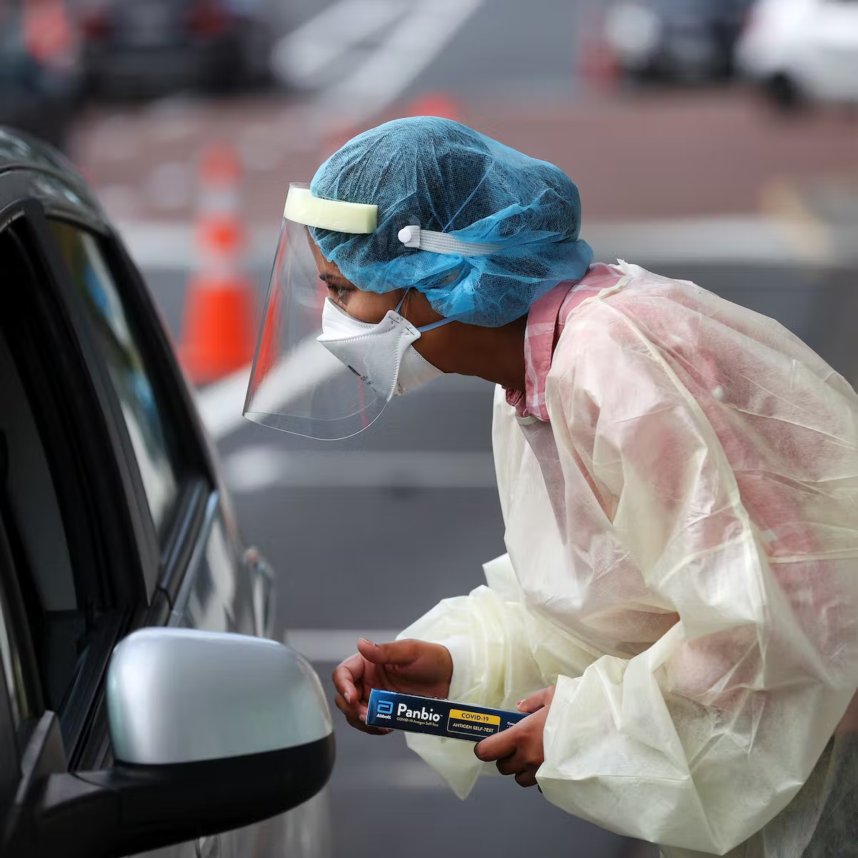

April 2023

CONTENTS
Introduction | 6
Pandemic Phases Definitions | 7
Further Reference  - The New Zealand Pandemic Plan for Influenza a Framework for Action  - Characteristics of Microbes Most Likely to Cause Pandemics and Global Catastrophes | 8
Primary Care Management | 9
Practice Responsibilities and Options for Service Delivery | 10
Recognition and Management | 10
Community Outreach Service | 11
Community Outreach Referral Information | 13
Patient Management Pathway | 14
Communication Plan | 14
Reporting Cases | 15
Surveillance | 15
Isolation of Suspected Cases | 16
Infection Control Precautions | 16
Environmental Cleaning | 17
Public Facing Information | 17
Radiology and Laboratory Facilities | 17
Supplies | 18
Temporary Accommodation | 18
Training | 19
Workforce Management | 19
Planning and Data Modelling | 20
Facility Preparedness | 21
Personal Protective Equipment | 22
Using PPE | 24
Doffing and Donning of PPE | 25
Specimen Collection | 26
Vaccines – General Information | 28
INFLUENZA | 32
Case Definition- Influenza | 29
Influenza Pandemic Strain- Checklist | 30
Primary Health Pandemic Influenza Presentation - Patient Care Clinical Pathway | 31
Pandemic Minimum data Set (PMDS) | 32
Management of a Patient with Influenza Like Illness | 33
Use of Antivirals | 34
Tamiflu | 36
Information on Quarantine (Home Isolation) for Influenza | 38
COVID-19
Case Definition COVID-19 | 40
Clinical Criteria COVID-19 | 41
HB COVID-19 Pandemic Data Set (as at September 2022) | 42
Testing Guidance COVID-19 | 42
COVID Care in the Community Framework (2022) | 42
MoH Primary Care Sector Guidance | 43
Hawkes Bay COVID Co-ordination System | 44
Patient Management Pathway | 45
Antiviral Therapy | 46
Types of COVID-19 Medicines | 47
COVID Variants of Concern | 48
Staying at Home, Patient Information | 50
Halcyon COVID-19 Screening Tool | 51
Post COVID Condition - Long COVID | 53

INTRODUCTION

Pandemics are typically characterised by the rapid spread of a novel type of virus, bacteria or other pathogenic agent to all areas of the world, resulting in unusually high morbidity and deaths for approximately two to three years. Factors that need to be present for a pandemic to occur include: the emergence of a new viral or bacterial subtype; the capacity for the pathogen to spread efficiently from person to person; and being virulent enough to cause disease.

The primary purpose of this plan is to provide the framework and methodology to efficiently respond to a pandemic in general practice. Te Whatu Ora Hawke’s Bay acknowledges as the situation develops primary care response will necessarily evolve with additional forms of care delivery being activated.

Assumptions

- Pandemics are inevitable

- The respiratory mode of transmission is most likely to lead to significant disease spread.

- Zoonotic diseases such as SARS, MERS, H7N7, Ebola and H1N1 are known, the risk of another zoonotic disease as a causative agent remains possible.

- There will be very little warning. Most experts believe that we will have between one and six months between the time that a novel pathogen is identified and the time that outbreaks begin to occur in New Zealand. SARS-CoV-2 originated in Wuhan in December 2019, the first recorded case for New Zealand was February 2020.

- Outbreaks are expected to occur simultaneously throughout much of New Zealand, preventing shifts in human and material resources that normally occur with other natural disasters.

- Widespread resource constraints will occur.

- The effect of a pandemic on individual communities will be relatively prolonged -- weeks to months -- when compared to minutes-to-hours observed in most other natural disasters.

- The majority of health care will be delivered in the primary health care setting.

- Effective preventative and therapeutic measures, including vaccines and antiviral agents will likely be in short supply, as well as other medications to treat infection.

- Health-care workers and other first responders will likely be at even higher risk of exposure and illness than the general population, further impeding the care of patients. SARS-CoV-2 evidenced the significant impact on the health care workforce and the requirement to plan is essential.

- Widespread illness in the community will also increase the likelihood of sudden and potentially significant shortages of personnel in other sectors who provide critical community service for example police, firemen, utility workers, and transportation workers, planning for external shortages is paramount.
PANDEMIC PHASES – DEFINITIONS

WHO Pandemic Phase | Definition
Inter-Pandemic Period  (WHO Phase 1) | A virus is seen in animals but has not been shown to infect humans
Novel Virus Alert  (WHO Phase 2) | A known animal virus has caused an infection in humans
Pandemic Alert  (WHO Phase 3) | Scattered or isolated incidence of cases or small clusters of the disease occurring in humans; possible cases of human-human transmission but not at a level to cause community-level outbreaks
(WHO Phase 4) | Human to human transmission at a rate that causes an outbreak in communities
(WHO Phase 5) | The spread of the disease between humans is now evident in more than one country
Pandemic Period  (WHO Phase 6) | Community level outbreaks are in at least one additional country other than that seen in Phase 5
For purposes of consistency, comparability and co-ordination of the national, regional and local response, identification and declaration of the following phases will be done at the national level.

Once phase 6 is reached preparation is then made for a global pandemic. Each phase has a list of actions that need to be followed to facilitate transparency and the education of health organisations and members of the public.
https://www.physio-pedia.com/Endemics,_Epidemics_and_Pandemics

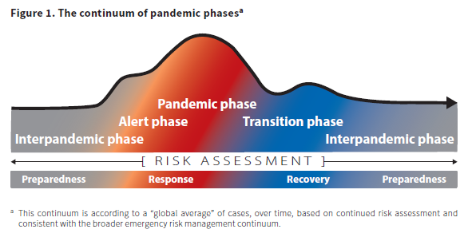
https://www.cdc.gov/flu/pandemic-resources/planning-preparedness/global-planning.html

FURTHER REFERENCES

The New Zealand Pandemic Plan for Influenza- a framework for action.
https://www.health.govt.nz/system/files/documents/publications/influenza-pandemic-plan-framework-action-2nd-edn-aug17.pdf (pages 62-63 pandemic phases)

Characteristics of microbes most likely to cause pandemics and global catastrophes.
https://ncbi.nlm.nih.gov/pmc/articles/PMC7122301/

PRIMARY CARE MANAGEMENT

During inter-pandemic period:
- Encourage annual vaccination of staff and consumers of communicable disease
- Promote self-care and ‘telephone first’ health initiatives as business as usual
- Ensure business and continuity plans include a pandemic response plan and are up to date
- Familiarise staff annually with the Business Continuity Plan

During pandemic alert: Activate Business Continuity Plan (Pandemic)
- Determine daily activities that can be deferred during the pandemic event
- Develop at risk patient databases to expedite planning and response for this cohort
- Contact at-risk patients to determine coping strategies/action plans, this may include pneumococcal vaccination to reduce incidence and severity of secondary infection.
- Provide updated clinical information on the emerging infectious disease including case definition, management and treatment guidelines to staff
- Make decisions regarding practice collaboration or referral of pandemic-related illness to a larger practice.
- Assess staff availability, including risk stratification of your workforce.
- Purchase sufficient supply of personal protective equipment to cover 7-10 days.
- Promote the public education strategy led by the Te Whatu Ora Hawke’s Bay.
- Initiate staff training plan.

During pandemic imminent stage:
- Fully activate the practice Pandemic Response Plan
- Obtain local contact details for advice about, and referral of, suspect patients from Te Whatu Ora Hawkes Bay
- Determine any additional service response required, i.e. triage, testing, treatment, monitoring or drive through
- Obtain the hospital admission criteria and treatment guidelines produced by Te Whatu Ora
- Triage and separate suspected infectious patients away from general patient streams at the practice
- Increase cleaning services in all areas
- Place appropriate visible signage advising patients and others of any restrictions or required actions
- Educate all patients who have pandemic symptoms to seek advice by phone before presenting at the practice
- Ensure provision for additional supplies of oxygen (BOC contracted by the Te Whatu Ora), pulse oximetry and radiology services along with increasing supplies of oxygen masks and tubing in consultation with Te Whatu Ora Hawke’s Bay procurement
- Prepare the workforce, PPE refresher training, pathogen recognition, and triage, as part of Pandemic Response Plan

During the pandemic:
- Notify the Medical Officer of Health of all probable cases of disease that meet the criteria, and all related deaths in the community
- Administer antiviral agents and vaccine to patients and staff according to national recommendations
- Utilize telephone service for general practitioners at Te Whatu Ora Hawke’s Bay on 0800 442 312, this service allows direct discussion with a consultant physician for advice and support
Admission criteria and treatment guidelines will be written by the Infectious Diseases Physicians nationally on confirmation of the pathogen involved. These will be disseminated to all general practices on completion.

Utilise triage checklists and patient care pathways appropriate to the presenting pathogen.

Practice Responsibilities

Every practice must identify a liaison person whose role will be to:
- Take lead responsibility for all infection prevention and control issues affecting the practice.
- Ensure that general practitioners, practice nurses and reception staff are kept up to date with current information from the Te Whatu Ora Hawke’s Bay and the Ministry of Health.
- Ensure that all staff are adequately trained in infection prevention and control practice.
- Ensure coding is correct for data mining or extraction for surveillance purposes (PHO led).

OPTIONS FOR SERVICE DELIVERY

Options to consider:
- Telephone triage, telephone consultation if not already part of the standard business model.
- Practices with a limited workforce may elect to take a collaborative approach with another practice.
- Community Assessment Centres activated by Te Whatu Ora Hawke’s Bay for the provision of primary care surge capacity arising from a sudden increase in demand (triggered by Code Red).
Functions:
  - Provision of clinical assessment and advice
  - Dispensing of antivirals and antibiotics
  - Provision of triage and referral to other primary or secondary care
  - Infection prevention and control
These centres are based around existing practices with the physical and management structures to support this form of care delivery, once activated an attached outreach service is available.
- Mobile general practitioner and practice nurse teams to manage home visits. Assessment of the patient and their household contacts should be by phone prior to the visit, if possible.
- Te Whatu Ora Hawke’s Bay Clinical Outreach Team referral for those patients at risk who are unable to be assessed by other means.
- Emergency Surge Facility, activated by Te Whatu Ora Hawke’s Bay when primary health care and the Emergency Department are overwhelmed.

RECOGNITION AND MANAGEMENT

Utilise the triage checklist to screen suspected cases and consider the best management pathway for the patient with consideration of
- risk of exposure to the pathogen, particularly for patients with comorbidities
- transport or access, do they have access to transport
- what assessment and treatment can be completed via telehealth technology
- what other services does the patient require to support wellbeing for them and their whanau.

Patients who telephone and are advised to attend the practice should be asked to bring their current medicines with them. Ensure updates about how to access care during the pandemic is communicated clearly to your enrolled patients, including after hours services available.

The patient care clinical pathway should be followed for all identified suspect cases. Antiviral medicines will be supplied to patients meeting the criteria, some antibiotics and paracetamol may also be supplied.

Admission and treatment guidelines will be supplied by Te Whatu Ora Hawke’s Bay.

Antiviral medicines will be used in the stamp it out phase for:
- The treatment of early cases
- Post-exposure prophylaxis of contracts
- Possibly pre-exposure prophylaxis of health-care workers

Antiviral medicines will be used in the manage it phase for:
- Patients with severe clinical illness resulting from the presenting pathogen
- Patients with clinical illness who are at high risk of pandemic-related complications (immunocompromised or suppressed patients, pregnant women, severe or poorly controlled congestive heart failure, severe chronic respiratory disease, severe asthma, patients on renal replacement therapy).
- Patients with pandemic symptoms who live or work in high risk institutions (residents of aged residential care facilities [ARRC] or other chronic care facility, people who provide services in relatively closed settings to persons at high-risk).
- Cluster and/or infection control where appropriate on discussion with the Medical Officer of Health.

The MOH will be responsible for application to the MoH for release of the national supply to the Hospital Pharmacy.

Effective vaccine is unlikely to be available for at least 12-16 weeks at which point the Public Health Unit will coordinate a mass immunisation campaign.

COMMUNITY OUTREACH SERVICE

Patients who are home bound and unable to access their primary care provider may need to be visited and assessed by a registered nurse or allied health professional. Referal to this service is outlined below.

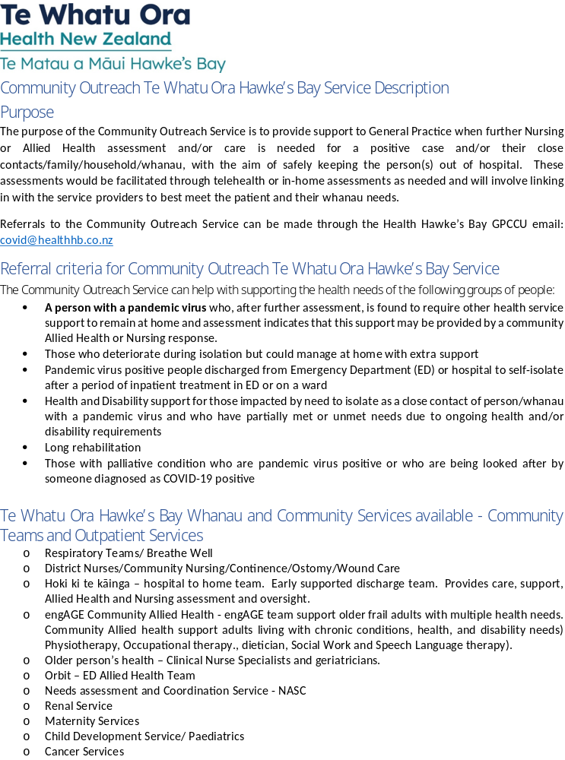
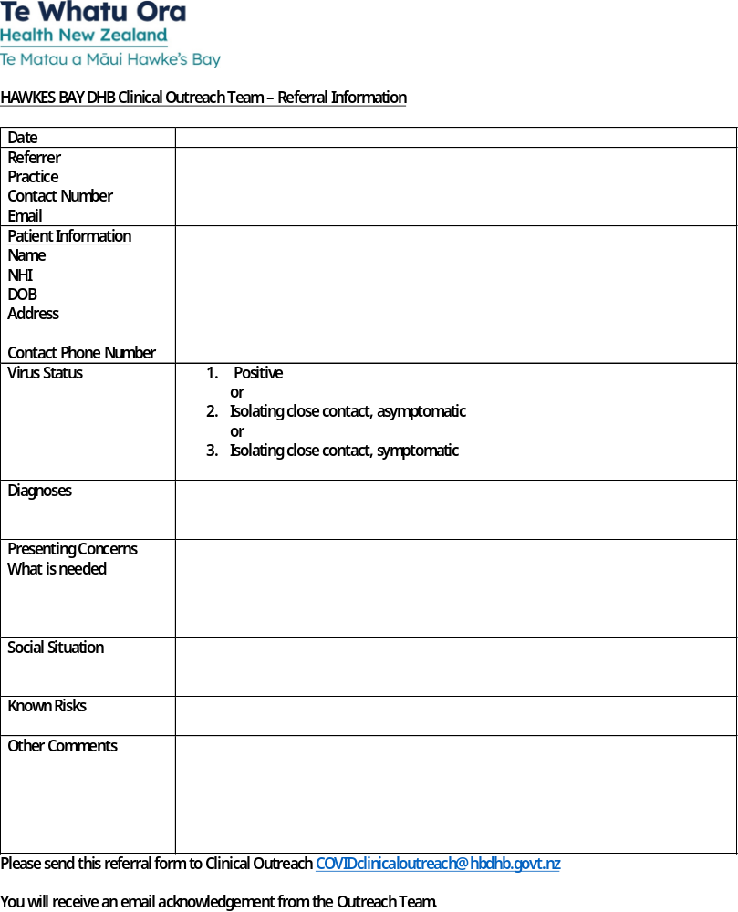

Patient Management Pathway
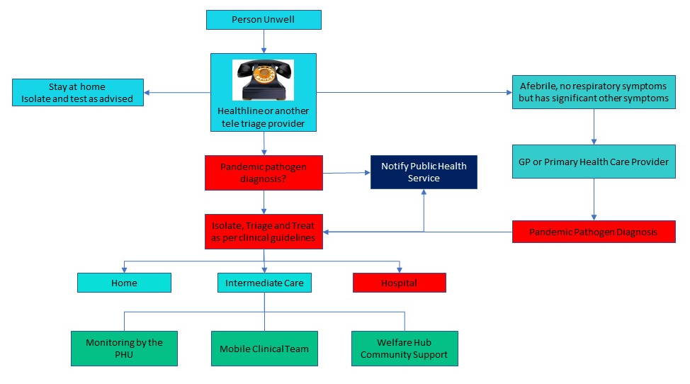

COMMUNICATION PLAN

Name | Title | Contact | Availability

Te Whatu Ora Hawke’s Bay - emergency.response@hbdhb.govt.nz
Sandra Bee | Emergency Management Advisor | 878-8109 | On-call
 | Infection Prevention and Control Advisor | 878-8109 | 0800-1700

Public Health Unit- CIMSOpsPublicHealthUnit@hbdhb.govt.nz
 | Medical Officer of Health | 878-8109 | On-call

Useful Websites:
Ministry of Health http://www.moh.govt.nz/pandemicinfluenza
WHO http://www.who.int
CDC http://www.cdc.gov

Daily reports to Emergency Operations Centre at Hawke’s Bay Hospital during Phases 5 and 6.

REPORTING CASES

Early in the Pandemic
Immediate notification of the first suspected cases is crucial. Phone 834-1815 (seven days). Ask to speak to a Medical Officer of Health (MOH). Make sure you speak directly to a MOH, do not leave a message. Detailed information will be required about each case and the MOH will work closely with the practice to formulate an immediate plan of action, including investigation and management of the case and contacts.

When the MOH advises that a Hawke’s Bay Pandemic is established
At this point the MOH will advise all centres that the reporting requirements will be reduced to a minimum Pandemic Minimum Data Set (PMDS), e.g. report date, name, age, gender, ethnicity and suburb or street address. PMDS Forms to be faxed to Te Whatu Ora Hawke’s Bay Emergency Operations Centre. emergency.response@hbdhb.govt.nz

SURVEILLANCE

Surveillance means collecting and reporting data about cases to describe the evolving epidemic to help guide a response. Surveillance will be carried out by the Public Health Service (PHS).

Surveillance updates will be available for practitioners on the Te Whatu Ora Hawke’s Bay: https://hawkesbay.health.nz/current-public-health-warnings-and-alerts/
ISOLATION OF SUSPECTED CASES

The separation of routine patients from those suspected of having the pandemic infection must be planned. This will be achieved by providing separate entrance/waiting rooms/treatment rooms for patients with symptoms. Designated staff should manage the patients in this area.

Prompt triage prior to entering the facility will assist in patient placement. Staff directing patients to the appropriate area should use the symptoms checklists. Providing a surgical mask and hand gel at the point of entry will minimise transmission to others and contamination of the environment.

INFECTION PREVENTION AND CONTROL PRECAUTIONS
Initial precautions
Such a major health event can only be handled by the whole facility including any Accident and Medical (A&M) team. The entire workforce team should be involved in any planning and preparation, do not forget the cleaner. Your first suspicion of outbreak in your community may come through a phone call. Consider how you will manage your facility’s response.
Staff able to work from home without effecting business, should be encouraged to do so.

It is recommended that all staff be vaccinated each year against seasonal influenza, coronavirus and other appropriate communicable diseases. While this may not protect against a pandemic, it will maintain the general wellness of your team. Unwell staff should stay at home.
Initial precautions for people dealing with someone suspected of having pandemic symptoms include:
  - Keep your distance
One metre is accepted as safe and significantly reduces your exposure
  - Wear a surgical mask, or PFR95 as clinically indicated
offer a mask to any patient and support people
  - Frequent hand hygiene- review “5 Movements of Hand Hygiene”
Use an antimicrobial hand gel or wash in warm water with flowing soap, dry hands with paper towels
  - Ensure separation patients with respiratory symptoms from other patients
  - Ventilation
Keep windows open if possible. If air conditioning is used, ensure that designated areas can be isolated from the rest of the facility or turn the air conditioning off. Mobile hepa filters may be utilised from the Emergency Management Advisor (Te Whata Ora Hawke’s Bay) if supply is available.
Each general practice or A&M should promote hand and personal hygiene, i.e. the use of tissues when coughing or sneezing, or sneezing/coughing into the elbow.

ENVIRONMENTAL CLEANING

Horizontal surfaces should be wiped down after each suspect patient. Patient care areas and bathrooms must be cleaned at least daily on completion of other routine cleaning.

Each facility must have documented Pandemic Environmental Cleaning Guidelines approved by IPC CNS, Te Whatu Ora Hawke’s Bay.

These should include:

Cleaning protocols for:
- High touch areas, floors, staff areas
- Use of environmental wipes
- PPE for cleaning personnel (mask, gown, gloves and eye protection)
- Approved cleaning equipment and chemicals (sodium hypochlorite 100mL in 1L of water 1:10)
- Disposable cleaning cloths
- Management of non-disposal patient equipment
- Waste and linen management

Minimal linen should be used and changed after each patient taking care not to shake it. All waste (except sharps) must go into the biohazard bag.

Linen and waste must be emptied daily or when containers are two thirds full.

PUBLIC FACING INFORMATION

Messages to the public will be distributed centrally by Te Whatu Ora Hawke’s Bay following MoH advice, this will assist in managing expectations. Te Whatu Ora will also provide public information on local arrangements.

Information pamphlets are available on the MoH website
https://www.health.govt.nz/covid-19-novel-coronavirus

Regular bulletins will be coordinated through Te Whatu Ora Hawke’s Bay. A hotline number may be made available through Te Whatu Ora for updated information on 0800 777 790.

Practices will also have their internal communication systems for providing information to their enrolled patients. It is important that regular, up to date and consistent messaging is provided to the public during a pandemic as anxiety is high and disinformation and misinformation is often targeted and abundant in the community.

LABORATORY AND RADIOLOGY FACILITIES

Laboratory specimens may only be collected in the early stages of the pandemic. See specimen collection procedures.

Patients with suspected pandemic illness should not be sent to a community laboratory for collection of throat or nasopharyngeal swabs.

Specimens should be double-bagged and couriered to the Laboratory at Te Whatu Ora Hawke’s Bay.

Radiology service arrangements will continue as normal practice arrangements dictate. They will be supported by TRG Imaging for non- pandemic patients with transport to services the responsibility of Te Whatu Ora Hawke’s Bay.

SUPPLIES

Supplies of PPE should be held by each practice to manage initial cases with resupply through the national reserve held by Te Whatu Ora on release by the MoH.

Essential supplies

  - Disposable gloves (if indicated)
  - Surgical masks
  - Infared thermometers
  - Tissues – for waiting and consulting rooms
  - Waste disposal bins with lids and medical waste disposal bags
  - Antimicrobial hand gel or hand washing facilities’ (flowing soap, water and paper towels for drying)
  - Gowns (when indicated)
  - PFR95 masks (when indicated)
  - Equipment for collection of multiple specimens for viral culture and PCR

Pandemic guidelines for PPE use must be followed. Including the appropriate use of PFR95 masks and gowns.

Ensure the pandemic plan for your facility includes stock management, and the process for re-ordering. Security of critical supplies is paramount due to short supply and demand for these items.

Anti-Viral Medication
The MOH will approve the distribution of antivirals and request the release of the national reserve.

Te Whatu Ora, Hawke’s Bay Pharmacy will:

- store antivirals
- pre-label the antivirals so that a doctor or nurse can issue the medicine by writing the name and required dose on the label
- arrange transport to the provider who will supply the medication to the patient
- monitor stock issued

TEMPORARY ACCOMMODATION

Arrangements for temporary accommodation for staff who are willing to work but do not wish to go home should be made. This may include an onsite facilities, mobile homes or motel accommodation.

Coordination of temporary accommodation, if required, for patients who live alone will be carried out by Te Whatu Ora Hawke’s Bay.

TRAINING

A staff training database ensuring regular infection prevention and control and PPE certification is recommended. Nominating a practice champion as the IPC lead will prevent the health system from being overwhelmed with training requests during a pandemic, and will ensure the practice is already operating within best practice guidelines.

Any additional training necessary to meet the pandemic requirements will be provided by Te Whatu Ora Hawke’s Bay.

WORKFORCE MANAGEMENT

Workforce management requires sensible rostering, cover for sickness and absenteeism and attention to staff welfare. Volunteers and ex staff may be utilised although considerable thought is required as to the tasks that may be allocated to these groups.

Ensure appropriate safe direction and delegation of duties is given to unfamiliar, unregulated or returning workforce. Consider a clinical preceptor to facilitate safe orientation of the extended workforce team. Rostering should consider short rotations for those providing care in PPE and adequate break time. Attention to providing protection from the weather in hot and cold conditions must form part of workforce planning if there is a requirement to work outdoors.

Workforce planning should start early in preparation for increased staffing required during the peak of the pandemic. Discussion with staff in the planning phase is essential to determine who will be most likely to be available, and which skills might be adapted to provide cover. Consider operationalising this by reviewing what jobs can be safely reallocated to others to utilise limited workforce most efficiently. Prepare contracts in advance (casual workforce) and train additional workforce early.

In the event of practices amalgamating to provide cover, advice should be given to patients using a standardised approach. Consider external telehealth providers for surge ensuring this is communicated with patients with consistent messaging.

PLANNING AND DATA MODELLING

The following graphs depict the pandemic wave based on a Ministry of Health data from the 2020-2023 pandemic. Standard pandemic planning uses a 40% attack rate and 2% case fatality rate. This would result in 72,600 cases and 1,452 deaths in Hawke’s Bay based on the population at 181,500 (2021 estimate).

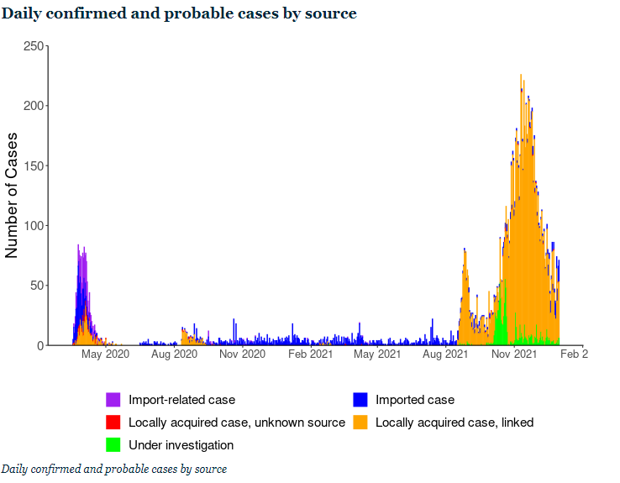
https://www.health.govt.nz/covid-19-novel-coronavirus/covid-19-data-and-statistics/covid-19-source-cases-2020-and-2021

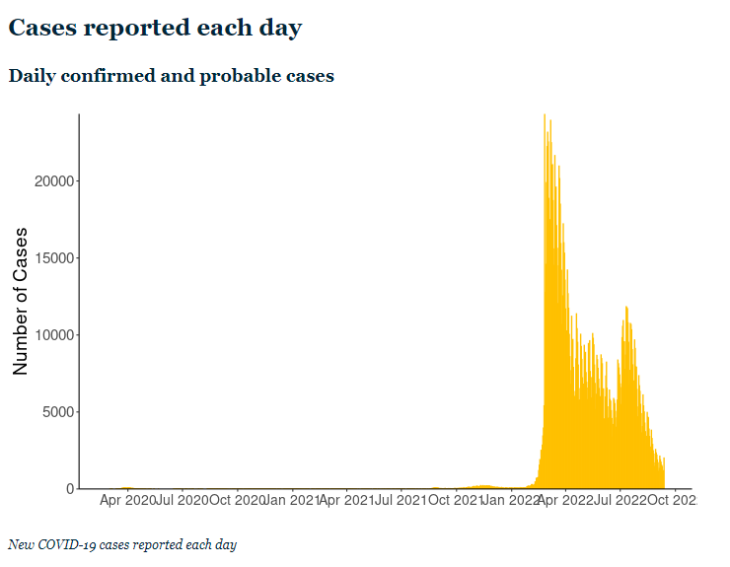
https://www.health.govt.nz/covid-19-novel-coronavirus/covid-19-data-and-statistics/covid-19-current-cases

FACILITY PREPAREDNESS

Assessment and Treatment Areas

Red line / green line to separate patients:
- Multiple entries
- Registration area
- Waiting area(s)
- Screens for reception areas
- Assessment area: triage
- Transfer and pre-hospital treatment area
- Patient education/information/counselling area(s)
- Discharge area
- Adjunct services: radiology, laboratory
- Consider external tentage for assessment and testing areas

Storage and Administration

- Secure pharmaceutical supplies area
- Medical supplies, especially secure stores for PPE
- Patient records
- Triage tags/transport and transfer forms
- Ability to stockpile equipment and supplies

Support Services

- Medical waste
- Laundry
- Catering

Staffing

- Current staff levels at all required skill levels, including security staff
- Access to additional staff (consider impact on other services) including volunteer and health support service staff
- Insurance and personal liability cover for practitioners and volunteers
- Staff support services, including staff family support
- Training needs: infection prevention and control; triage methods; communication; telephone advice and triage; personal protection

Physical Requirements (Infection Prevention and Control Only)

Entry

- Posters, masks and hand gels outside facility to be put on/used before entering
- Antimicrobial hand gel dispensers outside facility so that people entering clean their hands before touching the door handle
- One point of entry for all patients so they do not miss triaging
- Protective screen at reception to minimise droplet spread

Reception area

- No toys magazines or newspapers
- Minimal, washable furniture

Treatment rooms

- Separate room to minimise exposure/ risk of transmission to others
- Designated toilet facility with appropriate hand hygiene facilities
- Sufficient space: wherever possible the practitioner should have sufficient space to be more than one metre away from the patient when not carrying out a physical examination
- Minimal equipment and supplies in the room
- Washable surfaces
- Pedal operated rubbish bins/linen skip
- Arm operated taps
- Wall dispensers: for antimicrobial hand gel

Equipment

- Disposable equipment should be used whenever possible
- Masks, gloves, gowns, eye protection
- Antimicrobial hand washes/gels
- Tympanic thermometers
- Pulse oximeters
- Biohazard bags
- Approved cleaning solutions: hospital grade surface disinfectant or wipes
- Disposable cloths
- Tissues

PERSONAL PROTECTIVE EQUIPMENT

Recommendations for PPE use
Personal protection equipment (PPE) includes masks, eye protection, gloves, gowns and aprons. Varying levels and types of PPE are required, depending on the level of exposure and the risk of transmission.

Whatever the level of PPE to be used, education and training is necessary to ensure the equipment is used and disposed of correctly, to maintain the equipment’s effectiveness.

Estimate for PPE for GP Practice

One patient requires one GP and one Nurse:
PPE required for 1 patient = 2 masks, 2 pair gloves, 2 gowns

GP sees 4 patients per hour = 8 pair gloves per hour
= 96 patients per 24 hours
= 192 pairs per 24 hours
= 672 patients per week
= 1344 pairs gloves per week
Gloves supplied per box = 100 therefore 26-27 boxes of gloves per week
PFR95 masks ≤4 hours = 12 per day per one GP and one Nurse
= 84 per week
PFR95 masks supplied per box = 35 therefore 2.4 boxes per week

Surgical masks for patients = 672 patients per week
Surgical masks supplied per box = 50 therefore 13-14 boxes per week

If the gown is to last 4 hours = 12 per day (as for masks)
= 84 per week
Gowns supplied per carton = 50 therefore 2 cartons per week

Gowns - you will need to decide how long your gown should last. In the hospital situation a gown is single use. In the primary care setting you may decide to use one gown for 4-8 hours. This will depend on the contact with patients and the care and contamination of the gown.

Gloves may not be required for all patient contacts. Hand hygiene (antimicrobial hand gel or soap and water wash) will be sufficient in most cases.

NOTE: These numbers are only estimates and may vary during the phases of a pandemic. There are many variables to be considered i.e. practice size, patients seen, acuity, potential for contamination of PPE.

Summary of PPE requirements:

 | Entering Room but no close contact (> 1 metre from patient) | Close patient contact (<1 metre from patient) | Aerosol generating procedure being performed (including nose/throat swabs)
PFR95 mask | No | No | Yes
Surgical mask | Yes | Yes | No
Isolation gown | No | No | Yes
Gloves, non-sterile | No | No | Yes
Eyewear, protective | No | No | Yes

Use of disposable surgical masks, gloves and gowns/aprons

Disposable surgical masks are recommended for first responders and health care/support workers in a health care setting who are at risk from droplet transmission.

Disposable gloves are recommended as a means of reducing the likelihood of transmission of a virus when handling objects contaminated with respiratory secretions. Apart from health care settings, the use of gloves is less important than careful hand hygiene. The use of gloves does not replace the need for hand hygiene.

Disposable gowns or splash resistant aprons may also reduce opportunities for transmitting a pandemic virus.

Using particulate respirator masks (PFR95), eye protection, gloves and gowns/aprons (full PPE)
Health care workers should wear particulate respirator masks, eye protection, gloves and gowns/aprons (i.e. full PPE) when there is a high risk of direct contact with respiratory secretions, particularly via aerosols. This will apply mostly in inpatient settings during some invasive procedures.

In most other settings a disposable surgical mask and regular hand hygiene will provide sufficient protection from droplet transmission for health care workers in close contact and/or providing direct personal care to patients with a pandemic virus.

Checklist for Staff before Entering Isolation Areas

The following points must be checked before entering a designated area:
- Cell phones or pagers left outside the area along with pens, stethoscopes and tourniquets
- Shoulder length hair must to clipped or tied back
- Shoes should cover and protect feet from splashes and dropped equipment and should have wipeable surfaces
- A mask must be worn and fit securely
- A gown must be worn and be tied firmly
- Gloves must be worn and cover the wrists

USING PERSONAL PROTECTIVE EQUIPMENT

NB: The correct donning and doffing process must be followed. A doffing area must be designated with the appropriate equipment i.e. hand hygiene products and waste disposal bins.

If any of the following occurs the mask must be changed:
- if you touch it
- if it is grossly contaminated
- if it becomes wet for any other reason
- if it becomes hard to breathe through

Masks should be placed in a biohazard bag after removal.

If at any time gloves become contaminated, they must be removed, hand hygiene performed and clean gloves put on.

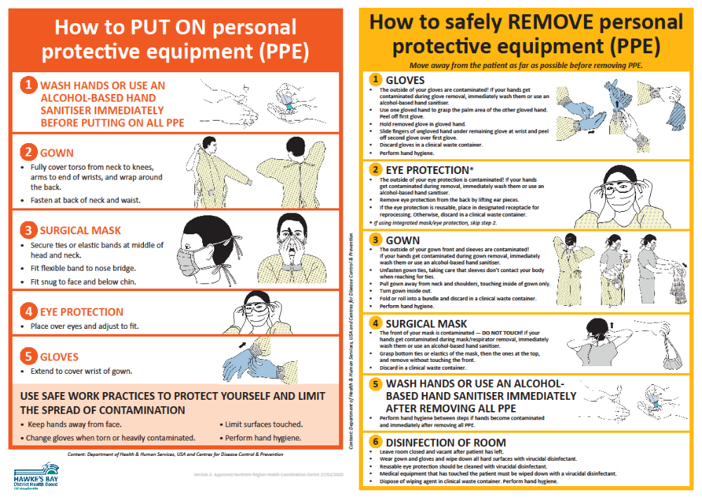
SPECIMEN COLLECTION

All samples should be sent by the usual Southern Community Laboratories specimen collection service to Hawke’s Bay Hospital Laboratory.

Who should be swabbed?
- Swabbing should be reserved for only those patients with pandemic illness who are in high risk groups or situations.

People on antiviral medicine
- Antiviral medicines reduce the yield from viral swabs.
- If an adult case has commenced a twice-daily treatment course of antiviral medicine, do not take swabs. Children excrete a higher viral load. If a child case has been on a twice-daily treatment course of antiviral medicine for >48 hours do not take swabs.
- For contacts on once-daily prophylaxis with antiviral medication who develop symptoms, a swab is indicated if within 48 hours of commencing antiviral medicine.

People not on antiviral medicine
- Virus shedding declines with time in untreated patients.
- Do not take swabs from an adult case who has had symptoms for five days or longer.
- Children (especially young children) shed for longer, so untreated children can be swabbed even if they have had symptoms for longer than five days.

Samples required
- Nasopharyngeal swab in viral transport medium

Sample collection
Respiratory specimens should be collected as early as possible in the course of the illness. The likelihood of recovering most viruses and many bacteria diminishes markedly >72 hours after symptom onset. Some respiratory pathogens may be isolated after longer periods.

Equipment
One nasopharyngeal swab with non-wooden shaft and synthetic fibre tip
One virology swab with viral transport medium
One pair of scissors
PPE i.e. gloves, gown, PFR95 mask, eye protection, antimicrobial hand gel

(i) Collection of nasopharyngeal swabs
Use a pernasal swab with non-wooden shaft and synthetic fibre tip:
Insert swab into one nostril, parallel to the palate, rotate gently and advance until resistance is felt. (One eye will often water when swab is in the correct position.)
Press swab tip on the mucosal surface of the mid-inferior portion of the inferior turbinate and leave in place for a few seconds, then slowly withdraw using a rotating motion.
Place swab into viral transport medium tube.
Snap or cut off the cap with scissors and discard the cap
Ensure tube lid is secure and labelled correctly.

- If the viral transport medium is liquid
Cut the swab sticks off just below the level of the bottle - so that there is no swab pressure for the viral media lid to pop off.
Ensure lid is firmly closed on viral specimen and taped to prevent leakage of viral media, ensure the specimen is labelled correctly.

Packaging and Transport:

- The laboratory form should clearly indicate that this is a request for “PCR testing for novel (pathogen) infection”. Write “copy result to the Medical Officer of Health”. Notifying the Medical Officer of Health is not required before sending the swab.
- Ensure the laboratory request form is fully completed with details including the NHI number and that the specimen container contains the patient name and NHI number.
- Specimens should always be bagged ensuring that the snap lock is securely sealed. Place the request form in the pocket of the outside bag.
- Specimens should be transported by Southern Community Laboratories to the Hawke’s Bay Hospital Laboratory.
VACCINES – GENERAL INFORMATION

Vaccine Management should be based on the following assumptions:
- There will be a minimum of 6 months between a novel virus alert and the availability of vaccine, as evidenced in the COVID-19 Pandemic.
- The entire population will be susceptible and may require two or more doses of vaccine for adequate protection.
- The proportion of vaccine to be distributed and administered through the public versus the private sector is unknown. Even so, the amount, if not the proportion, of vaccine that will be distributed through the public sector during a pandemic will be greater than the amount distributed by the public sector in non-pandemic years.
- There will be a national contract for purchase of vaccine.
- Multiple vaccines will likely be available quickly, requiring workforce training, education and preparedness.

Vaccine Administration
Vaccinators are authorised by the Medical Officer of Health pursuant to regulation 44a of the Medicines Regulations. Hawkes Bay has authorised vaccinators available with a database being maintained to record all vaccinations. A list of currently authorised vaccinators is held by the PHU.

In response to the COVID-19 pandemic, the provisional vaccinator workforce was instrumental in providing a rapidly trained vaccination workforce. In addition, non-regulated vaccinator roles i.e. COVID Vaccinator working under supervision (CVWUS) or similar workforce may also feature as part of a regular vaccination team. It is important that the workforce is trained and supervised to ensure Vaccinators comply with current legislation.

Priority Groups List for Receipt of Vaccine
Because vaccine shortage during a pandemic is likely, the MoH, in conjunction with various advisory committees, will formulate recommendations for a rank-order list of high priority groups for vaccination. The order of these groups will be based on a number of factors, including the need to maintain the infrastructure necessary to carrying out the pandemic response plan; to limit mortality among high-risk groups; to reduce morbidity to the general population; and to minimize social disruption and economic losses.

While any Priority Groups List will be subject to change, the list will most likely include the following groups:
- Health-care workers and public health personnel involved in the distribution of vaccine and antiviral agents
- Persons responsible for community safety and security, e.g. police, fire-fighters, military personnel, corrections officers, "first responders" not included in first priority group (e.g. ambulance officers)
- Other highly skilled persons who provide essential community services whose absence would either pose a significant hazard to public safety (e.g. air traffic controllers) or severely disrupt the pandemic response effort (e.g. persons who operate telecommunications or electric utility grids, care givers at residential facilities). [NOTE: Members of this target group are likely to vary widely from region to region, depending on local circumstances.]
- Persons considered to be at increased risk of severe influenza illness and mortality

Vaccination will be coordinated by the Public Health Service at Te Whatu Ora Hawke’s Bay.

INFLUENZA

MINISTRY OF HEALTH CASE DEFINITION

Suspected case of Pandemic Influenza
Person with an influenza like illness of abrupt onset, characterised by:
  - History of fever, chills and sweating; or
  - Clinically documented temperature ≥38˚C ; and
  - Cough or sore throat

Probable case of Pandemic Influenza
Person with an influenza like illness who has a strong epidemiological link to a confirmed case or defined cluster.
Confirmed case
An individual for whom laboratory testing demonstrates one or more of the following:
      - positive viral culture for Pandemic Influenza; or
      - positive RT-PCR for Pandemic Influenza; or
      - four-fold rise in novel influenza virus specific neutralising antibodies.

CHECKLIST – INFLUENZA PANDEMIC STRAIN

Complete the following checklist at first contact with patient, i.e. in triage room or over the telephone.

May 2019

Yes/No
1. |  | History of fever, chills, myalgia or clinically documented fever > 38⁰C
2. |  | PLUS, two or more of the following
 |  | Headache

Malaise

Cough

Sore throat

Patients with both 1 and 2 meet the definition of influenza-like illness.

If you have a suspect case, direct patient to nearest community assessment centre, if activated, or general practice caring for influenza related illness if triage over the phone. If patient has presented at general practice, put a mask on the patient and put on protective clothing immediately, direct the patient to the designated influenza area.

Primary Health Pandemic Influenza Presentation - Patient Care Clinical Pathway

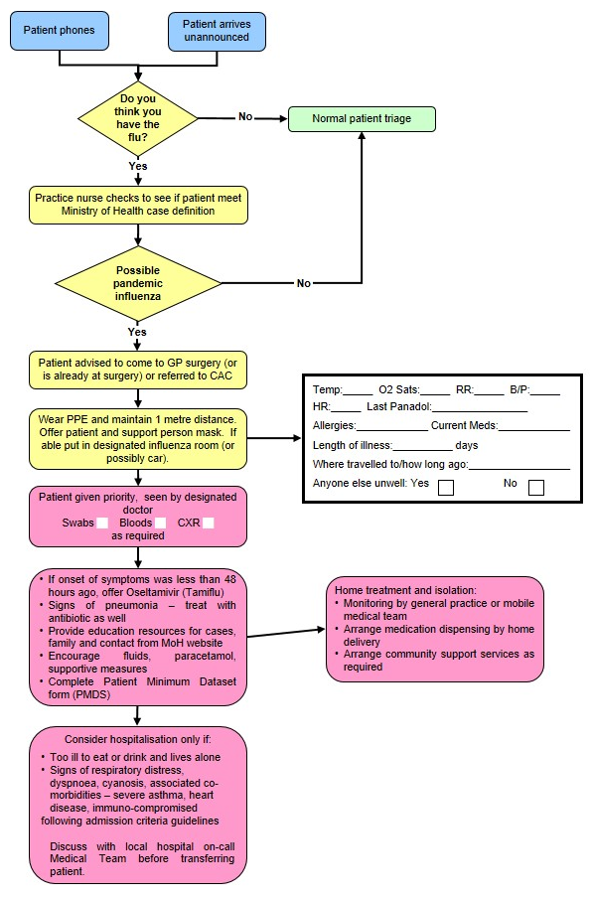

PANDEMIC MINIMUM DATA SET

Name of Practice: | Date:
Clinical Assessor: | Signature:

Name: Given |  | Middle |  |  | Family
Address:
House Number:
Street:
Suburb:
Town:
Gender: M / F | DOB: |  |  | NHI:
Ethnicity: | European |  | Maori | Pacific |  | Other

Please Circle Appropriate Codes
Category Codes |  |  | Antiviral Status Codes
GEN | General Public |  | TRT-T | Treatment provided – Tamiflu
HCN | Health Care Nurse |  | TRT-R | Treatment provided – Relenza
HCD | Health Care Doctor |  | OWN-T | Antiviral treatment from own supply - Tamiflu
HPA | Health Care Ambulance |  | OWN-R | Antiviral treatment from own supply - Relenza
HCO | Health Care Other Direct Contact |  | POP-T | Post exposure prophylaxis with Tamiflu
BOR | Border Worker |  | POP-R | Post exposure prophylaxis with Relenza
POL | Police |  | Antibiotic Codes
DEF | NZDF Member |  | NIL | No antibiotics provided
COR | Corrections Worker |  | TRT | Antibiotic treatment provided – evidence of existing respiratory bacterial infection
FIR | Fire Service Worker |  | PRO | Prophylactic/precautionary antibiotics provided because of unusual vulnerability to bacterial infection (e.g. person with COPD, CHF, asthma or other condition)
SOC | Civilian Social Support Worker |  | Antibiotic Prescribed
Treatment Rationale Codes |  |  | AUG | Augmentin
ILI | Severe influenza-like illness |  | COT | Co-Trimoxazole
HRG | High risk group |  | DOX | Doxycycline
HRI | High risk institution – MUST be discussed with the Medical Officer of Health |  | FLU | Flucloxacillin

Management of Patient with Influenza-Like Illness
Influenza-like Illness (ILI)

History of fever, chills, myalgia or clinically documented fever ≥ 38°C
and two or more of the following
Cough, sore throat, headache, malaise
High Risk Groups

People with influenza-like Illness who are at high risk of influenza-related complications:
People who are immune compromised or suppressed (transplantation, haematological and solid organ malignancy on chemotherapy/radiotherapy, HIV, autoimmune disorders, etc)
Pregnant women – discuss with infectious diseases physician
Mental health patients on Clozapine

Anyone over six months of age with chronic medical conditions, such as:
Severe or poorly controlled congestive heart failure
Severe chronic respiratory disease
More severe asthmatics (e.g. people on oral steroids, high dose steroid inhalers, or steroids and long acting beta-agonists)
Renal replacement therapy

People with influenza-like illness who live or work in residential institutions, (e.g. prisons, boarding schools, nursing homes). Please discuss with Medical Officer of Health telephone: 8341815.

Does this person meet clinical criteria for Severe ILI?
SIRS Criteria
Clinical Criteria for Severe ILI
More than one of the following:
Temperature ≥ 38°C
Heart Rate > 90
Respiratory Rate >20

Is the patient in a high risk group?
Self-manage at home.
Do not prescribe National Reserve Tamiflu or antibiotics
Fax prescription(s) to authorised pharmacy
Fax Patient Minimum Data Set form to 0800 856 923
Instruct patient or relative to collect Tamiflu
Advise to stay in isolation until well

Consider hospital assessment if patient has any of the following:

T > 39°C
SBP < 100
HR > 110
RR > 25
O² Saturation < 92
Vomiting > 1 in 24 hrs
Confusion
Rigors
Pleuritic Chest Pain
Inability to self-care
Dehydration

These criteria are not prescriptive and cannot replace clinical judgement
Yes
No
Yes
No

USE OF ANTIVIRALS

Influenza viruses develop significant resistance quickly for M2 channel blockers. In New Zealand, zanamivir is for ‘in hospital’ treatment and prophylaxis of influenza in hospitalised patients subject to restriction. Therefore, only oseltamivir (Tamiflu) will be described in detail.

First line health care workers will be using antivirals from the Governments stockpile, because the antiviral medication will be in short supply when the pandemic strikes. The MoH (directly or through Medical Officers of Health) will be communicating guidelines, protocols, and priorities for its use.

Tamiflu might be used prophylactically for exposed travellers, containment of sporadic clusters, essential services staff and therapeutically for all patients (initially), high-risk patients, essential services staff.

Tamiflu is indicated for the treatment of influenza in adults and children 2 weeks of age and older who have been symptomatic for no more than 2 days (see section 4.4 Special warnings and precautions for use).
https://www.medsafe.govt.nz/profs/Datasheet/t/Tamiflucapsusp.pdf

Tamiflu is indicated for the prophylaxis of influenza in adults and children >1 years of age. Vaccination is the preferred method of routine prophylaxis against infection with influenza virus.

Presentation

Tamiflu 30 mg hard capsules
Tamiflu 45 mg hard capsules
Tamiflu 75 mg hard capsules

Tamiflu 6mg/ml powder for oral suspension

Dosage and Method of Administration

Tamiflu may be taken with or without food. However, Tamiflu taken with food may enhance tolerability in some patients.

Standard Dosage

Treatment of influenza

Treatment should begin within the first 48 hours of the onset of symptoms of influenza.

Adults and adolescents
The recommended oral dose of Tamiflu capsules in adults and adolescents ≥ 13 years is a 75mg capsule twice daily, for 5 days. Adults and adolescents ≥ 13 years of age that are unable to swallow capsules may receive a dose of 75mg Tamiflu suspension BD for 5 days.

Infants and Children ≥1 to < 13 years of age
Infants and children 1 year old may receive the required Tamiflu dose in the form of capsules. Patients unable to swallow capsules may receive the appropriate dose of Tamiflu oral suspension, see Patients unable to swallow capsules).
The recommended weight adjusted dosing regimens of Tamiflu for children ≥ 1 year of age are:

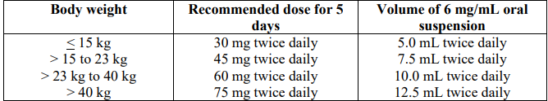

Infants 2 weeks to < 1 year of age.
The recommended oral dose of Tamiflu for infants 2 weeks to less than 1 year of age is 3 mg/kg twice daily, for 5 days. These dosing recommendations are not intended for infants who have a post conceptual age of less than 36 weeks.

Special dosage instructions
No dose adjustment is necessary for patients with creatinine clearance above 60mL/minute. In patients with creatinine clearance between 10 and 30mL/minute receiving Tamiflu it is recommended that the dose be reduced to 75mg of Tamiflu every other day or 30mg suspension every day. No dosing recommendation is available for patients undergoing routine haemodialysis and continuous peritoneal dialysis with end stage renal disease and for patients with creatinine clearance ≤ 10mL/minute.

No dose adjustment is required for patients with hepatic dysfunction and no dose adjustment is required for elderly patients.

The safety and efficacy of Tamiflu in children under 1 year has not been established. Tamiflu should not be used in children under 1 year of age.

A bottle of 30g Tamiflu powder for oral suspension contains 25.713g of sorbitol. One dose of 45mg oseltamivir administered twice daily delivers 2.6g of sorbitol. For subjects with hereditary fructose intolerance this is above the recommended daily maximum limit of sorbitol.

Prophylaxis of influenza

The recommended oral dose of Tamiflu for prophylaxis of influenza is 75mg once daily for at least 10 days. Therapy should begin within two days of exposure.

Contraindications

Hypersensitivity to oseltamivir phosphate or any component of the product.

Information derived from pharmacology and pharmacokinetic studies of oseltamivir suggest that clinically significant interactions with other medicines are unlikely.

At present, insufficient data are available in pregnant women taking Tamiflu to enable an evaluation of the potential for oseltamivir cause foetal malformations or foetal toxicity. Tamiflu should therefore be used during pregnancy only if the potential benefit justifies the potential risk to the foetus.

https://www.medsafe.govt.nz/profs/Datasheet/t/Tamiflucapsusp.pdf
INFORMATION ON TAMIFLU

How effective is the anti-viral medicine Tamiflu against influenza?

Tamiflu is one of two medicines that are effective against the strains of Influenza A and B.

The WHO have advised all health authorities to stockpile anti-viral medicines to prepare for a pandemic. New Zealand has followed that advice.

Will Tamiflu cure people sick with the Pandemic Influenza virus?

We don't know for sure.

When people have seasonal influenza, Tamiflu reduces symptoms and may shorten the duration of illness by a day and a half.

If otherwise healthy people who are ill with influenza take it, they are less likely to develop complications of influenza. Those complications are usually treated with antibiotics.

Does Tamiflu prevent people from getting influenza?

Yes, it does, but it is not the best means of preventing influenza. Vaccination is the best protection against influenza, which is why people are encouraged to immunise against seasonal influenza every year. Tamiflu will help until a pandemic vaccine arrives.

For more information on Tamiflu, including how it works against influenza, see the datasheet, http://www.medsafe.govt.nz/profs/datasheet/+/Tamiflucapsusp.pdf.

How does Tamiflu work?

It is a medicine that only works against influenza viruses A and B.

It does not work against other viruses or bacteria that can cause illness similar to influenza or that can cause respiratory infection. If taken within 48 hours of becoming ill it stops the virus from bursting out of infected cells, infecting new cells and possibly other people.

Will masks help protect me and my family from the influenza virus?

A surgical mask, if put on someone who is sick, will help reduce the spread of infection, because it will reduce the amount of virus spread by coughs and sneezes.

People who are not sick and who are very close to the person who is coughing and sneezing - closer than 1 metre - may get some protection by covering their own nose and mouth with a mask. Again, this is because the mask will catch some of the virus in the cough and sneeze droplets.

What about interactions between Tamiflu and other drugs I am taking?

There are no significant interactions known.

Side effects
Most people taking Tamiflu experience no side effects. A small proportion will experience one or more of the following:

Common | Less commonly
Nausea 8-10%  Vomiting 2-8%  Headache 2-17%  Diarrhoea  Abdominal pain 1-4 %  Dyspepsia  Conjunctivitis | Eczema  Rash  Convulsions  Arrhythmias  Altered consciousness  (usually in children or adolescents)

Information on Quarantine (Home Isolation) for Influenza
You have been asked to stay in isolation because:

- You have suspected influenza and are infectious to others. Isolation in your home should continue for 72 hours after starting Tamiflu or 7 days from the onset of illness if you are not taking Tamiflu.

- You may have been exposed to influenza. Isolation in your home should continue for 72 hours after starting Tamiflu or 7 days from the onset of illness if you are not taking Tamiflu.

The period of isolation may be lengthened if somebody else in your household becomes sick with suspected influenza.

We want you to restrict your activities to protect the safety of your family, friends and the community. This information sheet is to tell you what isolation means.

Staying at home

You must not go to school, work, child care or out in public until cleared by the Public Health Nurse. This means you must not attend shopping centres, movies, parties or any social gatherings at all.

Visitors

You should have no visitors until you come out of isolation. Talk by phone and have things delivered to the door. Sometimes a visitor is essential (for example someone has to come into the house to give you essential home support). The visit should be brief. You and the visitor must both wear a mask. Talk with the visitor outside in the open air if possible and keep at least two metres away from them.

Preventing the spread of infection

- Stay in a part of the house where you have minimal contact with other people. Try to keep well people and sick people apart.
- Give people who have a fever and/or diarrhoea plenty to drink.
- Give Paracetamol for fever. Do not give Aspirin to children under 12 if they have a fever.
- Open doors and windows and ventilate the house as much as possible.
- Cover your mouth and nose with a tissue or toilet paper when you are coughing or sneezing. Put the used tissue straight into a rubbish container. Wash and dry your hands afterwards.
- Wash and dry your hands after you use the bathroom or toilet. Wash and dry your hands before you prepare food and eat, and when you are looking after sick people.
- If you have more than one toilet, then one should be reserved for use by sick people.
- Twice a day clean the following:
- with 1-part household bleach to 10 parts water:
- toilet handle and door handle of the toilet, bathroom and rooms of isolated people
- bathroom sink and taps
- Nobody else should use anything that could be contaminated with your throat or nose secretions or coughing or faeces – e.g. towels, handkerchiefs, eating utensils, food, bed linen, cigarettes, marijuana joints, P pipes, kava bowls.
- Sharing bedding, clothing and utensils may spread infection, but you do not need to wash a sick person’s bedding, clothing and utensils separately from the rest of the families. If you wash and dry all these things in the usual way they will then be safe for others to use.

Using face masks

- Sick people should wear a surgical mask if anyone is in their room and if they have to leave their room.
- People who are in quarantine but not sick should wear a particulate respirator (N95) mask if they are in the same room as a sick person.
- Essential visitors to the house should wear a particulate respirator (N95) mask through their visit.

Used masks should be put in the normal household rubbish.

Coming out of isolation

You will receive notification when you are cleared to come out of isolation. At that time, you will be non-infectious to others. It will then be safe for you to resume your normal life.

Questions

Your Public Health Nurse, general practice or Healthline will be happy to answer any questions.

COVID-19

COVID-19, MINISTRY OF HEALTH CASE DEFINITION (2022)

Confirmed case

A case that has laboratory definitive evidence.
Laboratory definitive evidence requires at least one of the following:
- detection of SARS-CoV-2 from a clinical specimen using a validated NAAT (PCR). Very weak positive results will only be labelled a confirmed case when the result is confirmed on a second sample.
- detection of coronavirus from a clinical specimen using pan-coronavirus NAAT (PCR) and confirmation as SARS-CoV-2 by sequencing
- significant rise in IgG antibody level to SARS-CoV-2 between paired sera
- detection of SARS-CoV-2 from a clinical specimen using a validated laboratory multi-target NAAT (PCR) OR a validated single target point of care NAAT (PCR) test

Probable case
A close contact of a confirmed case that has a high exposure history, meets the clinical criteria and for whom testing cannot be performed, or
A close contact of a confirmed case that has a high exposure history, meets the clinical criteria, and has a negative PCR result but it has been more than 7 days since symptom onset before their first negative PCR test was taken.
An individual with a positive result from a clinical specimen using a certified rapid antigen test (RAT), either supervised or self-tested who
- Has symptoms consistent with COVID-19 OR
- Is a close contact of a confirmed or positive case OR
- Is asymptomatic (in phase 3 only)

Historical case

A confirmed case that is deemed to have recovered (no longer considered infectious) at the time of testing or a person with a positive NAAT(PCR) result with a high CT value, which is followed by a negative rapid antigen test (RAT).

Under investigation case

A case that has been notified where information is not yet available to classify it as confirmed, probable or not a case.

Not a case

An ‘under investigation’ case who:
- has a negative test and has been assessed as not a case;
- a person where SARS-CoV-2 has been detected, where the detection is determined to be due to a previous COVID-19 infection which has already been recorded either in New Zealand or overseas within the previous 28 days from release.
- a person who has detection of SARS-CoV-2 from a clinical specimen but, following further investigations such as serology, repeat testing, history, and symptoms, they are deemed to not be a case (e.g. a likely false positive).

CLINICAL CRITERIA FOR COVID-19

The clinical criteria support health professionals to identify those with a higher risk of having COVID-19.

Common symptoms of COVID-19 infection are similar to other viral illnesses such as colds and influenza.

COVID-19 positive persons usually present with at least one of the following symptoms:

- new or worsening cough
- sneezing or runny nose
- fever
- temporary loss of smell or altered sense of taste
- sore throat
- shortness of breath
- fatigue/feeling of tiredness

Less common symptoms may include diarrhoea, headache, muscle aches, nausea, vomiting, malaise, chest pain, abdominal pain, joint pain or confusion/irritability.

Symptoms tend to arise around two to five days after a person has been infected but can take up to 14 days to appear. The virus can be passed to others from up to two days before symptoms develop.
Other conditions that require urgent assessment and management should always be considered as possible diagnoses alongside COVID-19.

https://www.health.govt.nz/system/files/documents/pages/primary_care_quick_reference_guide_june_2022.pdf

HB COVID-19 PANDEMIC DATA SET (as @ Sept 2022)

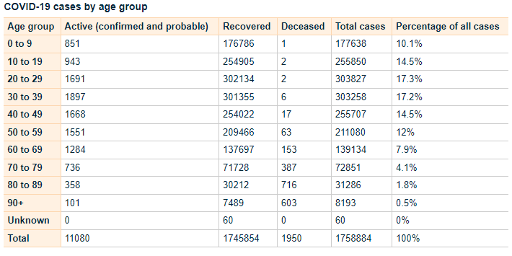
https://www.health.govt.nz/covid-19-novel-coronavirus/covid-19-data-and-statistics/covid-19-case-demographics#all-cases

Testing Guidance COVID-19

https://www.health.govt.nz/system/files/documents/pages/testing_operational_guidance_for_general_practice_10_march_2022.pdf

COVID Care in the Community Framework (2022)

https://www.health.govt.nz/system/files/documents/pages/covid-19-care_in-the-community-framework-25aug22.pdf

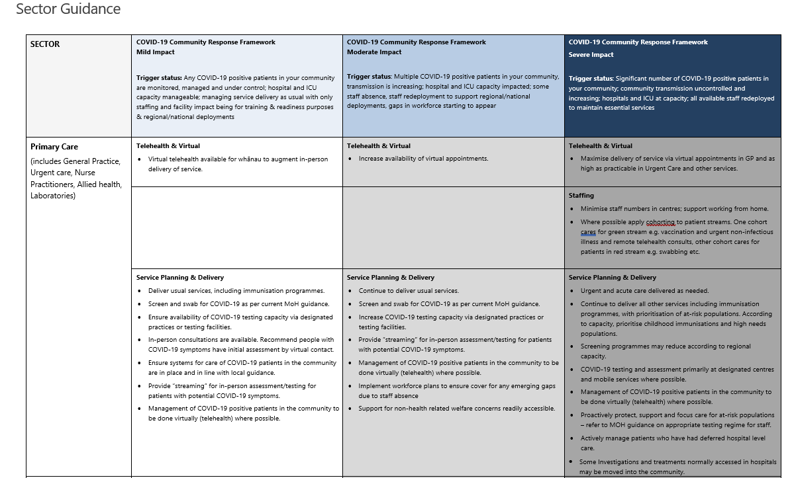
HAWKE’S BAY COVID CO-ORDINATION SYSTEM

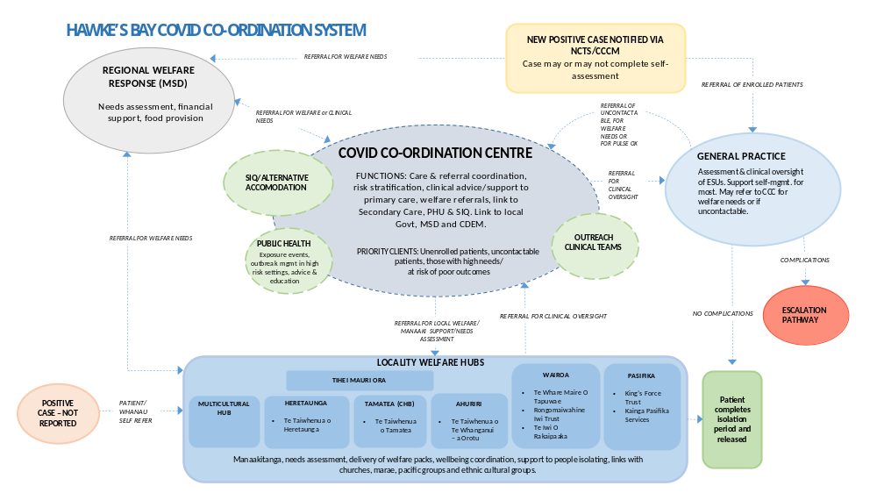
Patient Management Pathway

Assessment and Definition | Severity | Mild |  | Moderate |  | Severe/Critical
Assessment and Definition | Clinical definition | No symptoms | Any COVID symptoms without features of pneumonitis | A clinically stable patient with any evidence of COVID-19 pneumonitis:  - New onset (or worsening) shortness of breath OR  - Infiltrates on plain chest radiograph OR  - Hypoxaemia that is EITHER: |  | Any of the following:  - Requiring CPAP or high-flow nasal oxygen to maintain saturation ≥ 92% OR  - Acute respiratory distress e.g. RR >30 OR  - Rapidly deteriorating clinical trajectory | Any of the following:  - Requiring mechanical ventilation to maintain saturation ≥ 92% OR  - Requiring advanced circulatory support
 |  |  |  | ...mild (92-94%), transient, or exercise-induced only (i.e. not requiring continuous oxygen therapy OR | …sustained but able to maintain ≥ 92% (≥90% for patients with chronic lung disease) with up to 4L/minute oxygen via standard nasal cannula
Assessment and Definition | Stage of infection | Almost all cases in the first 5 days; throughout in most vaccinated patients without risk factors |  | Progression to moderate/severe disease most commonly develops ~ 5-7 days post onset of illness in patients with significant risk factors; the trajectory of deterioration can sometimes be rapid
Assessment and Definition | Site of care | Community |  | Individual decision | Hospital
 | Anti-viral therapy | Paxlovid OR Remdesivir OR Molnupiravir  If <5 days illness AND meets high risk criteria |  |  | Consider Remdesivir if <7days illness |  | Nil
Therapeutics | Respiratory support | Nil |  |  | Oxygen via NP | CPAP (or HFNO) | Mechanical ventilation
Therapeutics | VTE prophylaxis | Nil | Low dose Enoxaparin  if hospitalised |  | Low dose Enoxaparin  (or consider therapeutic dose) | Low dose Enoxaparin
Therapeutics | Corticosteroids | Nil | Consider inhaled Budesonide  if meets high risk criteria |  | Dexamethasone
Therapeutics | Immune modulation | Nil |  |  | Baricitinib or Tocilizumab |  | Tocilizumab
 | Antibody therapy | Nil

ANTIVIRAL THERAPY

Taking antiviral medicines to treat COVID-19

COVID-19 antiviral medicines are available to treat eligible people with COVID-19 at home. COVID-19 medicines must be commenced within the first five days of onset of COVID-19 symptoms. When taken early in COVID-19 illness, these medicines have been proven to reduce hospitalisation and death.

These medicines are free for eligible people with COVID-19 within five days of their symptoms starting. If eligible, persons may get a prescription from their usual healthcare provider, or the medicine may be supplied without a prescription from some pharmacies.

Eligibility for COVID-19 medicines

People with a high risk of severe illness from COVID-19 are eligible for treatment with COVID-19 medicines.

To be eligible for COVID-19 antiviral medicine the consumer must:
- have symptoms and have tested positive for COVID-19 or
- have symptoms and be a household contact of a person with COVID-19

One of the following must also apply:
- severely weakened immune system
- Down syndrome
- sickle cell disease
- aged 75 years or older
- previously been admitted to an intensive care unit as a result of COVID-19 and have tested positive again

Persons may also be eligible if they meet two or more of the below criteria:
- high-risk medical conditions
- over 50 years of age
- Māori or Pacific Island ethnicity
- not vaccinated for COVID-19, or are not up to date with your COVID-19 vaccinations

Please note: These medicines may not be suitable for everyone, even if they meet eligibility criteria.
More information about eligibility can be found on the Pharmac website, including its access criteria assessment tool.
Te Whatu Ora has developed an Eligibility Guide for COVID-19 antiviral medicines:

https://www.health.govt.nz/system/files/documents/pages/eligibility-guide-for-covid-19-oral-antiviral-meds-12aug22.pdf

Types of COVID-19 medicines available

Three COVID-19 antiviral medicines are available to treat eligible people with COVID-19 in the community:

Nirmatrelvir with ritonavir (branded as Paxlovid)
Molnupiravir (branded as Lagevrio)
Remdesivir, an infusion treatment (branded as Veklury).

For more information please see the following links

Paxlovid
https://www.healthnavigator.org.nz/paxlovid/
https://www.medsafe.govt.nz/profs/Datasheet/p/paxlovidtab.pdf

Lagevrio
https://www.healthnavigator.org.nz/medicines/m/molnupiravir/
https://www.medsafe.govt.nz/profs/datasheet/l/lagevirocap.pdf

remdesivir
https://www.healthnavigator.org.nz/medicines/r/remdesivir/
https://www.medsafe.govt.nz/COVID-19/treatment-applications.asp

https://www.health.govt.nz/covid-19-novel-coronavirus/covid-19-health-advice-public/advice-people-covid-19/covid-19-medicines

Return of Symptoms Following Paxlovid Treatment

For some people, symptoms may return after completing a course of Paxlovid. This is known as Paxlovid rebound.

People experiencing Paxlovid rebound do not appear to get severely ill. Symptoms are usually mild and typically resolve within three days.

It is normal for some people recovering from COVID-19 to have symptoms that come and go for some time, regardless of whether they have taken antiviral medicines.

Patients should stay home and recover until 24 hours after they no longer have symptoms if:

- their symptoms returned after finishing the five-day course of Paxlovid
- and it’s 28 days or less since their first symptoms appeared or they tested positive

There is no need to take another course of Paxlovid if symptoms return during this time.

COVID VARIANTS OF CONCERN

There is a high likelihood that a new COVID-19 Variant of Concern will emerge within weeks or months. The timeframe and clinical impacts of these variants is not clear, but it is important that we prepare for new, more severe variants that could emerge.

On 30 March 2022, the World Health Organization (WHO) released its Strategic Preparedness, Readiness and Response Plan to End the Global COVID-19 Emergency in 2022. It sets out key strategic adjustments that, if implemented rapidly and consistently at national, regional, and global levels, will enable the world to end the acute phase of the pandemic.

The capacity and adjustments necessary to end the acute phase of the COVID-19 pandemic can and should lay the foundations for a future in which the world is prepared to prevent, detect, and respond to pandemic threats.

To support Government preparedness and response efforts, the Ministry of Health (the Ministry) has developed Aotearoa New Zealand’s Strategic Framework for COVID-19 Variants of Concern (the Strategic Framework), which builds on the plans and enabling systems that have held the Ministry in good stead over the last two years. It identifies the contextual factors, range of indicators, and baseline and response measures required to ensure that we are prepared to respond to the emergence of a new variant of concern.

Variant Scenarios

Five scenarios have been developed to inform the potential range of responses that may be required. There may be particular viral characteristics that may change, and any decisions are likely to be made before a detailed evidence base is formed.

The scenarios are based on evidence on the likely characteristics of new variants and their characteristics, including research into similar scenarios that other countries have used, and have been externally reviewed by the COVID-19 Technical Advisory Group and the Strategic Public Health Advisory Group. They have also been considered by the COVID-19 Independent Continuous Review, Improvement and Advice Group as part of engagement.

The scenarios range from high clinical severity and high immune escape to low clinical severity and low immune escape, and a scenario that includes co-circulating diseases. All scenarios assume a variant that is able to out-compete Omicron BA2 because it is more transmissible.

The variant scenarios are:

- High clinical severity, high immune evasion: similar to Omicron but with greater severity. Therapeutics, vaccines and/or prior infection may not work or protect well.
- Low clinical severity high immune evasion: similar to Omicron. Therapeutics and vaccines may not be effective at controlling spread or symptoms, but hospitalisation rates remain manageable.
- High clinical severity, low immune evasion: the virus is highly transmissible with high case numbers, but current effective immunity and vaccination is protective for most.
- Low clinical severity, low immune evasion: the virus has enough transmissibility to create a high case load, but current effective immunity is protective and what disease there is, is milder than experienced in previous waves. Effective treatments are available for vulnerable populations.
- Multiple co-circulating variants of concern with different levels of virulence and severity and different levels of cross-protection, as we see with influenza. This scenario potentially draws features from the other scenarios.

For reference, all the hypothetical scenarios are compared to the current Omicron planning scenario. For further information please click on the following link.

https://www.health.govt.nz/system/files/documents/pages/220601_final_summary_of_voc_sf_for_cabinet_paper_21_june.pdf

STAYING AT HOME, PATIENT INFORMATION

If you have been advised to stay at home after a test, you should do so until you receive a negative test result.

If someone in your household or bubble is a Close Contact and they develop symptoms, it is recommended that you (regardless of whether you are vaccinated or unvaccinated) stay at home until the Close Contact returns a negative test (taken after their symptoms started).

If you develop symptoms, you should get a test and stay at home (or in your current accommodation) until you receive a negative test result and until 24 hours after your symptoms resolve.

What it means to stay at home:

- If you have symptoms, stay away from your household members if possible.
- You should not go to work or school. If you are unable to work from home while awaiting COVID-19 test results, a short-term payment may be available to your employer (or you, if you are self-employed) to help support you. For more information visit the Work and Income website.
- It is important that you do not use public transport, taxis or similar transport methods.
- You should not have any visitors in your home (including tradespeople).
- Where possible, ask friends or family to shop for you. If this isn’t possible, order supplies online. Make sure any deliveries are left outside your home for you to collect. If you need assistance, the Ministry of Social Development has information about where you can go for services and support, what you can get help with, and contact information. Visit the Ministry of Social Development website.
- If you need medical assistance, call ahead to your health provider. Clean your hands with hand gel and put on a face mask before you enter any health care facility.

https://www.health.govt.nz/covid-19-novel-coronavirus/covid-19-health-advice-public/covid-19-staying-home

HALCYON COVID-19 SCREENING TOOL (DOUBLE CLICK TO OPEN)

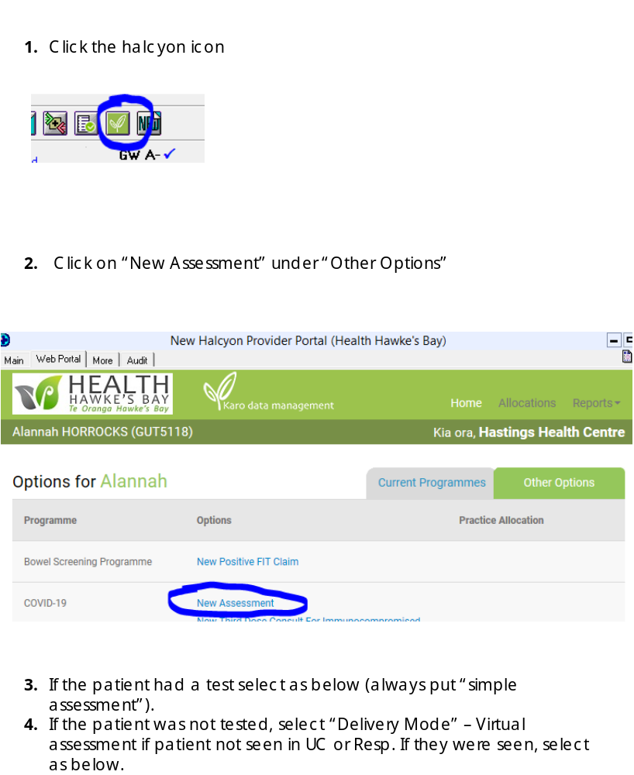

OTHER USEFUL LINKS MoH

Epidemic Notice and Orders
https://www.health.govt.nz/covid-19-novel-coronavirus/covid-19-response-planning/covid-19-epidemic-notice-and-orders

Community Response Framework
https://www.health.govt.nz/covid-19-novel-coronavirus/covid-19-response-planning/covid-19-community-response-framework

For more information see the MoH Website.

POST COVID CONDITION - LONG COVID

Some people feel they do not fully recover or regain their previous health following infection from COVID-19. The World Health Organisation (March, 2021) published some UK national research on COVID-19 that indicated.

- 1 in 10 respondents testing positive for COVID-19 may exhibit symptoms for a period of 12 weeks or longer
- studies indicated around a third of people testing positive for SARS-CoV-2 had not returned to their usual state of health when interviewed 3-6 weeks post diagnosis
- Up to 30% of COVID-19 patients surveyed still had persistent symptoms after nine months, the majority of these (85% were outpatients with mild illness)

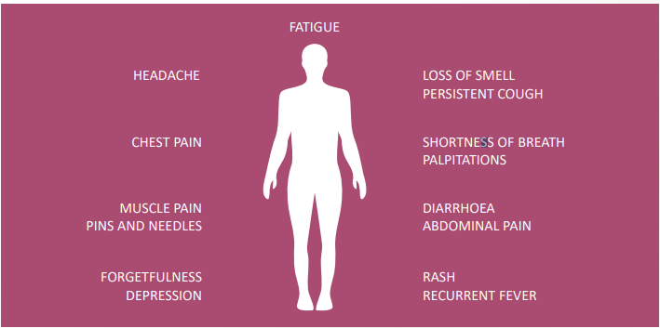
This is not an exhaustive list; other symptoms are reported.

file:///G:/Downloads/Update54_clinical_long_term_effects.pdf

Other Coronavirus infections such as SARS, MERS found significant impairment of exercise capacity and health status in survivors of SARS over 24 months. Another study revealed that 40% of people recovering from SARS still had chronic fatigue symptoms 3.5 years after being diagnosed.

More research is needed to examine the long-term consequences of COVID-19.

COVID-19 can result in prolonged illness, even in young adults and children without underlying chronic medical conditions. Much is still unknown about how COVID-19 affects people over time and more research and multi-year studies are needed to understand:
- long-term effects of COVID-19
- why symptoms persist or recur
- how these health problems affect patients
- clinical course and likelihood of full recovery
- Implication of long-term health effects on return to work
- How protective measures continue to be important in preventing COVID-19

Long COVID patients internationally have voiced the need to be heard and have their symptoms acknowledged and treated as real. The qualitative evidence suggests not doing so can have long term mental health implications.

