
Hawke’s Bay
Pandemic
Plan for Health Services

Pandemic Plan for Health Services
TMMHB/EPM/015
Approved by: | Interim Lead H&SS | Date of first issue: | April 2003 | 
Signature: | Chris Ash | Date of review: | May 2023
Signature: | Chris Ash | Date of next review: | May 2026

Pandemic Plan for Health Services

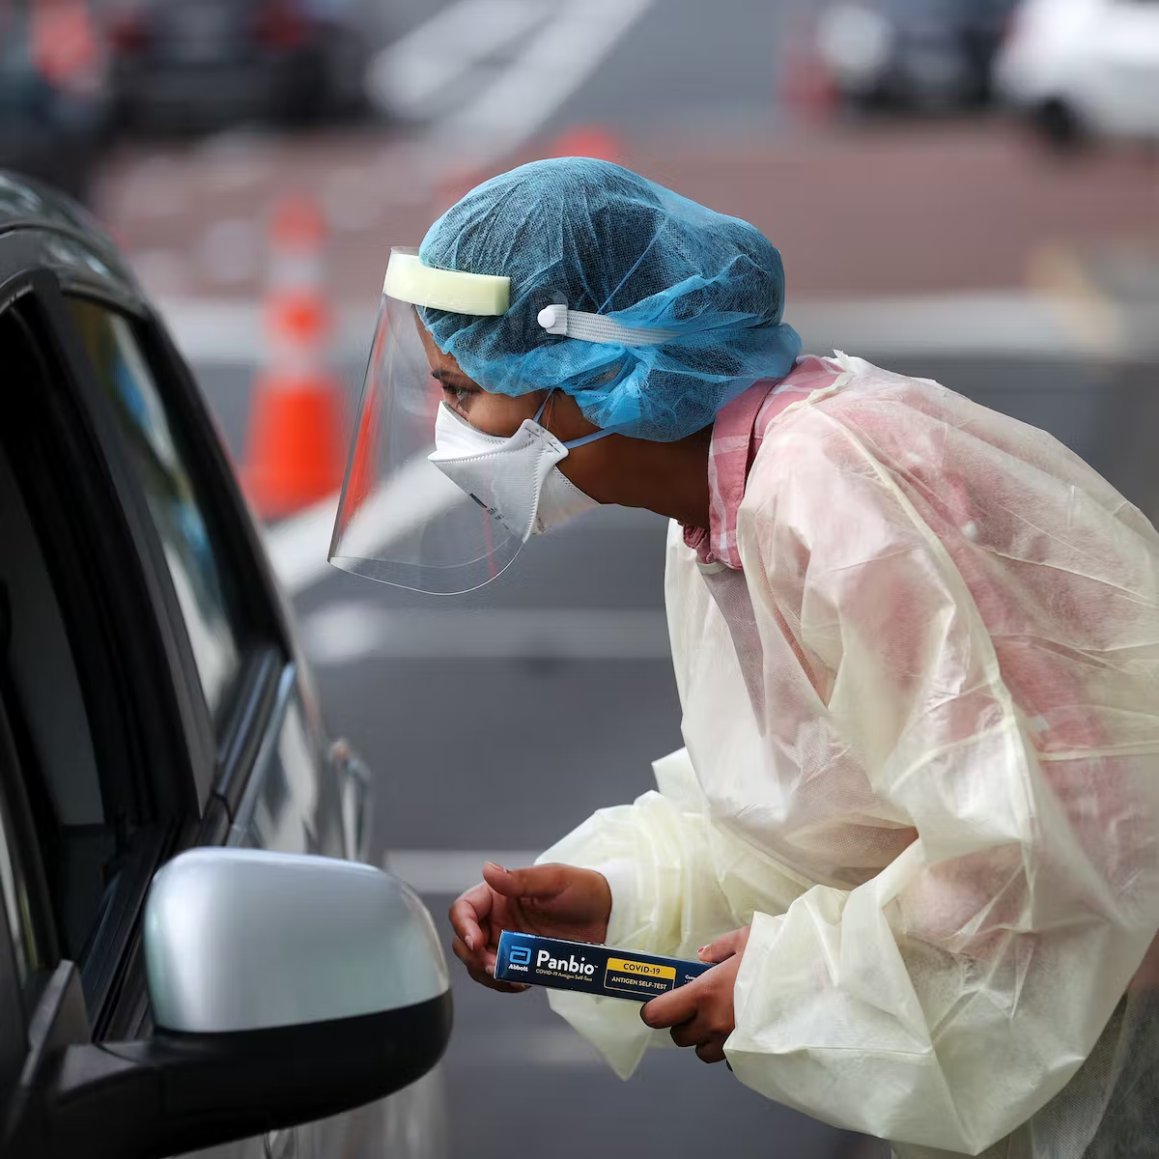
May 2023

TABLE OF CONTENTS

Table of Contents | 4
Introduction | 5
Pandemic Phases | 6
Pandemic Management Strategy | 8
Section A – Direction and Control | 11
Attachment 1 Activation Procedure | 19
Attachment 2 Direction and Control Process | 20
Attachment 3 CIMS Structure | 21
Attachment 4 Communication Flow | 22
Attachment 5 Community Direction and Control | 23
Section B – Communication | 24
Section C – Primary Care Services Response | 26
Section D – Secondary Care Services Response | 33
Section E – Management of Issues | 37
Section F – Vaccination Plan | 43
Section G – Training Plan | 47
Section H – Recovery | 49
Section I – Outbreak Management | 51
Section J – Influenza | 59
Section K – COVID-19 | 70
Section L – Health Services Guidelines | 82
Appendix 1 – Patient and Staff Information Resources | 103
Appendix 2 – Forms | 109
Appendix 3 – Legislation | 117
Appendix 4 – References | 118

INTRODUCTION

Pandemics are typically characterised by the rapid spread of a novel type of virus, bacteria or other pathogenic agent to all areas of the world, resulting in unusually high morbidity and deaths for approximately two to three years. Factors that need to be present for a pandemic to occur include:
- the emergence of a new viral or bacterial subtype;
- the capacity for the pathogen to spread efficiently from person to person; and
- being virulent enough to cause disease.

The primary purpose of the Te Whatu Ora Hawke’s Bay Pandemic Emergency Plan (PEP) is to provide the framework and methodology to efficiently respond to a pandemic within Hawke’s Bay to minimize morbidity and mortality, and maintain health care and other essential community services during periods of high absenteeism due to illness.

The protection of the health and welfare of the residents of Hawkes Bay must be managed at the district level. If resources are available, national assistance may be provided when requested or in cases where emergency needs exceed the capability of local response resources. However, in a pandemic, all communities will be impacted to the same degree and national agencies will probably not be able to meet all requests for assistance.

This plan has been specifically designed to serve as an Annex to the National Emergency Management Plan and supplements that document.

OBJECTIVES

The objectives of the Te Whatu Ora Hawke’s Bay Pandemic Plan are to:

- Establish procedures to ensure a coordinated response by health services.

- Describe courses of action that will minimize morbidity and mortality

- Establish procedures to provide for a coordinated effort by local authorities / NGO’s in response to a pandemic.

- Identify emergency response organizations, facilities and other resources, that can be utilised during a pandemic.

- Provide a mechanism to integrate community and facility response procedures.

ASSUMPTIONS

- Pandemics are inevitable

- The respiratory mode of transmission is most likely to lead to significant disease spread.

- Zoonotic diseases such as SARS, MERS, H7N7, Ebola and H1N1 are known, the risk of another zoonotic disease as a causative agent remains possible.

- There will be very little warning. Most experts believe that we will have between one and six months between the time that a novel pathogen is identified and the time that outbreaks begin to occur in New Zealand.

- Outbreaks are expected to occur simultaneously throughout much of New Zealand, preventing shifts in human and material resources that normally occur with other natural disasters.

- Widespread resource constraints will occur.

- The effect of a pandemic on individual communities will be relatively prolonged -- weeks to months -- when compared to minutes-to-hours observed in most other natural disasters.

- The majority of health care will be delivered in the primary health care setting.

- Effective preventative and therapeutic measures, including vaccines and antiviral agents will likely be in short supply, as well as other medications to treat infection.

- Health-care workers and other first responders will likely be at even higher risk of exposure and illness than the general population, further impeding the care of patients.

- Widespread illness in the community will also increase the likelihood of sudden and potentially significant shortages of personnel in sectors who provide critical community service for example police, firemen, utility workers, and transportation workers, planning for external shortages is paramount.

PLANNING AND DATA MODELLING

Standard pandemic planning uses a 40% attack rate and 2% case fatality rate. This would result in 72,600 cases and 1452 deaths in Hawke’s Bay based on the population at 181,500 (2021 estimate).

PANDEMIC PHASES

WHO Pandemic Phase | Definition
Inter-Pandemic Period  (WHO Phase 1) | A virus is seen in animals but has not been shown to infect humans
Novel Virus Alert  (WHO Phase 2) | A known animal virus has caused an infection in humans
Pandemic Alert  (WHO Phase 3) | Scattered or isolated incidence of cases or small clusters of the disease occurring in humans; possible cases of human-human transmission but not at a level to cause community-level outbreaks
(WHO Phase 4) | Human to human transmission at a rate that causes an outbreak in communities
(WHO Phase 5) | The spread of the disease between humans is now evident in more than one country
Pandemic Period  (WHO Phase 6) | Community level outbreaks are in at least one additional country other than that seen in Phase 5.
For purposes of consistency, comparability and co-ordination of the national, regional and local response, identification and declaration of the following phases will be done at the national level.

Once phase 6 is reached preparation is then made for a global pandemic.
Each phase has a list of actions that need to be followed to facilitate transparency and the education of health organisations and members of the public.
https://www.physio-pedia.com/Endemics,_Epidemics_and_Pandemics

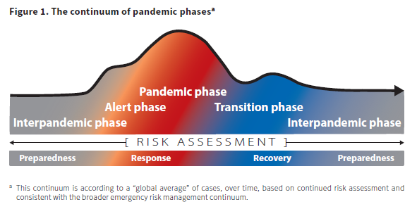
https://www.cdc.gov/flu/pandemic-resources/planning-preparedness/global-planning.html

MINISTRY OF HEALTH PANDEMIC MANAGEMENT STRATEGY

STAGE | NZ STRATEGY | MoH / DHB ALERT CODE | OBJECTIVE AND ACTION
1 | Plan for it  (Planning)  No human cases in New Zealand | WHITE  (Information / advisory) | - Objective: plan and prepare to reduce the health, social and economic impact of a pandemic on New Zealand  - Full engagement of whole of government  - Consultation with and input from many agencies
1 | Plan for it  (Planning)  No human cases in New Zealand | YELLOW  (Standby) | - Prepare to implement pandemic response action plans
2 | Keep it out  (Border Management)  No human cases in New Zealand | YELLOW or RED  (Activation) | - Objective: prevent or delay to the greatest extent possible the arrival of the pandemic virus in New Zealand  - Wide range of border management options, up to:  - Closure of New Zealand’s border to all non-nationals  - Quarantine of all returning New Zealand citizens  - Enhance internal disease surveillance and notification  - Investigate and follow up any suspect cases
3 | Stamp it out  (Cluster Control)  First case identified in New Zealand | YELLOW or RED  (Activation) | - Objective: control and/or eliminate any clusters that are found in New Zealand  - Isolate and treat patients and households  - Contact trace and treat all contacts  - Restrict movement into/out of affected area(s)  - Close schools and other places where people congregate, and prohibit mass gatherings  - Maintain border management
4 | Manage it  (Pandemic Management)  Increased and substantial transmission in general population | YELLOW or RED  (Activation) | - Objective: to reduce the impact of pandemic disease on New Zealand’s population  - Health service reconfiguration to support community response in affected areas  - Social distancing measures  - Support for people cared for at home, and their families
 | Manage it  (Post Peak) |  | - Expedite recovery and prepare for a re-escalation response
5 | Recover from it  (Recovery)  Pandemic over and/or population protected by vaccine | GREEN  (Stand down) | - Objective: expedite the recovery of population health, communities and society where affected by the pandemic, pandemic management measures, or disruption to normal services  - Phase starts when the population is protected by vaccination, or the pandemic abates in New Zealand

RESPONSIBILITIES DURING THE INTERPANDEMIC PERIOD

- The Emergency Management Advisor will perform the following functions:
  - Activate, co-ordinate and maintain the Pandemic Emergency Plan (PEP)
  - Coordinate PEP exercises as needed in consultation with the Public Health Service
  - Conduct PEP training as needed in consultation with the Public Health Service

    - Te Whatu Ora Hawke’s Bay Public Health Service will perform the following functions:
      - Maintain an effective surveillance system within and across Hawke’s Bay
      - Inform the Emergency Management Advisor of any local, regional, national and/or international issues relating to pandemic planning
      - Maintain effective communication systems with other health professionals, NGO’s and the general public
      - Co-ordinate all information provision in relation to the pandemic

    - Departments and agencies with responsibilities under this plan will maintain procedures for implementing this PEP.

SURVEILLANCE

An effective national surveillance system is an essential component of pandemic preparedness and response. Its aim is to provide timely information to the Ministry of Health, public health services, regional localities, health care providers and the general public pandemic activity and circulating strains.

There are currently two national surveillance systems in New Zealand, with additional surveillance carried out by the Ministry of Health and Stats NZ.

- The GP sentinel disease and virological surveillance system operates annually during the winter months (May to September). Each sentinel practice records the daily number of consultations that fit the case definition of an influenza-like illness (ILI), the patient’s age, and on each Monday, Tuesday and Wednesday provides ESR or a regional laboratory with the respiratory samples from the first patient seen with an ILI on these days. Collated national data are presented in the weekly Influenza Surveillance Update. Available on the ESR website www.esr.cri.nz.

- Ongoing virological surveillance is carried out by the four regional virus diagnostic laboratories at Auckland, Waikato, Christchurch and Dunedin hospitals, and by the ESR virology laboratory. Data collected from these laboratories is reported nationally in the Virology Weekly Report.

- The Ministry of Health (MOH, 2022) collects COVID19 surveillance data including case numbers and vaccination status. Stats NZ reports on the economic, environmental and social aspects of New Zealand’s recovery from COVID-19.

An important inter-pandemic priority is to enhance and improve pandemic surveillance. With the assistance of NSIIG and the NPPC, the Ministry of Health will collect and analyse data to allow early determination of national trends using networks to facilitate prompt public health action. Te Whatu Ora will promote immunisation and awareness to the public and health care professionals. Options for further surveillance include expanding the current surveillance network to include sentinel nursing homes and the collection of employee absenteeism data, and the weekly reporting of mortality data. This action may also be undertaken at the district or regional level.

MEDICAL OFFICER OF HEALTH’S (MOH) POWERS IN A PANDEMIC EMERGENCY

Activation of the PEP begins when a potential pandemic is identified.

Once special powers available in the Health Act 1956 are unlocked by the Minister of Health, local Medical Officers of Health have wide ranging powers designed to prevent the outbreak or spread of any infectious disease. These powers include the ability to:

- Require people to submit themselves for medical examination;
- Require people, places, buildings, ships, animals, and things to be isolated, quarantined, or disinfected;
- Forbid persons, ships, animals, or things to be brought to any (air or sea) port or place in the health district from any port or place which is or is supposed to be infected;
- Forbid persons to leave a place or area until they have been medically examined and found to be free from infectious disease;
- Require theatres and other places of public amusement (such as racecourses and recreation grounds), bars, billiard rooms, churches, reading rooms, and public halls, and all other premises where people are accustomed to assemble for any purpose within the district, to be closed for admission to the public (for more detailed information refer Public Gathering Plan);
- Prohibit the attendance of children under the age of 16 years in schools, Sunday schools, theatres, or places of public amusement within the district; and
- Have infected animals destroyed.

These powers have been extended in the Epidemic Preparedness Act 2006.

PRINCIPLES OF PANDEMIC MANAGEMENT

  - Rapid exclusion of patients not meeting the diagnosis
  - Rapid recognition of patients meeting the diagnosis
  - Rapid containment of the patient
  - Protection for staff

SECTION A
DIRECTION AND CONTROL

SITUATION

Te Whatu Ora Hawke’s Bay has a Major Incident Plan and interlocking Emergency Control Plans detailing the response to major disasters such as earthquakes, plane crashes and hazardous materials events. These plans will be very useful as a starting point for certain aspects of pandemic planning, including command and control functions, descriptions and operation of emergency communication systems, hospital and medical care resources, and other key response elements. However, pandemic planning will require special emphasis on certain functions that are not normally included in the Major Incident and Emergency Control Plans, such as delivery of vaccines and mitigation efforts. One of the main differences between a pandemic and other natural disaster is the widespread nature of health effects – along with disruption of critical human infrastructure because of those health effects -- which will require expansion of the typical disaster management team. This management team must include the local Medical Officer of Health and key representatives from partner and stakeholder organizations.

DIRECTION AND CONTROL

Te Whatu Ora Responsibilities

Te Whatu Ora is responsible for:

- Initiation, activation, escalation and stand-down of New Zealand’s response to the threat of a pandemic.
- National intelligence and planning, including liaison with and reporting to, the World Health Organisation and other international bodies responsible for providing high-level advice and recommendations to national authorities.
- Convening advisory groups and national dissemination of clinical and public health advice nationally.
- Provision of inter-regional support for health services.
- Co-ordination of surveillance activities and dissemination of information.
- Co-ordination of media management and communication including advice to health professions, the public and media.
- National liaison with, and advice to other government agencies.
- National oversight of clinical response to ensure consistency of advice and action across the country.
- Provision of public information, including public awareness and information campaigns, telephone advice lines and internet postings, and providing access to travel advisories produced by border control agencies.
- Co-ordination of services and resources nationally, as required.

Other responsibilities include:

- Activation of the National Health Co-ordinating Centre (NHCC) to make high-level policy decisions and ensure that all agencies implement these decisions.
- Ensuring close coordination and communication of response activities.
- Ensuring that continuity of management and operations is maintained through a clear command authority and identification of staff to assume higher-level responsibilities in the event of the absence or incapacity of key leadership.
- Dissemination of information regarding declaration of the stages of a pandemic alert to the Regional Public Health Units, also responsible for dissemination of information about the prevention and control of the invading pathogen.

Unified Command

This plan addresses the requirement for direction and delegation within a multi-jurisdiction/multi-agency pandemic response. This highlights the demand for a unified command structure among responding organizations under the direction of the Pandemic Response Co-ordinator. The concept of Unified Command simply means that all agencies that have jurisdictional responsibilities and authority at an incident will contribute to the process of:
- Determining overall response objectives
- Selection of response strategies
- Ensuring joint planning and application of tactical activities
- Ensuring integrated planning and application of operational requirements; including emergency measures and vaccine management and distribution
- Maximizing use of available resources
- Ensuring dissemination of accurate and consistent information

Regional Hospitals and Public Health response teams will be responsible for:
- Co-ordination with the Medical Officer of Health and CDEM Group Controller.
- Implementation of the Te Whatu Ora Hawke’s Bay Pandemic Plan and contributing to the implementation of the regional health coordination plan.
- Implementation of instructions, advice and guidelines issued by Te Whatu Ora via the regional coordination team.
- Ensuring hospitals and health services will function to the fullest possible extent during and after the pandemic including infection prevention and control and laboratory capacities.
- Ensuring community-based health services are available to meet increased demand for assessments, including establishment of Community Assessment Centres as required.
- Implementation of vaccination campaigns.
- Communication with and support of primary care providers within the district.
- Liaison with other agencies at a local level, as appropriate (including local government, local civil defence emergency management, education providers, welfare and border agencies and national health groups with local representation).
- Communication with community leaders and support as required.
- Contribution to the regional co-ordination team and local implementation of decisions reached at a regional level.

In an emerging infectious disease-related emergency, regional response co-ordination teams will be established and responsible for:
- Operationalisation of the clinical escalation pathway, including the ongoing development of patient referral protocols based on available information.
- Reconfiguration of services as necessary, such as moving elective procedures to another facility if a hospital is overwhelmed by infectious patients.
- Regional transport arrangements.
- Regional co-ordination of equipment and supplies.
- Regional planning for quarantine/isolation and maintenance of patient contacts.

Each individual with a response function under this plan is responsible for appointing a deputy and ensuring that his/her deputy is informed and able to cover during periods of absence.

Emergency Operations Centre (EOC)

Te Whatu Ora Hawke’s Bay is the lead agency for pandemic response in Hawke’s Bay. An Emergency Operations Centre will be established in the Clinical Skills Laboratory at Hawke’s Bay Hospital to guide the district response. Representatives housed in this centre will include NZ Police, Civil Defence Emergency Management and the Welfare Coordinating Group.

Governance Arrangements

In the case of a pandemic incident and during an emergency declared under the CDEM Act 2002, Te Whatu Ora Hawke’s Bay will be the lead agency managing all matters of a medical and health nature in partnership with the CDEM Group Controller who will manage all matters related to community continuity. This close working relationship will be facilitated through the Emergency Operations Centre with Local Government providing a supporting role through the CDEM Group structure. The responsibility for duty of care remains with the mandated agency.

Te Whatu Ora Hawke’s Bay holds the following responsibilities:
- Provision of pandemic intelligence, advice and guidance under pandemic response;
- The coordination and management of the health response;
- Communication and promotion of messages concerning the pandemic ensuring a consistent and focused approach to information provision.

The NZ Police hold responsibility for:
- Maintenance of law and order;
- Taking all measures within their power and authority to protect life and property and to assist the movement of rescue, medical, fire, and other essential services;
- Assisting the coroner as required by the Coroners Act 1988;
- Coordinating movement control over land, including communications and traffic control.

Individuals and communities are ultimately responsible for their own safety and the security of their livelihoods. They must be able to care for themselves, as much as possible, when the normal functions of daily life are disrupted. The CDEM Group will support and encourage ownership of this responsibility.

The CDEM Group supporting role is seen as:
- Community leadership by the Mayor of each Territorial Authority;
- The coordination and management of resources available to maintain local governance and maintain critical Local Government functions;
- Providing or arranging the provision of, or making available materials, services, information, and any other resources necessary to support the health led response;
- Responding to and managing the non-health CDEM adverse effects of a pandemic
- Coordination of the Hawke’s Bay Welfare Coordinating Group with functions activated as required;
- The management and coordination of community recovery.

The principles that guide the provision of welfare services are:
- Welfare services shall meet the welfare needs of all people affected or threatened by an adverse event or civil defence emergency.
- Organisations providing services will operate in an integrated and coordinated manner, through the use of agreed standards and operating procedures.
- All welfare services will be provided in accordance with the operational and recovery principles set out in the Civil Defence Emergency Management Group Plan.

For more detailed information refer Pandemic Hazard Plan 2 a sub-plan to the Hawke’s Bay CDEM Group Plan.

Te Whatu Ora Hawke’s Bay Health Incident Controller

This individual ensures the activation of the Health Emergency Co-ordinating Committee consisting of representatives of the Infection Prevention and Control Team, the Public Health Service, Health Services, the Ambulance Service, General Practitioners, NZ Police, CDEM Group, other healthcare providers, and includes the Emergency Management Advisor and the Communications Manager. This committee is responsible for the initial response to the event.

This team is supported by the activation of this plan and consequent activation of the Emergency Operations Centre. The Health Incident Controller maintains the lead role until activation of the plan, at which time the incident control becomes Hawke’s Bay region wide and the Executive Director takes the role of Response Coordinator leading the community wide response. The Health Emergency Co-ordinating Committee is stood down at this time and the CIMS structure activated.

Health Emergency Co-ordinating Committee

The initial meeting of the Health Emergency Co-ordinating Committee is required to discuss the event and its implications assigning responsibilities to each individual team member. The Emergency Management Advisor will chair this planning meeting. The NZ Police representative will convene a meeting of the Emergency Services Coordinating Committee to inform members of the current situation.

An Action Plan is to be completed at the initial meeting with progress monitored at subsequent meetings.

Actions Expected from Individuals at Alert Phase – Code Yellow

Individual/Service | Action
Emergency Management Advisor | - Activate the Health Emergency Co-ordinating Committee  - Inform Medical Officer of Health  - Prepare for Pandemic Emergency Plan activation
Medical Officer of Health | - Attend Health Emergency Co-ordinating Committee meeting  - Provision of ongoing information to the Incident Controller  - Respond according to the PEP
Executive Director | - Inform Te Whatu Ora and Group Managers  - Maintain contact with the Medical Officer of Health and Emergency Management Advisor and assist as required  - Authorisation of media releases

Trigger Points

Code | Description | Local Actions | Plans to consider activating
White | Interpandemic period or human infections overseas, but rare or no human to human spread. | HECC to review plans  Increased vigilance | Communication plan
Yellow | Human infection in NZ (but not in Hawke’s Bay) but no human to human spread or rare instances of spread to close contacts. | Convene Incident Management team  Activate EOC  Enhance Surveillance | Hawke’s Bay Pandemic plan  Communication plan  Training plan
Yellow | Human infection in Hawke’s Bay but no human to human spread or rare instances of spread to close contacts. | Convene Incident Management team  Activate EOC  Enhance Surveillance | Hawke’s Bay Pandemic plan  Communication plan  Training plan
Yellow | Increasing transmissibility of virus (substantial pandemic risk) overseas but no cases in NZ. | Convene Incident Management team  Activate EOC  Enhance Surveillance | Hawke’s Bay Pandemic plan  Communication plan  Training plan
Yellow | Increasing transmissibility of virus (substantial pandemic risk) overseas. Clusters or multiple cases in NZ (none in Hawke’s Bay). | Convene Incident Management team  Activate EOC  Enhance Surveillance  Prepare to activate for code red  Prepare to activate CACs  Ensure familiarisation of unit / agency specific plans.  Commence briefing of staff  Establish links with recovery manager | Hawke’s Bay Pandemic plan  Command and control plan  Communication plan  Training plan
Red | Human case or cases in Hawke’s Bay (human to-human transmission limited or localised). | Convene Incident Management team  Activate EOC 24/7  Enhance Surveillance  Case management and contact tracing  Consider request for Epidemic powers | Command and Control plan  Training plan  Communication plan  Port and Airport procedures  Antiviral and PPE plan  Community Assessment Centres  First case management plan  Quarantine and Isolation plan  Closure of public places  Management of the dead
Red | Increased and substantial transmission of virus within New Zealand (whether or not cases in Hawke’s Bay). | Full activation | Activate all plans
Green | Pandemic over and or population protected by vaccination. | Stand down of critical staff  Plan for deferred activities  Transition to recovery manager | Communication plan

RESPONSE LEVELS

DURING THE NOVEL VIRUS ALERT – CODE WHITE:
- Convene the Health Emergency Co-ordinating Committee.
- Meet with appropriate partners and stakeholders and audit systems in place to manage an outbreak.
- Modify the plan as needed on an urgent basis.
- Review communication plan, including provision for:
  - Staff self-care information, i.e. health strategies and virus information.
  - Identification of information required by child care facilities, rest homes, correctional facilities, schools, general practitioners and large employers.
  - Lines of communication with emergency services and Civil Defence Emergency Management.
  - Information required regarding community support and critical incident stress management.
  - Identification of avenues of information dissemination, including but not limited to the Te Whatu Ora Hawke’s Bay website, talkback radio, occupational health network and educational institutions such as schools and early childhood centres.
  - A system for calling for volunteers and retired nurses and medical staff.
(e) Develop a listing of essential community services (and corresponding personnel) whose absence would pose a serious threat to public safety or would significantly interfere with the ongoing response to the pandemic.

DURING THE PANDEMIC ALERT – CODE YELLOW:
- Activate communications plan.
- Begin vaccine and antiviral distribution.
- Notify key government officials and legislators of the need for additional monetary resources (if not already available).
- Dissemination of Te Whatu Ora guidelines on the prevention, diagnosis and treatment of the presenting pathogen and pathogen related illness
- Ensure that human resources and logistics are in place to provide health care and to maintain essential community services.
- Initiate daily reporting from all areas, utilize PHO for general practice.

DURING THE PANDEMIC IMMINENT STAGE – CODE RED:
- Fully activate the pandemic emergency plan, including Emergency Operations Centre standard operating procedures, and commence preparation of the first incident action plan.
- Report daily to Te Whatu Ora.
- Activate CIMS structure. Selected members of the Health Emergency Coordinating Committee now take on the function of the Clinical/Technical Advisory Group advising the Incident Controller as required, this will include the Medical Officer of Health.
- Ensure Public Health liaison is sited in the Emergency Operations Centre.
- Coordinate activities with neighbouring jurisdictions.
- Monitor international situation.
- Interface with appropriate counterparts at national level.
- Continue dissemination of information from Te Whatu Ora.
- Prepare and present a briefing to community leaders.
- Activate major incident cost centre to allow tracking of costs.
- Ensure the activation of the Regional Health Coordination Team.
- Ensure distribution of the national reserve when activated by Te Whatu Ora.

DURING THE PANDEMIC – CODE RED:
  - Daily communication with other localities, utilizing the Inter-locality Communication Plan, to ascertain bed status and staffing resource.
  - Activation of an Information/Media Centre to efficiently provide and disseminate accurate information to the general public, consistent with information provided by the National Information Centre. A Te Whatu Ora Hawke’s Bay 0800 telephone number will be employed as required. Release of information concerning what volunteer goods and services are needed, and where volunteers and donors may go to deliver such goods or potential services will occur from this information centre.
  - Ensure epidemiological information processing by the Public Health Service to assist planning.

Funding

Te Whatu Ora will closely involve the crown in decisions on whether to provide the locality with additional funding to cover the cost of extra or additional services required during a major incident.

A separate cost centre will be utilised by Finance for the capturing of additional costs, costs collected by the provider arm will be tracked to the major incident cost centre

Planning, Informatics and Finance can enter into Memoranda of Understanding with providers prior to major incidents. Once an event occurs Memoranda of Understanding can be activated and contracts created to provide services. The centralisation of the memoranda of understanding allows the co-ordination of activation of agreements.

All contracts that have been issued, but are unsigned, would be paid in draft. Contracts that have expired would be rolled over on the current terms and conditions for a period estimated to be the length of the major incident.

Providers will contact their Portfolio Managers with issues. Issues that are not addressed through current contracts can be addressed through additional contracts. Portfolio Managers will be able to action contracts through Finance Department or Health Pac, whichever is more appropriate. Weekly reporting to Te Whatu Ora on expenditure incurred and the Major Incident cost centre will be required.

Attachment 1
ACTIVATION PROCEDURE

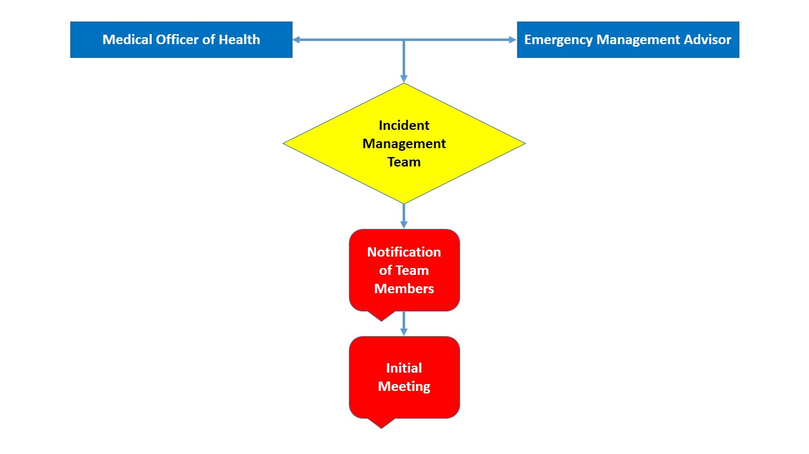

DIRECTION AND CONTROL PROCESS
Attachment 2
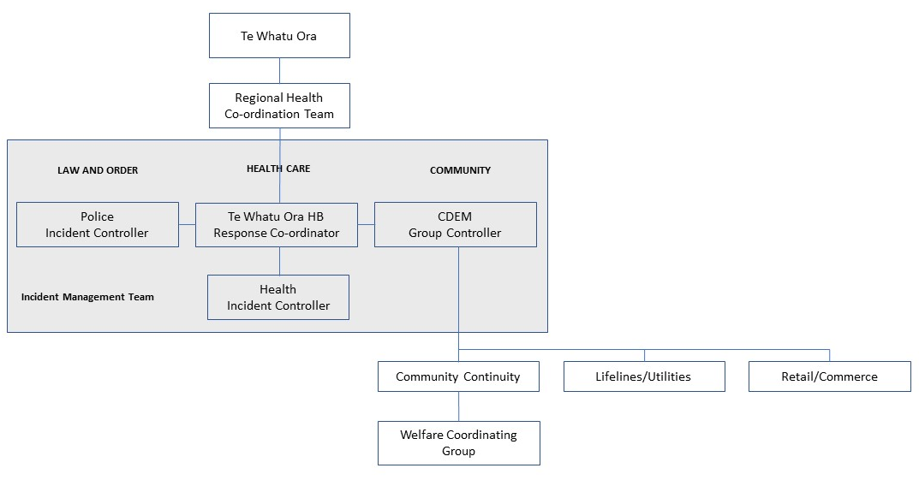

HEALTH CIMS STRUCTURE

Attachment 3
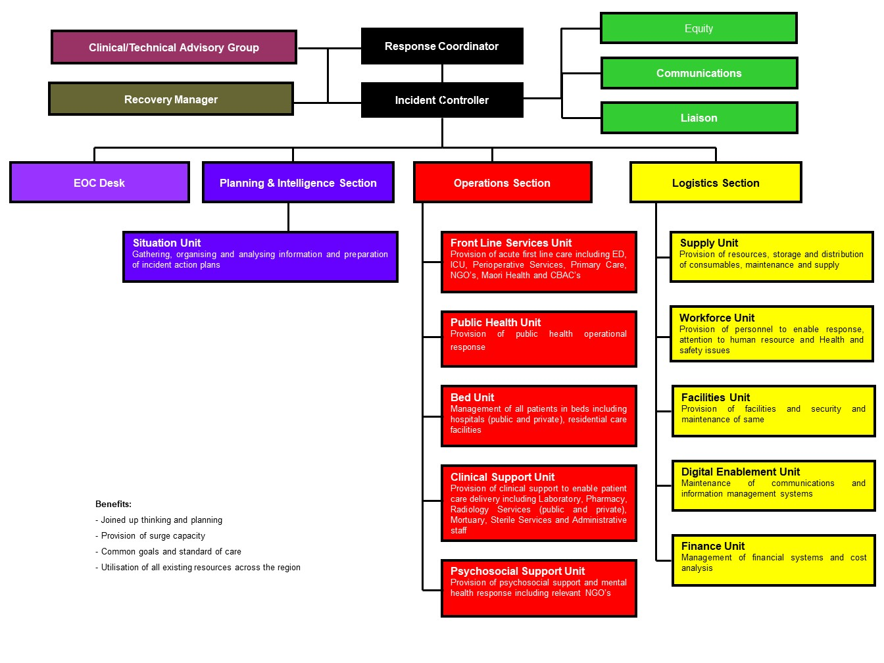
Premise: Less than 3% of pandemic related care delivery occurs in secondary care.
Attachment 4
Communication Flow

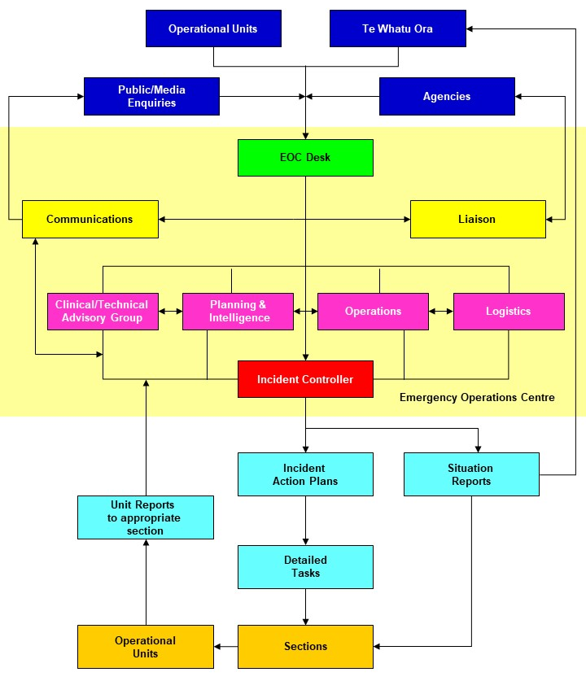

Attachment 5
COMMUNITY DIRECTION AND CONTROL

POSITION | NAME/AGENCY | TELEPHONE
Health Incident Controller | Emma Foster  Te Whatu Ora HB | 878 8109  021 311 756
Health Incident Controller | Robin Whyman  Te Whatu Ora HB | 878 8109  027 445 3493
Health Incident Controller | Chris Ash  Te Whatu Ora HB | 878 8109  027 575 4390
Health Incident Controller | David Warrington  Te Whatu Ora HB | 878 8109  027 451 0023
Medical Officer of Health | Dr Bridget Wilson  Te Whatu Ora HB | 878 8109  027 285 4542
Medical Officer of Health | Dr Simon Baker  Te Whatu Ora HB | 878 8109  027 533 8371
Emergency Management Advisor | Sandra Bee  Te Whatu Ora HB | 878 8109  027 245 3692
Infection Prevention and Control Advisor | Racquel Lewis  Te Whatu Ora HB | 878 8109  027 234 6304
Infection Prevention and Control Advisor | Jessica Hawke  Te Whatu Ora HB | 878 8109  027 202 9509
Infectious Disease Physician | Dr Andrew Burns  Te Whatu Ora HB | 878 8109  027 234 7050
Communications Manager | Emma Horsley  Te Whatu Ora HB | 878 8109  027 299 1566
NZ Police | Jeanette Park  Area Commander | 831 0721  021 192 3909
Eastern Fire Region | Ken Cooper  Area Commander | 835 2114  027 436 3114
HB Ambulance Service | Ian Murphy  Operations Manager | 844 1950  027 200 0895
Welfare Manager | Andrew Dunning  CDEM | 835 3601  027 258 6895
Hawkes Bay Regional Council | Chief Executive | 835 9200
Hawkes Bay Hospital | Call Centre  Te Whatu Ora HB | 878 8109
CHB Health Centre | Reception  Te Whatu Ora HB | 06 858 9090
Wairoa Hospital | Reception  Te Whatu Ora HB | 06 838 7099
Royston Hospital | Reception | 873 1111

SECTION B
COMMUNICATION

Timely, informative and accurate communication during all phases of a pandemic is critical for an effective emergency response operation. Dissemination and sharing of timely and accurate information among public health staff, government officials, medical care providers, the media and the general public will be one of the most important facets of the pandemic response.

- Different types of information will have to be communicated, often to different audiences.

- There will be widespread circulation of conflicting information, misinformation and rumours. Communication must be coordinated among all relevant agencies to ensure consistent messages to the general public.

- There will be a great demand for accurate and timely information regarding:
  - Circulation of a pandemic strain
  - Disease burden
  - Disease complications and mortality
  - Disease control efforts, including availability and use of vaccines, antivirals and other preventive and treatment measures
  - "Do's and Don'ts" for the general public
  - Maintenance of essential community services.

    - There will be a special need for information for the general public about how and why a Priority Group List for receipt of vaccine was developed.

    - Public education will be an important part of the immunization campaign because, as in a mass immunization with any vaccine, it is likely that following problems will be encountered:
(a) any symptom or illness that closely follows vaccination may be attributed to the vaccine, and
(b) any febrile respiratory illness that later occurs will be viewed incorrectly as vaccine failure

- Certain groups will be hard to reach, including people whose primary language is not English, people who are hearing and visually impaired.

- Demand for information by health care providers will be so great that existing methods for educating health care providers will have to be expanded during the inter-pandemic period.

Responsibilities for Communication during a Pandemic

During a pandemic, Te Whatu Ora will have the primary responsibility for:

- Collecting and interpreting surveillance data, and for disseminating this information to national and district public health agencies, health care providers and hospitals.
- With guidance from CDC and other national advisory groups, developing and disseminating to local public health services, health care providers and hospitals (specifically hospital managers, emergency managers, emergency department directors, infection prevention and control nurses and hospital epidemiologists, infectious diseases physicians), guidelines on the prevention, diagnosis and treatment of pandemic-related illnesses.
- Providing the general public, through the news media, with information on anticipated and on-going emergency response efforts necessary to maintain essential community services during the pandemic. This strategy will include an 0800 telephone number, national advertisements and regular press conferences.

Information, recommendations and guidelines will be available to the Public Health Service and health care providers through:

- Te Whatu Ora web site: Fact sheets and frequently asked questions for medical/health practitioners and the public will be posted on the Te Whatu Ora web site, and updated on a regular basis. These fact sheets will include general information on vaccines, medication and treatment guidelines.
- Healthscape, the Public Health Service fast-dial phone/fax system for general practitioners, Health Hawke’s Bay website, Medlab mail-out system and 24-hour General Practice Services.

The Te Whatu Ora Hawke’s Bay Communications Management Plan will be activated by the Incident Management Team.

Communications Officer

Below are the actions for the Communications Officer during the various phases of a pandemic:

- Ensure that all information is clear, confirmed and approved by appropriate authority before release to the media or public. Do not release unconfirmed information or speculate on the extent of the emergency, despite repeated urging by reporters to do so.
- Monitor news programs and review news articles for accuracy. Correct serious misinformation whenever possible.
- Establish an Information/Media Centre, in consultation with the Incident Management Team.
- Respond to staff requirement for accurate information. Utilise information attached to pay-slips, email system, occupational health service, information telephone line, notice boards and posters.
- Provide public information according to priorities. Particular attention may need to be given to the rationale for public gathering restrictions and food safety requirements.
- Ensure that official spokespersons (Response Coordinator, Incident Controller, Medical Officer of Heath) are thoroughly briefed about all aspects of the pandemic.
- Keep the Te Whatu Ora Hawke’s Bay Incident Controller informed of all media actions taken or planned.
- Keep Communications Co-ordinators in other jurisdictions and at other government levels informed of information released.
- Maintain log and a file of all information.
- Release prevention, control and treatment information, as appropriate.
- Respond promptly to media and public calls.
- Release public inquiry ("Rumour Control") telephone line number when staffed.
- Consider additional methods of distributing emergency instructions.
- Arrange media briefings/press conferences on a regular or "as needed" basis utilizing media contact list.
- Prepare news releases, as required.
- Provide emergency information in foreign languages, as required.
- Release morbidity and mortality figures when obtained.
- Gather all records kept during all phases of the incident and prepare a chronological summary of events, actions taken, inquiries made, and response given. Collect newspaper clippings and TV videotapes, if available.

NOTE: All news releases are to be handled by the authorized Communications Officer.

For more detailed information refer Communication Plan.
SECTION C
PRIMARY CARE SERVICES RESPONSE

Steps to Reduce Rate of Spread
It is unlikely that pandemic spread can be halted, but options to slow transmission should be considered to distribute and reduce demand on health services over a longer time period and increase the opportunity of protecting people through vaccination. Sick people should be advised to stay at home and the public should be advised against unnecessary travel.

Medical Officers of Health have the power with support from Te Whatu Ora to cancel public events. Isolating cases, quarantining contacts and vaccinating health professionals when a vaccine becomes available may reduce nosocomial spread of the pathogen

Contingency Plans for General Practitioners
The threat of pandemic will raise a degree of concern within the community which may result in increased numbers of people presenting to primary care facilities. Accurate information is essential in managing the process of prevention and treatment of illness. Co-ordination of the primary care services response will be conducted by activation of the Te Whatu Ora Hawke’s Bay Pandemic Plan. Information and resource provision will be carried out from the Emergency Operations Centre sited at Hawke’s Bay Hospital.

In the event of an emerging infectious disease-related emergency all primary care practices need to have the following minimum capabilities:
- Contact details for advice about, and referral of, suspect patients.
- Access to updated clinical information on the emerging infectious disease including case definition and management and treatment guidelines.
- Appropriate visible signage advising patients and others of any restrictions or required actions.
- Access to appropriate personal protective equipment for staff, including receptionists.
- Availability of infection control review of facilities.
- Availability and accessibility of infection control training.

DURING THE NOVEL VIRUS ALERT:
- Respond to the activation of sentinel general practices.
- Become familiar with information provided from Te Whatu Ora and the Health Emergency Co-ordinating Committee.
- Prepare for estimated potential number of primary health care visits over the 6-8 week period of the "first wave" of the pandemic; assume that the peak in incidence will occur at ~3-4 weeks.
- Discuss additional resource requirements with Te Whatu Ora Hawke’s Bay emergency response staff.
- Meet with Health Emergency Co-ordinating Committee and review major elements of response plans.
- Modify plan as needed to account for updates, if any, on projected impact of the pandemic.

DURING THE PANDEMIC ALERT – CODE YELLOW:
- Ensure that human resources and logistics are in place to provide medical care and to maintain essential services.
- Determine daily activities that can be deferred during the pandemic event.
- Contact at-risk patients to determine coping strategies/action plans, this may include additional vaccination to reduce incidence and severity of secondary infection.
- Ensure access to updated clinical information on the emerging infectious disease including case definition and management and treatment guidelines.
- Make decisions regarding practice collaboration or referral of pandemic-related illness to a larger practice.
- Assess staff availability.
- Purchase sufficient supply of personal protective equipment to cover 7-10 days.
- Promote the public education strategy led by Te Whatu Ora Hawke’s Bay Communications Lead
- Initiate staff training plan.

DURING THE PANDEMIC IMMINENT STAGE – CODE RED:
- Fully activate the practice response plan.
- Obtain contact details for advice about, and referral of, suspect patients.
- Obtain the pandemic hospital admission criteria and treatment guidelines produced by Te Whatu Ora Hawke’s Bay.
- Increase cleaning services in all areas.
- Place appropriate visible signage advising patients and others of any restrictions or required actions.
- Educate all patients who think they have pandemic symptomology to seek advice by phone before presenting at the practice.
- Ensure provision of additional supplies as required.

DURING THE PANDEMIC – CODE RED:
- Notify the Medical Officer of Health of all suspected cases that meet the case definition, including any related deaths in the community.
- Administer anti-viral agents and vaccine to patients and staff according to national recommendations.
- Provide treatment and advice to presenting patients.
- Utilize telephone service for general practitioners at Hawke’s Bay Hospital on 0800-442-312, this service allows direct discussion with a consultant physician for advice and support.
- Provide treatment of secondary infection as required and refer patients to hospital services when necessary.

OPTIONS FOR SERVICE DELIVERY

Options to consider:
- Practices with a limited number of staff may elect to take a collaborative approach with another practice.
- Community based assessment centres for the provision of primary care surge capacity arising from a sudden increase in demand (triggered by Code Red).
Functions:
  - Provision of clinical assessment and advice
  - Dispensing of antivirals and antibiotics
  - Provision of triage and referral to other primary or secondary care
  - Infection prevention and control
These centres would be based around those existing practices with the physical and management structures to support this form of care delivery.
- Mobile general practitioner and practice nurse teams to manage home visits. Assessment of the patient and their household contacts should be by phone prior to the visit, if possible.
- Consider utilisation of Te Whatu Ora Hawke’s Bay Community Outreach Team.
PATIENT MANAGEMENT PATHWAY

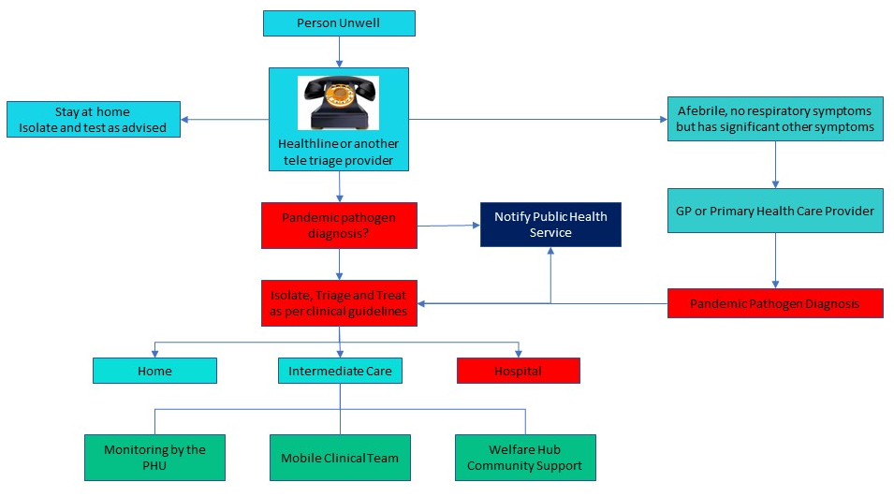
LABORATORY SPECIMENS

Laboratory specimens will only be collected in the early stages of the pandemic.

The general practitioner who first sees the patient should discuss required specimens immediately with the MOH. Patients with suspected pandemic illness should not be sent to a community laboratory for collection of throat or nasopharyngeal swabs. Specimens should be double-bagged and couriered to the laboratory at Hawke’s Bay Hospital.

Rapid Antigen Testing (RAT) may become available which will enable self-testing at home or as a requirement prior to entering health care or other community facilities whereby confirming diagnosis and need for isolation and follow up.

Contingency Plans to Meet the Needs of Persons Confined to their Homes
Persons may be confined to their homes by choice, out of fear of being exposed and becoming ill, or by direction from national or district health officials in order to reduce transmission in the community.

The provision of food, medical and other essential support for persons confined to their homes will be the responsibility of local communities, this will be coordinated by the district Welfare Coordinating Group. Local communities are encouraged to make use of civic organizations and other volunteers to meet these needs. For instance, local agencies already engaged in providing services to the homebound (Meals-on Wheels, etc.) may become the nucleus for voluntary efforts to provide services to people confined to their homes. In addition, there will likely be situations in which care providers of children or the elderly will become ill and unable to care for their children or elderly parents.

During the COVID-19 pandemic, Care in the Community (CitC) organisations were developed to support community welfare and ensure the appropriate response was deployed to assist whanau, communities and individuals as required. See COVID section for details.

Resources at the national level will have to be allocated according to need and all needs may not be met. Local communities are required to have plans in place that will ensure as much self-sufficiency as possible.

MEDICAL CARE FOR PEOPLE SICK AT HOME

Families will need information about how to take care of sick family members at home, and guidelines regarding when to seek professional medical care. This first-line triage will be essential to eliminating unnecessary calls and decreasing the burden on health care providers, freeing them to care for the seriously ill.

For more detailed information refer Primary Care Plan, Annex 2.

RESIDENTIAL CARE

Healthcare providers across Hawke’s Bay provide a resource available for residential care during pandemic response. Each facility has an individual but interlocking plan for care of existing residents with the collective response allowing for provision of additional beds for primary and/or secondary care if required.

For more detailed information refer Residential Home Plan, Annex 2.

COMMUNITY ASSESSMENT CENTRES

During a pandemic, the role of Community Assessment Centres (CACs) will be to provide the primary care surge capacity arising from a sudden increase in demand. These centres will be a means of concentrating the initial assessment of people who may have pandemic disease away from individual general practices and the hospital Emergency Department, the usual first ports of call for people who are unwell. CACs will be for pandemic like illness that meets the case definition and for people that are likely to benefit from available clinical intervention. As well, CACs will support the provision of home-based self-care in association with tele triage and advice.

The primary functions of a CAC will be to:
- provide clinical assessment and advice;
- provide triage and referrals to other primary health or secondary health care (if capacity exists);
- enable health professionals to specialize in pandemic management and infection control;
- practice and provide advice on infection prevention and control; and
- provide secure distribution centres for anti-virals in accordance with Te Whatu Ora guidelines.

Suggested Sites
Hastings Health Centre The Doctors Napier
Te Mata Peak Practice City Medical
Totara Health Flaxmere Taradale Medical Centre
The Doctors Hastings Tamatea Medical Centre
CHB Health Centre Wairoa Health Centre

It may be appropriate as the situation progresses to consult with local marae in rural areas regarding the operation of a Community Assessment Centre directly from the marae.

Community Outreach Service
Patients who are home bound will need to be visited and assessed by a registered nurse following infection prevention and control procedure. Identification will occur via the hospital, Community Assessment Centre, General Practitioners or local marae. Patients will be logged on telephone triage and the call sheet provided to the rostered nurse covering the Outreach Service. The nurse will operate under the patient care clinical pathway and standing orders for supply of antiviral and other medicines. The nurse must have direct access to a designated general practitioner at the CAC for advice as required. The local taxi service should be used as transport, serving also as a level of security for the nurse. Any patient requiring assistance at home should be referred to the Welfare Coordinating Group by contacting Civil Defence Emergency Management.

For more detailed information refer Community Assessment Centre Plan, Annex 1.

PHARMACEUTICAL PROVISION

Assumptions
- The impact of a pandemic could have a devastating effect on the health and wellbeing of the public and pharmacy workforce. This may affect a pharmacy’s ability to provide pharmaceutical services.
- The regular supply of pharmaceuticals to Hawke’s Bay may be affected due to worldwide production difficulties and transportation problems.
- Pharmacists and staff will be at increased risk due to their frequent contact with the public.
- Illegal attempts by some members of the public to obtain antiviral and antibiotic medications could affect the safety of pharmacy staff.
- Some home delivery services will need to be provided to ensure continued access to regular medications for those in isolation or unable to access pharmacies.

Process
The pharmacies of Hawke’s Bay are primarily individually owned but are able to work together in a collegial manner in some circumstances.

Three communication systems have been organised:
- Fax system – fax messages can be sent to all pharmacies in the HB region through an auto-fax system.
- E-mail messages can also be sent through Healthscape (a group contacts system).
- In the event of the two above systems not operating, the cluster group system will be used where pharmacies will operate collectively in clusters to ensure continuity of pharmaceutical services to the community.

For more detailed information refer Pharmacy Plan for Community, Annex 2.

FIRST CASE MANAGEMENT

Assumptions
  - The first case(s) are notified to the Medical Officer of Health before the epidemic has become widespread in Hawke’s Bay.
  - Isolation of cases and quarantine of contacts are important steps early in an epidemic and may help to slow the spread of the disease. Isolation and quarantine will be enforced early in an epidemic.
  - Not all cases will be sick enough to be hospitalised.
  - General practitioners have access to PPE and are trained in its use.

Process
The General Practitioner or Medical Officer will diagnose a case and contact the Medical Officer of Health. The Medical Officer of Health and Public Health Service will be responsible for management of the case in the community. Cases requiring hospitalisation will be admitted into the cohort area in B2 at Hawke’s Bay Hospital with the medical practitioner briefing the Emergency Management Advisor before the case arrives to ensure preparation is made.

For more detailed information refer Interagency Plan for Management of First Cases, Annex 1.

QUARANTINE AND ISOLATION PROCEDURES

Assumptions
- During an epidemic most cases will not be able to be hospitalised (or not be sick enough to be hospitalised).
- Quarantine will reduce transmission from those contacts who become cases.
- Isolation of cases as early as possible may help to control the rate of growth of the epidemic in its early stages. Isolation and quarantine are likely to be less effective when an epidemic is established. Enforcement of isolation and quarantine (as opposed to education and persuasion) are not useful when an epidemic is established.
- Duration of isolation and quarantine will be determined when more is known about the virus. As an example, COVID-19 initially required a 10-day isolation period with testing at days 3 and 7. This changed later in the pandemic to a 7 day isolation period.
Process
At the beginning of an epidemic the Public Health Service (PHS) will coordinate management of the cases and contacts including daily monitoring. Primary health care providers and police will be asked to assist as needed. Cases and contacts who are not seriously ill and do not have a home in Hawke’s Bay will be accommodated at a quarantine centre.

When an epidemic is established the PHS will not be able to be involved in individual cases, but will provide guidance for the health care sector and the public about recommendations for isolation and quarantine.

A count of the number of cases in isolation and contacts in quarantine will be included in the PHS situation report daily.

For more detailed information refer Quarantine and Isolation Plan and Port and Airport Procedures, Annex 2.

COORDINATION OF NON-GOVERNMENT ORGANISATIONS

Planning, Informatics and Finance will perform a co-ordination function between the Non-Government Organisations (NGO's) contracted by Te Whatu Ora Hawke’s Bay and the Incident Management Team. The objective of this coordination will be to ensure resources (including staff, buildings and knowledge) within Hawke's Bay are utilised effectively and to provide an efficient communication pathway to end users of these services with feedback to Te Whatu Ora Hawke’s Bay as necessary.

This will predominantly be performed through telephone and email contact by Portfolio Managers with the providers in their portfolio. These responses will be co-ordinated by the Contracts Manager who will provide the information to the Health Incident Controller. The Health Incident Controller will be able to access NGO information through the Contracts Manager.

SECTION D

SECONDARY CARE SERVICES RESPONSE

SITUATION

Unlike the typical focal disaster, a pandemic will be widespread, with many geographic areas affected simultaneously.

If pandemic-associated illness is especially severe, local health services could easily become overwhelmed very quickly, with:

- potential shortfalls of ICU beds, ventilators and other critical-care needs;
- potential shortfalls of general isolation beds
- potential shortages of antiviral agents and antibiotics for treatment of secondary (bacterial) pneumonia;
- potential needs for ancillary or "non-traditional" treatment centres;
- potential high demand for mortuary/funeral services; and
- potential high demand for social and counselling services

Moreover, unlike natural disasters, demands on medical care in each community will last 6-8 weeks until the "first wave" of infection is complete.

Because of the threat of pandemic exposure, the elderly and other high-risk and special-needs populations may be fearful of leaving their homes to seek proper medical attention for chronic medical conditions and may require home visits for health care.

In summary, high attack rates of pandemic illness will place overwhelming demands on the health care system. Health care providers and emergency response and public safety personnel will be equally or more likely to become infected than the general public. Certain high-risk groups will be less likely to have access to information and services (e.g. people who are homebound, poor or who do not speak English). Because the pandemic will be widespread, it is unlikely that resources could be diverted from other geographic areas. Every community will have to be prepared to be self-sufficient, while at the same time-sharing resources such as hospitals and mortuary services.

RESPONSE PROCEDURES

Response Levels

DURING THE NOVEL VIRUS ALERT – CODE WHITE:

- Activate sentinel general practices and diagnostic coding of in-patients.
- Estimate potential number of primary health care visits, hospitalizations/hospital days and deaths over the 6-8-week period of the "first wave" of the pandemic; assume that the peak in incidence will occur at ~3-4 weeks.

CDC Estimates of Percent of Population Affected by Pandemic outbreak | Number Affected in Hawke's Bay (HB)
Total population of HB as at Dec 2022 | 182,700
Up to 37% of population will become unwell | 67,599
Up to 17% of population will require out-patient visits | 31,059
Up to 0.4% of population will require hospitalisation | 731
Up to 0.1% of population will die of pandemic related causes | 183

(c) Examine adequacy of existing health-care infrastructure in light of those estimates:
- Hospital beds
- ICU beds
- Ventilators
- Ready (or contingency) supplies of required personal protective equipment, i.e. PFR95 masks, face shields, theatre caps, impermeable gowns, disposable gloves and overshoes. N.B. Six weeks supply at normal consumption rates are held in the Hospital Warehouse.
- Ready (or contingency) supplies of antiviral agents for treatment of ill patients and for chemoprophylaxis of health-care workers (amantadine, zanamavir, osetamivir).
- Ready (or contingency) supplies of antibiotics that may be used to treat secondary infection i.e. bacterial pneumonia (e.g. beta-lactams [cefotaxime or ceftriaxone] + macrolides, erythromycin, clarithromycin, azithromycin] or a fluoroquinolone alone [levofloxacin, sparfloxacin, grepafloxacin, trovafloxacin]).
- Respiratory resources audit.
- Workforce analysis including health status risk assessment for working in infectious environments.
- Adequacy of contingency medical-care facilities designated as Community Assessment Centres.
- Adequacy of mortuary/burial services.
- Adequacy of social and psychological services for families of those affected.
  - Develop contingency plans to address any of the items above that are thought to be inadequate.
  - Develop contingency plans for emergency backup of such services and/or provision of additional personnel. Additional personnel could come from lists of retired personnel and/or government or private sector employees with relevant expertise. Note that critical personnel in the non-health sector should also be considered as high-priority candidates for vaccination and/or chemoprophylaxis.
  - Implement contingency plans for obtaining critical equipment (e.g. ventilators) and medicines (e.g. antibiotics for treatment of secondary pneumonia).

DURING THE PANDEMIC ALERT – CODE YELLOW:

- Ensure that human resources and logistics are in place to provide medical care and to maintain essential community services. Utilise Incident Action Plan.
- Activate phase-down of planned surgery contracts.
- Plan for proactive management of identified at-risk groups in consultation with general practitioners.
- Contact at-risk patients to determine coping strategies/action plans, this may include further vaccination to reduce incidence and severity of secondary infection.
- Increase provision for community management of patients with simplification of management as appropriate.
- Develop admission criteria for use in the Emergency Department and communicate to general practitioners.
- Increase monitoring of infection prevention and control practices within healthcare facilities.
- Workforce Unit to provide a list identifying nursing staff not currently in nursing roles. Upskilling of this staff group to be undertaken.
- Introduce a 24-hour discharge planning service for Emergency Department patients.
- Plan for increasing social distancing in workplaces where possible and ensure adequate ventilation.
- Ensure distribution of pandemic guidelines manuals to all areas.
- Calculate personal protective equipment requirements based on 2 masks/1 gown/10 pairs of gloves per staff member per shift.
- Initiate training plan.

DURING THE PANDEMIC IMMINENT STAGE – CODE RED:

- Fully activate the Pandemic Emergency Plan.
- Coordinate activities with neighbouring districts.
- Downscale activities to be deferred.
- Activate the first of the Community Assessment Centres.
- Increase out-patient clinics to adequately prepare patients with complicated conditions.
- Determine minimum acceptable staffing ratios and tasks appropriate for volunteers.
- Cancel all staff annual leave and introduce a policy of no new leave approval and bereavement leave restriction of no more than two days. Communication statement for staff to be released by the Incident Controller in consultation with the Communications Manager.
- Communicate with alternate facilities to determine bed availability and initiate patient transfer as appropriate.
- Increase cleaning services and waste disposal in all areas (use disposable equipment where possible).
- Consider shutting down or isolating air conditioning and lamson pneumatic delivery system.
- Complete and action Unit Operational Plans in all areas.
- Ensure secure storage in each area for supplies and designated individual to monitor stock and initiate reordering.

DURING THE PANDEMIC – CODE RED:

- Cease activities to be deferred.
- Cancel all planned surgery.
- Cancel non-essential out-patient clinics.
- Commence eight hourly reporting and regular staff information provision.
- Redeploy staff as required.
- Activate telephone service for general practitioners with consultant physician for advice and support. Physician to be conversant with community services available.
- Utilise the Emergency Department Resuscitation Room for usual patients and the isolation suite and cubicle area for patients suspected to be infected.
- Initiate 24-hour clinical nurse manager roster with eight hourly reporting to the Emergency Operations Centre.
- Commence Cohorting plan, admitting patients ward by ward. With only the seriously ill patients being admitted and all others being cared for at home. Designated staff only to deliver care.
- Activate the infection prevention and control monitoring network.
- Initiate supply monitoring and control.
- Initiate twice daily rounding by consultant medical staff.
- Activate staffing plan utilising 24-hour staff bureau service, shift lengths and breaks to be monitored and on-call provision initiated.
- Initiate staff support systems.
- Initiate designated staff wellness monitoring.
- Provision of on-site general practitioner service at Te Whatu Ora, Te Matau o Māui
- Introduce visitors policy of one nominated visitor per patient.
- Activate temporary mortuary provision. Contact all funeral directors utilising the list held in the Healthscape contact database and advise of mortuary areas, delivery and uplifting procedures. New Zealand Police to be contacted also.
- Activate alternative arrangements for hospital beds in the event of shortage.
- Meal provision to all areas.

Viral Testing
Rapid antigen testing may be available depending on the presenting pathogen at Hawke’s Bay Hospital within a time frame of 20 minutes. PCR testing is carried out at Hawke’s Bay Hospital. Results are available within 4 hours.

Service Provision
Service provision will be assessed by the Incident Management Team on completion of Unit Operational Contingency Plans and will be subject to change over time.

Use of Alternate Facilities
Alternate venues for the service delivery in health may need to be considered.

Motels may be considered for staff accommodation, bringing together patients or clients managed in the community, post hospital step-down care or supply and distribution centres.

Residential care facilities have separate but interlocking pandemic plans, they may also be considered for infectious wards, post hospital step-down care or home care patients unable to cope.

The district’s private hospital may be considered for a clean surgical unit or post hospital step-down care.

Decisions regarding use of alternate facilities will be made by Incident Management Team in the Emergency Operations Centre in consultation with the agencies involved based on patient volumes.

SECTION E

MANAGEMENT OF ISSUES

Human Resource Issues

Health Considerations for Staff Caring for Pandemic Patients

It is recommended that staff with the following medical conditions do not care for patients with pandemic-related illness:
- Immunosuppressed
- Ongoing respiratory or kidney disease
- Insulin dependent diabetes mellitus
- Cancer
- Heart disease

Consideration should also be given to
- Older staff members (70+)
- Māori or Pacifica staff with co-morbidities
- Staff with immunosuppressed or vulnerable whanau at home

Nursing Obligations

Code of Ethics: Nurses’ primary professional code is to those requiring nursing care. Nurses provide care that respects human rights. (ICN Code of Ethics).

Human Rights Act 1993: It is unlawful to discriminate against those with a disability. Disability includes the presence in the body of organisms capable of causing illness. (S22).

Code of Health and Disability Services Consumers Rights has 10 rights for patients including Right 2 – to receive care free from discrimination.

Health and Safety at Work Act 2015

Employers must take all practicable steps to mitigate the risk and protect employees, especially those at high risk, such as health care personnel, support staff and first responders (fire/police /ambulance/other emergency workers) from pandemic illness.

Employers need to actively plan to cover their risks and the risks to their workers and the public.

The most relevant sections of the Health and Safety at Work Act 2015 are:

Section 22: defines all reasonably practicable steps
That which is, or was, at a particular time, reasonably able to be done in relation to ensuring health and safety, considering and weighing up all relevant matters, including:
- the likelihood of the hazard or the risk concerned occurring; and
- the degree of harm that might result from the hazard or risk; and
- what the person concerned knows, or ought reasonably to know about the hazard or risk and ways of eliminating or minimizing the risk; and
- the availability and suitability of ways to eliminate or minimize the risk.

Section 36: “All practicable steps”
Every employer must ensure, so far as is reasonably practicable, the health and safety of employees while at work.

Where a significant hazard, including the likelihood of a pandemic is identified, the steps an employer must take include:

1. Where practicable, the significant hazard must be eliminated;
This may involve removing the hazard or hazardous work practice from the workplace.

2. If elimination is not practicable, the significant hazard must be isolated;
This may involve isolating or separating the hazard or hazardous work practice from people not involved in the work or the general work areas. It could mean reducing the potential for contamination through changing work practices to achieve a greater degree of social distancing, or installing screens or barriers.

3. If it is impracticable to eliminate or isolate the hazard completely, then the employer must minimise the likelihood that the hazard will harm employees. In addition, the employer must, where appropriate:
- Provide, make available to, and ensure the use of suitable clothing and equipment to protect the employees from any harm arising from the hazard;
- Monitor employee’s exposure to the hazard;
- Seek the consent of employees to monitor their health; and
- With their informed consent, monitor employee’s health.

Section 45: Employees must take steps to ensure health
Requires employees to take all reasonable steps to ensure their own health and safety at work, and that they do not cause harm to others.

Section 83: Employees may refuse to perform work likely to cause serious harm
Employees have the right to refuse to perform work if they believe it is likely to lead to their suffering serious harm. However, their belief must be on reasonable grounds, and they must have attempted to resolve the matter with their employer before they can continue to refuse. The right to refuse unsafe work does not apply unless the understood risks of the work have materially increased. The right of an ambulance worker or nurse to refuse is therefore different to that of, say, a carpenter. It is also different to that of a sworn staff-member of the police, fire service or armed forces. Note that independent contractors and volunteer workers have the right to withdraw their labor or services at any time, including when they feel the work environment presents an unsatisfactory level of risk.

Therefore, it is a reasonable expectation that staff will attend workplaces where practicable steps have been taken to ensure their health and safety while at work. Terms and conditions of employment essentially remain the same, however flexibility may be required with regard to the nature of tasks and duties to complete, hours and location of work.

Where equipment is available and IT network capacities allow, managers may request or allow members to work from home. Where members work from home the employer needs to identify whether the home is a safe workplace, as it becomes a “place of work”.

For an information sheet for employees refer Human Resources Frequently Asked Questions, Annex 1.

Staff Monitoring

Process
- The Manager receives a call from a person suspecting they may have the pandemic illness that is circulating
- Do not visit the person if this can be avoided – manage the process over the telephone according to the identified pathogen pathway.

Assumptions
- 15% of the workforce will be absent for 8 weeks because school closures oblige working parents to stay home and look after children. Note that this proportion will vary according the particular workforce.
- 40% of those remaining at work become ill at some time during the 8 weeks of the pandemic wave.
- The workplace attack wave follows a pattern similar to that expected in the general population.
- Every person who becomes ill has 7 days off work.
- There is a 100% additional absence rate – that is, for every person in the remaining workforce who gets ill, another does not come to work because of the need to look after a spouse or children, or a disinclination to travel or work.
- The additional absences follow the workplace attack pattern.
- 2% of workers who become ill die.
- Note that no estimate is made for people doing extra shifts or longer shifts, or for any recruitment into the workforce during the pandemic.

Volunteer Management

Procedure
Reception and recruitment of volunteers will be carried out centrally with placement of volunteers being made according to the information supplied by each agency detailing tasks that may be allocated, skills required and exclusion criteria. The following steps will be taken:
- Volunteer to complete an application form
- Completion of a register for all potential candidates documenting skills
- Health clearance question on the application form completion, if doubt as to suitability occurs contact the Occupational Health Service
- Request permission to conduct a criminal record check
- Confirmation of volunteer status and agency/area of work, job description and written agreement provision and certificate of acceptance
- Generic orientation programme completion
- Provision of organisation identification and uniform if required
- Nominated person in proposed work area informed who will be responsible for briefing and area specific orientation and the appointment of a supervisor

For more detailed information refer Volunteer Management Plan, Annex 2.

Case Notification

1. Early in the epidemic
Immediate notification of the first suspected cases is crucial. Phone 878-8109 (seven days). Ask to speak to the Medical Officer of Health (MOH). Detailed information will be required about each case and the MOH will work closely with the practice to formulate an immediate plan of action, including investigation and management of the case and contacts.

2. When the MOH advises that a Hawke’s Bay epidemic is established
At this point the MOH will advise all practices that the reporting requirements are to be reduced to a minimum (Pandemic Minimum Data Set), e.g. report date, age, gender, ethnicity and suburb or street address. Reporting arrangements will be advised at the time. Possibilities include download of the required data into an emailed report extracted from the practice patient management system, or a simple faxed table.

Resource Distribution

The MOH will approve the distribution of antivirals and request the release of the national reserve.

Te Whatu Ora Hawke’s Bay Pharmacy will:
- store antivirals
- pre-label the antivirals so that a doctor or nurse can issue courses by writing the name and required dose on the bottle
- arrange transport to the provider who will supply the medication to the patient
- monitor stock issued

In the “stamp-it-out” phase antivirals will be distributed only from the Hospital Pharmacy Department, PHS and/or authorised pharmacies. In the “manage-it” phase antivirals will be distributed from the Hospital Pharmacy Department, CACs and by home-visiting community Outreach Services.

Antivirals will be prescribed by doctors (or supplied by nurses operating under standing orders).
For further information see the Antiviral and PPE Distribution Plan, Annex 1.

Te Whatu Ora Hawke’s Bay will approve the distribution of the national reserve following notification from the MoH.

Te Whatu Ora Hawke’s Bay Procurement and Logistics Department will control access to PPE but will work with the Incident Controller for the health response under a CIMS structure.

The PPE will be supplied to:
- Hospitals and health centres
- Public Health Unit
- General practices
- NGO’s
- Residential care facilities
- Ambulance Service
- Police
- Fire Emergency NZ

An initial supply will be designated with some supply held in reserve to ensure availability to areas of greatest need.

For more detailed information refer Antiviral and PPE Distribution Plan, Annex 1.

Security

Potentially at-risk premises, processes and infrastructure include:
  - Facilities, including Community Assessment Centres, that may be set up
  - Personnel
  - Pharmacies
  - Supermarkets and food outlets
  - Petrol stations
  - St John Ambulance Service

There may be a need for 24-hour security at certain premises and this will be the responsibility of individual organisation to arrange.

The NZ Police will aim to provide a "priority one" capability. This is an immediate response to all calls involving actual threat to life or property happening now, violence being used or threatened, serious offence/incident in progress and offenders present or leaving the scene, serious vehicle crashes.

The NZ Police communication centres will be supplied with a current list of high-risk facilities to ensure immediate response to any calls for assistance.

The NZ Police will liaise with local security firms in relation to high priority facilities in terms of need, risk and action required.

The NZ Police will consider swearing in temporary Constables in order to assist with maintaining law and order. The local territorial force may be a useful source for these staff.

Te Whatu Ora Hawke’s Bay will be responsible for the security of all medicines and medical supplies under their care including the movement of medical supplies to other facilities and the storage of medical supplies at Community Assessment Centres. Te Whatu Ora will be responsible for the safety of all personnel working for them.

Te Whatu Ora Hawke’s Bay will immediately inform police of any threats against any of their personnel, facilities or supplies.

The NZ Police will monitor community activity on a daily basis and allocate policing priorities based on the most recent intelligence through the Police Daily Tasking and Coordination process.

The NZ Police will aim to operate from currently designated Police Stations and Community Policing Centres where able along with a mobile response capability.

For more detailed information refer Security Plan, Annex 2.

Deceased Persons Procedures

If a deceased person has been identified, certified as deceased and a cause of death is established and certified, the body will be transported from the place of death by a funeral director directly to the grave and interred or removed to a temporary mortuary following notification of next of kin (whanau representative).

The manner in which life extinct and cause of death will be certified is dependent upon legislation. At present this can only be completed by a Registered Medical Practitioner or Nurse Practitioner who has examined the body and found life to be extinct. As a result of legislative change this function may also be carried out by an appropriately qualified nurse. (This could be a Level 4 nurse who is suitably trained and authorised).

Te Whatu Ora Hawke’s Bay will be responsible for contacting funeral directors utilising the list held in the Healthscape contact database and advising of mortuary areas and delivery and uplifting procedures. The New Zealand Police must also be contacted.

Personal Protection Equipment (PPE) must be used by all personnel dealing with any patient who has died as a result of the pandemic. The body is to be sealed in a bag prior to transfer to a mortuary and that transfer is to occur as soon as possible after the death.

Cultural obligations must be given consideration. To this end, on activation of the temporary mortuary facility, contact will be made with the Maori Health Unit of Te Whatu Ora Hawke’s Bay. The unit will ensure an individual responsible for cultural liaison will be on site at the facility during its operation. Every effort must be made by the funeral director to advise NOK (whänau representative) of the death as soon as possible. If this cannot be achieved, Police will assist at the request of the funeral director.

In the event a large volume of deceased are required to be buried or cremated it may be appropriate to place the bodies in storage pending the ability to hold public gatherings (funerals) and complete the internment process. Temporary mortuary provision, if required, will be established by Te Whatu Ora Hawke’s Bay.

Transportation from the scene of a death to the temporary or permanent mortuary facility will be coordinated and facilitated by funeral directors.

Police will appoint a Mortuary Manager to assist Te Whatu Ora Hawke’s Bay in co-ordinating temporary mortuary facilities.

There will be a need for security at the premises and this must be 24 hours.

Provision will be made by the Te Whatu Ora Hawke’s Bay at the temporary mortuary for the secure temporary storage of property and personal effects associated to deceased persons pending uplifting by next of kin.

In the event a Disaster Victim Identification (DVI) procedure is to be implemented, this is a Police responsibility. The focus will be on applying correct identification procedures and then moving the body on for either cremation or burial as soon as possible.

Police will be responsible for preparing sudden death files and liaising with the Coroner regarding Inquests. Police will investigate sudden deaths as directed by the Coroner.

The Ministry of Health and/or the Medical Officer of Health will provide guidance regarding public gatherings (funeral services) during the pandemic event.

For more detailed information refer Deceased Persons Procedures, Annex 1.

Staff Support

Provision for staff support is essential. The following strategies will be employed:
- Provision of designated staff rest areas
- Meal provision to all areas
- Use of chaplains, psychologists and social workers for psychosocial support
- Availability of temporary accommodation for staff prepared to work but unwilling to return home
- Team meetings at beginning and end of each shift to monitor staff wellbeing and keep people informed
- Contact with families maintained by the Workforce Unit as required
- Dedicated and accessible PC’s to be used to communicate with family members

SECTION F

VACCINATION PLAN

Vaccination will serve as the central preventive strategy during the next pandemic. The amount of vaccine that will have to be managed (ordered, stored, distributed and accounted for) will be affected by the following factors:

- Vaccine availability - manufacturers' ability to produce and distribute vaccine.
- The proportion of available vaccine that will be purchased and distributed by the public versus the private sector.
- National, regional and district funds available for the public purchase of vaccine.
- Amount of vaccine available for public purchase through national contract(s).
- Amount of vaccine available for public purchase through contracts negotiated between the MoH and manufacturers.

Vaccine Management should be based on the following assumptions:

- There may be a delay of 3-6 months in the availability of a vaccine following human-to-human transmission of the novel virus.
- The entire population will be susceptible and may require two doses of vaccine, one month apart, for adequate protection.
- There will be a national contract for purchase of vaccine.
- The Public Health Service will be responsible for planning and implementation of a mass vaccination programme.
- Administration of vaccine to the general public will occur at the district level.
- Vaccines may initially arrive in multi dose vials, this may change to single dose vials as the pandemic progresses.
- Even if the maximum amount of vaccine becomes available to Hawke’s Bay (2 doses for everyone 6 months of age and older), it will arrive over a period of time. Management of vaccine during the pandemic will most likely occur over a number of months.
- Because there is likely to be a moderate to severe shortage of vaccine, at least in the early phases of the pandemic, security for the vaccine must be addressed.
- While distribution of all other vaccines will be maintained during the pandemic, inventories of non-pandemic vaccine will be reduced at the regional and local distributor sites.

Response Levels

DURING THE PRE-PANDEMIC PERIOD – CODE WHITE:
- Enhance vaccination coverage levels in traditional "high-risk" groups, particularly subgroups in whom coverage levels are particularly low – e.g. persons < 65 years of age with chronic underlying medical conditions and children. Although vaccinating people now will not protect them against illness during the next pandemic, increasing routine (annual) vaccination coverage levels in these groups will normalise health preparedness and may provide some herd immunity when a pandemic occurs.
- Maintain other vaccination coverage levels in traditional "high risk" groups (to reduce the incidence and severity of secondary disease outbreaks for example MMR). The length of a pandemic can in itself cause outbreak of other community disease due to normal screening and vaccination not being prioritised.
- Develop a programmatic scheme for providing the pandemic vaccine to high-priority target groups and the general population:
  - In the presence of severe vaccine shortages
  - In the presence of moderate shortages
  - In the presence of no shortages
    - Consider community-specific modifications or refinements in priority groups, depending on local circumstances. For example, there may be specific groups of persons in some communities whose absence (due to illness) could pose disastrous consequences in terms of public safety or disruption of essential community services. Examples of such unique, special-skill groups might include air traffic controllers at major airports, and workers who operate major telecommunications or electrical grids, fire service and or supermarkets.
    - Coordinate proposed vaccine distribution plan with bordering communities.
    - Review and modify vaccine distribution plans as needed on a periodic basis.

The decision to vaccinate may occur at any stage of the alert process, once this has been made:
- Ensure that human resources and logistics are in place to begin vaccination. This will include identifying additional staff within TeWhatu Ora Hawke’s Bay who would be able to support and assist the Public Health Service staff. Occupational Health staff will be responsible for vaccination of healthcare workers and maintenance of a database of this vaccination.
- Fully activate the vaccination program.

1. Vaccine Ordering

CDC will notify the MoH as to how much vaccine will be available for New Zealand through a national contract. Vaccine may also be available through contracts negotiated directly between the MoH and vaccine manufacturers. Once the total amount of vaccine that will be available is known, the MoH will determine the proportion of vaccine that will be held for administration to essential national personnel (based on the Priority Group List), and how much vaccine will be available to each district. The MoH will then notify each district accordingly.

2. Security for Vaccine

Vaccine will likely not be available until sometime into the pandemic, and is likely to be in short supply when it does become available. There may be a large demand for the vaccine and security during vaccine storage, transport and distribution may be an issue.

In order to dispel rumours and decrease panic, it will be important to ensure that the general public has information about the availability of vaccine, how it will be distributed, how decisions were made regarding priority groups for the vaccine, and other measures that can be undertaken to prevent and control the pandemic virus. Refer to the Communications section of this plan for a full description of how information will be disseminated during a pandemic.

It is likely that vaccine will be received in multiple shipments over a period of time, perhaps even months.

Security for vaccine during transport between the MoH and the regional distribution sites, and during vaccine storage and distribution at the local distribution sites, will be the responsibility of the regional authorities.

3. Vaccine Storage

Once it has been received at the central distribution site, vaccine will be moved very quickly through the system to regional localities. Vaccine will not be stored in any one place for any length of time. As soon as the MoH is notified that vaccine is arriving, the MoH will alert the regional centres. Regional localities will pick up vaccine on an as needed basis, they will not be responsible for storing large amounts of vaccine at any one time.

4. Vaccine Accountability

During a pandemic, it will be particularly important to maintain strict accountability for vaccine. At the regional centres and local distributor sites, a special log for vaccine will be maintained to record the manufacturer (assuming multiple manufacturers), lot number, expiration date and quantity of vaccine received and distributed.

Regional localities will use the Vaccine Administration Record, which is currently used for public immunization clinics unless a specific national database has been created.

5. Vaccine Administration

Non-Medical Vaccinators are authorised by the Medical Officer of Health pursuant to regulation 44a of the Medicines Regulations. Hawke’s Bay has authorised vaccinators available with a database being maintained to record all vaccinations. A list of currently authorised vaccinators is held by Te Whatu Ora Hawke’s Bay Immunisation Team.

During the SARS-CoV-2 pandemic a provisional vaccinator qualification was established and an amendment to the Medicines Act was undertaken. The provisional vaccinator completed an online training programme and initial supervision to ensure competencies were met. This enabled a wider workforce to distribute a selected group of vaccines within a particular age group. This initiative may be enabled or resurrected again for future pandemic responses.

Priority Groups List for Receipt of Vaccine

Because vaccine shortage during a pandemic is likely, the MoH, in conjunction with various advisory committees, will formulate recommendations for a rank-order list of high priority groups for vaccination. The order of these groups will be based on a number of factors, including the need to maintain the infrastructure necessary to carry out the pandemic response plan; to limit mortality among high-risk groups; to reduce morbidity to the general population; and to minimize social disruption and economic losses.

While any Priority Groups List will be subject to change, the list will most likely include the following groups:
- Health-care workers and public health personnel involved in the distribution of vaccine and antiviral agents
- Persons responsible for community safety and security, e.g. police, fire-fighters, military personnel, corrections officers, first responders not included in first priority group (e.g. ambulance officers)
- Other highly skilled persons who provide essential community services whose absence would either pose a significant hazard to public safety (e.g. air traffic controllers) or severely disrupt the pandemic response effort (e.g. persons who operate telecommunications or electric utility grids, care givers at residential facilities). [NOTE: Members of this target group are likely to vary widely from region to region, depending on local circumstances].
- Persons traditionally considered to be at increased risk of severe illness and mortality:

- Persons of any age with high-risk medical conditions
- Pregnant women
- Māori and Pasifica
- Persons in nursing homes and other long-term care facilities
- Persons > 50 years of age without high-risk medical conditions
- Infants age 6-12 months (if supported by epidemiologic and clinical data)
- Household contacts of persons with high-risk medical conditions
- Others who, in the judgement of national and district health officials, provide critical community services (e.g. utility workers, funeral services personnel, personnel involved in the transport of essential goods such as food)
- Healthy persons age 18-49 years
- Pre-school-age (especially day care centre attendees) and school-age children (the population least likely to have severe illness)

For more detailed information refer Vaccination Plan, Annex 2.

SECTION G

TRAINING PLAN

Prior to activation of the training plan a meeting of all involved trainers will be held to ensure preparedness and to update any training material as required. This meeting will be facilitated by Te Whatu Ora Hawke’s Bay’s Emergency Management Advisor. At this point a plan for session delivery will be formulated.

Package | Facilitator | Target Groups | MoH Code  WHO Phase | Method
Pandemic Pathogen – An Introduction | Emergency Management | HB Community | Code Yellow  WHO Phase 3 | Presentation  Discussion
Infection Control – Basic Hygiene | Infection Prevention and Control | HB Community | Code Yellow  WHO Phase 3 | Presentation  Discussion
Specimen Collection | Laboratory Scientist | Primary Care  Front Line Secondary Care | Code Yellow  WHO Phase 4 | Discussion  Demonstration  Practice
Infection Control – Level One | Infection Prevention and Control | Primary Care  Secondary Care  Ambulance Service  Residential Facilities  Prison Service  Police  Cleaning Services  Community Pharmacy  Local Authorities (relevant staff)  Education Providers  Funeral Directors  Child Care Centres | Code Red  WHO Phase 5 | Presentation  Demonstration
Managing Challenging Behaviour | Mental Health Educator | All staff of involved agencies | Code Red  WHO Phase 5 | Workshop  Discussion
Debriefing and Stress Management | Occupational Health | Front line staff of all involved agencies | Code Red  WHO Phase 5 | Presentation  Discussion

Intensive Care Orientation | Nurse Educator ICU | Registered Nurses relocating to ICU | Code Red  WHO Phase 5 | Presentation  Workshop  Demonstration  Practice
Cause of Death Certification | Clinical Director Medical and Acute Service | Approved Level 4 Registered Nurses | Code Red  WHO Phase 6 | Mini Lecture  Discussion
Volunteer Orientation | Nurse Educators | Volunteers | Code Red  WHO Phase 6 | Mini Lecture  Discussion  Workshop  Practice
Infection Control – Level Two | Infection Prevention and Control | Primary Care  Secondary Care  Ambulance Service  Residential Facilities  Prison Service  Police | Code Red  WHO Phase 6 | Demonstration  Practice
Patient Management | Infection Prevention and Control Committee  Nurse Educators  Respiratory Nurse Practitioners | Primary Care  Secondary Care  Ambulance Service  Residential Facilities  Prison Service | Code Red  WHO Phase 6 | Presentation  Discussion
Vaccination System Preparation | Public Health Service | All staff involved in mass vaccination campaign | Code Red  WHO Phase 6 | Discussion  Workshop

The facilitators are responsible for the preparation of training sessions. Training may be delivered by a variety of trainers using a train the trainer’s approach to enable efficient and timely coverage of all individuals and agencies. Resources required will be provided to all agencies with a central database of training attended maintained by Te Whatu Ora Hawke’s Bay.

For more detailed information refer TWO Training Plan, Annex 2.

SECTION H
RECOVERY

The process of recovery is to re-establish the quality of life to the community following an emergency. Recovery starts as soon as possible in the local community and addresses the social, economic, natural and built environments.

For the health sector the main recovery objective is to provide for the effective short, medium and long term restoration and management of health services within the community as quickly as possible following an emergency event. This can best be achieved by bringing together the key affected members of the community supported by local, regional and national structures.

The health sector has a key role within the Social Environment subtask group of the overall Recovery Plan that is established and co-ordinated by the Hawke’s Bay Civil Defence Emergency Management Group (HB CDEMG) to help rebuild the community after a disaster. When activated, the group and subtask groups meet together to share information and resources to plan, finance and implement a recovery strategy thus rebuilding confidence and making the community more secure.

Recovery begins on day one of an emergency. It can take a relatively short time or may take many years. As initial emergency response activities conclude the process to begin returning the affected community to its proper level of functioning must be carefully managed. This transition process from response to recovery may be staged or be variable across areas and is often divided into “initial recovery” and “long-term recovery” or reconstruction.

Although the overall recovery action plan will be prepared and co-ordinated by the CDEM Group and its associated recovery task groups, the health sector, as a primary health care strategy provider, also needs to be involved in the preparation of any actions to be taken to facilitate recovery. Therefore, in order to best determine health sector needs for the community in a disaster, the Recovery Action Plan Template should be used.

Control of the Recovery Phase is achieved by the appointment of a Recovery Manager who functions to coordinate activities of the agencies involved in the Recovery Phase.

Te Whatu Ora Hawke’s Bay Recovery Manager is responsible for ensuring that:
- Planning, prioritisation and management functions are undertaken
- Effective reporting mechanisms are in place
- The Incident Management Team is informed of local and regional issues
- Recovery resources are identified and obtained as required
- Information is provided on the impact of the event on the affected area
- Emerging issues are identified and solutions sought
- Monitoring and evaluation of the implementation of the agreed recovery strategy is carried out

Recovery Coordinators may be appointed for a specific period, typically 2-3 weeks initially, with terms of reference that require them to:
- Establish an interim management structure to coordinate relief and recovery measures for the various government and non-government agencies involved in recovery activity
- Identify areas where existing policy provisions are unlikely to be sufficient to achieve the desired recovery and to suggest policies that may be applied

Specific Actions in this Phase:
  - Review actions and decisions and lift controls and pandemic programs when feasible
  - Debrief staff and agencies and collate lessons learned
  - Evaluate the effectiveness of measures used and update plans and guidelines
  - Prepare to return to the new business as usual
SECTION I

OUTBREAK MANAGEMENT

Situation Management

Phase 4 – Ready

- Health Emergency Coordinating Committee convened.
- Estimate potential number of primary health care visits, hospitalizations/hospital days and deaths in each jurisdiction over the 6-8 week period of the "first wave" of the pandemic; assume that the peak in incidence will occur at ~3-4 weeks.
- Audit systems in place to manage an outbreak.
- Implement contingency plans for obtaining critical resources.
- Ensure training plan initiated.

Phase 5 – Steady

- Activate Incident Management Team and EOC.
- Ensure that human resources and logistics are in place to provide medical care and to maintain essential community services. Utilise Incident Action Plan.
- Distribute Pandemic Guidelines Manuals to all areas.
- Downscale activities to be deferred.
- Ensure preparation of roster for Clinical Nurse Manager 24 hour cover.
- Ensure PPE available in all designated areas.
- Advise additional staffing sources of impending need for assistance.
- Advise first CAC’s to prepare to activate.
- Advise quarantine facility.
- Introduce enhanced staff surveillance and sickness reporting.
- Arrange meeting with MOH and hospital and community laboratory staff to agree specimen collection process.
- Arrange meeting with MOH and Pharmacy staff to agree antiviral distribution process.

Phase 6 – Go

- Fully activate the Pandemic Emergency Plan with pathogen specific detail.
- Ensure completion of Unit Operational Plans in all areas.
- Reports from each area to be prepared by the staff member in charge on an eight-hourly basis. Reports to include staffing levels, staff sickness, bed occupancy or patient throughput, acuity, deaths, and treatment and discharge barriers.
- Maintain contact with all involved areas. Review reports from primary care, aged residential providers (ARC), disability providers and other NGO’s.
- Ensure resource provision.
- Cease activities to be deferred.
- Initiate Clinical Nurse Manager roster (In-patient Coordinator).
- Commence cohort plan.
- Redeploy staff as required.
- Initiate supply monitoring and control.
- Initiate staff support systems.
- Ensure initiation of four hourly updates to staff in all areas.
- Activate CAC – one in Hastings and one in Napier.

MONITORING REQUIREMENTS

  - Information from CAC’s, primary care and hospitals regarding patients seen, clinical status, capacity of critical services and usage of national reserve supplies
  - Pandemic illness and mortality data from each facility or location
  - Workforce absence
  - Antiviral resistance
  - Laboratory capacity
  - Load on and capacity of health service
  - School absenteeism (a sensitive indicator of infection spread)

ACTIVITES TO BE DEFERRED HOSPITAL

- Non-essential elective surgery and procedures
- Non-urgent referrals/admissions
- Non-urgent interventional work, CT’s and imaging
- Non-urgent patient transfers
- Non-essential out-patient clinics
- Non-essential reception
- Microbiology screening for MRSA, VRE and ESBL, faecal culturing, routine blood and urine testing
- Proactive clinical pharmacy service
- Aseptic compounding
- Clinical trials
- Orthotic service
- Meal service to community
- Education, projects and meetings
- Revenue gathering and reporting

BED MANAGEMENT

Phase 4 – Ready

- Continue daily bed status monitoring and reporting.

Phase 5 – Steady

- Develop admission criteria for use in the Emergency Department and communicate to general practitioners.
- Communicate with alternate facilities to determine bed availability and initiate patient transfer as appropriate.
- Plan for proactive management of identified at-risk groups in consultation with general practitioners. Communicate with all patients in these groups ensuring action plans are in place, utilise Nurse Practitioners and Clinical Nurse Specialists and Home Health.

Phase 6 – Go

- Utilise the Emergency Department Isolation Suite for triage of suspected patients.
- Consider activation of an Emergency Surge Facility near to the Emergency Department
- Introduce a 24-hour discharge planning service for Emergency Department patients.
- Provision of on-site general practitioner service at Hawke’s Bay Hospital.
- Activate telephone service for general practitioners with consultant physician for advice and support. Physician to be conversant with community services available.
- Increase provision for community management of patients with simplification of management as appropriate.
- Isolate / cohort patients, initially activating the cohort facility in B2 then ward by ward as the situation requires. With only the seriously ill patients being admitted and all others being cared for at home.
- Initiate twice daily rounding by consultant medical staff and twice-daily bed status reporting.
- Activate alternative arrangements for hospital beds in the event of shortage.
- Discharge management plans to include notification of general practitioner, discharge advice leaflets, follow-up arrangements as required and prescriptions faxed to a community pharmacy for home delivery.
- Activate temporary mortuary provision. Contact all funeral directors utilising the list held in the Healthscape contact database and advise of mortuary areas and delivery and uplifting procedures. New Zealand Police to be contacted also.

STAFFING

Phase 4 – Ready

- Contact additional staffing sources and determine availability. These may include EIT, registered nurses and caregivers within the organisation in non-patient care roles, registered nurses and caregivers in the community, private hospitals and students.
- Consider a standby surge workforce to mitigate the need to stand up a workforce at short notice.

Phase 5 – Steady

- Human Resource Advisor to provide a list identifying nursing staff not currently in nursing roles. Up-skilling of this staff group to be undertaken.
- Prepare minimum staffing ratios and tasks for volunteers.

Phase 6 – Go

- Cancel all staff annual leave and introduce a policy of no new leave approval and bereavement leave restriction of no more than two days. Communication statement for staff to be released by the Incident Controller in consultation with the Communications Manager.
- Redeploy staff in areas of phase down or closure.
- Activate staffing plan utilising 24-hour roster office service and on-call provision.
- Schedule work shift and breaks to enhance attention span. Shifts in dedicated facilities to be no more than 12 hours with a minimum of a 20 minute break period every 2 hours. Part or shared shifts may be considered along with on-call provision.

VOLUNTEER MANAGEMENT

As the pandemic progresses, volunteers and staff family members may offer their assistance. These individuals will be registered in the Emergency Operations Centre.

Tasks that may be delegated, with training, include:
- Basic patient care or assisting with same
- Managing supplies
- Bedmaking
- Cleaning and serving food duties
- Deliveries
- Medical typing

INFECTION PREVENTION AND CONTROL SURVEILLANCE

Phase 5 – Steady

- Increase monitoring of infection prevention and control practices within healthcare facilities.
- Provide additional infection prevention and control information and training to all staff and contracted companies e.g. laundry service provider, OCS.
- Ensure the provision of adequate personal protective equipment to all areas required to respond.
- Monitor compliance and effectiveness of infection control activities daily.
- Collect surveillance data i.e. numbers, ages and demographics.
- Consider scrubs for all staff involved in direct patient care and designated staff footwear.

Phase 6 – Go

- Establish an infection prevention and control monitoring network within the hospital.
- Increase cleaning services in all areas.
- Investigate all breakthrough infections.

STAFF SUPPORT

Phase 5 – Steady

- Key staff to be identified and deputies assigned.
- Prepare staff rest areas.

Phase 6 – Go

- Key staff to be on-call for a period of no more than 3 days without a 24 hour stand-down period.
- Meal provision to all areas.
- Chaplains and social workers to visit all areas regularly.
- Inform all staff of the availability of Employee Assistance Program.
- Offer accommodation to staff prepared to work but unwilling to return home.
- Team meetings to be held at the beginning and end of each shift to monitor staff wellbeing.
- Utilize shift coordinators, information systems and management staff to monitor staff workloads.

SUPPLIES

Phase 4 – Ready

- Each area must stock take essential supplies and address shortfalls through the Procurement Service.
- A secure room in each area should be designated as the store room.
- Calculate PPE requirements based on 2 masks/1 gown/10 pairs of gloves per staff member per shift.

Phase 5 – Steady

- Assign an individual in each area responsible for supplies and inventory.
- Supplies must be at a maximum available level.
- PPE distributed through the Procurement Service.

Phase 6 – Go

- Activate monitoring and control of supply levels.
- Distribute national reserve supplies on notification from Te Whatu Ora.

VISITORS

Phase 5 – Steady

- Prepare information for visitors regarding the need for restrictions of access.

Phase 6 – Go

- Introduce visitor’s policy of one nominated visitor per patient and no visits to other patients if visiting a patient with pandemic-related illness.
- Provide education in infection prevention and control precautions to nominated visitors.
- Any visitor refusing to comply with visiting restrictions may be issued with a Trespass Order. This is obtained by contacting the Security staff.

PUBLIC HEALTH SERVICE

Phase 5 – Steady

- Re prioritise workload.
- Re assess staff leave.

Phase 6 – Go

- Follow PHS management of disease outbreak procedure.
- Provide epidemiological information processing to the Incident Management Team.

AMBULANCE SERVICE RESPONSE

Infection Prevention and Control Precautions:

As soon as there is reason to believe that a patient is a possible pandemic case, the following precautions should be undertaken:

- Droplet precautions including the use of a disposable gown and mask for ambulance crew in contact with the patient.

- Careful attention to hand hygiene.

- If transporting relatives to hospital with the patient, limit to one and they should also wear a disposable surgical mask.

Hospital Notification:

If transporting a patient who is a possible pandemic case, advise the Emergency Department.

Arrival at Hawke’s Bay Hospital:

- An infection prevention and control nurse trained in the use of PPE and attired to carry out this role will meet all patients on the ambulance bay.

- Suspected patients will be taken direct to a designated area within the Emergency Department.

- Ambulance Officers will remove personal protective equipment in the usual manner, with Te Whatu Ora Hawke’s Bay responsible for disposal. Normal infection prevention and control and cleaning is to be undertaken with the ambulance.

Wairoa and Central Hawke’s Bay:

Wairoa and Central Hawke’s Bay Health Centres will also have designated areas. The same procedure as for Hawke’s Bay Hospital is to be followed.

EMERGENCY DEPARTMENT RESPONSE

Phase 4 – Ready

- Notify staff and prepare rosters
- Ensure training plan initiated
- Remove unnecessary equipment from isolation suite
- Liaise with primary providers

Phase 5 – Steady

- Utilize isolation suite for patient triage and management
- Prepare resuscitation room to become the isolation area in the next phase and the assessment area to manage resuscitation
- Increase monitoring of infection prevention and control practices
- Monitor staff availability

Phase 6 – Go

- Complete and action Unit Operational Plan
- Utilize resuscitation room as isolation area for patient triage and management
- Initiate supply monitoring and control
- Initiate staff support systems

Triage on ED Presentation:

- Complete checklist and pandemic minimum data set forms.
- Patients with symptoms should be triaged immediately into the designated isolation area.
- The following history should be obtained:
  - Current vaccination status and date of same?
  - Co-morbidities (including domiciliary oxygen use)?
  - Social situation? If the patient lives alone or other household members are unwell, coping strategy assessment is required. Does the patient work or live in a high-risk institution, e.g. prison, residential care facility?

Staff must:
- Use Contact and Droplet Precautions.
- Wear protective clothing i.e. mask, gown and gloves.
- Contact the Infection Prevention and Control Advisor if patient admission is likely.

The Infection Prevention and Control Advisor will:

- Notify Bed/Duty Manager of possible admission of a pandemic case, ensuring that appropriate bed placement is available.

Note: A log book for all staff entering the isolation area should be kept for follow up as required.

Discharge Management

Utilize discharge planning service for patients who do not meet the admission criteria.

Terminal Cleaning

Ensure the room is cleaned thoroughly with an approved detergent based wipe or detergent on patient’s transfer or discharge. Then surfaces should be wiped over with sodium hypochlorite (100mL/1L of water) and left to dry. Discard cleaning cloths.

Rapid diagnostic viral testing can be carried out in the Laboratory at Hawke’s Bay Hospital.

Admission Process

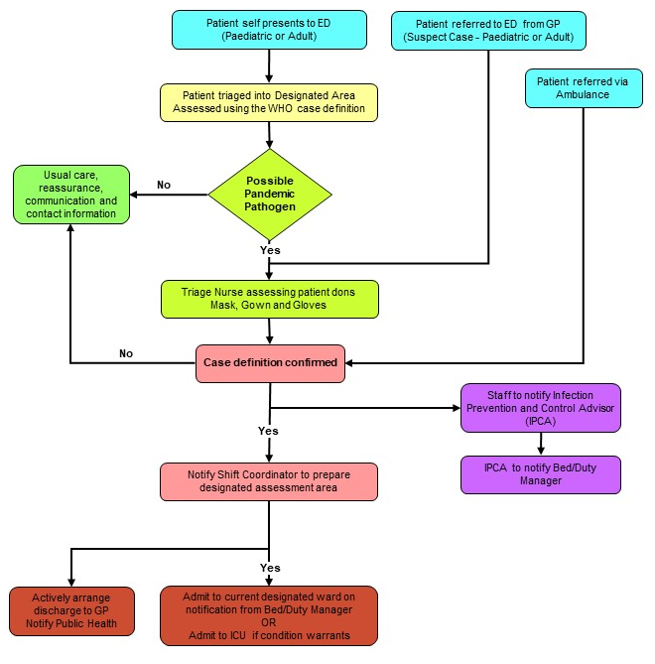
Section J
Influenza

CASE DEFINITION

Suspected case of Pandemic Influenza
Person with an influenza like illness of abrupt onset, characterised by:
  - History of fever, chills and sweating; or
  - Clinically documented temperature ≥38˚C ; and
  - Cough or sore throat

Probable case of Pandemic Influenza
Person with an influenza like illness who has a strong epidemiological link to a confirmed case or defined cluster.
Confirmed case
An individual for whom laboratory testing demonstrates one or more of the following:
      - positive viral culture for Pandemic Influenza; or
      - positive RT-PCR for Pandemic Influenza; or
      - four-fold rise in novel influenza virus specific neutralising antibodies.

CHECKLIST – INFLUENZA PANDEMIC STRAIN

Complete the following checklist at first contact with patient, i.e. in triage room or over the telephone.

May 2023

Yes/No
1. |  | History of fever, chills, myalgia or clinically documented fever > 38⁰C
2. |  | PLUS, two or more of the following
 |  | Headache

Malaise

Cough

Sore throat

Patients with both 1 and 2 meet the definition of influenza-like illness.
Patient Care Clinical Pathway
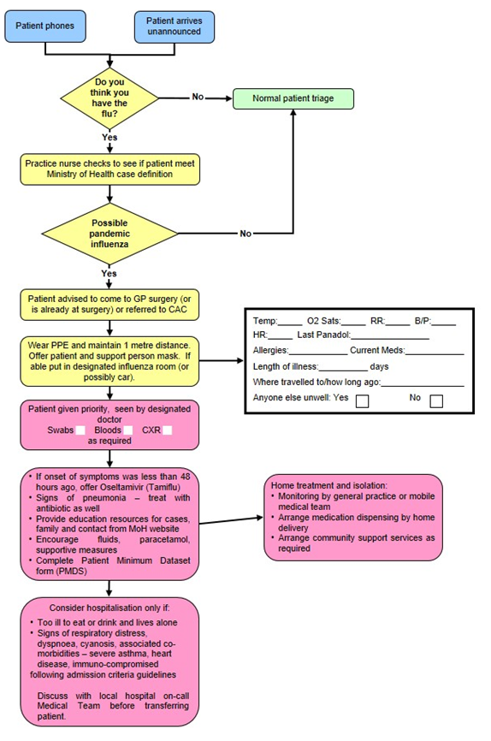

 | Pandemic Minimum  Data Set

Name of Practice: | Date:
Clinical Assessor: | Signature:

Name: Given | Middle | Family
Address:
House Number:
Street:
Suburb:
Town:

Gender: M / F | DOB: |  | NHI:
Ethnicity: | European | Maori | Pacific | Other

Please Circle Appropriate Codes
Category Codes |  |  | Antiviral Status Codes
GEN | General Public |  | TRT-T | Treatment provided – Tamiflu
HCN | Health Care Nurse |  | TRT-R | Treatment provided – Relenza
HCD | Health Care Doctor |  | OWN-T | Antiviral treatment from own supply - Tamiflu
HPA | Health Care Ambulance |  | OWN-R | Antiviral treatment from own supply - Relenza
HCO | Health Care Other Direct Contact |  | POP-T | Post exposure prophylaxis with Tamiflu
BOR | Border Worker |  | POP-R | Post exposure prophylaxis with Relenza
POL | Police |  | Antibiotic Codes
DEF | NZDF Member |  | NIL | No antibiotics provided
COR | Corrections Worker |  | TRT | Antibiotic treatment provided – evidence of existing respiratory bacterial infection
FIR | Fire Service Worker |  | PRO | Prophylactic/precautionary antibiotics provided because of unusual vulnerability to bacterial infection (e.g. person with COPD, CHF, asthma or other condition)
SOC | Civilian Social Support Worker |  | Antibiotic Prescribed
Treatment Rationale Codes |  |  | AUG | Augmentin
ILI | Severe influenza-like illness |  | COT | Co-Trimoxazole
HRG | High risk group |  | DOX | Doxycycline
HRI | High risk institution – MUST be discussed with the Medical Officer of Health |  | FLU | Flucloxacillin

Management of Patient with Influenza-Like Illness

Influenza-like Illness (ILI)

History of fever, chills, myalgia or clinically documented fever ≥ 38°C
Plus two or more of the following
Cough, sore throat, headache, malaise
High Risk Groups
People with influenza-like Illness who are at high risk of influenza-related complications:
People who are immune compromised or suppressed (transplantation, haematological and solid organ malignancy on chemotherapy/radiotherapy, HIV, autoimmune disorders, etc)
Pregnant women – discuss with infectious diseases physician
Mental health patients on Clozapine
Anyone over six months of age with chronic medical conditions, such as:
Severe or poorly controlled congestive heart failure
Severe chronic respiratory disease
More severe asthmatics (e.g. people on oral steroids, high dose steroid inhalers, or steroids and long acting beta-agonists)
Renal replacement therapy

People with influenza-like illness who live or work in residential institutions, (e.g. prisons, boarding schools, nursing homes). Please discuss with Medical Officer of Health ph: 8341815.

Does this person meet clinical criteria for Severe ILI?
SIRS Criteria
Clinical Criteria for Severe ILI
More than one of the following:
Temperature ≥ 38°C
Heart Rate > 90
Respiratory Rate >20

Is patient in a high risk group?
Self manage at home

Do not prescribe Tamiflu or antibiotics
Consider Tamiflu
Fax prescription(s) to authorised pharmacy
Instruct patient or relative to collect Tamiflu
Advise to stay in isolation until well

Consider hospital assessment if patient has any of the following:
T > 39°C
SBP < 100
HR > 110
RR > 25
Sats < 92
Vomiting > 1 in 24 hrs
Confusion
Rigors
Pleuritic Chest Pain
Inability to self care
Dehydration

These criteria are not prescriptive and cannot replace clinical judgement
Yes
Nopo
Yes
No

USE OF ANTIVIRALS

Influenza viruses develop significant resistance quickly for M2 channel blockers. In New Zealand, zanamivir is for ‘in hospital’ treatment and prophylaxis of influenza in hospitalised patients subject to restriction. Therefore, only oseltamivir (Tamiflu) will be described in detail.

First line health care workers will be using antivirals from the Governments stockpile, because the antiviral medication will be in short supply when the pandemic strikes. The MoH (directly or through Medical Officers of Health) will be communicating guidelines, protocols, and priorities for its use.

Tamiflu might be used prophylactically for exposed travellers, containment of sporadic clusters, essential services staff and therapeutically for all patients (initially), high-risk patients, essential services staff.

Tamiflu is indicated for the treatment of influenza in adults and children 2 weeks of age and older who have been symptomatic for no more than 2 days (see section 4.4 Special warnings and precautions for use).
https://www.medsafe.govt.nz/profs/Datasheet/t/Tamiflucapsusp.pdf

Tamiflu is indicated for the prophylaxis of influenza in adults and children >1 years of age. Vaccination is the preferred method of routine prophylaxis against infection with influenza virus.

Presentation

Tamiflu 30 mg hard capsules
Tamiflu 45 mg hard capsules
Tamiflu 75 mg hard capsules

Tamiflu 6mg/ml powder for oral suspension

Dosage and Method of Administration

Tamiflu may be taken with or without food. However, Tamiflu taken with food may enhance tolerability in some patients.

Standard Dosage

Treatment of influenza

Treatment should begin within the first 48 hours of the onset of symptoms of influenza.

Adults and adolescents
The recommended oral dose of Tamiflu capsules in adults and adolescents ≥ 13 years is a 75mg capsule twice daily, for 5 days. Adults and adolescents ≥ 13 years of age that are unable to swallow capsules may receive a dose of 75mg Tamiflu suspension BD for 5 days.

Infants and Children ≥1 to < 13 years of age
Infants and children 1 year old may receive the required Tamiflu dose in the form of capsules. Patients unable to swallow capsules may receive the appropriate dose of Tamiflu oral suspension, (see patients unable to swallow capsules).
The recommended weight adjusted dosing regimens of Tamiflu for children ≥ 1 year of age are:

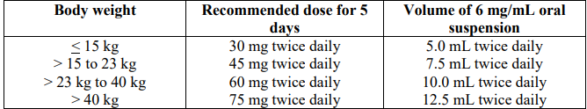

Infants 2 weeks to < 1 year of age.
The recommended oral dose of Tamiflu for infants 2 weeks to less than 1 year of age is 3 mg/kg twice daily, for 5 days. These dosing recommendations are not intended for infants who have a post conceptual age of less than 36 weeks.

Special dosage instructions:
No dose adjustment is necessary for patients with creatinine clearance above 60mL/minute. In patients with creatinine clearance between 10 and 30mL/minute receiving Tamiflu it is recommended that the dose be reduced to 75mg of Tamiflu every other day or 30mg suspension every day. No dosing recommendation is available for patients undergoing routine haemodialysis and continuous peritoneal dialysis with end stage renal disease and for patients with creatinine clearance ≤ 10mL/minute.

No dose adjustment is required for patients with hepatic dysfunction and no dose adjustment is required for elderly patients.

The safety and efficacy of Tamiflu in children under 1 year has not been established. Tamiflu should not be used in children under 1 year of age.

A bottle of 30g Tamiflu powder for oral suspension contains 25.713g of sorbitol. One dose of 45mg oseltamivir administered twice daily delivers 2.6g of sorbitol. For subjects with hereditary fructose intolerance this is above the recommended daily maximum limit of sorbitol.

Prophylaxis of influenza

The recommended oral dose of Tamiflu for prophylaxis of influenza is 75mg once daily for at least 10 days. Therapy should begin within 48 hours of exposure.

Contraindications

Hypersensitivity to oseltamivir phosphate or any component of the product.

Information derived from pharmacology and pharmacokinetic studies of oseltamivir suggest that clinically significant interactions with other medicines are unlikely.

At present, insufficient data are available in pregnant women taking Tamiflu to enable an evaluation of the potential for oseltamivir cause foetal malformations or foetal toxicity. Tamiflu should therefore be used during pregnancy only if the potential benefit justifies the potential risk to the foetus.

https://www.medsafe.govt.nz/profs/Datasheet/t/Tamiflucapsusp.pdf

INFORMATION ON TAMIFLU

How effective is the anti-viral medicine Tamiflu against influenza?

Tamiflu is one of two medicines that are effective against the strains of Influenza A and B.

The WHO have advised all health authorities to stockpile anti-viral medicines to prepare for a pandemic. New Zealand has followed that advice.

Will Tamiflu cure people sick with the Pandemic Influenza virus?

We don't know for sure.

When people have seasonal influenza, Tamiflu reduces symptoms and may shorten the duration of illness by a day and a half.

If otherwise healthy people who are ill with influenza take it, they are less likely to develop complications of influenza. Those complications are usually treated with antibiotics.

Does Tamiflu prevent people from getting influenza?

Yes, it does, but it is not the best means of preventing influenza. Vaccination is the best protection against influenza, which is why people are encouraged to immunise against seasonal influenza every year. Tamiflu will help until a pandemic vaccine arrives.

For more information on Tamiflu, including how it works against influenza, see the datasheet, http://www.medsafe.govt.nz/profs/datasheet/+/Tamiflucapsusp.pdf.

How does Tamiflu work?

It is a medicine that only works against influenza viruses A and B.

It does not work against other viruses or bacteria that can cause illness similar to influenza or that can cause respiratory infection. If taken within 48 hours of becoming ill it stops the virus from bursting out of infected cells, infecting new cells and possibly other people.

Will masks help protect me and my family from the influenza virus?

A surgical mask, if put on someone who is sick, will help reduce the spread of infection, because it will reduce the amount of virus spread by coughs and sneezes.

People who are not sick and who are very close to the person who is coughing and sneezing - closer than 1 metre - may get some protection by covering their own nose and mouth with a mask. Again, this is because the mask will catch some of the virus in the cough and sneeze droplets.

What about interactions between Tamiflu and other drugs I am taking?

There are no significant interactions known.

Side effects
Most people taking Tamiflu experience no side effects. A small proportion will experience one or more of the following:

Common | Less commonly
Nausea 8-10%  Vomiting 2-8%  Headache 2-17%  Diarrhoea  Abdominal pain 1-4 %  Dyspepsia  Conjunctivitis | Eczema  Rash  Convulsions  Arrhythmias  Altered consciousness  (usually in children or adolescents)

Information on Quarantine (Home Isolation) for Influenza

You have been asked to stay in isolation because:

- You have suspected influenza and are infectious to others. Isolation in your home should continue for 72 hours after starting Tamiflu or 7 days from the onset of illness if you are not taking Tamiflu.

- You may have been exposed to influenza. Isolation in your home should continue for 72 hours after starting Tamiflu or 7 days from the onset of illness if you are not taking Tamiflu.

The period of isolation may be lengthened if somebody else in your household becomes sick with suspected influenza.

We want you to restrict your activities to protect the safety of your family, friends and the community. This information sheet is to tell you what isolation means.

Staying at Home

You must not go to school, work, child care or out in public until cleared by the Public Health Nurse. This means you must not attend shopping centers, movies, parties or any social gatherings at all.

Visitors

You should have no visitors until you come out of isolation. Talk by phone and have things delivered to the door. Sometimes a visitor is essential (for example someone has to come into the house to give you essential home support). The visit should be brief. You and the visitor must both wear a mask. Talk with the visitor outside in the open air if possible and keep at least two metres away from them.

Preventing the spread of infection

- Stay in a part of the house where you have minimal contact with other people. Try to keep well people and sick people apart.
- Give people who have a fever and/or diarrhoea plenty to drink.
- Give Paracetamol for fever. Do not give Aspirin to children under 12 if they have a fever.
- Open doors and windows and ventilate the house as much as possible.
- Cover your mouth and nose with a tissue or toilet paper when you are coughing or sneezing. Put the used tissue straight into a rubbish container. Wash and dry your hands afterwards.
- Wash and dry your hands after you use the bathroom or toilet. Wash and dry your hands before you prepare food and eat, and when you are looking after sick people.
- If you have more than one toilet, then one should be reserved for use by sick people.
- Twice a day clean the following:
- toilet handle and door handles of toilet, bathroom and rooms of isolated people
- bathroom sink and taps
Use 1 part household bleach to 10 parts water.
- Nobody else should use anything that could be contaminated with your throat or nose secretions or coughing or faeces – e.g. towels, handkerchiefs, eating utensils, food, bed linen, cigarettes, marijuana joints, P pipes, kava bowls.
- Sharing bedding, clothing and utensils may spread infection, but you do not need to wash a sick person’s bedding, clothing and utensils separately from the rest of the family's. If you wash and dry all these things in the usual way they will then be safe for others to use.

Using face masks

The Public Health Nurse will show you how to wear a mask.
- Sick people should wear a surgical mask if anyone is in their room and if they have to leave their room.
- People who are in quarantine but not sick should wear a surgical mask if they are in the same room as a sick person.
- Essential visitors to the house should wear a particulate respirator (PFR95) mask through their visit.

Used masks should be put in the normal household rubbish.

Coming out of isolation

The Public Health Nurse or your doctor will tell you when you are cleared to come out of isolation. At that time you will be non-infectious to others. It will then be safe for you to resume your normal life.

Questions

Your Public Health Nurse will be happy to answer any questions.

Section K
COVID-19

COVID-19, MINISTRY OF HEALTH CASE DEFINITION (2022)

Confirmed case

A case that has laboratory definitive evidence.
Laboratory definitive evidence requires at least one of the following:
- detection of SARS-CoV-2 from a clinical specimen using a validated NAAT (PCR), very weak positive results will only be labelled a confirmed case when the result is confirmed on a second sample
- detection of coronavirus from a clinical specimen using pan-coronavirus NAAT (PCR) and confirmation as SARS-CoV-2 by sequencing
- significant rise in IgG antibody level to SARS-CoV-2 between paired sera
- detection of SARS-CoV-2 from a clinical specimen using a validated laboratory multi-target NAAT (PCR) OR a validated single target point of care NAAT (PCR) test

Probable case
A close contact of a confirmed case that has a high exposure history, meets the clinical criteria and for whom testing cannot be performed, or
A close contact of a confirmed case that has a high exposure history, meets the clinical criteria, and has a negative PCR result but it has been more than 7 days since symptom onset before their first negative PCR test was taken.
An individual with a positive result from a clinical specimen using a certified rapid antigen test (RAT), either supervised or self-tested who:
- Has symptoms consistent with COVID-19 OR
- Is a close contact of a confirmed or positive case OR
- Is asymptomatic (in phase 3 only)

Historical case

A confirmed case that is deemed to have recovered (no longer considered infectious) at the time of testing or a person with a positive NAAT(PCR) result with a high CT value, which is followed by a negative rapid antigen test (RAT).

Under investigation

A case that has been notified where information is not yet available to classify it as confirmed, probable or not a case.

Not a case

An ‘under investigation’ case who:
- has a negative test and has been assessed as not a case;
- a person where SARS-CoV-2 has been detected, where the detection is determined to be due to a previous COVID-19 infection which has already been recorded either in New Zealand or overseas within the previous 28 days from release.
- a person who has detection of SARS-CoV-2 from a clinical specimen but, following further investigations such as serology, repeat testing, history, and symptoms, they are deemed to not be a case (e.g. a likely false positive).

CLINICAL CRITERIA FOR COVID-19

The clinical criteria support health professionals to identify those with a higher risk of having COVID-19.

Common symptoms of COVID-19 infection are similar to other viral illnesses such as colds and influenza.

COVID-19 positive persons usually present with at least one of the following symptoms:

- new or worsening cough
- sneezing or runny nose
- fever
- temporary loss of smell or altered sense of taste
- sore throat
- shortness of breath
- fatigue/feeling of tiredness

Lesser common symptoms may include diarrhoea, headache, muscle aches, nausea, vomiting, malaise, chest pain, abdominal pain, joint pain or confusion/irritability.

Symptoms tend to arise around two to five days after a person has been infected but can take up to 14 days to show. The virus can be passed to others before they know they have it from up to two days before symptoms develop.

Other conditions that require urgent assessment and management should always be considered as possible diagnoses alongside COVID-19.

https://www.health.govt.nz/system/files/documents/pages/primary_care_quick_reference_guide_june_2022.pdf

HB COVID-19 PANDEMIC DATA SET (as at September 2022)

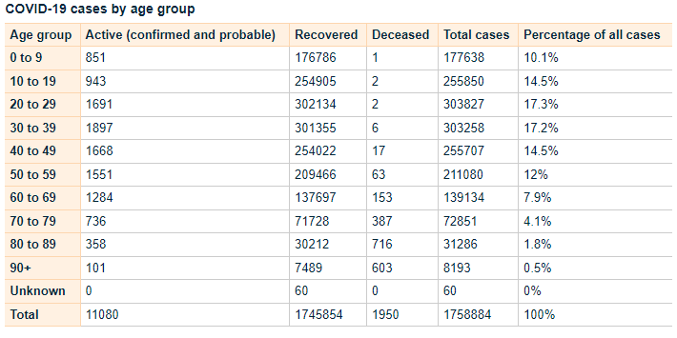
https://www.health.govt.nz/covid-19-novel-coronavirus/covid-19-data-and-statistics/covid-19-case-demographics#all-cases

Testing Guidance COVID-19

https://www.health.govt.nz/system/files/documents/pages/testing_operational_guidance_for_general_practice_10_march_2022.pdf

COVID-19 Care in the Community Framework (2022)

https://www.health.govt.nz/system/files/documents/pages/covid-19-care_in-the-community-framework-25aug22.pdf

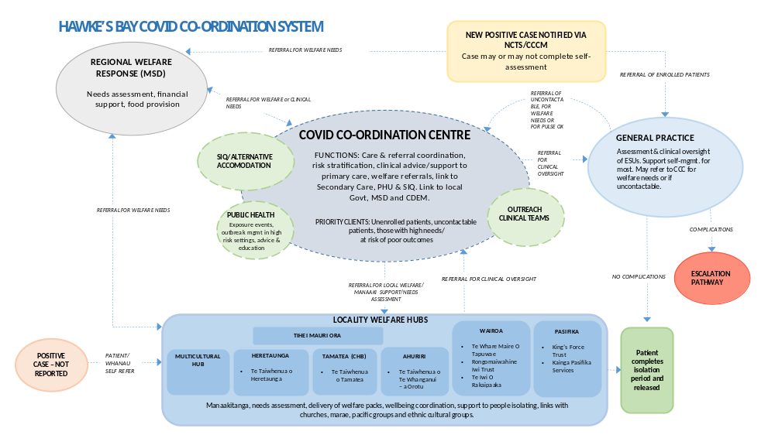
Patient Management Pathway

Assessment and Definition | Severity | Mild |  | Moderate |  | Severe/Critical
Assessment and Definition | Clinical definition | No symptoms | Any COVID symptoms without features of pneumonitis | A clinically stable patient with any evidence of COVID-19 pneumonitis:  - New onset (or worsening) shortness of breath OR  - Infiltrates on plain chest radiograph OR  - Hypoxaemia that is EITHER: |  | Any of the following:  - Requiring CPAP or high-flow nasal oxygen to maintain saturation ≥ 92% OR  - Acute respiratory distress e.g. RR >30 OR  - Rapidly deteriorating clinical trajectory | Any of the following:  - Requiring mechanical ventilation to maintain saturation ≥ 92% OR  - Requiring advanced circulatory support
 |  |  |  | ...mild (92-94%), transient, or exercise-induced only (i.e. not requiring continuous oxygen therapy OR | …sustained but able to maintain ≥ 92% (≥90% for patients with chronic lung disease) with up to 4L/minutes oxygen via nasal cannula
Assessment and Definition | Stage of infection | Almost all cases in the first 5 days; throughout in most vaccinated patients without risk factors |  | Progression to moderate/severe disease most commonly develops ~ 5-7 days post onset of illness in patients with significant risk factors; the trajectory of deterioration can sometimes be rapid
Assessment and Definition | Site of care | Community |  | Individual decision | Hospital
 | Anti-viral therapy | Paxlovid OR remdesivir OR molnupiravir  If <5 days illness AND meets high risk criteria |  |  | Consider remdesivir if <7days illness |  | Nil
Therapeutics | Respiratory support | Nil |  |  | Oxygen via NP | CPAP (or HFNO) | Mechanical ventilation
Therapeutics | VTE prophylaxis | Nil | Low dose enoxaparin  if hospitalised |  | Low dose enoxaparin  (or consider therapeutic dose) | Low dose enoxaparin
Therapeutics | Corticosteroids | Nil | Consider inhaled budesonide  if meets high risk criteria |  | Dexamethasone
Therapeutics | Immune modulation | Nil |  |  | Baricitinib or Tocilizumab |  | Tocilizumab
 | Antibody therapy | Nil

ANTIVIRAL THERAPY

Taking antiviral medicines to treat COVID-19

COVID-19 antiviral medicines are available to treat eligible people with COVID-19 at home. COVID-19 medicines must be commenced within the first five days of COVID-19 symptoms. When taken early in COVID-19 illness, these medicines have been proven to reduce hospitalisation and death.

These medicines are free for eligible people with COVID-19 within five days of their symptoms starting. If eligible, persons may get a prescription from their usual healthcare provider, or the medicine may be supplied without a prescription from some pharmacies.

Eligibility for COVID-19 medicines

People with a high risk of severe illness from COVID-19 are eligible for treatment with COVID-19 medicines.

To be eligible for COVID-19 antiviral medication the consumer must:
- have symptoms and have tested positive for COVID-19 or
- have symptoms and be a household contact of a person with COVID-19

One of the following must also apply:
- have a severely weakened immune system
- have Down syndrome
- have sickle cell disease
- are aged 75 years or older
- have previously been admitted to an intensive care unit as a result of COVID-19 and have tested positive again

Persons may also be eligible if they meet two or more of the below criteria:
- have high-risk medical conditions
- are over 50 years of age
- are of Māori or Pacific Island ethnicity
- have not been vaccinated for COVID-19, or are not up to date with your COVID-19 vaccinations

Please note: These medicines may not be suitable for everyone, even if they meet eligibility criteria.
More information about eligibility can be found on the Pharmac website, including its access criteria assessment tool.
Te Whatu Ora has developed an eligibility guide for COVID-19 antiviral medicines:

https://www.health.govt.nz/system/files/documents/pages/eligibility-guide-for-covid-19-oral-antiviral-meds-12aug22.pdf

Available COVID-19 medicines

Three COVID-19 antiviral medicines are available to treat eligible people with COVID-19 in the community:

nirmatrelvir with ritonavir (branded as Paxlovid)
molnupiravir (branded as Lagevrio)
remdesivir, an infusion treatment (branded as Veklury).

For more information please see the following links:

Paxlovid
https://www.healthnavigator.org.nz/paxlovid/
https://www.medsafe.govt.nz/profs/Datasheet/p/paxlovidtab.pdf

Lagevrio
https://www.healthnavigator.org.nz/medicines/m/molnupiravir/
https://www.medsafe.govt.nz/profs/datasheet/l/lagevirocap.pdf

Remdesivir
https://www.healthnavigator.org.nz/medicines/r/remdesivir/
https://www.medsafe.govt.nz/COVID-19/treatment-applications.asp

https://www.health.govt.nz/covid-19-novel-coronavirus/covid-19-health-advice-public/advice-people-covid-19/covid-19-medicines

Return of Symptoms Following Paxlovid Treatment

For some people, symptoms may return after completing a course of Paxlovid. This is known as Paxlovid rebound.

People experiencing Paxlovid rebound do not appear to get severely ill. Symptoms are usually mild and typically resolve within three days.

It is normal for some people recovering from COVID-19 to have symptoms that come and go for some time, regardless of whether they have taken antiviral medicines.

Patients should stay home and recover until 24 hours after they no longer have symptoms if:
- their symptoms returned after finishing the five-day course of Paxlovid,
- and it’s 28 days or less since their first symptoms appeared or they tested positive

There is no need to take another course of Paxlovid if symptoms return during this time.

COVID-19 VARIANTS OF CONCERN

There is a high likelihood that a new COVID-19 Variant of Concern will emerge within weeks or months. The timeframe and clinical impacts of these variants is not clear, but it is important that we prepare for new, more severe variants that could emerge.

On 30 March 2022, the World Health Organization (WHO) released its Strategic Preparedness, Readiness and Response Plan to End the Global COVID-19 Emergency in 2022. It sets out key strategic adjustments that, if implemented rapidly and consistently at national, regional, and global levels, will enable the world to end the acute phase of the pandemic.

The capacity and adjustments necessary to end the acute phase of the COVID-19 pandemic can and should lay the foundations for a future in which the world is prepared to prevent, detect, and respond to pandemic threats.

To support Government preparedness and response efforts, the Ministry of Health (the Ministry) has developed Aotearoa New Zealand’s Strategic Framework for COVID-19 Variants of Concern (the Strategic Framework), which builds on the plans and enabling systems that have held the Ministry in good stead over the last two years. It identifies the contextual factors, range of indicators, and baseline and response measures required to ensure that we are prepared to respond to the emergence of a new variant of concern

Variant Scenarios

Five scenarios have been developed to inform the potential range of responses that may be required. There may be particular viral characteristics that may change, and any decisions are likely to be made before a detailed evidence base is formed.

The scenarios are based on evidence on the likely characteristics of new variants and their characteristics, including research into similar scenarios that other countries have used, and have been externally reviewed by the COVID-19 Technical Advisory Group and the Strategic Public Health Advisory Group. They have also been considered by the COVID-19 Independent Continuous Review, Improvement and Advice Group as part of engagement.

The scenarios range from high clinical severity and high immune escape to low clinical severity and low immune escape, and a scenario that includes co-circulating diseases. All scenarios assume a variant that is able to out-compete Omicron BA2 because it is more transmissible.

The variant scenarios are:

- High clinical severity, high immune evasion: similar to Omicron but with greater severity. Therapeutics, vaccines and/or prior infection may not work or protect well.
- Low clinical severity high immune evasion: similar to Omicron. Therapeutics and vaccines may not be effective at controlling spread or symptoms, but hospitalisation rates remain manageable.
- High clinical severity, low immune evasion: the virus is highly transmissible with high case numbers, but current effective immunity and vaccination is protective for most.
- Low clinical severity, low immune evasion: the virus has enough transmissibility to create a high case load, but current effective immunity is protective and what disease there is, is milder than experienced in previous waves. Effective treatments are available for vulnerable populations.
- Multiple co-circulating variants of concern with different levels of virulence and severity and different levels of cross-protection, as we see with influenza. This scenario potentially draws features from the other scenarios.

For reference, all the hypothetical scenarios are compared to the current Omicron planning scenario. For further information please click on the following link.

https://www.health.govt.nz/system/files/documents/pages/220601_final_summary_of_voc_sf_for_cabinet_paper_21_june.pdf

STAYING AT HOME, PATIENT INFORMATION

If you have been advised to stay at home after a test, you should do so until you receive a negative test result.

If someone in your household or bubble is a Close Contact and they develop symptoms, it is recommended that you (regardless of whether you are vaccinated or unvaccinated) stay at home until the Close Contact returns a negative test (taken after their symptoms started).

If you develop symptoms, you should get a test and stay at home (or in your current accommodation) until you receive a negative test result and until 24 hours after your symptoms resolve.

What it means to stay at home:

- If you have symptoms, stay away from your household members if possible.
- You should not go to work or school. If you are unable to work from home while awaiting COVID-19 test results, a short-term payment may be available to your employer (or you, if you are self-employed) to help support you. For more information visit the Work and Income website.
- It is important that you do not use public transport, taxis or similar transport methods.
- You should not have any visitors in your home (including tradespeople).
- Where possible, ask friends or family to shop for you. If this isn’t possible, order supplies online. Make sure any deliveries are left outside your home for you to collect. If you need assistance, the Ministry of Social Development has information about where you can go for services and support, what you can get help with, and contact information. Visit the Ministry of Social Development website.
- If you need medical assistance, call ahead to your health provider. Clean your hands with hand sanitiser and put on a face mask before you enter any health care facility.

https://www.health.govt.nz/covid-19-novel-coronavirus/covid-19-health-advice-public/covid-19-staying-home

POST COVID CONDITON -LONG COVID

Some people feel they do not fully recover or regain their previous health following infection from COVID-19. The World Health Organisation (March, 2021) published some UK national research on COVID-19 that indicated.

- 1 in 10 respondents testing positive for COVID-19 may exhibit symptoms for a period of 12 weeks or longer
- studies indicated around a third of people testing positive for SARS-CoV-2 had not returned to their usual state of health when interviewed 3-6 weeks post diagnosis
- Up to 30% of COVID-19 patients surveyed still had persistent symptoms after nine months. The majority of these (85% were outpatients with mild illness).

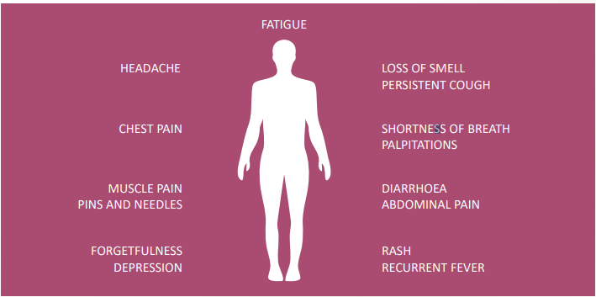
This is not an exhaustive list; other symptoms are reported.

file:///G:/Downloads/Update54_clinical_long_term_effects.pdf

Other Coronavirus infections such as SARS, MERS found significant impairment of exercise capacity and health status in survivors of SARS over 24 months. Another study revealed that 40% of people recovering from SARS still had chronic fatigue symptoms 3.5 years after being diagnosed.

More research is needed to examine the long-term consequences of COVID-19.

COVID-19 can result in prolonged illness, even in young adults and children without underlying chronic medical conditions. Much is still unknown about how COVID-19 affects people over time and more research and multi-year studies are needed to understand:
- long-term effects of COVID-19
- why symptoms persist or recur
- how these health problems affect patients
- clinical course and likelihood of full recovery
- implication of long-term health effects on return to work
- how protective measures continue to be important in preventing COVID-19

Long COVID patients internationally have voiced the need to be heard and have their symptoms acknowledged and treated as real. The qualitative evidence suggests not doing so can have long term mental health implications.
Section L

HEALTH SERVICE GUIDELINES

ICU RESPONSE

Phase 4 – Ready
- Notify staff and prepare rosters
- Assess adequacy of beds and ventilation equipment
- Develop contingency plans for increasing resources as required
- Ensure training plan initiated

Phase 5 – Steady
- Increase monitoring of infection prevention and control practices
- Initiate upskilling workshops to provide additional staff to manage expected workload
- Communicate with alternate facilities to determine bed availability including Perioperative Unit Manager
- Monitor staff availability

Phase 6 – Go
- Complete and action Unit Operational Plan
- Patients to be admitted initially to the isolation rooms, then the paediatric room
- On impending admission of third infected patient:
  - ICU closed to non infected patients
  - Non infected patients transferred to temporary ICU facility in PACU
  - Rosters written for dedicated infectious unit and intensive care facility as separate entities
  - Retrieve portable blood gas analyser from the Laboratory
- Initiate supply monitoring and control
- Initiate staff support systems

Management in ICU:

Staff Precautions

Hand hygiene and use of Standard Precautions are the most important hygiene measure in preventing the spread of infections.

In addition staff must:

- Use Droplet Precautions when in close contact (<1 metre) with cases.
- Wear protective clothing (mask, gown gloves).
- Ensure correct disposal of PPE and decontamination of shoes between patient cares.
- Ensure correct disposal of contaminated items into Biohazard waste bags and linen bags.
- Collection of linen, rubbish and used patient items should be grouped to minimise movement in and out of the unit.
- Horizontal surfaces should be cleaned daily with sodium hypochlorite 100mL to 1L (1:10 dilution).
- Doors and windows must be kept closed and secured at all times in areas used for patients with influenza-related illness except when required by entry or exit of personnel.
- A laminated “STOP” isolation sign must be placed on the door or where it will be visible to all who enter the area.
- Hand hygiene is the most important hygiene measure for preventing the spread of infection. Gloves are not a substitute for hand hygiene. Hand hygiene must be performed and gloves replaced before and after significant contact with the patient, after activities involving handling of contaminated items and after removal of gloves.
- All staff must put on mask, gown and gloves as instructed before entering the designated area.
- On leaving the designated area, staff should remove gown, gloves and mask (in that order, masks should be handled only by strings).
- Single use items must be placed into a yellow Biohazard waste bag.

Staff Allocation

- The primary focus must be appropriate, skilled response to the clinical needs of the patient
- The nurses allocated to direct patient care on each shift are responsible for directing other health care workers on the nature of the precautions required.
- Whenever possible, care is provided by nurses/staff usually working in the unit.
- If care cannot be provided from within the unit, the nurse in charge contacts the Unit Manager (CNM) or deputy or the after hours Duty Manager for assistance.
- Instruction in wearing and removing protective clothing must be given to staff members.

Equipment and Supplies

- A range of sizes of non-sterile gloves must be available inside and at the entrance to the designated area. Gloves must be changed as clinically indicated and removed and disposed of in the Biohazard waste each time personnel leave the area or have contact with contaminated items.
- Disposable gowns are to be worn by healthcare workers assisting with patient cares. Gowns are single use items and must not be kept for reuse – they must be removed and disposed of in the Biohazard waste when personnel leave the area and a new gown must be worn for re-entry.
- Masks must be worn to prevent droplet inhalation.
Masks must be used by the patient to prevent dispersal of respiratory droplets if the patient must leave the area.
These masks are single use items and must be removed and disposed of in the Biohazard waste each time staff leave the area and a new mask must be worn for re-entry.
- Equipment and supplies necessary for patient treatment, safety and comfort must be available in the area but storage of supplies and equipment within the room must be kept to a minimum and be replenished daily if necessary.
- All non-disposable equipment (e.g. blood pressure cuffs, stethoscopes, tympanic membrane thermometers and including mobile units such as X-ray machines, IV pumps etc) that is taken into the room must be decontaminated after removal from the area and before it may be reused in the care of other patients. Items will require cleaning by surface wiping with an environmental wipe followed by sodium hypochlorite 100mL to 1L of water. Disinfection and sterilisation processes should be used for items normally reprocessed by these methods.
- Metal surgical instruments requiring sterilisation in the Sterile Services Department (SSD) can be placed in a clear plastic bag, the opening secured and then returned in the usual container to SSD for routine decontamination.
- A designated sharps container must be available in the area plus phlebotomy equipment if required (tourniquet, vacutainer collection system, disposal unit for vacutainer needles, etc).
- Wash bowls, bedpans and urinals should be emptied and reprocessed immediately after use by the usual method in unit sanitisers.

Specific Patient Management Considerations:

- If intubation and assisted mechanical ventilation is required, a closed suction system must be incorporated into the ventilation circuit and scavenging should be provided by the vacuum wall suction.
- A scavenging Bassoon is to be used on all ventilators.
- The unit scavenging pump can provide sufficient scavenging for only four ventilators at one time.
- HMEF will be used on all patients’ circuits (not F&P humidifiers).

Environmental Management:

Food Service

- Disposable dishes and utensils may be used. Menus should be phoned through.
- After use, waste food should be disposed of within the ward in plastic rubbish bags. Disposable items should be discarded into Biohazard waste bags. Staff in this area routinely wear protective clothing and the usual machine dishwashing process is adequate to decontaminate the trays and utensils.

Linen and Waste Handling

- A linen skip with a lid or cover and a Biohazard waste bag must be kept in the area.
- A sharps container must be kept in the area.
- All waste (except sharps which must go into the sharps container) produced in the area must go into the Biohazard waste bag.
- Change the bed linen completely each morning shift and carefully scoop and fold used linen to place it in the linen skip. Care should be taken not to shake or flap the bed linen.
- Linen and waste bags are to be replaced at least daily and when two thirds full.
- Nursing staff are responsible for the closure and replacement of bags. Double bagging and labelling are not required.
- Orderlies must collect linen and waste from the area at least once a day.

Daily Cleaning

Equipment needed:
Hypochlorite solution
Neutral detergent
Disposable pink cleaning cloths
Microfibre mops and mop heads

- Clean area with an approved detergent followed by sodium hypochlorite 100mL in 1L water (1:10).
- The room and ensuite, (including door handles, taps, toilet seat) must be cleaned in the usual manner. Cleaning staff must wear an apron and gloves.
- All horizontal surfaces (locker tops, bed tables, overhead lights) and all surfaces touched by patients and staff (washbasins, taps, door handles, telephones, bed rails) must be cleaned with disposable cleaning cloths.
- The floor must be cleaned with microfiber mops.
- Place microfiber mop in plastic bag for laundering.

Terminal Cleaning (on patient discharge)

- Cleaning staff are responsible for the safe cleaning of the area (as above). Wearing protective clothing (mask, gown and gloves) and using sodium hypochlorite 1:10.
- Infection Prevention and Control advice must be sought for the decontamination of complex equipment.
- Disposable curtains must be taken down and put in yellow Biohazard bags. (If cloth curtains are used, these are taken down and placed in labeled linen bags with other linen).
- All waste and disposable equipment is placed in biohazard bags, secured and readied for collection.
- All non-disposable patient equipment (stethoscopes, telephones etc) should be cleaned with an environmental wipe followed by sodium hypochlorite 1:10 and left to dry.

VENTILATION SETUP

It is important that you read the entire contents of this set-up procedure before proceeding to Step One.

NOTE: It is preferable to set this up before the patient has arrived. If this is not possible then set up as much as possible outside the patient area before putting on full protective clothing (See step 8).

1. Turn ON scavenging, (switch on wall in HDU).
2. Select appropriate ventilator, place on scavenging bassoon and connect to ventilator.
3. Remove humidified circuit and humidifier from ventilator, and replace with appropriate (adult/paed) disposable anaesthesia circuit (minus the inbuilt filter), F & P filter at expiratory channel inlet, HME and extension distal to wye.

A method for ensuring there is no residual PEEP in the circuit when changing the circuits of HMEF.
Extension
Viral Filter
HME Syringe
Expiratory

Inspiratory

In-Line Suction Disposable Circuit

5. Connect two-way connector to CO₂ monitoring port on circuit. Make sure the clamps are on i.e. circuit is sealed.
6. Connect in line suction to circuit extension and connect to test bag to avoid circuit contamination. DO NOT use a swivel or bodai.
7. Gather together intubation drugs, intubation airway tray with appropriate ET tube and laryngoscope blade, disposable resuscitation bag, spare HME’s and extensions and along with the ventilator place outside patient area.
8. If the patient is already in the bed space, with the assistance of a “minder” dress in protective equipment, this includes gown or blue overalls, sterile surgical gloves and mask. (Remove all unnecessary items from your scrubs pockets first).
9. Connect ventilator, including scavenging, and leak test (this is important). Check settings and leave running for patient connection. (Ensure disposable Hamilton flow sensor tubing is used).
10. Connect resuscitation bag to oxygen supply.
11. Check suction for yankeur and patency.
12. Assist with intubation if required, taking care to avoid cross contamination of respiratory contaminates.
13. After ventilator connection, connect the suction tubing to the in-line suction. Connect the ventilator check bag to the resuscitation bag to avoid room contamination.
14. Leave all equipment used for intubation in the patient area.

On leaving the patient area, with the assistance of a “minder”, you must “disrobe” in the appropriate order (see card) to avoid contaminating yourself and others. Immediately shower and put on a new set of scrubs. Avoid other patients for as long as possible.

CLEANING PROCEDURES FOR VENTILATION EQUIPMENT

It is important to read the entire contents of this procedure before proceeding to Step One as some equipment, e.g. bucket and plastic bags, will need to be at hand.

NOTE: All procedures are to be performed at the patient’s bed space using full viral protective clothing. Equipment is not to be cleaned in other areas of the unit.

1. Turn the ventilator off, reduce the ventilator circuit pressure by attaching a leur lock syringe to the 2-way connector, and open the clamp. Disconnect the ventilator from the patient and cover the in-line suction.
2. Disconnect the ventilator O₂, air and power.
3. Keeping the entire circuit intact, disconnect from the ventilator at the inspiratory and expiratory ports of the ventilator and discard into the yellow biohazard bag.
4. Drain the scavenging system, then disconnect both from the ventilator and the roof outlet. Discard any disposable parts of the scavenging system into the Biohazard waste bag. Place the non-disposable bassoon into a large plastic bag and seal.
6. Dispose of resuscitation bag if disposable, if not then breakdown into components and place in container already filled with water to rinse. Remove from water and place in plastic bag.
7. Place all components for SSD into a clean bucket without touching the bucket.
8. Wipe down ventilator with an approved viral cleaning agent.
9. Discard protective clothing in the appropriate place and manner.
10. Seal the bucket with sleek and discreetly label, for removal to SSD. Notify SSD staff of the need for protective measures. The ICU Technician will be responsible for cleaning equipment that needs to be cleaned in the Endoscopy suite.

VENTILATION EQUIPMENT PROCEDURE CHANGES

Protective clothing should be worn. If these procedures are being performed by a technician, the technician should perform these tasks at the end of their working day, to avoid cross contamination of other patients.

Filter changes: There are two filters on the patient’s circuit:

1. A viral/bacterial filter at the expiratory channel inlet which needs to be changes every 24 hours or more often if needed i.e. wet and/or unexplained high minute volumes develop.

2. A viral/bacterial heat and moisture exchange filter at the patient end of the circuit which needs to be changed every 24 hours or more often if wet and/or unexplained high airway pressures develop.

Procedure for changing filters, extensions, and in-line suctions (every 24 hours):

Note: This is a two person procedure.

1. Attach a new HME, extension and in-line suction to the resuscitation bag, turn on resuscitation bag O₂.
2. Turn ventilator to 100% O₂.
3. Attach leur lock syringe to 2-way extension port. Leaving ventilator connected to patient, place ventilator in standby mode. Release 2-way extension port clamp and release excess pressure in the circuit.
4. Disconnect patient from circuit at ET tube, taking care to cover dirty in-line suction, and connect patient to resuscitation bag. Commence bagging.
5. Disconnect the dirty in-line suction, extension and HME in one piece from the patient circuit and dispose of in the yellow biohazard bag.
6. Replace the expiratory inlet viral filter with a clean viral only filter. Place the dirty filter in the Biohazard waste bag.
7. Reconnect the circuit to the clean in-line suction, extension and HME from the resuscitation bag, inject the syringe contents back into the circuit and close the clamp, then turn the ventilator on to the original patient settings. Check for adequate ventilation.
8. Turn off the resuscitation bag O₂ and connect to a new HME, extension, and test bag.

Procedure for changing filters only if needed:

1. Make sure replacement filter is at hand.
2. Turn ventilator O₂ to 100% for 2 minutes.
3. Attach leur lock syringe to 2-way extension port. Leaving ventilator connected to patient, place ventilator in standby mode. Release 2-way extension port clamp and release excess pressure in the circuit.
4. Change appropriate filter, inject the syringe contents, close the clamp and then turn the ventilator on to the original patient settings.
5. Dispose of the dirty filter into the Biohazard waste bag.

Circuit changes (every week or more often if needed):

NOTE: This is a two person procedure, preferably one to be a technician.

1. Attach a new HME, extension and in-line suction to the resuscitation bag, turn on resuscitation bag O₂.
2. Turn ventilator to 100% O₂ for 2 minutes.
3. Attach leur lock syringe to 2-way extension port. Leaving ventilator connected to patient, place ventilator in standby mode. Release 2-way extension port clamp and release excess pressure in the circuit.
4. Disconnect patient from circuit at ET tube, taking care to cover dirty in-line suction, and connect patient to resuscitation bag. Commence bagging.
5. Remove circuit, expiratory inlet filter, 2-way extension and place in a Biohazard waste bag.
6. Place clean circuit, expiratory inlet filter, 2-way extension on ventilator and perform a leak test. Place the ventilator back into standby mode.
7. Connect the clean circuit to the HME, extension and in-line suction from the resuscitation bag. Turn on the ventilator to the original patient settings, and check for adequate ventilation.
8. Turn off the resuscitation bag O₂ and connect to a new HME, extension, and test bag.

All protective clothing to be removed in the correct order, in the designated place.

PERIOPERATIVE UNIT RESPONSE

Phase 4 – Ready
- Notify staff and prepare rosters (survey staff availability)
- Ensure training plan initiated
- Assess adequacy of equipment and plan to increase supplies as required
- Review safe staffing plan

Phase 5 – Steady
- Postpone all non urgent elective surgery
- Increase monitoring of infection prevention and control practices
- Downscale activities to be deferred
- Prepare information for patients on elective surgery waiting lists regarding surgery delay
- Increase out-patient clinics to adequately prepare patients with complicated conditions
- Monitor staff availability
- Ensure PPE available in all designated areas
- Advise additional staffing sources of impending need for assistance

Phase 6 – Go
- Complete and action Unit Operational Plan
- Cancel all elective surgery and cease other activities to be deferred
- Resource one acute theatre with a second available on-call
- Utilize Kaweka and Royston Hospital facilities or staff in Perioperative Unit teams
- Redeploy staff as required
- Ensure at least one metre distance maintained between patients in PACU
- Initiate supply monitoring and control
- Initiate staff support systems
- Initiate four hourly updates to staff

Principles of Management:

- Protection for staff

In the case of a patient requiring emergency surgery the following precautions should be taken:

- Minimal staff to be allocated to the operating room.
- Training of staff re donning and removing mask and protective clothing.

The patient will be escorted to the Perioperative Unit by the nurse caring for them in the designated area. Transfer through to the theatre for surgery must occur without delay. On completion of surgery the patient should be recovered as usual using Contact and Droplet precautions.

A designated theatre suite should be nominated for use along with designated and trained nursing and anaesthetic staff. During the surgery all doors to the theatre must remain closed with no entry signs being placed on doors.

On completion of surgery all theatre staff must change their clothing, including scrubs.

Equipment

- As much anaesthetic equipment as practicable must be disposable.
- Non-disposable equipment requiring sterilisation must be covered and taken immediately through to the decontamination area of SSD.
- Expired gas flows must be filtered and scavenged, including side port sampling flows.
- Prior to commencement of surgery all non essential equipment should be removed from the theatre.

Terminal Cleaning

Protective clothing must be worn by the designated nurse while he/she is cleaning the theatre on completion of surgery.

All horizontal surfaces (including floors) are to be washed down with detergent and water followed by sodium hypochlorite 200mL to 1L of water (1:5).

All disposable equipment and supplies to be disposed of into a Biohazard waste bag.

All non disposable equipment must be washed with detergent and water followed by sodium hypochlorite 200mL to 1L of water (1:5). Equipment unable to be washed should be decontaminated in the usual way with Viracleans.

All linen to be placed into a linen bag.

WARD RESPONSE

Phase 4 – Ready
- Notify staff and prepare rosters (survey staff availability)
- Ensure training plan initiated
- Initiate proactive discharge planning
- Assess adequacy of equipment and plan to increase supplies as required
- Confirm cohort plan and bed management system
- Review safe staffing plan

Phase 5 – Steady
- Increase monitoring of infection prevention and control practices
- Downscale activities to be deferred
- Transfer in-patients out of designated cohort area
- Consider alternate use of discharge lounge and day rooms
- Monitor staff availability
- Prepare roster for Clinical Nurse/Service Manager 24 hour cover
- Ensure PPE available in all designated areas
- Advise additional staffing sources of impending need for assistance

Phase 6 – Go
- Complete and action Unit Operational Plan
- Cease activities to be deferred
- Initiate Clinical Nurse/Service Manager roster (In-patient Coordinator)
- Commence cohort plan
- Redeploy staff as required
- Initiate supply monitoring and control
- Initiate staff support systems
- Each area to report to In-patient Coordinator on a two hourly basis
- Utilise additional bed capacity in other areas of the hospital and other agencies
- Initiate four hourly updates to staff in all areas

Patient Management

Shift Co-ordinator

On notification of admission of a patient with an influenza-related illness by the Bed Manager:
- Ensures availability of designated nurse

Designated Nurse

- Ensure that the area to be used is made ready.
- Remove all non essential equipment (extra bathroom equipment, gloves etc).
- Check supplies of PPE.
- Prepare to receive patient.

The dedicated nurse is responsible for ensuring that all individuals entering the area comply with infection control precautions.

NB: Access to the isolation area is strictly limited and monitored.

Note: A log book for all staff entering the isolation area should be kept for follow up as required.

Staff Precautions

Hand hygiene and use of Standard Precautions are the most important hygiene measures in preventing the spread of infections.

In addition staff must:

- Use Contact and Droplet Precautions when in close contact with probable cases.
- Wear protective clothing (mask, impermeable gown, gloves).
- Ensure correct disposal and decontamination of protective clothing at the end of each shift.
- Ensure correct disposal of contaminated items into Biohazard waste bags and linen bags.
- Collection of linen, rubbish and used patient items should be grouped to minimise movement in and out of the room.
- Horizontal surfaces should be cleaned daily with detergent and water followed by sodium hypochlorite 100mL to 1L of water (1:10).

Designated Area

- The patient must be cohorted in the designated area.
- Doors must be kept closed at all times in this area except on entry or exit of personnel.
- A laminated “STOP” isolation sign must be placed on the door or where it will be visible to all who enter the area.
- Patients should leave the area only when clinically necessary.
- Hand hygiene must be performed and gloves replaced before and after significant contact with the patient, after activities involving handling of contaminated items and after removal of gloves. Gloves are not a substitute for hand hygiene.
- All staff must put on a mask, gown and gloves before entering the designated area.
- On leaving the designated area, staff should remove gloves, gown and mask (in that order, masks should be handled only by strings).
- Single use items must be placed into a yellow Biohazard waste bag. Single use items - gowns, gloves and masks must be put on for any subsequent entry into the designated area.
- Hands hygiene must be performed before leaving the area.
- Provide patients with ample supplies of disposable tissues and teach them to cover their mouth and nose when coughing or sneezing. Tissues must be handled and disposed of as Biohazard waste.
- Patient notes, including medicine and observation charts (and clinical staff’s pens) must be kept in the designated area.

Staff Allocation

- The primary focus must be appropriate, skilled response to the clinical needs of the patient.
- Registered nurses should be dedicated to the area each shift.
- Nurses allocated to direct patient care on each shift are responsible for directing other health care workers on the nature of the precautions required.
- The number of staff allocated to the area should be as small as possible to decrease the possibility of transmission to other patients within the ward or to other areas of the hospital.
- Whenever possible, care is provided by nurses/staff usually working in the ward.
- If care cannot be provided from within the ward, the nurse in charge contacts the Clinical Nurse Manager, her deputy or the after hours Duty Manager for assistance.
- Instruction in wearing and removing protective clothing must be given to staff members.

Equipment and Supplies

- A range of sizes of non-sterile gloves must be available inside and at the entrance to the designated area. Gloves must be changed as clinically indicated and removed and disposed of in the Biohazard waste each time personnel leave the area or have contact with contaminated items.
- Disposable impermeable gowns are to be worn by healthcare workers assisting with patient cares. Gowns are single use items must be removed and disposed of in the Biohazard waste when personnel leave the area and a new gown must be worn for re-entry
- Masks must be worn to prevent droplet inhalation.
Masks must be used by the patient to prevent dispersal of respiratory droplets if the patient must leave the area.
Masks are single use items and must be removed and disposed of in the Biohazard waste each time staff leave the area and a new mask must be worn for re-entry.
- Equipment and supplies necessary for patient treatment, safety and comfort must be available in the area but storage of supplies and equipment within the area must be kept to a minimum and be replenished daily if necessary.
- All non-disposable equipment (e.g. blood pressure cuffs, stethoscopes, tympanic membrane thermometers and including mobile units such as X-ray machines, IV pumps etc.) that is taken into the area must be decontaminated after removal from the area and before it may be reused in the care of other patients. Items will require cleaning by surface wiping with an environmental wipe followed by sodium hypochlorite 100mL to 1L of water (1:10). Disinfection and sterilisation processes should be used for items normally reprocessed by these methods.
- Metal surgical instruments requiring sterilisation in the Sterile Services Department (SSD) can be placed in a clear plastic bag, the opening secured and then returned in the usual container to SSD for routine decontamination.
- Designated sharps containers must be available in the area plus phlebotomy equipment if required (tourniquet, vacutainer collection system, disposal unit for vacutainer needles, etc).
- Wash bowls, bedpans and urinals should be emptied, rinsed and disinfected with sodium hypochlorite 200mL to 1L of water (1:5) between uses and remain in the area until termination of isolation.

Documentation

All clinical assessment and progress notes, recording charts, flowcharts should be kept in the area.

Paediatric Patients

Paediatric patients will be assessed and admitted using the same process as for adults in the Child Health Unit.

Environmental Management:

Food Service

- Disposable dishes and utensils may be used. Menus should be phoned through.
- After use, waste food should be disposed of within the ward into plastic waste bags. Disposable items should be discarded into Biohazard waste bags. Staff in this area routinely wear protective clothing and the usual machine dishwashing process is adequate to decontaminate the trays and utensils.

Linen and Waste Handling

- A linen skip (with a linen bag) and a Biohazard waste bag must be kept in the area.
- A sharps container must be kept in the area.
- All waste (except sharps which must go into the sharps container) produced in the area must go into the Biohazard waste bag.
- Change the bed linen completely each morning shift and carefully scoop and fold used linen and place it in the linen skip. Care should be taken not to shake or flap the bed linen.
- Linen and waste bags are to be replaced at least daily and when two thirds full.
- Nursing staff are responsible for the closure and replacement of bags. Double bagging and labelling are not required.
- Orderlies must collect linen and waste from the area at least once a day.

Daily Cleaning

Equipment needed:
Sodium hypochlorite 1:10 solution
Neutral detergent
Disposable cleaning cloths
Microfibre mops and mop heads

- Clean area with Nature Clean followed by sodium hypochlorite 100mL in 1L water (1:10).
- The room and ensuite, (including door handles, taps, toilet seat) must be cleaned in the usual manner. Cleaning staff must wear an apron and gloves.
- All horizontal surfaces (locker tops, bed tables, overhead lights) and all surfaces touched by patients and staff (washbasins, taps, door handles, telephones, bed rails) must be cleaned with disposable cleaning cloths.
- The floor must be cleaned with microfiber mops.
- Place microfiber mop in plastic bag for laundering.

Terminal Cleaning (on patient discharge)

- Cleaning staff are responsible for the safe cleaning of the area (as above). Wearing protective clothing (mask, gown and gloves) and using sodium hypochlorite 1:10.
- Infection Prevention and Control advice must be sought for the decontamination of complex equipment.
- Disposable curtains must be taken down and put in yellow Biohazard bags. (If cloth curtains are used, these are taken down and placed in labeled linen bags with other linen).
- All waste and disposable equipment is placed in biohazard bags, secured and readied for collection.
- All non-disposable patient equipment (stethoscopes, telephones etc) should be cleaned with an environmental wipe followed by sodium hypochlorite 1:10 and left to dry.

COHORTING
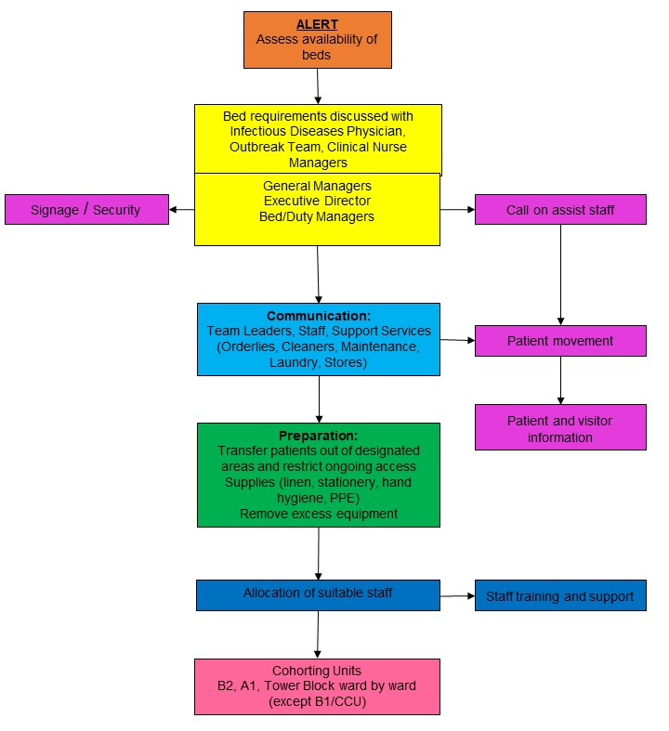

MEDICAL INVESTIGATIONS

1 Blood drawn for:
- Blood culture (routine bacterial pathogens)
- Full blood count
- U&E, creatinine
- Other tests as indicated
2 O₂ saturation (finger probe)
3 Urine
4 x1 Nasopharyngeal swabs in viral transport medium
x1 Oropharnygeal swabs in viral transport medium
- Use sterile swabs with plastic shaft. Insert swabs into nostril parallel to the palate and leave in place for 5 seconds to absorb secretions. Swab both nostrils and oropharyngeal swab from both posterior pharynx and tonsilar areas (avoiding the tongue).

Rapid antigen and PCR testing for Influenza can be carried out at Hawke’s Bay Hospital and samples can also be sent to Canterbury Health Laboratory.

RESUSCITATION IN WARD

In the event of a deterioration in the ward patient’s condition, early assessment for possible transfer to ICU is indicated.

Immediate consultation with the Medical Registrar on-call by the designated nurse is indicated if the patient exhibits any 3 or more of the following criteria:

- Increase in respiratory rate > 25 breaths per minute
- Increase in heart rate > 110
- Systolic blood pressure < 90 mmHg
- Oxygen saturation < 90%
- Increased work of breathing
- Increased patient fatigue
- Decreased level of consciousness
- Urine output < 120 mL over last 4 hours

Following a resuscitation event all equipment used must be cleaned with an environmental wipe followed by sodium hypochlorite 1:10 solution and allowed to dry.

MENTAL HEALTH RESPONSE

RESPONSE:

Phase 4 – Ready
- Notify staff and prepare rosters (survey staff availability), determine shift length and on-call provision
- Ensure training plan initiated
- Assess adequacy of equipment and plan to increase supplies as required
- Review safe staffing plan
- Identify staff who could work from their homes and ensure remote network accessibility
- Initiate proactive discharge planning in the MHIPU

Phase 5 – Steady
- Downscale activities to be deferred
- Centralize workload planning for community services
- Prepare roster for Clinical Nurse Manager/Team Leader/General Manager 24 hour cover
- Monitor staff availability
- Increase monitoring of infection prevention and control practices
- Ensure PPE available in all areas
- Reduce admissions to in-patient care where possible
- Limit home visits
- Consider use of alternative accommodation for community clients
- Advise additional staffing sources of impending need for assistance
- Monitor in-patients for symptoms of influenza, notify any suspected cases to the Medical Officer of Health immediately and isolate patient pending advice
- Close Springhill facility and transfer of clients to their homes
- Close day programmes and return regional referrals to their areas
- Design a resource package for clients managing withdrawal from methadone

Phase 6 – Go
- Cease activities to be deferred
- Initiate Clinical Nurse Manger/Team Leader/General Manager roster (Coordinator)
- Complete and action Unit Operational Plan
- Redeploy staff as required
- Increase cleaning of all work areas and vehicles
- Initiate supply monitoring and control
- Initiate staff support systems
- Initiate four hourly updates to staff in all areas
- Activate area reporting to the Coordinator on an eight hourly basis, reports to be used to report to the Emergency Operations Centre
- Initiate daily staff meetings to monitor the workload and staff wellness
- Activate crisis assessment and triage service management by telephone
- Reduce face-to-face contacts with community clients where possible
- Initiate provision of helpline services to assist family, tangata whairoa and whanau to manage clients at home and the effects of sudden death (Springhill may be considered a venue for this service)
- Initiate fax system for prescriptions and home delivery where required
- Allocate staff to Hawke’s Bay and temporary hospitals to assist in managing grief reactions
- Activate provision of kaumatua for managing multiple deaths of Maori and staff when appropriate
- Consider provision of assistance at community pharmacies for methadone dispensing

IMPACTS:

- Basic service provision will be affected
- Specialist services will be forced to reduce client contact in favour of telephone and helpline services
- Access to regional services, respite care and in-patient care will be restricted
- Staffing levels will be suboptimal due to illness and death
- Medication provision will be affected
- Elevated unwellness will be triggered by deaths of infection and inability to access services in the normal manner
- Large numbers of deaths will result in an increased need for counseling services

OCCUPATIONAL HEALTH

The Occupational Health Service will work closely as part of the Response Team.

The Occupational Health Service will initiate monitoring of all dedicated staff and reporting to the Incident Management Team.
The Service will be guided by the specialist advice, and local and national information.

Outbreak from Northern Hemisphere:

In the event of a major outbreak of a pandemic virus generated from the Northern Hemisphere there would be time available for staff to be prepared for the arrival in New Zealand and Hawke’s Bay.

During this time
- Staff will offered and encouraged to accept vaccination
- A register of all vaccinated staff will be kept in the Occupational Health Service
- Antiviral medicines will be available

Sudden Epidemic:

In the event of an epidemic generated from elsewhere in New Zealand:

- Search of register of those already vaccinated
- Assign these staff to the designated areas
- Antiviral medicines will be available

Exposure with an Unexpected Patient

In the event of a staff member being exposed to influenza from an unexpected patient:

- Search of register for vaccination histories
- Provide prophylaxis
- Vaccinate staff

The costs of vaccine and prophylaxis therapy is with the Te Whatu Ora Hawke’s Bay.

Monitoring of staff contracting a pandemic virus will be carried out by the Occupational Health Service.

HOME HEALTH

Phase 4 – Ready
- Notify staff and prepare rosters (survey staff availability)
- Ensure training plan initiated
- Assess adequacy of equipment and plan to increase supplies as required
- Review safe staffing plan

Phase 5 – Steady
- Prioritise patient caseloads, high risk patients may be referred to alternate care, e.g. residential home hospital level bed
- Increase provision for community management of patients with simplification of management as appropriate
- Plan to refer non priority cases back to general practice or other healthcare provider
- Plan for proactive management of identified at-risk groups in consultation with general practitioners, communicate with all patients in these groups ensuring action plans are in place
- Increase monitoring of infection prevention and control practices
- Downscale activities to be deferred
- Review succession plan for management of service
- Monitor staff availability
- Ensure PPE available in all designated areas
- Advise additional staffing sources of impending need for assistance

Phase 6 – Go
- Complete and action Unit Operational Plan
- Report to be prepared by the staff member in charge on an eight hourly basis, reports to include staffing levels, staff sickness, patient throughput, referrals to other agencies and deaths
- Cease activities to be deferred
- Redeploy staff as required
- Increase cleaning and waste disposal services (including vehicles)
- Initiate supply monitoring and control with provision for drop-off points for medical supplies as required
- Initiate staff support systems
- Initiate four hourly updates to staff in all areas

RURAL HEALTH

The principles of management of pandemic patients are:

- Rapid recognition of patients meeting the diagnosis
- Rapid containment of the patient
- Protection for staff

Phase 4 – Ready
- Notify staff and prepare rosters (survey staff availability)
- Ensure training plan initiated
- Initiate proactive discharge planning
- Assess adequacy of equipment and plan to increase supplies as required
- Confirm cohort plan

Phase 5 – Steady
- Increase monitoring of infection prevention and control practices
- Downscale activities to be deferred
- Transfer in-patients out of designated cohorting area
- Monitor staff availability
- Ensure PPE available in all designated areas
- Advise additional staffing sources of impending need for assistance

Phase 6 – Go
- Complete and action Unit Operational Plan
- Cease activities to be deferred
- Commence cohort plan
- Redeploy staff as required
- Initiate supply monitoring and control
- Initiate staff support systems

Triage

Patients with symptoms of influenza should be triaged immediately into a designated isolation area.

RADIOLOGY

Basic Considerations:

- Spread is by droplet infection
- Droplet or contact infection is likely within one metre of infected patients
- Infection occurs from contaminated droplets in the environment or from contaminated hands touching the eyes, nose, or mouth
- Radiological procedures that involve direct patient contact or close proximity to patients involve the greatest risk
- Strict infection prevention and control practice is essential to prevent cross infection to staff and other patients

Staff Responsibilities:

Ensure that you are familiar with infection prevention and control guidelines relating:

- Putting on and removing personal protective clothing
- Correct fitting of masks
- Disposal of contaminated clothing and equipment
- Cleaning of equipment and the environment
- Hand hygiene

Management of In-patient X-Rays:

ICU / ED

- X-ray forms should indicate risk status of the patient
- X-ray cassettes should be taken immediately to the developing room with minimal handling and processed immediately
- Perform hand hygiene after handling cassette

HRCT

- Bookings should be arranged at the close of usual daily appointments
- All non-essential equipment should be removed from the CT room
- Equipment unable to be safely moved must be covered with sheets
- No Entry signs must be placed on the doors when scanning is taking place
- Clinical notes should be left outside the examination room
- The designated nurse (in protective clothing) escorts the patient (wearing a mask) into the scanning room and follows instructions via the intercom to set up the patient and machine
- On completion of CT scanning the patient and designated nurse leave the room and the door is closed
- A cleaner will be allocated from ICU to wipe over all radiology equipment with environmental wipes
- All horizontal surfaces including the floor will be cleaned with an environmental wipe followed by sodium hypochlorite 100mL to 1L of water (1:10)
- Biohazard waste bags should be replaced and used linen placed in a linen bag
- Orderlies should collect these as soon as practicable

LABORATORY

Management of Specimens:

- Routine precautions i.e. wearing of gloves/gowns and preventing aerosol production, must be observed.
- Good work practice is essential to prevent contamination from mishandled specimens.
- Safety glasses to be used as required

Specimens will include:

- Respiratory secretions:
- Nasopharyngeal swabs
- Oropharyngeal swabs
- Blood cultures
- Blood for routine biochemistry and haematology

Handling of Specimens:

1. Respiratory:

  - Rapid antigen and PCR testing, then specimen sent to Canterbury Health laboratory if required.

2. Blood:

  - Blood for routine Haematology and Biochemistry is processed by using gloves and preventing aerosol production.
  - Original lids of tubes must be replaced as soon as possible after sampling in Biochemistry and Haematology.
  - Centrifugation: all bloods requiring centrifugation are spun in capped buckets.

Dispose of gloves and perform hand hygiene.

SPECIMENS – COLLECTION OF VIROLOGY

Note: All samples will be transported to Laboratory Registration in the usual manner.

Investigations:

- Blood for culture and FBC, UECG, CRP, LFT’s, ESR, coagulation screen
- Throat and/or nasopharyngeal swabs

BODILY FLUIDS:

1. Respiratory Tract Specimens

Respiratory specimens should be collected as soon as possible in the course of the illness. The likelihood of recovering most viruses and many bacteria diminishes markedly >72 hours after symptom onset. Some respiratory pathogens may be isolated after longer periods.

Three types of specimens may be collected for viral or bacterial isolation and PCR.
These include:

- Nasopharyngeal wash/aspirates;
- Nasopharyngeal swabs
- Oropharyngeal swabs

Nasopharyngeal aspirates are the specimen of choice for detection of respiratory viruses and are the preferred collection method among children aged <2 years.

(A) Upper Respiratory Tract

1. Collection of nasopharyngeal wash/aspirate
Have the patient sit with the head tilted slightly backward. Instill 1 – 1.5mL of nonbacteriostatic saline (pH 7.0) into one nostril. Flush a plastic catheter or tubing with 2-3mL of saline. Insert the tubing into the nostril parallel to the palate. Aspirate nasopharyngeal secretions. Repeat this procedure for the other nostril. Collect specimen in sterile vials. If shipped domestically, ship on wet ice. If shipped internationally, ship on dry ice.

2. Collection of nasopharyngeal or oropharyngeal swabs
Use only sterile dacron or rayon swabs with plastic shafts. Do NOT use calcium alginate swabs or swabs with wooden sticks, as they may contain substances that inactivate some viruses and inhibit PCR testing.

Nasopharyngeal swabs
Insert swab into nostril and advance as far as possible along the floor of the nasal cavity. It will generally advance for about 5-10cm before reaching the posterior nasopharynx. Rotate the swab gently rubbing against the posterior nasopharynx and leave in place for a few seconds to absorb secretions. The goal is to collect epithelial cells. Note: some coughing and tearing may occur.

Oropharyngeal swabs
Use the plastic shafted Dacron swab:
Get the patient to say “aaah”.
Use a tongue depressor to prevent contamination of the swab with saliva.
Swab both posterior pharynx and tonsillar areas, avoiding the tongue.
Place this swab into the same pre-labelled viral transport medium tube, pushing the nasopharyngeal swab down into the medium.

Place swabs immediately into sterile vials containing 2mL of viral transport media or a bacterial transport media, such as serum tryptone glucose glycerol (STGG) media. Break applicator sticks off near the tip to permit tightening of the cap. If using liquid medium, ensure the lid is firmly closed on the viral specimen and taped to prevent leakage. If shipped domestically, ship on wet ice. If shipped internationally, ship on dry ice.

Packaging and Transport:

- The laboratory form should clearly indicate that this is a “suspect case of pandemic pathogen” and must be placed in the outer specimen bag.
- Specimens should be double bagged ensuring that the snap lock is sealed on both bags.

PHARMACY

Phase 4 – Ready
- Notify staff and prepare rosters
- Ensure training plan initiated (general precautions and self care)
- Assess adequacy of supplies and plan to increase as required

Phase 5 – Steady
- Ensure PPE available
- Prepare and dispense antiviral medication as directed
- Ensure Pharmacy keys and alarm PIN access available in Call Centre

Phase 6 – Go
- Defer aseptic compounding, proactive clinical pharmacy service and clinical trials
- Activate roster
- Ensure one metre distance from patients
- Initiate staff support systems
- Dispense discharge medications to patients returning to in remote areas

STERILE SERVICES

Issues for Sterile Services Personnel:

The possibility of cross infection to Sterile Services Department (SSD) staff should be minimal.

Used non disposable equipment will be returned in a container following normal process.

No additional personal protective clothing is required to be worn by SSD staff.

Basins and benches should be washed with Viroclean after equipment cleaning.

Frequent hand hygiene is an essential Infection Prevention and Control practice.

Any symptoms such as fever or cough should be reported to Occupational Health or your GP for follow-up.

HEALTH RECORDS

Phase 4 – Ready
- Notify staff and prepare rosters
- Ensure training plan initiated
- Assess adequacy of equipment and plan to increase supplies as required

Phase 5 – Steady
- Alert non essential areas of impending close down
- Ensure adequate PPE available
- Advise staff to prepare for a change in work practice (including family arrangements)

Phase 6 – Go
- Close down non essential reception and redeploy staff to acute services on 24 hour cover
- Initiate on-call system
- Initiate supply monitoring and control

SECURITY

Responsibilities:
- Notify staff and prepare rosters with a minimum of two personnel per shift
- Ensure training plan initiated
- Cancellation of planned annual leave
- Advise Armourguard of possible assistance required
- Ensure PPE available for staff
- Report to be prepared by the staff member in charge on an eight hourly basis
- Initiate staff support systems
- Initiate four hourly updates to staff

Areas for Increased Surveillance:
- Emergency Department
- Pharmacy
- Temporary Mortuary

Appendix 1

PATIENT AND STAFF INFORMATION RESOURCES

ADMISSION:

You are being admitted to the designated isolation area in the hospital.

This means that you will be cared for in an area where access is restricted.

Nurses will wear a mask and may also wear a gown and gloves when required, and so will the other people coming in contact with you.

We would like to keep your visitors to one designated support person only to help stop the spread of this infection. There will be access to a telephone for you to ring your relatives to keep them up to date with your progress.

They will need to wear a gown and mask when visiting you and will be asked to wash their hands carefully when leaving your room.

Nursing staff will explain how to put this on and where to dispose of it after use.

If you are required to leave your room for any investigations, you will need to wear a mask.

If you or your visitor have any questions please ask the staff caring for you.

TRIAGE:

If you have a cough, fever or shortness of breath the Triage Nurse may ask you to put on a mask. This is to protect other people from the possibility of catching your infection. The mask is very comfortable and you will need to wear it until a cause for your symptoms is found.

The Triage Nurse will ask you whether you have had an influenza vaccination and the approximate date of the vaccination and what other medical conditions you have.

If pandemic-related illness is suspected you will be taken to a designated area until you have been examined and a diagnosis is made.

If your chest x-ray is clear and your symptoms are not severe, you may be well enough to go home. You will be given some advice or asked to seek medical attention if your condition becomes worse.

DISCHARGE ADVICE

ADVICE TO PATIENTS ON MANAGEMENT OF SYMPTOMS:

Viruses are easily passed from person to person through coughing and sneezing by infected individuals. The virus enters the body through the nose and throat and it can then take between 1 to 4 days before symptoms appear. Adults are usually infectious (i.e. able to pass the virus on to others) from the day before symptoms appear through to 5-7 days afterwards. Children can be infectious for more than 10 days after the onset of symptoms and severely immunocompromised people (people with existing conditions which impair their body’s immune response to infection) can shed virus for weeks or months after symptoms begin.

It is likely that you are no longer infectious – however you should discuss this before discharge.

If it is likely that you are still infectious (this is more likely in children or severely immunocompromised people) then you should:

- Stay home and avoid contact with other non-infected people
- Cover your nose and mouth with a tissue when coughing or sneezing until at least 10 days after the onset of your influenza symptoms.

If your symptoms return or if your health in other ways deteriorates please contact your doctor, and say that you have recently been in hospital with influenza or an influenza-related illness.

ADVICE – INFECTION CONTROL MEASURES:

1. Stay indoors and keep contact with others to a minimum until the resolution of symptoms.

2. Frequent handwashing with liquid soap rather than bar soap, especially after contact with nose, mouth and respiratory secretions e.g. after coughing. Use disposable hand towels to dry hands. Used tissues must be carefully discarded.

3. Family members should practice handwashing frequently and avoid touching the eyes, nose and mouth with their hands.

4. Avoid close contact with family members (e.g. kissing, hugging).

5. Avoid sharing food, eating utensils and towels with family members.

6. Maintain good ventilation at home.

7. These precautionary measures should be adopted until the resolution of symptoms.

12. Telephone your GP if condition deteriorates and any further symptoms develop.
STAFF INFECTION CONTROL MEASURES

1. Uniforms are not to be worn to and from your place of work. Changing must occur immediately prior to and on completion of each shift with used uniforms being taken home in a closed plastic bag for laundering.

2. Frequent hand hygiene with liquid soap rather than bar soap, especially after contact with nose, mouth and respiratory secretions e.g. after sneezing. Use disposable hand towels to dry hands. Used tissues must be carefully discarded.

3. Family members should practice handwashing frequently and avoid touching the eyes, nose and mouth with their hands.

4. Shower immediately after work.

5. Maintain good ventilation at home.

6. These precautionary measures should be adopted for the duration of the influenza outbreak.

7. Report any symptoms such as fever or cough to the Occupational Health staff, advice regarding work attendance will be given.

PERSONAL PROTECTIVE EQUIPMENT

Order for putting on and removing personal protective clothing:

- Change into uniform, shoes must be work allocated and/or suitable for disinfection

- Perform hand hygiene

- Gown or apron

- Mask - check fitting correctly to ensure a good seal (replace if damp or can be worn for 4 hours before being replaced)

Removal:

- Remove gown/apron and gloves (if worn) taking care to minimise contamination of self and clothes

- Perform hand hygiene

- Using two hands, remove mask and lift off forwards taking care not to touch the pouch of the mask

Perform hand hygiene

Notes:
- If any of the following occurs the mask must be changed:
  - if you touch it
  - if it is grossly contaminated
  - if it becomes wet for any other reason
  - if it becomes hard to breathe through
- Masks should be placed in a Biohazard bag after removal.
- If at any time gloves become contaminated, they must be removed, hand hygiene performed and clean gloves put on.
- Gloves are not a replacement for hand hygiene.
- When collecting respiratory specimens, face shields are to be worn.

Watchpoint: A group of staff have been specifically trained and certified to provide first line care and will act as the trainers for all other staff.

Checklist for Staff Before Entering Designated Areas:

Protect yourself from possible exposure by checking the following points each time you enter a designated area.

- Have you given cellphones and pagers to 'clean' ward/unit staff to manage while you are in the designated area? Pens, paper, stethoscopes, tourniquets etc must not go in and out of the area – there will be dedicated equipment in the area.
- Is your hair restrained (clipped or tied back)?
- Are you wearing shoes that cover and protect your feet from splashes and dropped instruments? Do they have a wipable surface? If not, put on shoe covers then perform hand hygiene.
- Is your mask on? Does it fit securely?
- Are you wearing a gown or apron? Is it firmly tied?
- Do you have gloves on? Are they the correct size - do they fit over the wrists of your gown?

If you have answered yes to all the above, enter the designated area now.

POST TRAUMATIC STRESS

Post traumatic stress can occur after any event causing people to experience unusually strong emotional reactions. These reactions have the potential to interfere with ability to function.

Even though the event may be over, you may still be experiencing some strong emotional or physical reactions. It is very common, in fact quite normal, for this to occur. These reactions may last a few days, a few weeks or perhaps longer. Understanding what is happening to you and having the support of loved ones are two things that will help these reactions pass more quickly.

The event itself is abnormal and to react to it is normal. Reactions may vary for each individual, this is because different events will have a different meaning for different people. Each person’s experience is therefore a unique personal event.

However, there are some reactions that commonly appear amongst people who are involved in an abnormal event. These are listed for your information:
- Generalized anger and irritability
- Awareness of personal vulnerability
- Panicky irrational feelings
- A sense of being overwhelmed
- More easily startled
- Inability to sleep
- Lack of concentration
- Physical symptoms – tiredness, palpitations, breathing difficulties, aches and pains, loss of appetite, nausea

THE FOLLOWING IDEAS MAY HELP IN COMING TO TERMS WITH THE EXPERIENCE

Acceptance
Recognize your personal reaction and acknowledge that you have been through a highly stressful experience.

Support and Expressing Feelings
Seek out other peoples physical and emotional support. Talk about your feelings with people who will understand.

Taking Care of Yourself
During a period of stress we are more prone to accidents and physical illness. It is important to look after yourself. The following ideas will help you do this:
- Maintain a good diet and eat regularly
- Keep a journal, write your thoughts down
- Maintain as normal a schedule as possible
- Have sufficient sleep
- Take time to relax

YOU SHOULD SEEK HELP IF
- You are unable to handle the intense feelings or physical reactions
- You feel your emotions are not returning to normal over a period of time
- You continue to have physical symptoms and/or disturbed sleep
MIHIROA WHARE

This information is for persons who have contact with patients with influenza and are staying in the Mihiroa Whare.

What should I do?

While staying in the Whare, you should watch carefully for any changes in your health. You should phone 2623 or 2621 if you become unwell.

Always phone first. You should tell the person on the phone that you have had contact with someone who has influenza.

If you become unwell, you should avoid seeing people outside the Whare until you have been seen by the doctor (i.e. stay away from work, school or public places).

Am I infectious to others?

If you are well, your risk of infecting others with influenza is considered very high. The most important preventative measure is to seek medical attention promptly if your health changes.

What else can I do?

A number of every day hygiene practices which help stop the spread of common infections such as colds also help prevent the spread of influenza. These include:

- Covering your nose and mouth with a tissue when coughing or sneezing. Used tissues must be carefully discarded.

- Avoiding sharing your eating utensils, towels and bedding with others (they can be used by others after normal cleaning such as washing with soap and hot water).

- Everyone in the household washing their hands frequently, particularly after contact with nose, mouth and respiratory secretions e.g. after sneezing.

- Avoiding close contact with family members (e.g. kissing and hugging).

- Maintaining good ventilation at the Whare.

- Cleaning any household surfaces soiled by body fluids with a household disinfectant at least once a day using diluted household bleach (i.e. adding 1 part of household bleach to 49 parts of water).

- Put on a surgical mask when going to the hospital.

Disposal of linen and rubbish at the Whare:

Linen should be disposed of into the yellow-topped linen bags provided. This will be collected daily.

Rubbish should be disposed of as usual into the brown multi-wall bags.

Appendix 2

SECONDARY CARE SERVICES RESPONSE

INCIDENT ACTION PLAN

Situation Summary: |  |  | Action Plan Number
 |  |  | Date
 |  |  | Time To be updated:
 |  |  | Prepared By: Approved By:
ACTION | KEY ISSUES | RESPONSIBILITY |  | PROGRESS

Attachment 1

INCIDENT ACTION PLAN

Operational Objective | Strategies | Anticipated Resources | Use of Resources | Service Continuity

SECONDARY CARE SERVICES RESPONSE
Attachment 2

UNIT OPERATIONAL CONTINGENCY PLAN
(to be completed in consultation with medical staff)

UNIT: DATE:

Part 1 – Patient Numbers Management

STRATEGY | ACTION | RESPONSIBILITY
Patient Transfers

Admissions Management

Discharge Planning

Service Reductions
(Electives, Clinics etc)

Redirection to Other Providers

UNIT OPERATIONAL CONTINGENCY PLAN
(to be completed in consultation with medical staff)

UNIT: DATE:

Part 2 – Service Provision with Reduced Staff Numbers

Estimated Staff Numbers: a.m. p.m. nocte on-call

RISKS | ACTIONS | RESPONSIBILITY
Staff Training

Acute Services

High Risk Patients

Maintenance of Current Services

Support Services

Recovery Action Plan Needs Template

Event

Date of Event

Recovery Manager

Date Commenced |  | Date to Review

Date(s) identified for transition from response to recovery activity:
Transition Date | Activity | Signature and Date

Brief Sitrep:
Date | Current Situation

Schedule of Meetings:
Date | Location | Type of Meeting | Agencies to Attend

Actions outstanding from Response Phase:
Date | Outstanding Actions | Risks Identified? Yes/No If Yes, What Risks? | Responsibility | Date to be Completed | Date Completed

Notes

Key short term recovery priorities:
Date | Short Term Recovery Priorities | Risks Identified? Yes/No If Yes, What Risks? | Responsibility | Date to be Completed | Date Completed

Notes

Key medium term recovery priorities:
Date | Medium Term Recovery Priorities | Risks Identified? Yes/No If Yes, What Risks? | Responsibility | Date to be Completed | Date Completed

Notes

Key long term recovery priorities:
Date | Long Term Recovery Priorities | Risks Identified? Yes/No If Yes, What Risks? | Responsibility | Date to be Completed | Date Completed

Notes

Development of an Exit Strategy:
 | Activities | Agency Responsible
Identification of assistance required in the longer term
A transition to business as usual to manage long term recovery activities
Planning and reporting in the longer term

Management of public information and communications
Opportunities for communities to discuss any unresolved issues and continue to participate in their recovery
Changes to organisational arrangements including need for subcommittees and contact lists
Learning from the event: debriefing and reviewing

Notes

Appendix 3
LEGISLATION
Legislation | Relevant sections | Further information in NZIPAP 2010
Health Act 1956 | Part 3 (Infectious and Notifiable management, Diseases):  - Special powers (sections 70, 71, 71A and 72)  - Routine powers (sections 77-82 and 96-101)  - Notifying diseases (sections 74, 74AA and 76)  - Power to enter premises and examine persons (section 77)  - Mortuaries and burials (sections 84 and 86)  Part 3A (Management of infectious diseases); written directions restricting movement and behaviour, and to seek medical examination (sections 92I to 92L), urgent public health orders to detain at specified premises for 72 hours (section 92ZF); application for court orders, including for treatment (sections 92ZF to 92ZJ); formal contact tracing (subpart 5); prosecution (e.g. sections 92V and 92W)  Part 4 (Quarantine) | Part B Border management, Cluster control
Epidemic Preparedness Act 2006 | Particularly sections 5, 8, 11-15 and 66-69 | Part B Border management, Cluster control
Health (Quarantine) Regulations Border Management 1983 | Regulations 3, 10 and 13 | Part B Cluster control
Health (Burial) Regulations 1946 |  | Part C, Manage It, care of the deceased
Biosecurity Act 1993 | Particularly:  - Restricting imports of animals and animal products (section 25)  - Animal surveillance (sections 43, 109, 114 and 121 and Part 7)  - Restricting movement of animals or any at-risk goods (sections 130 and 131 and Part 7 dealing with biosecurity emergencies) | Part A, Intersectoral Response, Biosecurity work stream; Part B
Civil Defence Emergency Management Act 2002 | Particularly Parts 4 (declaration of state of emergency) and 5 (powers in relation to civil defence emergency management) | Part A, Intersectoral Response, Civil Defence Emergency Management work stream; Part B; all phases
Customs and Excise Act 2018 | Section 21 and regulation 13 (advanced passenger information | to Parts B and C, Border management; Part B all phases

Appendix 4
REFERENCES
- Ministry of Health. 2001. Primary Health Care Strategy.
- Ministry of Health. 2006. Guidance for Infection Prevention and Control during an Influenza Pandemic.
- Ministry of Health. 2008. Guidance on Community-based Assessment Centres and Other Support Services.
- Ministry of Health. 2017. New Zealand Influenza Pandemic Action Plan.

The New Zealand Pandemic Plan for Influenza – A Framework for Action
https://www.health.govt.nz/system/files/documents/publications/influenza-pandemic-plan-framework-action-2nd-edn-aug17.pdf (pages 62-63 pandemic phases)

Health Sector Pandemic Influenza Guidance
https://www.health.govt.nz/your-health/healthy-living/emergency-management/pandemic-planning-and-response/health-sector-pandemic-influenza-guidance-0#plan

Characteristics of Microbes Most Likely to Cause Pandemics and Global Catastrophes
https://ncbi.nlm.nih.gov/pmc/articles/PMC7122301/

Pandemic Legislation
https://www.health.govt.nz/your-health/healthy-living/emergency-management/pandemic-planning-and-response/pandemic-legislation

