**May 2023**



###### Pandemic Plan

###### Annexes Part 2A

**Contents**

Pharmacy Plan for Community

Port and Airport Procedures (refer Management of Communicable Disease Policy at the Port and Airport 8146 on Our Hub)

Primary Care Plan

Public Gathering Standard Operating Procedures

Pharmacy Plan for Community

DOCUMENT CONTROL

|  |  |  |  |
| --- | --- | --- | --- |
| Revision date | Previous revision date | Summary of Changes | |
| December 2021 | September 2021 | General | Added document name and version to page footer |
| Page 4 | Updated PSNZ link for COVID resources |
| Page 6 | Corrected cell phone number for Hawke’s Bay Pharmacy Alert System |
| Page 9 | Remove fax number for CDC Pharmaceuticals |
| Page 11 | Reminder of medicine advice and counselling obligations under ICPSA |
| Page 13 | Updated *International Consensus Statement (*[Consensus statement on the use of clozapine during the COVID-19 pandemic | JPN](https://www.jpn.ca/content/45/3/222)*)*  Added reference to Medsafe article: <https://www.medsafe.govt.nz/safety/Alerts/ClozapineDatasheetUpdates.asp#Clozapine> |
| Page 16 | Reordered Community Based Assessment Centre list |
| Page 17 | Removed Charleston Pharmacy and Unichem UFS |
| Page 18 | Added Countdown Hastings Pharmacy  Modified Hastings clusters |

Hawke’s Bay

Community Pharmacy

Pandemic Plan

INTRODUCTION 5

Aims and general purpose 5

Assumptions 5

Related Legislation 5

HBDHB EMERGENCY MANAGEMENT (CIMS) 6

Operational Structure Relevant to this Plan 6

Communication Plan 6

Information Sources 7

PHARMACY BUSINESS CONTINUITY PLANNING 8

Preparedness 8

Finances 8

Work Force Issues 9

Health and Safety 9

PPE 9

Stock Control 9

In the event of a pharmacy not being able to open 10

DISPENSING 11

Legislation 11

Medicine advice 11

Medicine delivery 11

SPECIFIC PHARMACY SERVICES 12

Vulnerable Patients 12

Vaccination Service 12

Opioid Substitution Treatment (OST) Service 12

Clozapine service 13

Community Pharmacy Anti-Coagulation Service (CPAMS) 14

Residential Care – Community and Age-related 14

PANDEMIC OPERATIONAL PROCEDURES 16

Pharmacy Clusters 16

Community Assessment Centres 16

Appendix A: Hawke’s Bay Pharmacy Cluster Groups 17

Appendix B: Te Whatu Ora Hawke’s Bay Supported Medicine Delivery Process 19

**Hawkes Bay Community Pharmacy**

**Pandemic Plan**

AUTHORITIES INVOLVED

Hawke’s Bay Community Pharmacies

**RELATED DOCUMENTS**

1. Individual pharmacy’s Emergency Plan and Business Continuity Plan.
2. Pharmaceutical Society of New Zealand.

* Pharmacy Practice During the COVID-19 Pandemic

https://www.psnz.org.nz/practicesupport/covid19/resources

* Emergency Response and Business Continuity Plan. Pharmaceutical Society of New Zealand, Wellington, 29 May 2014.

<https://www.psnz.org.nz/Folder?Action=Download&Folder_id=86&Folder_File=Pharmacyemergencyresponseplantemplate.doc>

* Step by Step Workbook. To Prepare your Pharmacy for a Disaster or Other Emergency. Pharmaceutical Society of New Zealand, Wellington, 29 May 2014.

<https://www.psnz.org.nz/Folder?Action=View%20File&Folder_id=86&File=Pharmacyemergencyresponseplanworkbook.pdf>

1. Te Whatu Ora Hawke’s Bay emergency documents

Relevant documents related to other pharmacy services include:

* Emergency Response – Pharmacy SUP/PHPPM/8117

Relevant documents related to CIMS and emergency response

* Coordinated Incident Management at Hawkes Bay District Health Board EPM/008
* Coordinated Incident Management A Scaled Response EPM035
* Emergency Response Communication Following Ministry of Health Alert EPM/028
* Public Health Emergency Response Plan EPM/039

1. Te Whatu Ora Hawke’s Bay COVID-19 related documents

* Response Plan
* Residential Care Plan
* Psychosocial Support Plan

# INTRODUCTION

## Aims and general purpose

The aim is to maintain the community-based dispensing of pharmaceuticals and other services provided by community pharmacies during a pandemic. These include services to, but not limited to:

* The public
* Residential care facilities (Rest Homes, IHC homes etc)
* Addiction services (Methadone clients)
* Mental health clients (Clozapine)
* General Practices and other medical facilities
* Hawke’s Bay Regional Prison

The aim of this document is to provide general direction; as each pandemic will have specific requirements which will communicated from Emergency Management as an Advisory Notice.

## Assumptions

1. A pandemic is inevitable.
2. There will be little warning. Experts believe there will be between one and six months between the time the novel virus is identified and the time that outbreaks begin in New Zealand.
3. Outbreaks are expected to occur simultaneously throughout much of New Zealand.
4. The effects on the community will be relatively prolonged compared to most other natural disasters.
5. The impact of the next pandemic could have a devastating effect on the health and well-being of the public and pharmacy work force. This may affect a pharmacy’s ability to provide pharmaceutical services.
6. The regular supply of pharmaceuticals to Hawke’s Bay may be affected due to world-wide production difficulties and transportation problems.
7. Pharmacists and staff will be at increased risk due to their frequent contact with the public.
8. Illegal attempts by the public to obtain antiviral and antibiotic medications could affect the safety of pharmacy staff. This could result in more aggressive behaviour by some individuals and an increase in pharmacy burglaries.

The Community Pharmacy Pandemic Plan will be implemented at the time the pandemic is identified in New Zealand and Hawke’s Bay.

## Related Legislation

Emergency legislation modifying the requirements of the Medicines and Misuse of Drugs Acts and their Regulations may be required. While it is not expected that the Pharmaceutical Schedule business rules will be changed an open mind needs to be maintained.

Employment law will be an important consideration and pharmacists should review contracts with their staff and work with them to understand how they will deal with issues like the temporary closure of a pharmacy and requiring to remain open as part of essential service delivery.

# TE WHATU ORA HAWKE’S BAY EMERGENCY MANAGEMENT (CIMS)

In the event of an emergency being declared Te Whatu Ora Hawke’s Bay will move into a Coordinated Incident Management Structure (CIMS). This is a specific structure designed to provide a platform to respond to an emergency.

## Operational Structure Relevant to this Plan

The pharmacies of Hawke’s Bay are primarily individually owned but are able to work together in a collegial manner in some circumstances. Each pharmacy has contractual obligations to Te Whatu Ora Hawke’s Bay in regards to the provision of pharmaceutical services. Sector Services reimburse the cost of most medicines and contracted pharmaceutical services, under direction from PHARMAC, from the Te Whatu Ora Hawke’s Bay combined community pharmaceutical budget.

As part of the CIMS structure, Pharmacy, as a whole, sits within the Te Whatu Ora Hawke’s Bay Operations Section During a pandemic a pharmacy leaders group may be convened to provide input into CIMS. Members of the Pharmacy leaders’ group may include:

* System Lead for Medicine
* Hospital Pharmacy Manager
* Health Hawke’s Bay Clinical Pharmacist Population Health
* Clinical Pharmacist Facilitator Team Leader
* Planning, Funding & Performance Pharmacy Portfolio Manager
* Others as determined necessary

## Communication Plan

The following communication systems have been organised:

1. ***Te Whatu Ora Hawke’s Bay***
2. ***email system (HealthScape)***

Email messages can be sent to all pharmacies in the Hawke’s Bay district through the HealthScape database:

Entry point: System Lead for Medicine 021 540 210 [Brendan.Duck@hbdhb.govt.nz](mailto:Brendan.Duck@hbdhb.govt.nz)

or Pharmacy Portfolio Manager 878 8109 ext 4617 [Di.Vicary@hbdhb.govt.nz](mailto:Di.Vicary@hbdhb.govt.nz)

or Emergency Management Advisor 027 245 3692 [sandra.bee@hbdhb.govt.nz](mailto:sandra.bee@hbdhb.govt.nz)

1. ***Telephone system (HealthScape)***

Text message to cell phone numbers of pharmacy points of contact.

1. ***Physical delivery of information***
2. **Alternatively email systems via**
3. ***Pharmaceutical Society of Hawke’s Bay Branch***

E-mail messages can also be sent to all pharmacies in the Hawke’s Bay region.

Entry point: PSNZ HB Branch President [hbpsnz@gmail.com](mailto:hbpsnz@gmail.com)

1. ***Hawke’s Bay Pharmacy Alert System***

E-mail messages can also be sent to all pharmacies in the Hawke’s Bay region.

Entry point: Hawke’s Bay Pharmacy Alert 027 849 7128

[pharmacyhawkesbay@gmail.com](mailto:pharmacyhawkesbay@gmail.com)

Any messages relevant to a pandemic can be disseminated quickly using either system or both systems simultaneously.

1. ***Communication within and between cluster groups.***

In the event that the two above systems are not able to operate the cluster groups will be used (see Appendix A). The link pharmacies in the clusters will also liaise with the hospital pharmacy where appropriate.

## Information Sources

1. Ministry of Health (MoH) Websites

During a pandemic the MoH may set up a dedicated website; this should be your ‘one source of truth’ around national situation and guidance. There may also be information on the general MoH website: <https://www.health.govt.nz/>

1. Te Whatu Ora Hawke’s Bay Websites

During a pandemic Te Whatu Ora Hawkes Bay will actively update the following website with local information

Public website: <http://www.ourhealthhb.nz/>

Professional website: <https://hawkesbay.health.nz/>

1. Advisory notice via Emergency Management

Emergency Management will develop a specific advisory for pharmacy; this will be communicated by the channel described in the above Communications Plan.

1. Pharmaceutical Society of New Zealand website

Professional guidance and links to key pharmacy information from MoH is shared via PSNZ emails to their members and their website: <https://www.psnz.org.nz/>

# PHARMACY BUSINESS CONTINUITY PLANNING

## Preparedness

Each pharmacy should have a pandemic planning document*.* Pharmacies pandemic plans should consider areas such as the following:

* Strategic aims of New Zealand’s Pandemic Plan
* Powers of the Medical Officer of Health in a pandemic emergency
* Human resource obligations
* Deciding whether a work place should stay open
* Risks to employees and others must be reasonable
* Health and Safety at Work Act 2015
* Other human resource legislation
* Preparing for the possibility of a workplace or business closing
* Keeping communication open and frequent
* Short, medium, and long-term planning for the pharmacy
* Activation of Pandemic Continuity Plan
* Communication with staff
* Maintaining essential business activities
* Identification of core people and core skills
* Business planning for absence
* Knowledge management
* Communications
* How might shortage of supplies affect business operations
* How we can protect staff and customers from getting sick
* Restrict work place entry of people with symptoms
* Personal hygiene
* Work place cleaning
* Air conditioning
* Increased social distancing
* Managing staff who become ill at work
* Contact management
* Personal protective equipment
* Information sources

The Pharmacy Guild of NZ has also prepared a document *Managing Infection Control in Your Pharmacy during a Pandemic.* This is an advisory note to help pharmacists planning during a pandemic. This document will be updated as new information comes to hand.

## Finances

Proprietors of pharmacies should plan with their bank that in the event of Sector Operations not being able to make payments on time (due to staff shortages) the pharmacy is able to carry on business in a regular manner.

In the event of a pandemic infection prevention and control become critical and, for this reason, a plan for transactions to move to contactless, including payment of co-payments and retail sales moving online is useful. Consider as part of the pharmacy business planning how you will manage contactless payments – mobile EFTPOS, online payments, accounts.

Maintain close communication with Te Whatu Ora Hawke’s Bay Pharmacy Portfolio Manager – Pharmacy if the pharmacy is facing financial difficulties. Financial difficulties may occur sometime after the pandemic; guidance is available within the Integrated Community Pharmacy Services Agreement around informing Te Whatu Ora Hawke’s Bay should this occur and impact the ongoing sustainability of the business.

## 

## Work Force Issues

During a pandemic some staff may be recommended to remain in self-isolation and therefore not be available to work, others may become unwell or be required to care for family members. Usual staffing levels may not be available during a pandemic and planning should consider this.

Consider if there is value in splitting your staff into two separate ‘bubbles’ that work within the pharmacy at different times so that if one ‘bubble’ becomes infected with the pandemic infection, and are placed into self-isolation, the other ‘bubble’ can continue to work and keep the pharmacy operating.

Pharmacy Council maintain a register of pharmacists and CDC Pharmaceuticals Ltd (🕿 06 831 0620, [murray@cdc.co.nz](mailto:murray@cdc.co.nz)) may also be able to assist with available locum pharmacists. During a pandemic it is important to also consider other non-pharmacist staff and skills that are essential to business continuity. Your staff training plan should consider who else has these skills or could do these roles.

It is recommended that the cluster groups work together to mitigate the problems of reduced staff levels. The pharmacist in charge needs to ensure staffing levels are adequate to provide appropriate pharmaceutical services. Maintain close communication with the Te Whatu Ora Hawke’s Bay Pharmacy Portfolio Manager – Pharmacy if assistance with staff is required. During COVID-19 the Pharmacy Council provided Pharmacy Portfolio Managers a list of available pharmacists.

## Health and Safety

Health and Safety obligations are important during a pandemic. Planning should include

* PPE supplies
* Staff training on safe PPE use
* Staff wellbeing and resilience resources
* Vaccination status of staff
* Vulnerable staff who may not be able to work during a pandemic e.g. immunocompromised

## Personal Protective Equipment (PPE)

During a pandemic the Ministry of Health will provide health professionals with guidance on use of PPE and the process to order government funded PPE. Note the government funded PPE is for government funded services, e.g. dispensing, the pharmacy needs to consider PPE supplies for other services within the pharmacy e.g. photography, Lotto, Post Shop or cosmetic counters.

The pharmacy must maintain a supply of PPE for use in a pandemic or outbreak.

Specific guidance on PPE use will be issued by advisory notes for specific events.

Staff training on use of PPE should be provided and regularly updated. Contact Te Whatu Ora Hawke’s Bay via [emergency.response@hbdhb.govt.nz](mailto:emergency.response@hbdhb.govt.nz) to request training.

## Stock Control

* Pharmacies will continue to maintain stock levels as well as they can using their computer stock control systems and anticipated stock use.
* Pharmaceutical wholesalers supplying Hawke’s Bay pharmacies include:
  1. CDC Pharmaceuticals based in Hawke’s Bay and
  2. Propharma based in Palmerston North

Both will maintain their stock as best they can. Disruption to deliveries from suppliers is possible.

* Neither wholesalers nor pharmacies are able to stockpile medication unless specific arrangements, along with funding, are put in place beforehand.
* The Ministry of Health has a plan to stockpile medication and is contracting with suppliers in an effort to ensure supply.

## 

## In the event of a pharmacy not being able to open

During COVID-19 Ministry of Health provided guidance to pharmacies regarding pharmacy licensing – closure and relocation and the process that is to be followed. This is available [HERE](https://www.health.govt.nz/system/files/documents/pages/pharmacy-licensing-closure-relocation-5apr20.pdf). Additional information is provided by Te Whatu Ora via TAS ([see link](https://tas.health.nz/assets/Community-pharmacy/CommPhcyCOVID19ExposureTempClosure-Final.pdf)).

When a pharmacy closes the Pharmacist in Charge will ensure that:

1. A sign is placed in the window explaining where pharmaceutical services will be available from. A contact phone number will also be displayed.
2. The following are notified
   * Te Whatu Ora Hawke’s Bay Pharmacy Portfolio Manager
   * Medicines Control
   * Local doctors
   * HBDHB hospital pharmacy so patient discharge records can be directed appropriately

Each pharmacy is expected to have a plan with a ‘back-up’ pharmacy who will provide services on behalf of your pharmacy while it is temporarily closed to ensure service continuity. Organise with this pharmacy how they will provide ‘back-up’ services either via

1. providing staff to work in the pharmacy following a ‘deep clean’ or
2. remote access into the dispensing database in order to dispense repeats

Any agreement between your Pharmacy and the ‘back-up’ pharmacy for the temporary transfer of services would be negotiated and terms agreed to between yourselves; such arrangements are outside of the ICPSA.

Each pharmacy is asked to inform the Te Whatu Ora Hawke’s Bay Pharmacy Portfolio Manager who the planned ‘back-up’ pharmacy is. The list of ‘back-up’ pharmacies is managed and modified by the Pharmacy Portfolio Manager and a copy provided to Emergency Management located: I:\Emergency Response\Plans.

# DISPENSING

### During COVID-19 the Pharmaceutical Society of New Zealand provided regular updates, [guidance](https://www.psnz.org.nz/Folder?Action=View%20File&Folder_id=96&File=PHARMACY%20PRACTICE%20DURING%20COVID-19%20PANDEMIC%20%20-%20Version%209%20-%202020%2010%2001-%20Final.pdf), and [FAQs](https://www.psnz.org.nz/Category?Action=View&Category_id=453); all which may be relevant for future pandemic planning and preparedness.

## Legislation

The Ministry of Health and PHARMAC control the rules for dispensing prescriptions. It is anticipated the rules will be reviewed in the event of a pandemic to help maintain supplies of pharmaceuticals.

Pharmacists are subject to audit and are required to dispense according to current rules. These allow for a repeat supply to be obtained once the previous supply is ‘substantially used up’. For a one-month supply this is considered to be no sooner than 20 days. An amendment has allowed the overruling of this limitation specifically for a ‘Pandemic Emergency Supply’. However, in the interests of stability and storage requirements any message to patients should be to advise them to ensure they do not make a habit of running out of their medicines before obtaining a new supply i.e. develop the habit of always having two weeks supply on hand rather than stockpiling an extra lot that may deteriorate in storage.

## Medicine advice

During a pandemic access to a community pharmacy may be restricted and particular community groups may be asked to remain at home in self-isolation e.g. immunocompromised.

The Integrated Community Pharmacy Services Agreement (ICPSA) outlines community pharmacies obligations for the dispensing and professional advisory services including advice and counselling to ensure that service users have sufficient knowledge to enable optimal therapy, therefore Pharmacists should plan how they will continue to provide medicine advice with dispensed medicines via alternative methods to face-to-face for example video or phone call to support written information.

## Medicine delivery

During a pandemic general population movement, to varying degrees, may be restricted to prevent the spread of infection. This has an impact on people’s ability to obtain their medicines for both long term conditions and acute illness.

For those pharmacies who provide a delivery service, their ability to provide a delivery service may also be compromised due to staff unavailability, rapid increase in demand which exceed capacity, or the need to redeploy staff for other activities. Pharmacists should make plans to meet this increased demand and where they are unable Te Whatu Ora Hawkes Bay is available to support pharmacies to ensure the public of Hawke’s Bay can access their medicines.

Provision of medicine delivery during a pandemic may be provided by:

* community pharmacy and/or
* contracted taxi provider and/or
* DHB staff
* The Civil Defence Emergency Management (CDEM) role is to support Te Whatu Ora Hawke’s Bay when our resources are stretched i.e. a back stop

The process for accessing support around medicine delivery is outlined in Appendix B and contracted taxi provider access will be circulated at the time.

# SPECIFIC PHARMACY SERVICES

## Vulnerable Patients

During a pandemic key patient groups as shown below will be vulnerable, and it is important as pharmacies manage their workload that these groups are priorities. Pharmacies are asked to have a heightened awareness of these patient groups and maintain contact to support these patients.

Vulnerable patient groups include:

* Elderly
* Those with disabilities
* Māori and Pacific
* Those with long term conditions – diabetes, CVD, respiratory and rheumatology conditions
* Transplant patients and those immunocompromised
* Patients with cancer
* Maternity – new mothers and their babies

Pharmacies can identify these patients via a number of ways including:

* LTC patient list
* Delivery list
* Text to remind list
* Reports generated from dispensary system for key medicines

Dispensation for some processes within key services e.g. LTC annual review may be granted and will be communicated to pharmacy providers during the Pandemic; however, where possible these services should continue and pharmacies plan to deliver these via telehealth means.

## Vaccination Service

During a pandemic, national guidance will be given for how vaccination services can be provided. Continued vaccination service provision may be important if a vaccine becomes available for the pandemic-inducing infection and also for other immunisations to prevent outbreaks e.g. influenza, measles.

Pharmacies providing vaccination services should include as part of their pandemic plan how they could provide this service as a drive-thru or located outside their pharmacy to enable social distancing.

## Opioid Substitution Treatment (OST) Service

The Te Whatu Ora Hawke’s Bay Community Mental Health (OST) services will plan how they will provide services to their clients and communicate directly with community pharmacies. The focus will be on

* Keeping OST clients safe from infection
* Maintaining contact via key workers
* Reducing the risk of accidental overdose

Options will include increasing the number of take-away doses, reducing the number of COP within pharmacy and implementation of key worker or pharmacy delivered COP to a client’s homes.

Pharmacies providing OST services will continue to do so. If a pharmacy is unable to make their supplies of OST medicines to clients, the after-hours arrangements already in place will be used. In such an emergency the alternative pharmacy providing the supply will be able to contact the OST Clinic (or client’s general practice, if methadone prescribed by a primary care practitioner) to obtain a prescription (before making the supply).

Please also refer to the PSNZ Pharmacy Practice during COVID-19 Pandemic document.

## 

## Clozapine Service

During a pandemic it will be important to be able to distinguish a client’s symptoms as being infectious or medication adverse reaction related. Anyone taking clozapine, with signs of infection should have a FBC done as soon as possible.

Pharmacies providing clozapine to clients should liaise with either Mental Health Intensive Services (if prescribed by a psychiatrist) or the client’s general practice (if prescribed by a primary care practitioner) to ensure information, prescriptions and test results are available.

There would only be a required change in frequency of monitoring if there is no safe or practical access to testing. Hawke’s Bay community laboratory providers work hard during a pandemic to continue to provide clients with a safe location for accessing blood tests, therefore patients should be encouraged to continue with normal frequency of monitoring and collection of medication.

***Mental Health Special Interest Group - Clozapine blood monitoring***

*The Ministry of Health's technical advisory group (TAG) has endorsed the International Consensus Statement (*[Consensus statement on the use of clozapine during the COVID-19 pandemic | JPN](https://www.jpn.ca/content/45/3/222)*) as appropriate guidance for the use of clozapine. Following this announcement, the Mental Health SIG has received multiple requests for further clarity regarding the supply of clozapine during this time. In response to these requests, the SIG Committee has agreed that the following suggested supply periods are an appropriate interpretation of the TAG’s advice.*

*The information in this document is not intended as a definitive treatment strategy, but as a suggested approach for health agencies. Each case should, of course, be considered individually.*

*The intention of these recommendations is for patients to receive a continuous supply of clozapine and to facilitate the national lockdown conditions. Maintaining access to routine Full Blood Count (FBC) monitoring as described by Medsafe remains the standard of care whenever this is safe and practical. Changes in monitoring is ‘an unapproved use of clozapine’ and health professionals are reminded of their obligations under the Code of Health and Disability Services Consumer's Rights.*

|  |  |
| --- | --- |
| *Maximum suggested supply periods following a GREEN blood result, in physically well patients:* ***Usual Monitoring Frequency*** | ***Suggested Maximum Supply Period*** |
| ***Weekly***  *AND there is no history of AMBER or RED blood results*  *NB: patients on weekly monitoring should be prioritised where possible* | *14 days*  *(additional 7 days)* |
| ***4-weekly***  *AND duration of continuous clozapine treatment is* ***less than*** *12 months*  *AND there is no history of AMBER or RED blood results* | *6 weeks*  *(additional 14 days)* |
| ***4-weekly***  *AND duration of continuous clozapine treatment is* ***more than*** *12 months*  *AND there is no history of AMBER or RED blood results* | *12 weeks*  *(additional 8 weeks)* |

Please also refer to the

* PSNZ Pharmacy Practice during COVID-19 Pandemic document and
* Medsafe article: <https://www.medsafe.govt.nz/safety/Alerts/ClozapineDatasheetUpdates.asp#Clozapine>

## 

## Community Pharmacy Anti-Coagulation Service (CPAMS)

During a pandemic public movement may be restricted and this could impact on the delivery of CPAMS.

Guidance for service delivery planning will be provided nationally via multiple sources, including:

1. Pharmacy Sector e.g. PSNZ Pharmacy Practice During the COVID-19 Pandemic
2. Ministry of Health

Guidance shown below provided during COVID-19 may be relevant in future pandemics:

1. Te Whatu Ora Hawke’s Bay recommends to review patients due an INR in the next 7 days and triage the person for illness and INR/Warfarin Stability.
   1. Active triage for patients entering the pharmacy
   2. Continue vaccination services and other essential services e.g. CPAMS
2. Joint pharmacy organisations pharmacy practice during COVID
   1. Patients with COVID symptoms or being instructed to self-isolate, should not enter the pharmacy or receive CPAMS service.  Direct the patient to phone GP/Healthline for assessment of COVID symptoms.  For CPAMS:
      1. If the patient is stable, i.e. INR in range last 2 assessments the INR can be deferred for 1-2 months
         1. Continue on the same dose.
         2. Discuss red flags and when to contact pharmacist for further advice
      2. If the patient is not stable and has COVID symptoms, discuss with GP and SCL for primary care management of INR and warfarin until negative COVID test and well.
   2. Patient has no symptoms, isn’t considered a close contact or travelled to a place of interest, or hasn’t been instructed to self-isolate
      1. If the patient is stable, i.e. INR in range last 2 assessments the INR can be deferred for 1-2 months
         1. Continue on the same dose.
         2. Discuss red flags and when to contact pharmacist for further advice
      2. If the patient is not stable, arrange INR in pharmacy
         1. See PPE guidance for unknown patients
            1. Mask to be worn by both patient and pharmacist
            2. Eye protection for the pharmacist is optional
            3. Limit time < 2meters e.g. take INR and ask the patient to wait out retail pharmacy area, while processing result, developing management plan and dosage instructions

## Residential Care – Community and Age-related

During a pandemic infection protection and control procedures will be important to not introduce potential infection into the residential area or to pharmacy staff.

**Infection Protection and Control**

There may be limited data available on how long the infective organism is active on different surfaces therefore residential care and community pharmacy staff should follow standard precautions and especially hand hygiene before and after contact/touching innate surfaces as a general rule.

**Non-Controlled Drug Medicine Waste**

To reduce the volume of medicine waste pharmacy staff must process and minimise a risk of infection to pharmacy staff. ARRC non-controlled drug medicine waste can be collected by Interwaste directly from ARRC facilities, rather than from the community pharmacy. If you would like to arrange this for the ARRC facilities that you provide services to, please email Sharon: [Wellington@interwaste.co.nz](mailto:Wellington@interwaste.co.nz). Please include the name of the ARRC, contact person and email address in your email to Interwaste.

**Controlled Drug Medicine Waste**

Due to legislative requirements CDs must be returned to the pharmacy for destruction. Please follow usual processes.

**Duration**

This change in process will occur while New Zealand operates within a national pandemic response.

**Communication to Residential Care Facilities**

Pharmacies are asked to communicate directly with the individual facilities, ensuring that they are clear on the following process and what is not able to be placed into these bins.

Residential Care Process:

1. Place medicine waste into a suitable container e.g. box
2. Sharps, including prefilled syringes, must be in an appropriate sharps container and kept separate from non-CD medicine waste
3. Contact Interwaste on (04) 237 6982 or Wellington@interwaste.co.nz to arrange pick-up and replacement

Items that are not accepted but can be recycled or disposed of with your household waste:

* Toiletries such as deodorant, creams, make-up, toothpaste
* Supplements
* Vitamins
* Rubbish – empty bottles, skillets, plastic bags, tablet organisers, point-of-care machines e.g. glucose meters

# PANDEMIC OPERATIONAL PROCEDURES

## Pharmacy Clusters

Hawke’s Bay pharmacies have been placed into cluster groups (see Appendix A).

These groups will work together to ensure a continuity of pharmaceutical services to the community and to mitigate the problems of reduced staffing levels.

The groups will also liaise with each other.

## Community Assessment Centres

The pharmacies nearest the Community Assessment Centres, set up to see suspected pandemic cases, will be seen as a priority for the maintenance of pharmacy services. This is to ensure a pharmacy service to pandemic victims.

|  |  |
| --- | --- |
| **Community Assessment Centre** | **Servicing Community Pharmacy** |
| Hastings Health Centre | The Pharmacy @ HHC |
| The Doctors Napier | Unichem Munroe Street Pharmacy |
| Wairoa Health Centre | Wairoa Pharmacy |
| TToH | Taiwhenua Pharmacy |
| Taradale Medical Centre | Taradale Medical Pharmacy |
| Totara Health Flaxmere | Flaxmere Pharmacy |
| Tamatea Medical Centre | Tamatea Pharmacy |
| The Doctors Hastings | Unichem Russell Street |
| Te Mata Peak Practice | Denton’s Peak Pharmacy |
| CHB Health Centre | Unichem Waipukurau Pharmacy |

# Appendix A: Hawke’s Bay Pharmacy Cluster Groups

|  |
| --- |
| **Wairoa** |
| Wairoa Pharmacy - link with Gisborne pharmacies |
|  |
| **Napier A** |
| Wairoa Pharmacy - link between Napier and Wairoa groups |
| Ahuriri Pharmacy - link between the two Napier groups |
| Life Pharmacy Napier (Gahagans) |
| Unichem Munroe Street Pharmacy |
| Napier Balmoral Pharmacy |
| Napier Pharmacy |
| Gilmours Pharmacy - link between Havelock North and Napier groups |
|  |
| **Napier B** |
| Ahuriri Pharmacy - link between the two Napier groups |
| Marewa Pharmacy |
| Maraenui Pharmacy |
| Andrew Spence Pharmacy |
| Tamatea Pharmacy - link between Napier and Taradale groups |
| Westshore Pharmacy |
| Bay View Village Pharmacy |
|  |
| **Taradale** |
| Tamatea Pharmacy - link between Napier and Taradale groups |
| Greenmeadows Pharmacy |
| Unichem Greenmeadows Pharmacy |
| Greendale Pharmacy |
| Glenns Pharmacy |
| Unichem Taradale Pharmacy |
| Taradale Medical Pharmacy |
| Gees Pharmacy |
| Flaxmere Pharmacy - link between CHB and Taradale groups |
|  |

|  |
| --- |
| **Central Hawke's Bay** |
| Flaxmere Pharmacy - link between Taradale and CHB groups |
| Unichem Waipukurau Pharmacy |
| Waipawa Pharmacy - link between CHB and Hastings groups |

|  |
| --- |
| **Hastings A** |
| Waipawa Pharmacy - link between CHB and Hastings groups |
| Raureka Pharmacy |
| Unichem Stortford Lodge |
| Hawke’s Bay Hospital Pharmacy |
| Care Pharmacy Hastings |
| Taiwhenua Pharmacy |
| Mahora Pharmacy - link between Hastings two groups |
| Countdown Hastings Pharmacy |
|  |
| **Hastings B** |
| Mahora Pharmacy - link between Hastings two groups |
| The Pharmacy @ Hastings Health Centre |
| Bay Plaza Pharmacy |
| Unichem Russell Street |
| Hastings UFS Pharmacy |
| Parkvale Pharmacy - link between Havelock North and Hastings groups |
| Life Pharmacy Hastings |
| Unichem Hastings Pharmacy (@ Pak ‘n Save) |
|  |
| **Havelock North** |
| Parkvale Pharmacy - link between Hastings and Havelock North groups |
| Denton’s Peak Pharmacy |
| Whittaker Pharmacy |
| Clive Pharmacy |
| Weleda |
| Gilmours Pharmacy - link between Napier and Havelock North groups |

# Appendix B: Te Whatu Ora Hawke’s Bay Supported Medicine Delivery Process

Step 1: Community pharmacy

1. identifies need for medicine delivery or
2. are informed by clinician or welfare provider that medicine delivery is required

Step 2: Community pharmacy contacts [emergency.response@hbdhb.govt.nz](mailto:emergency.response@hbdhb.govt.nz).

1. Routine or planned deliveries: send request for a medicine driver by 9am on the day to [emergency.response@hbdhb.govt.nz](mailto:emergency.response@hbdhb.govt.nz)

Subject line: Welfare – medicine delivery

Message: Pharmacy Name, and number and location of deliveries, for those which can be done in the afternoon or following day.

1. Urgent deliveries send request to [emergency.response@hbdhb.govt.nz](mailto:emergency.response@hbdhb.govt.nz)

Subject Line: Welfare – URGENT medicine delivery

Message: Pharmacy Name, number and location of deliveries, and by what time

Step 3: CIMS Logistics triage request:

* Pharmacies needing deliveries completed (each day)
* Prioritise by urgency

Step 4: Logistics

* Notifies medicines delivery drivers (the driver) required for deliveries daily – based on the drivers list
* Books Fleet vehicle, for time required for deliveries

Step 5: The driver reports to allocated pharmacies at appointed time

Step 6: Community pharmacy:

* Check the driver’s details
* Provide a printed delivery register for the driver (see below)
* Check each item, with the driver, against the register
* Attach specific information to the outside of the parcel (see below)

Step 7: Driver completes each delivery as per check list and fills in the delivery register (time of delivery)

Step 8: Driver returns completed delivery sheets to it community pharmacy with undelivered packages (if any), community pharmacy and the driver reconcile delivery sheet and sign

NOTE: Community pharmacies will assess the need for delivery assistance and are responsible for the security of medicines and provision of advice with dispensed medicines.

**Training for Te Whatu Ora Hawke’s Bay redeployed staff**

Logistics will redeploy staff identified as potential medicines delivery drivers, via the following criteria:

* Current driver’s license
* Access to mobile phone and data for Google Maps
* Physically able to get in and out of vehicle and sit for extended periods
* Approved Fleet user

Redeployed Te Whatu Ora Hawke’s Bay staff are provided training by Clinical Support Unit / Pharmacy Team.

Trained medicines delivery drivers are allocated specific pharmacies, based on locality and efficiency for deliveries, by Logistics. Maintain a driver’s roster covering for each drivers, the allocated pharmacies, medicines pick up time and delivery area rostered days.

Areas of training to be covered include:

1. Health and Safety
   1. Infection prevention and control
   2. Dogs
   3. GPS – location
2. Vehicle use
   1. Petrol
   2. Mileage
3. Medicine delivery
   1. Delivery process:
   * Understanding delivery register
   * Following special instructions with the delivery
   * Delivery process - Knock on the door and leave delivery at the door step and stand back 2 meters (approximately 2-3 large steps backwards)
   * If no one comes to the door or signals in other ways that they are aware of the delivery:
     + Go back to the parcel and call the number on the parcel
     + If there is no answer please return the delivery to the pharmacy
   * Safe to deliver of medicines steps:
     + Keep 2 meters from another person
     + Avoid touching gate handles or door handles
     + If this is not possible please wash/sanitise hands as soon as possible
     + Avoid touching your face, mouth, and eyes
   * Completing the delivery register - record time of delivery
   * Once deliveries are completed return the delivery register to the pharmacy, reconcile and sign
   1. Medicine security and safety
   * Lock the car
   * Return undelivered medicines to the pharmacy at end of shift – no medicine to be left over night in the car or taken home
   1. Medicine advice – refer them to their community pharmacist

**Medicine Delivery Register**

Each pharmacy is to maintain a delivery register to allow tracking of deliveries and reconciliation (suggested format see below). Information to be recorded includes:

* Date
* Name
* Address
* Phone number
* Delivery person
* Time the delivery left the pharmacy

Suggested Delivery Register format:



### Details to be recorded on the parcel

* Name of person who the medicine is for
* Contact name for delivery (if someone else will be receiving the medicine delivery)
* Where possible a contact number for the medicine delivery
* Any special delivery instructions e.g.
  + Front door or back door
  + Hard of hearing please ring
  + Dogs on property etc



Primary Care

Pandemic

**Plan**

**Pandemic Plan Guidelines for**

**General Practice**

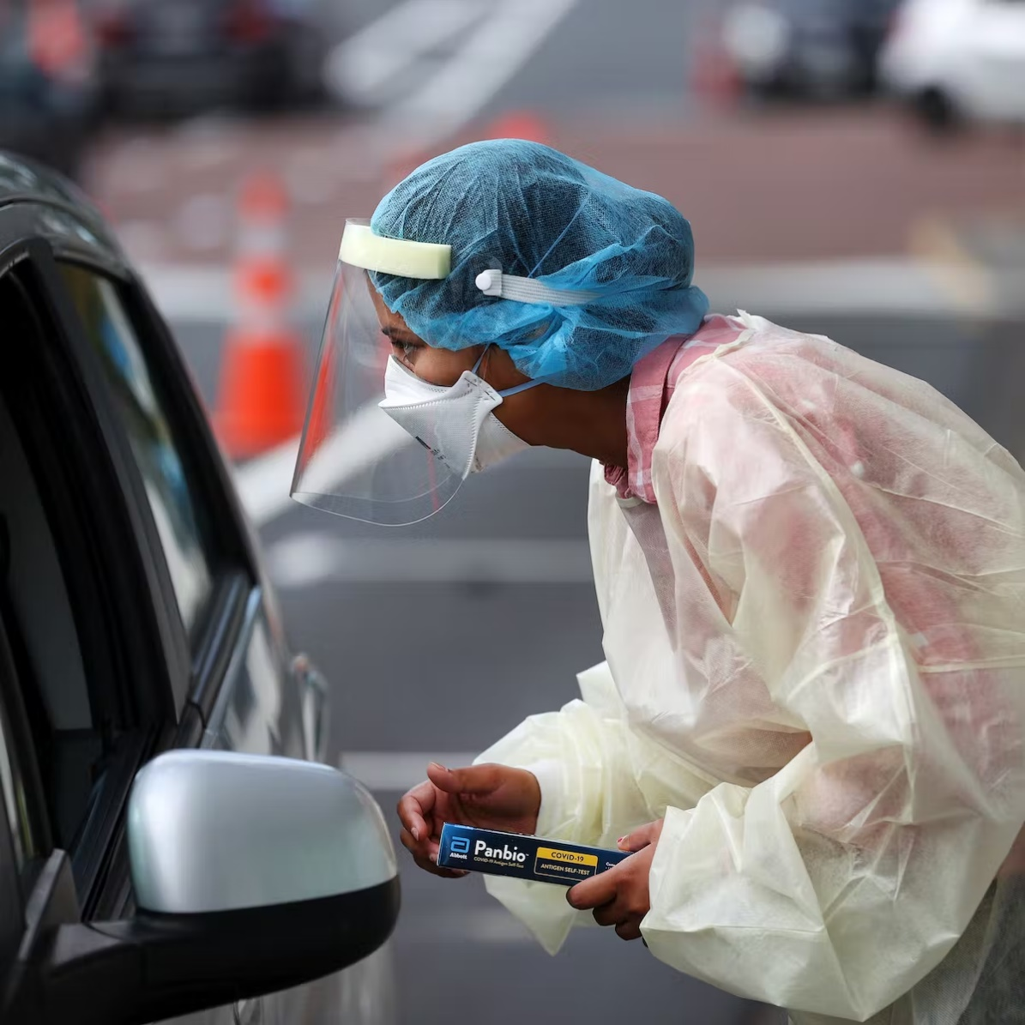

**April 2023**

**CONTENTS**

|  |  |
| --- | --- |
| Introduction | 6 |
| Pandemic Phases Definitions | 7 |
| Further Reference   * The New Zealand Pandemic Plan for Influenza a Framework for Action * Characteristics of Microbes Most Likely to Cause Pandemics and Global Catastrophes | 8 |
| Primary Care Management | 9 |
| Practice Responsibilities and Options for Service Delivery | 10 |
| Recognition and Management | 10 |
| Community Outreach Service | 11 |
| Community Outreach Referral Information | 13 |
| Patient Management Pathway | 14 |
| Communication Plan | 14 |
| Reporting Cases | 15 |
| Surveillance | 15 |
| Isolation of Suspected Cases | 16 |
| Infection Control Precautions | 16 |
| Environmental Cleaning | 17 |
| Public Facing Information | 17 |
| Radiology and Laboratory Facilities | 17 |
| Supplies | 18 |
| Temporary Accommodation | 18 |
| Training | 19 |
| Workforce Management | 19 |
| Planning and Data Modelling | 20 |
| Facility Preparedness | 21 |
| Personal Protective Equipment | 22 |
| Using PPE | 24 |
| Doffing and Donning of PPE | 25 |
| Specimen Collection | 26 |
| Vaccines – General Information | 28 |
| **INFLUENZA** | 32 |
| Case Definition- Influenza | 29 |
| Influenza Pandemic Strain- Checklist | 30 |
| Primary Health Pandemic Influenza Presentation - Patient Care Clinical Pathway | 31 |
| Pandemic Minimum data Set (PMDS) | 32 |
| Management of a Patient with Influenza Like Illness | 33 |
| Use of Antivirals | 34 |
| Tamiflu | 36 |
| Information on Quarantine (Home Isolation) for Influenza | 38 |
|  |  |
| **COVID-19** |  |
| Case Definition COVID-19 | 40 |
| Clinical Criteria COVID-19 | 41 |
| HB COVID-19 Pandemic Data Set (as at September 2022) | 42 |
| Testing Guidance COVID-19 | 42 |
| COVID Care in the Community Framework (2022) | 42 |
| MoH Primary Care Sector Guidance | 43 |
| Hawkes Bay COVID Co-ordination System | 44 |
| Patient Management Pathway | 45 |
| Antiviral Therapy | 46 |
| Types of COVID-19 Medicines | 47 |
| COVID Variants of Concern | 48 |
| Staying at Home, Patient Information | 50 |
| Halcyon COVID-19 Screening Tool | 51 |
| Post COVID Condition - Long COVID | 53 |

**INTRODUCTION**

Pandemics are typically characterised by the rapid spread of a novel type of virus, bacteria or other pathogenic agent to all areas of the world, resulting in unusually high morbidity and deaths for approximately two to three years. Factors that need to be present for a pandemic to occur include: the emergence of a new viral or bacterial subtype; the capacity for the pathogen to spread efficiently from person to person; and being virulent enough to cause disease.

The primary purpose of this plan is to provide the framework and methodology to efficiently respond to a pandemic in general practice. Te Whatu Ora Hawke’s Bay acknowledges as the situation develops primary care response will necessarily evolve with additional forms of care delivery being activated.

## Assumptions

1. Pandemics are inevitable
2. The respiratory mode of transmission is most likely to lead to significant disease spread.
3. Zoonotic diseases such as SARS, MERS, H7N7, Ebola and H1N1 are known, the risk of another zoonotic disease as a causative agent remains possible.
4. There will be very little warning. Most experts believe that we will have between one and six months between the time that a novel pathogen is identified and the time that outbreaks begin to occur in New Zealand. SARS-CoV-2 originated in Wuhan in December 2019, the first recorded case for New Zealand was February 2020.
5. Outbreaks are expected to occur simultaneously throughout much of New Zealand, preventing shifts in human and material resources that normally occur with other natural disasters.
6. Widespread resource constraints will occur.
7. The effect of a pandemic on individual communities will be relatively prolonged -- weeks to months -- when compared to minutes-to-hours observed in most other natural disasters.
8. The majority of health care will be delivered in the primary health care setting.
9. Effective preventative and therapeutic measures, including vaccines and antiviral agents will likely be in short supply, as well as other medications to treat infection.
10. Health-care workers and other first responders will likely be at even higher risk of exposure and illness than the general population, further impeding the care of patients. SARS-CoV-2 evidenced the significant impact on the health care workforce and the requirement to plan is essential.

1. Widespread illness in the community will also increase the likelihood of sudden and potentially significant shortages of personnel in other sectors who provide critical community service for example police, firemen, utility workers, and transportation workers, planning for external shortages is paramount.

**PANDEMIC PHASES – DEFINITIONS**

|  |  |
| --- | --- |
| **WHO Pandemic Phase** | **Definition** |
| **Inter-Pandemic Period**  (WHO Phase 1) | A virus is seen in animals but has not been shown to infect humans |
| **Novel Virus Alert**  (WHO Phase 2) | A known animal virus has caused an infection in humans |
| **Pandemic Alert**  (WHO Phase 3) | Scattered or isolated incidence of cases or small clusters of the disease occurring in humans; possible cases of human-human transmission but not at a level to cause community-level outbreaks |
| (WHO Phase 4) | Human to human transmission at a rate that causes an outbreak in communities |
| (WHO Phase 5) | The spread of the disease between humans is now evident in more than one country |
| **Pandemic Period**  (WHO Phase 6) | Community level outbreaks are in at least one additional country other than that seen in Phase 5 |

For purposes of consistency, comparability and co-ordination of the national, regional and local response, identification and declaration of the following phases will be done at the national level.

Once phase 6 is reached preparation is then made for a global pandemic. Each phase has a list of actions that need to be followed to facilitate transparency and the education of health organisations and members of the public.

<https://www.physio-pedia.com/Endemics,_Epidemics_and_Pandemics>

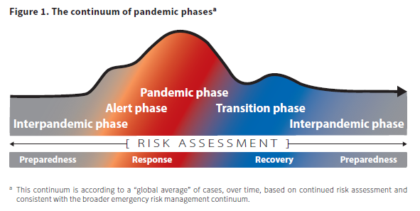

https://www.cdc.gov/flu/pandemic-resources/planning-preparedness/global-planning.html

## FURTHER REFERENCES

The New Zealand Pandemic Plan for Influenza- a framework for action.

<https://www.health.govt.nz/system/files/documents/publications/influenza-pandemic-plan-framework-action-2nd-edn-aug17.pdf> (pages 62-63 pandemic phases)

Characteristics of microbes most likely to cause pandemics and global catastrophes.

<https://ncbi.nlm.nih.gov/pmc/articles/PMC7122301/>

## PRIMARY CARE MANAGEMENT

**During inter-pandemic period:**

* Encourage annual vaccination of staff and consumers of communicable disease
* Promote self-care and ‘telephone first’ health initiatives as business as usual
* Ensure business and continuity plans include a pandemic response plan and are up to date
* Familiarise staff annually with the Business Continuity Plan

**During pandemic alert: Activate Business Continuity Plan (Pandemic)**

* Determine daily activities that can be deferred during the pandemic event
* Develop at risk patient databases to expedite planning and response for this cohort
* Contact at-risk patients to determine coping strategies/action plans, this may include pneumococcal vaccination to reduce incidence and severity of secondary infection.
* Provide updated clinical information on the emerging infectious disease including case definition, management and treatment guidelines to staff
* Make decisions regarding practice collaboration or referral of pandemic-related illness to a larger practice.
* Assess staff availability, including risk stratification of your workforce.
* Purchase sufficient supply of personal protective equipment to cover 7-10 days.
* Promote the public education strategy led by the Te Whatu Ora Hawke’s Bay.
* Initiate staff training plan.

**During pandemic imminent stage:**

* Fully activate the practice Pandemic Response Plan
* Obtain local contact details for advice about, and referral of, suspect patients from Te Whatu Ora Hawkes Bay
* Determine any additional service response required, i.e. triage, testing, treatment, monitoring or drive through
* Obtain the hospital admission criteria and treatment guidelines produced by Te Whatu Ora
* Triage and separate suspected infectious patients away from general patient streams at the practice
* Increase cleaning services in all areas
* Place appropriate visible signage advising patients and others of any restrictions or required actions
* Educate all patients who have pandemic symptoms to seek advice by phone before presenting at the practice
* Ensure provision for additional supplies of oxygen (BOC contracted by the Te Whatu Ora), pulse oximetry and radiology services along with increasing supplies of oxygen masks and tubing in consultation with Te Whatu Ora Hawke’s Bay procurement
* Prepare the workforce, PPE refresher training, pathogen recognition, and triage, as part of Pandemic Response Plan

**During the pandemic:**

* Notify the Medical Officer of Health of all probable cases of disease that meet the criteria, and all related deaths in the community
* Administer antiviral agents and vaccine to patients and staff according to national recommendations
* Utilize telephone service for general practitioners at Te Whatu Ora Hawke’s Bay on 0800 442 312, this service allows direct discussion with a consultant physician for advice and support

Admission criteria and treatment guidelines will be written by the Infectious Diseases Physicians nationally on confirmation of the pathogen involved. These will be disseminated to all general practices on completion.

Utilise triage checklists and patient care pathways appropriate to the presenting pathogen.

**Practice Responsibilities**

Every practice must identify a liaison person whose role will be to:

1. Take lead responsibility for all infection prevention and control issues affecting the practice.
2. Ensure that general practitioners, practice nurses and reception staff are kept up to date with current information from the Te Whatu Ora Hawke’s Bay and the Ministry of Health.
3. Ensure that all staff are adequately trained in infection prevention and control practice.
4. Ensure coding is correct for data mining or extraction for surveillance purposes (PHO led).

**OPTIONS FOR SERVICE DELIVERY**

Options to consider:

1. Telephone triage, telephone consultation if not already part of the standard business model.
2. Practices with a limited workforce may elect to take a collaborative approach with another practice.
3. Community Assessment Centres activated by Te Whatu Ora Hawke’s Bay for the provision of primary care surge capacity arising from a sudden increase in demand (triggered by Code Red).

Functions:

* + Provision of clinical assessment and advice
  + Dispensing of antivirals and antibiotics
  + Provision of triage and referral to other primary or secondary care
  + Infection prevention and control

These centres are based around existing practices with the physical and management structures to support this form of care delivery, once activated an attached outreach service is available.

1. Mobile general practitioner and practice nurse teams to manage home visits. Assessment of the patient and their household contacts should be by phone prior to the visit, if possible.
2. Te Whatu Ora Hawke’s Bay Clinical Outreach Team referral for those patients at risk who are unable to be assessed by other means.
3. Emergency Surge Facility, activated by Te Whatu Ora Hawke’s Bay when primary health care and the Emergency Department are overwhelmed.

**RECOGNITION AND MANAGEMENT**

Utilise the triage checklist to screen suspected cases and consider the best management pathway for the patient with consideration of

* risk of exposure to the pathogen, particularly for patients with comorbidities
* transport or access, do they have access to transport
* what assessment and treatment can be completed via telehealth technology
* what other services does the patient require to support wellbeing for them and their whanau.

Patients who telephone and are advised to attend the practice should be asked to bring their current medicines with them. Ensure updates about how to access care during the pandemic is communicated clearly to your enrolled patients, including after hours services available.

The patient care clinical pathway should be followed for all identified suspect cases. Antiviral medicines will be supplied to patients meeting the criteria, some antibiotics and paracetamol may also be supplied.

Admission and treatment guidelines will be supplied by Te Whatu Ora Hawke’s Bay.

Antiviral medicines will be used in the stamp it out phase for:

* The treatment of early cases
* Post-exposure prophylaxis of contracts
* Possibly pre-exposure prophylaxis of health-care workers

Antiviral medicines will be used in the manage it phase for:

* Patients with severe clinical illness resulting from the presenting pathogen
* Patients with clinical illness who are at high risk of pandemic-related complications (immunocompromised or suppressed patients, pregnant women, severe or poorly controlled congestive heart failure, severe chronic respiratory disease, severe asthma, patients on renal replacement therapy).
* Patients with pandemic symptoms who live or work in high risk institutions (residents of aged residential care facilities [ARRC] or other chronic care facility, people who provide services in relatively closed settings to persons at high-risk).
* Cluster and/or infection control where appropriate on discussion with the Medical Officer of Health.

The MOH will be responsible for application to the MoH for release of the national supply to the Hospital Pharmacy.

Effective vaccine is unlikely to be available for at least 12-16 weeks at which point the Public Health Unit will coordinate a mass immunisation campaign.

###### COMMUNITY OUTREACH SERVICE

Patients who are home bound and unable to access their primary care provider may need to be visited and assessed by a registered nurse or allied health professional. Referal to this service is outlined below.





Patient Management Pathway

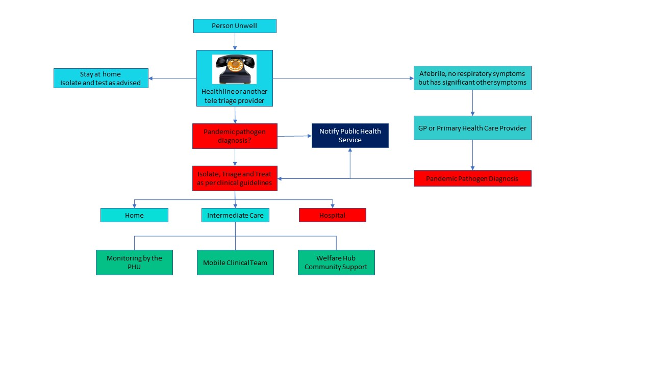

**COMMUNICATION PLAN**

|  |  |  |  |
| --- | --- | --- | --- |
| **Name** | **Title** | **Contact** | **Availability** |
| Te Whatu Ora Hawke’s Bay - [emergency.response@hbdhb.govt.nz](mailto:emergency.response@hbdhb.govt.nz) | | | |
| Sandra Bee | Emergency Management Advisor | 878-8109 | On-call |
|  | Infection Prevention and Control Advisor | 878-8109 | 0800-1700 |
| Public Health Unit- [CIMSOpsPublicHealthUnit@hbdhb.govt.nz](mailto:CIMSOpsPublicHealthUnit@hbdhb.govt.nz) | | | |
|  | Medical Officer of Health | 878-8109 | On-call |

Useful Websites:

**Ministry of Health** <http://www.moh.govt.nz/pandemicinfluenza>

**WHO**  <http://www.who.int>

**CDC** <http://www.cdc.gov>

Daily reports to Emergency Operations Centre at Hawke’s Bay Hospital during Phases 5 and 6.

**REPORTING CASES**

###### Early in the Pandemic

Immediate notification of the first suspected cases is crucial. Phone 834-1815 (seven days). Ask to speak to a Medical Officer of Health (MOH). Make sure you speak directly to a MOH, do not leave a message. Detailed information will be required about each case and the MOH will work closely with the practice to formulate an immediate plan of action, including investigation and management of the case and contacts.

###### When the MOH advises that a Hawke’s Bay Pandemic is established

At this point the MOH will advise all centres that the reporting requirements will be reduced to a minimum Pandemic Minimum Data Set (PMDS), e.g. report date, name, age, gender, ethnicity and suburb or street address. PMDS Forms to be faxed to Te Whatu Ora Hawke’s Bay Emergency Operations Centre. [emergency.response@hbdhb.govt.nz](mailto:emergency.response@hbdhb.govt.nz)

###### SURVEILLANCE

Surveillance means collecting and reporting data about cases to describe the evolving epidemic to help guide a response. Surveillance will be carried out by the Public Health Service (PHS).

Surveillance updates will be available for practitioners on the Te Whatu Ora Hawke’s Bay: <https://hawkesbay.health.nz/current-public-health-warnings-and-alerts/>

**ISOLATION OF SUSPECTED CASES**

The separation of routine patients from those suspected of having the pandemic infection must be planned. This will be achieved by providing separate entrance/waiting rooms/treatment rooms for patients with symptoms. Designated staff should manage the patients in this area.

Prompt triage prior to entering the facility will assist in patient placement. Staff directing patients to the appropriate area should use the symptoms checklists. Providing a surgical mask and hand gel at the point of entry will minimise transmission to others and contamination of the environment.

**INFECTION PREVENTION AND CONTROL PRECAUTIONS**

**Initial precautions**

Such a major health event can only be handled by the whole facility including any Accident and Medical (A&M) team. The entire workforce team should be involved in any planning and preparation, do not forget the cleaner. Your first suspicion of outbreak in your community may come through a phone call. Consider how you will manage your facility’s response.

Staff able to work from home without effecting business, should be encouraged to do so.

It is recommended that all staff be vaccinated each year against seasonal influenza, coronavirus and other appropriate communicable diseases. While this may not protect against a pandemic, it will maintain the general wellness of your team. Unwell staff should stay at home.

Initial precautions for people dealing with someone suspected of having pandemic symptoms include:

* + **Keep your distance**

One metre is accepted as safe and significantly reduces your exposure

* + **Wear a surgical mask, or PFR95 as clinically indicated**

offer a mask to any patient and support people

* + **Frequent hand hygiene- review “5 Movements of Hand Hygiene”**

Use an antimicrobial hand gel or wash in warm water with flowing soap, dry hands with paper towels

* + **Ensure separation patients with respiratory symptoms from other patients**
  + **Ventilation**

Keep windows open if possible. If air conditioning is used, ensure that designated areas can be isolated from the rest of the facility or turn the air conditioning off. Mobile hepa filters may be utilised from the Emergency Management Advisor (Te Whata Ora Hawke’s Bay) if supply is available.

Each general practice or A&M should promote hand and personal hygiene, i.e. the use of tissues when coughing or sneezing, or sneezing/coughing into the elbow.

**ENVIRONMENTAL CLEANING**

Horizontal surfaces should be wiped down after each suspect patient. Patient care areas and bathrooms must be cleaned at least daily on completion of other routine cleaning.

Each facility must have documented Pandemic Environmental Cleaning Guidelines approved by IPC CNS, Te Whatu Ora Hawke’s Bay.

These should include:

Cleaning protocols for:

* High touch areas, floors, staff areas
* Use of environmental wipes
* PPE for cleaning personnel (mask, gown, gloves and eye protection)
* Approved cleaning equipment and chemicals (sodium hypochlorite 100mL in 1L of water 1:10)
* Disposable cleaning cloths
* Management of non-disposal patient equipment
* Waste and linen management

Minimal linen should be used and changed after each patient taking care not to shake it. All waste (except sharps) must go into the biohazard bag.

Linen and waste must be emptied daily or when containers are two thirds full.

**PUBLIC FACING INFORMATION**

Messages to the public will be distributed centrally by Te Whatu Ora Hawke’s Bay following MoH advice, this will assist in managing expectations. Te Whatu Ora will also provide public information on local arrangements.

Information pamphlets are available on the MoH website

<https://www.health.govt.nz/covid-19-novel-coronavirus>

Regular bulletins will be coordinated through Te Whatu Ora Hawke’s Bay. A hotline number may be made available through Te Whatu Ora for updated information on 0800 777 790.

Practices will also have their internal communication systems for providing information to their enrolled patients. It is important that regular, up to date and consistent messaging is provided to the public during a pandemic as anxiety is high and disinformation and misinformation is often targeted and abundant in the community.

**LABORATORY AND RADIOLOGY FACILITIES**

Laboratory specimens may only be collected in the early stages of the pandemic. See specimen collection procedures.

Patients with suspected pandemic illness should not be sent to a community laboratory for collection of throat or nasopharyngeal swabs.

Specimens should be double-bagged and couriered to the Laboratory at Te Whatu Ora Hawke’s Bay.

Radiology service arrangements will continue as normal practice arrangements dictate. They will be supported by TRG Imaging for non- pandemic patients with transport to services the responsibility of Te Whatu Ora Hawke’s Bay.

**SUPPLIES**

Supplies of PPE should be held by each practice to manage initial cases with resupply through the national reserve held by Te Whatu Ora on release by the MoH.

**Essential supplies**

* + Disposable gloves (if indicated)
  + Surgical masks
  + Infared thermometers
  + Tissues – for waiting and consulting rooms
  + Waste disposal bins with lids and medical waste disposal bags
  + Antimicrobial hand gel or hand washing facilities’ (flowing soap, water and paper towels for drying)
  + Gowns (when indicated)
  + PFR95 masks (when indicated)
  + Equipment for collection of multiple specimens for viral culture and PCR

Pandemic guidelines for PPE use must be followed. Including the appropriate use of PFR95 masks and gowns.

Ensure the pandemic plan for your facility includes stock management, and the process for re-ordering. Security of critical supplies is paramount due to short supply and demand for these items.

**Anti-Viral Medication**

The MOH will approve the distribution of antivirals and request the release of the national reserve.

Te Whatu Ora, Hawke’s Bay Pharmacy will:

* **store** antivirals
* **pre-label** the antivirals so that a doctor or nurse can issue the medicine by writing the name and required dose on the label
* arrange **transport** to the provider who will supply the medication to the patient
* **monitor** stock issued

**TEMPORARY ACCOMMODATION**

Arrangements for temporary accommodation for staff who are willing to work but do not wish to go home should be made. This may include an onsite facilities, mobile homes or motel accommodation.

Coordination of temporary accommodation, if required, for patients who live alone will be carried out by Te Whatu Ora Hawke’s Bay.

**TRAINING**

A staff training database ensuring regular infection prevention and control and PPE certification is recommended. Nominating a practice champion as the IPC lead will prevent the health system from being overwhelmed with training requests during a pandemic, and will ensure the practice is already operating within best practice guidelines.

Any additional training necessary to meet the pandemic requirements will be provided by Te Whatu Ora Hawke’s Bay.

**WORKFORCE MANAGEMENT**

Workforce management requires sensible rostering, cover for sickness and absenteeism and attention to staff welfare. Volunteers and ex staff may be utilised although considerable thought is required as to the tasks that may be allocated to these groups.

Ensure appropriate safe direction and delegation of duties is given to unfamiliar, unregulated or returning workforce. Consider a clinical preceptor to facilitate safe orientation of the extended workforce team. Rostering should consider short rotations for those providing care in PPE and adequate break time. Attention to providing protection from the weather in hot and cold conditions must form part of workforce planning if there is a requirement to work outdoors.

Workforce planning should start early in preparation for increased staffing required during the peak of the pandemic. Discussion with staff in the planning phase is essential to determine who will be most likely to be available, and which skills might be adapted to provide cover. Consider operationalising this by reviewing what jobs can be safely reallocated to others to utilise limited workforce most efficiently. Prepare contracts in advance (casual workforce) and train additional workforce early.

In the event of practices amalgamating to provide cover, advice should be given to patients using a standardised approach. Consider external telehealth providers for surge ensuring this is communicated with patients with consistent messaging.

**PLANNING AND DATA MODELLING**

The following graphs depict the pandemic wave based on a Ministry of Health data from the 2020-2023 pandemic. Standard pandemic planning uses a 40% attack rate and 2% case fatality rate. This would result in 72,600 cases and 1,452 deaths in Hawke’s Bay based on the population at 181,500 (2021 estimate).

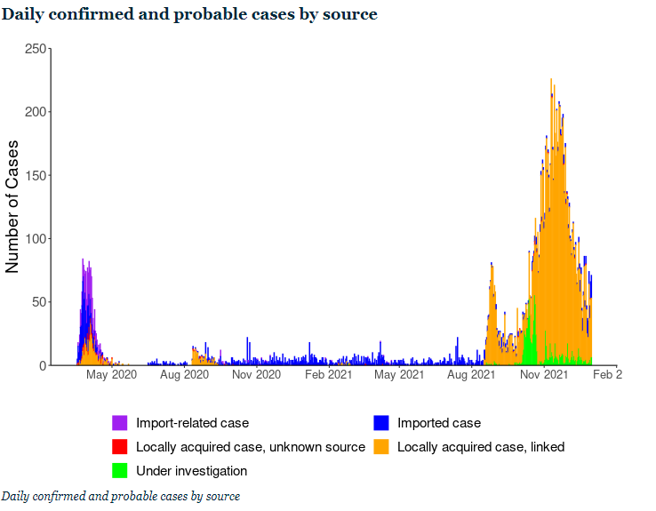

*https://www.health.govt.nz/covid-19-novel-coronavirus/covid-19-data-and-statistics/covid-19-source-cases-2020-and-2021*

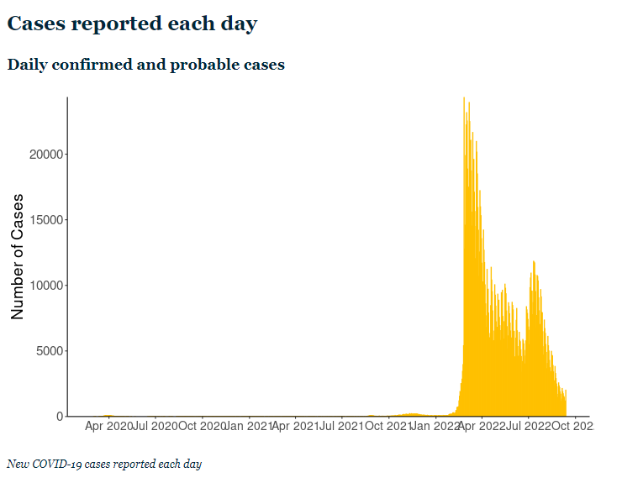

[*https://www.health.govt.nz/covid-19-novel-coronavirus/covid-19-data-and-statistics/covid-19-current-cases*](https://www.health.govt.nz/covid-19-novel-coronavirus/covid-19-data-and-statistics/covid-19-current-cases)

FACILITY PREPAREDNESS

Assessment and Treatment Areas

Red line / green line to separate patients:

* Multiple entries
* Registration area
* Waiting area(s)
* Screens for reception areas
* Assessment area: triage
* Transfer and pre-hospital treatment area
* Patient education/information/counselling area(s)
* Discharge area
* Adjunct services: radiology, laboratory
* Consider external tentage for assessment and testing areas

Storage and Administration

* Secure pharmaceutical supplies area
* Medical supplies, especially secure stores for PPE
* Patient records
* Triage tags/transport and transfer forms
* Ability to stockpile equipment and supplies

Support Services

* Medical waste
* Laundry
* Catering

Staffing

* Current staff levels at all required skill levels, including security staff
* Access to additional staff (consider impact on other services) including volunteer and health support service staff
* Insurance and personal liability cover for practitioners and volunteers
* Staff support services, including staff family support
* Training needs: infection prevention and control; triage methods; communication; telephone advice and triage; personal protection

**Physical Requirements (Infection Prevention and Control Only)**

**Entry**

* Posters, masks and hand gels outside facility to be put on/used before entering
* Antimicrobial hand gel dispensers outside facility so that people entering clean their hands before touching the door handle
* One point of entry for all patients so they do not miss triaging
* Protective screen at reception to minimise droplet spread

**Reception area**

* No toys magazines or newspapers
* Minimal, washable furniture

**Treatment rooms**

* Separate room to minimise exposure/ risk of transmission to others
* Designated toilet facility with appropriate hand hygiene facilities
* Sufficient space: wherever possible the practitioner should have sufficient space to be more than one metre away from the patient when not carrying out a physical examination
* Minimal equipment and supplies in the room
* Washable surfaces
* Pedal operated rubbish bins/linen skip
* Arm operated taps
* Wall dispensers: for antimicrobial hand gel

**Equipment**

* Disposable equipment should be used whenever possible
* Masks, gloves, gowns, eye protection
* Antimicrobial hand washes/gels
* Tympanic thermometers
* Pulse oximeters
* Biohazard bags
* Approved cleaning solutions: hospital grade surface disinfectant or wipes
* Disposable cloths
* Tissues

**PERSONAL PROTECTIVE EQUIPMENT**

### Recommendations for PPE use

Personal protection equipment (PPE) includes masks, eye protection, gloves, gowns and aprons. Varying levels and types of PPE are required, depending on the level of exposure and the risk of transmission.

Whatever the level of PPE to be used, education and training is necessary to ensure the equipment is used and disposed of correctly, to maintain the equipment’s effectiveness.

# Estimate for PPE for GP Practice

One patient requires one GP and one Nurse:

PPE required for 1 patient = 2 masks, 2 pair gloves, 2 gowns

GP sees 4 patients per hour = 8 pair gloves per hour

= 96 patients per 24 hours

= 192 pairs per 24 hours

= 672 patients per week

= 1344 pairs gloves per week

Gloves supplied per box = 100 therefore 26-27 boxes of gloves per week

PFR95 masks ≤4 hours = 12 per day per one GP and one Nurse

= 84 per week

PFR95 masks supplied per box = 35 therefore 2.4 boxes per week

Surgical masks for patients = 672 patients per week

Surgical masks supplied per box = 50 therefore 13-14 boxes per week

If the gown is to last 4 hours = 12 per day (as for masks)

= 84 per week

Gowns supplied per carton = 50 therefore 2 cartons per week

Gowns - you will need to decide how long your gown should last. In the hospital situation a gown is single use. In the primary care setting you may decide to use one gown for 4-8 hours. This will depend on the contact with patients and the care and contamination of the gown.

Gloves may not be required for all patient contacts. Hand hygiene (antimicrobial hand gel or soap and water wash) will be sufficient in most cases.

**NOTE:These numbers are only estimates and may vary during the phases of a pandemic. There are many variables to be considered i.e. practice size, patients seen, acuity, potential for contamination of PPE.**

**Summary of PPE requirements:**

|  |  |  |  |
| --- | --- | --- | --- |
|  | Entering Room but no close contact (> 1 metre from patient) | Close patient contact (<1 metre from patient) | Aerosol generating procedure being performed (including nose/throat swabs) |
| PFR95 mask | No | No | Yes |
| Surgical mask | Yes | Yes | No |
| Isolation gown | No | No | Yes |
| Gloves, non-sterile | No | No | Yes |
| Eyewear, protective | No | No | Yes |

### Use of disposable surgical masks, gloves and gowns/aprons

Disposable surgical masks are recommended for first responders and health care/support workers in a health care setting who are at risk from droplet transmission.

Disposable gloves are recommended as a means of reducing the likelihood of transmission of a virus when handling objects contaminated with respiratory secretions. Apart from health care settings, the use of gloves is less important than careful hand hygiene. The use of gloves does not replace the need for hand hygiene.

Disposable gowns or splash resistant aprons may also reduce opportunities for transmitting a pandemic virus.

### Using particulate respirator masks (PFR95), eye protection, gloves and gowns/aprons (full PPE)

Health care workers should wear particulate respirator masks, eye protection, gloves and gowns/aprons (i.e. full PPE) when there is a high risk of direct contact with respiratory secretions, particularly via aerosols. This will apply mostly in inpatient settings during some invasive procedures.

In most other settings a disposable surgical mask and regular hand hygiene will provide sufficient protection from droplet transmission for health care workers in close contact and/or providing direct personal care to patients with a pandemic virus.

**Checklist for Staff before Entering Isolation Areas**

The following points must be checked before entering a designated area:

* Cell phones or pagers left outside the area along with pens, stethoscopes and tourniquets
* Shoulder length hair must to clipped or tied back
* Shoes should cover and protect feet from splashes and dropped equipment and should have wipeable surfaces
* A mask must be worn and fit securely
* A gown must be worn and be tied firmly
* Gloves must be worn and cover the wrists

**USING PERSONAL PROTECTIVE EQUIPMENT**

NB: The correct donning and doffing process must be followed. A doffing area must be designated with the appropriate equipment i.e. hand hygiene products and waste disposal bins.

If any of the following occurs the mask must be changed:

* if you touch it
* if it is grossly contaminated
* if it becomes wet for any other reason
* if it becomes hard to breathe through

Masks should be placed in a biohazard bag after removal.

If at any time gloves become contaminated, they must be removed, hand hygiene performed and clean gloves put on.



**SPECIMEN COLLECTION**

All samples should be sent by the usual Southern Community Laboratories specimen collection service to Hawke’s Bay Hospital Laboratory.

**Who should be swabbed?**

* Swabbing should be reserved for only those patients with pandemic illness who are in high risk groups or situations.

***People on antiviral medicine***

* Antiviral medicines reduce the yield from viral swabs.
* If an adult case has commenced a *twice-daily treatment* course of antiviral medicine, do not take swabs. Children excrete a higher viral load. If a child case has been on a *twice-daily treatment* course of antiviral medicine for >48 hours do not take swabs.
* For contacts on *once-daily prophylaxis* with antiviral medication who develop symptoms, a swab is indicated if within 48 hours of commencing antiviral medicine.

***People not on antiviral medicine***

* Virus shedding declines with time in untreated patients.
* Do not take swabs from an adult case who has had symptoms for five days or longer.
* Children (especially young children) shed for longer, so untreated children can be swabbed even if they have had symptoms for longer than five days.

**Samples required**

* Nasopharyngeal swab in viral transport medium

**Sample collection**

Respiratory specimens should be collected as early as possible in the course of the illness. The likelihood of recovering most viruses and many bacteria diminishes markedly >72 hours after symptom onset. Some respiratory pathogens may be isolated after longer periods.

**Equipment**

One nasopharyngeal swab with non-wooden shaft and synthetic fibre tip

One virology swab with viral transport medium

One pair of scissors

PPE i.e. gloves, gown, PFR95 mask, eye protection, antimicrobial hand gel

(i) Collection of nasopharyngeal swabs

Use a pernasal swab with non-wooden shaft and synthetic fibre tip:

Insert swab into one nostril, parallel to the palate, rotate gently and advance until resistance is felt. (One eye will often water when swab is in the correct position.)

Press swab tip on the mucosal surface of the mid-inferior portion of the inferior turbinate and leave in place for a few seconds, then slowly withdraw using a rotating motion.

Place swab into **viral transport medium tube.**

Snap or cut off the cap with scissors and discard the cap

Ensure tube lid is secure and labelled correctly.

1. If the viral transport medium is liquid

Cut the swab sticks off just below the level of the bottle - so that there is no swab pressure for the viral media lid to pop off.

Ensure lid is firmly closed on viral specimen and taped to prevent leakage of viral media, ensure the specimen is labelled correctly.

**Packaging and Transport:**

* The laboratory form should clearly indicate that this is a request for “PCR testing for novel (pathogen) infection”. Write “copy result to the Medical Officer of Health”. Notifying the Medical Officer of Health is not required before sending the swab.
* Ensure the laboratory request form is fully completed with details including the NHI number and that the specimen container contains the patient name and NHI number.
* **Specimens should always be bagged ensuring that the snap lock is securely sealed. Place the request form in the pocket of the outside bag.**
* Specimens should be transported by Southern Community Laboratories to the Hawke’s Bay Hospital Laboratory.

**VACCINES – GENERAL INFORMATION**

**Vaccine Management should be based** **on the following assumptions:**

1. There will be a minimum of 6 months between a novel virus alert and the availability of vaccine, as evidenced in the COVID-19 Pandemic.
2. The entire population will be susceptible and may require two or more doses of vaccine for adequate protection.
3. The proportion of vaccine to be distributed and administered through the public versus the private sector is unknown. Even so, the amount, if not the proportion, of vaccine that will be distributed through the public sector during a pandemic will be greater than the amount distributed by the public sector in non-pandemic years.
4. There will be a national contract for purchase of vaccine.
5. Multiple vaccines will likely be available quickly, requiring workforce training, education and preparedness.

**Vaccine Administration**

Vaccinators are authorised by the Medical Officer of Health pursuant to regulation 44a of the Medicines Regulations. Hawkes Bay has authorised vaccinators available with a database being maintained to record all vaccinations. A list of currently authorised vaccinators is held by the PHU.

In response to the COVID-19 pandemic, the provisional vaccinator workforce was instrumental in providing a rapidly trained vaccination workforce. In addition, non-regulated vaccinator roles i.e. COVID Vaccinator working under supervision (CVWUS) or similar workforce may also feature as part of a regular vaccination team. It is important that the workforce is trained and supervised to ensure Vaccinators comply with current legislation.

**Priority Groups List for Receipt of Vaccine**

Because vaccine shortage during a pandemic is likely, the MoH, in conjunction with various advisory committees, will formulate recommendations for a rank-order list of high priority groups for vaccination. The order of these groups will be based on a number of factors, including the need to maintain the infrastructure necessary to carrying out the pandemic response plan; to limit mortality among high-risk groups; to reduce morbidity to the general population; and to minimize social disruption and economic losses.

While any Priority Groups List will be subject to change, the list will most likely include the following groups:

* Health-care workers and public health personnel involved in the distribution of vaccine and antiviral agents
* Persons responsible for community safety and security, e.g. police, fire-fighters, military personnel, corrections officers, "first responders" not included in first priority group (e.g. ambulance officers)
* Other highly skilled persons who provide essential community services whose absence would either pose a significant hazard to public safety (e.g. air traffic controllers) or severely disrupt the pandemic response effort (e.g. persons who operate telecommunications or electric utility grids, care givers at residential facilities). [NOTE: Members of this target group are likely to vary widely from region to region, depending on local circumstances.]
* Persons considered to be at increased risk of severe influenza illness and mortality

Vaccination will be coordinated by the Public Health Service at Te Whatu Ora Hawke’s Bay.

**INFLUENZA**

## MINISTRY OF HEALTH CASE DEFINITION

|  |
| --- |
| **Suspected case of Pandemic Influenza**  Person with an influenza like illness of abrupt onset, characterised by:   * + History of fever, chills and sweating; or   + Clinically documented temperature ≥38˚C ; and   + Cough or sore throat   **Probable case of Pandemic Influenza**  Person with an influenza like illness who has a strong epidemiological link to a confirmed case or defined cluster.  **Confirmed case**   An individual for whom laboratory testing demonstrates one or more of the following:   * + - 1. positive viral culture for Pandemic Influenza; or       2. positive RT-PCR for Pandemic Influenza; or       3. four-fold rise in novel influenza virus specific neutralising antibodies. |

**CHECKLIST – INFLUENZA PANDEMIC STRAIN**

Complete the following checklist at first contact with patient, i.e. in triage room or over the telephone.

May 2019

Yes/No

|  |  |  |  |
| --- | --- | --- | --- |
| **1.** |  | History of fever, chills, myalgia **or** clinically documented fever > 380C |  |
| **2.** |  | **PLUS, two or more of the following** |  |
|  |  | Headache |  |

|  |  |  |  |
| --- | --- | --- | --- |
|  |  | Malaise |  |

|  |  |  |  |
| --- | --- | --- | --- |
|  |  | Cough |  |

|  |  |  |  |
| --- | --- | --- | --- |
|  |  | Sore throat |  |

Patients with **both** 1 **and** 2 meet the definition of influenza-like illness.

If you have a suspect case, direct patient to nearest community assessment centre, if activated, or general practice caring for influenza related illness if triage over the phone. If patient has presented at general practice, put a mask on the patient and put on protective clothing immediately, direct the patient to the designated influenza area.

Primary Health Pandemic Influenza Presentation - Patient Care Clinical Pathway

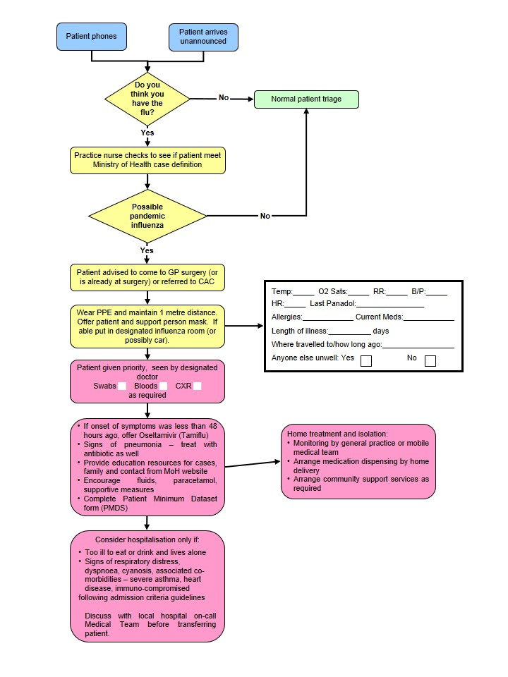

|  |  |
| --- | --- |
|  | **PANDEMIC MINIMUM DATA SET** |

|  |  |
| --- | --- |
| Name of Practice: | Date: |
| Clinical Assessor: | Signature: |

|  |  |  |  |  |  |  |
| --- | --- | --- | --- | --- | --- | --- |
| Name: Given | | Middle | | | Family | |
| Address: | | | | | | |
| House Number: | | | | | | |
| Street: | | | | | | |
| Suburb: | | | | | | |
| Town: | | | | | | |
| Gender: M / F | DOB: | | | NHI: | |  | |
| Ethnicity: | European | | Maori | Pacific | | Other | |

**Please Circle Appropriate Codes**

|  |  |  |  |  |
| --- | --- | --- | --- | --- |
| **Category Codes** | |  | **Antiviral Status Codes** | |
| GEN | General Public |  | TRT-T | Treatment provided – Tamiflu |
| HCN | Health Care Nurse |  | TRT-R | Treatment provided – Relenza |
| HCD | Health Care Doctor |  | OWN-T | Antiviral treatment from own supply - Tamiflu |
| HPA | Health Care Ambulance |  | OWN-R | Antiviral treatment from own supply - Relenza |
| HCO | Health Care Other Direct Contact |  | POP-T | Post exposure prophylaxis with Tamiflu |
| BOR | Border Worker |  | POP-R | Post exposure prophylaxis with Relenza |
| POL | Police |  | **Antibiotic Codes** | |
| DEF | NZDF Member |  | NIL | No antibiotics provided |
| COR | Corrections Worker |  | TRT | Antibiotic treatment provided – evidence of existing respiratory bacterial infection |
| FIR | Fire Service Worker |  | PRO | Prophylactic/precautionary antibiotics provided because of unusual vulnerability to bacterial infection (e.g. person with COPD, CHF, asthma or other condition) |
| SOC | Civilian Social Support Worker |  | **Antibiotic Prescribed** | |
| **Treatment Rationale Codes** | |  | AUG | Augmentin |
| ILI | Severe influenza-like illness |  | COT | Co-Trimoxazole |
| HRG | High risk group |  | DOX | Doxycycline |
| HRI | High risk institution – **MUST** be discussed with the Medical Officer of Health |  | FLU | Flucloxacillin |

**Management of Patient with Influenza-Like Illness**

**Influenza-like Illness (ILI)**

* History of fever, chills, myalgia or clinically documented fever ≥ 38°C

**and two or more of the following**

* Cough, sore throat, headache, malaise

**High Risk Groups**

1. People with influenza-like Illness who are at high risk of influenza-related complications:

* People who are immune compromised or suppressed (transplantation, haematological and solid organ malignancy on chemotherapy/radiotherapy, HIV, autoimmune disorders, etc)
* Pregnant women – discuss with infectious diseases physician
* Mental health patients on Clozapine

Anyone over six months of age with chronic medical conditions, such as:

* Severe or poorly controlled congestive heart failure
* Severe chronic respiratory disease
* More severe asthmatics (e.g. people on oral steroids, high dose steroid inhalers, or steroids and long acting beta-agonists)
* Renal replacement therapy

1. People with influenza-like illness who live or work in residential institutions, (e.g. prisons, boarding schools, nursing homes). Please discuss with Medical Officer of Health telephone: 8341815.

Does this person meet clinical criteria for Severe ILI?

**SIRS Criteria**

**Clinical Criteria for Severe ILI**

More than one of the following:

* Temperature ≥ 38°C
* Heart Rate > 90
* Respiratory Rate >20

Is the patient in a high risk group?

Self-manage at home.

Do not prescribe National Reserve Tamiflu or antibiotics

* Fax prescription(s) to authorised pharmacy
* Fax *Patient Minimum Data Set* form to 0800 856 923
* Instruct patient or relative to collect Tamiflu
* Advise to stay in isolation until well

**Consider hospital assessment if patient has any of the following:**

T > 39°C

SBP < 100

HR > 110

RR > 25

O2 Saturation < 92

Vomiting > 1 in 24 hrs

Confusion

Rigors

Pleuritic Chest Pain

Inability to self-care

Dehydration

These criteria are not prescriptive and cannot replace clinical judgement

**Yes**

**No**

**Yes**

**No**

USE OF ANTIVIRALS

Influenza viruses develop significant resistance quickly for M2 channel blockers. In New Zealand, zanamivir is for ‘in hospital’ treatment and prophylaxis of influenza in **hospitalised** patients subject to restriction. Therefore, only oseltamivir (Tamiflu) will be described in detail.

First line health care workers will be using antivirals from the Governments stockpile, because the antiviral medication will be in short supply when the pandemic strikes. The MoH (directly or through Medical Officers of Health) will be communicating guidelines, protocols, and priorities for its use.

Tamiflu might be used prophylactically for exposed travellers, containment of sporadic clusters, essential services staff and therapeutically for all patients (initially), high-risk patients, essential services staff.

Tamiflu is indicated for the treatment of influenza in adults and children 2 weeks of age and older who have been symptomatic for no more than 2 days (see section 4.4 Special warnings and precautions for use).

<https://www.medsafe.govt.nz/profs/Datasheet/t/Tamiflucapsusp.pdf>

Tamiflu is indicated for the prophylaxis of influenza in adults and children >1 years of age. Vaccination is the preferred method of routine prophylaxis against infection with influenza virus.

**Presentation**

Tamiflu 30 mg hard capsules

Tamiflu 45 mg hard capsules

Tamiflu 75 mg hard capsules

### Tamiflu 6mg/ml powder for oral suspension

### Dosage and Method of Administration

Tamiflu may be taken with or without food. However, Tamiflu taken with food may enhance tolerability in some patients.

#### Standard Dosage

##### Treatment of influenza

Treatment should begin within the first 48 hours of the onset of symptoms of influenza.

*Adults and adolescents*

The recommended oral dose of Tamiflu capsules in adults and adolescents ≥ 13 years is a 75mg capsule twice daily, for 5 days. Adults and adolescents ≥ 13 years of age that are unable to swallow capsules may receive a dose of 75mg Tamiflu suspension BD for 5 days.

*Infants and Children* ≥*1 to < 13 years of age*

Infants and children 1 year old may receive the required Tamiflu dose in the form of capsules. Patients unable to swallow capsules may receive the appropriate dose of Tamiflu oral suspension, see Patients unable to swallow capsules).

The recommended weight adjusted dosing regimens of Tamiflu for children ≥ 1 year of age are:

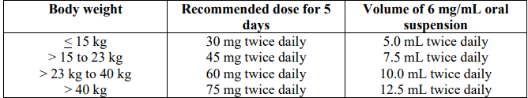

*Infants 2 weeks to < 1 year of age.*

The recommended oral dose of Tamiflu for infants 2 weeks to less than 1 year of age is 3 mg/kg twice daily, for 5 days. These dosing recommendations are not intended for infants who have a post conceptual age of less than 36 weeks.

Special dosage instructions

No dose adjustment is necessary for patients with creatinine clearance above 60mL/minute. In patients with creatinine clearance between 10 and 30mL/minute receiving Tamiflu it is recommended that the dose be reduced to 75mg of Tamiflu every other day or 30mg suspension every day. No dosing recommendation is available for patients undergoing routine haemodialysis and continuous peritoneal dialysis with end stage renal disease and for patients with creatinine clearance ≤ 10mL/minute.

No dose adjustment is required for patients with hepatic dysfunction and no dose adjustment is required for elderly patients.

The safety and efficacy of Tamiflu in children under 1 year has not been established. Tamiflu should not be used in children under 1 year of age.

A bottle of 30g Tamiflu powder for oral suspension contains 25.713g of sorbitol. One dose of 45mg oseltamivir administered twice daily delivers 2.6g of sorbitol. For subjects with hereditary fructose intolerance this is above the recommended daily maximum limit of sorbitol.

##### Prophylaxis of influenza

The recommended oral dose of Tamiflu for prophylaxis of influenza is 75mg once daily for at least 10 days. Therapy should begin within two days of exposure.

### Contraindications

Hypersensitivity to oseltamivir phosphate or any component of the product.

Information derived from pharmacology and pharmacokinetic studies of oseltamivir suggest that clinically significant interactions with other medicines are unlikely.

At present, insufficient data are available in pregnant women taking Tamiflu to enable an evaluation of the potential for oseltamivir cause foetal malformations or foetal toxicity. Tamiflu should therefore be used during pregnancy only if the potential benefit justifies the potential risk to the foetus.

<https://www.medsafe.govt.nz/profs/Datasheet/t/Tamiflucapsusp.pdf>

INFORMATION ON TAMIFLU

**How effective is the anti-viral medicine Tamiflu against influenza?**

Tamiflu is one of two medicines that are effective against the strains of Influenza A and B.

The WHO have advised all health authorities to stockpile anti-viral medicines to prepare for a pandemic. New Zealand has followed that advice.

**Will Tamiflu cure people sick with the Pandemic Influenza virus?**

We don't know for sure.

When people have seasonal influenza, Tamiflu reduces symptoms and may shorten the duration of illness by a day and a half.

If otherwise healthy people who are ill with influenza take it, they are less likely to develop complications of influenza. Those complications are usually treated with antibiotics.

**Does Tamiflu prevent people from getting influenza?**

Yes, it does, but it is not the best means of preventing influenza. Vaccination is the best protection against influenza, which is why people are encouraged to immunise against seasonal influenza every year. Tamiflu will help until a pandemic vaccine arrives.

For more information on Tamiflu, including how it works against influenza, see the datasheet, <http://www.medsafe.govt.nz/profs/datasheet/+/Tamiflucapsusp.pdf>.

**How does Tamiflu work?**

It is a medicine that only works against influenza viruses A and B.

It does not work against other viruses or bacteria that can cause illness similar to influenza or that can cause respiratory infection. If taken within 48 hours of becoming ill it stops the virus from bursting out of infected cells, infecting new cells and possibly other people.

**Will masks help protect me and my family from the influenza virus?**

A surgical mask, if put on someone who is sick, will help reduce the spread of infection, because it will reduce the amount of virus spread by coughs and sneezes.

People who are not sick and who are very close to the person who is coughing and sneezing - closer than 1 metre - may get some protection by covering their own nose and mouth with a mask. Again, this is because the mask will catch some of the virus in the cough and sneeze droplets.

**What about interactions between Tamiflu and other drugs I am taking?**

There are no significant interactions known.

**Side effects**

Most people taking Tamiflu experience no side effects. A small proportion will experience one or more of the following:

|  |  |
| --- | --- |
| **Common** | **Less commonly** |
| Nausea 8-10%  Vomiting 2-8%  Headache 2-17%  Diarrhoea  Abdominal pain 1-4 %  Dyspepsia  Conjunctivitis | Eczema  Rash  Convulsions  Arrhythmias  Altered consciousness  (usually in children or adolescents) |

## Information on Quarantine (Home Isolation) for Influenza

You have been asked to stay in isolation because:

1. You have suspected influenza and are infectious to others. Isolation in your home should continue for 72 hours after starting Tamiflu or 7 days from the onset of illness if you are not taking Tamiflu.
2. You may have been exposed to influenza. Isolation in your home should continue for 72 hours after starting Tamiflu or 7 days from the onset of illness if you are not taking Tamiflu.

The period of isolation may be lengthened if somebody else in your household becomes sick with suspected influenza.

We want you to restrict your activities to protect the safety of your family, friends and the community. This information sheet is to tell you what isolation means.

**Staying at home**

You must not go to school, work, child care or out in public until cleared by the Public Health Nurse. This means you must not attend shopping centres, movies, parties or any social gatherings at all.

**Visitors**

You should have no visitors until you come out of isolation. Talk by phone and have things delivered to the door. Sometimes a visitor is essential (for example someone has to come into the house to give you essential home support). The visit should be brief. You and the visitor must both wear a mask. Talk with the visitor outside in the open air if possible and keep at least two metres away from them.

Preventing the spread of infection

* Stay in a part of the house where you have minimal contact with other people. Try to keep well people and sick people apart.
* Give people who have a fever and/or diarrhoea plenty to drink.
* Give Paracetamol for fever. *Do not give Aspirin to children under 12 if they have a fever.*
* Open doors and windows and ventilate the house as much as possible.
* Cover your mouth and nose with a tissue or toilet paper when you are coughing or sneezing. Put the used tissue straight into a rubbish container. Wash and dry your hands afterwards.
* Wash and dry your hands after you use the bathroom or toilet. Wash and dry your hands before you prepare food and eat, and when you are looking after sick people.
* If you have more than one toilet, then one should be reserved for use by sick people.
* Twice a day clean the following:
* with 1-part household bleach to 10 parts water:
* toilet handle and door handle of the toilet, bathroom and rooms of isolated people
* bathroom sink and taps
* Nobody else should use anything that could be contaminated with your throat or nose secretions or coughing or faeces – e.g. towels, handkerchiefs, eating utensils, food, bed linen, cigarettes, marijuana joints, P pipes, kava bowls.
* Sharing bedding, clothing and utensils may spread infection, but you do not need to wash a sick person’s bedding, clothing and utensils separately from the rest of the families. If you wash and dry all these things in the usual way they will then be safe for others to use.

**Using face masks**

* Sick people should wear a surgical mask if anyone is in their room and if they have to leave their room.
* People who are in quarantine but not sick should wear a particulate respirator (N95) mask if they are in the same room as a sick person.
* Essential visitors to the house should wear a particulate respirator (N95) mask through their visit.

Used masks should be put in the normal household rubbish.

**Coming out of isolation**

You will receive notification when you are cleared to come out of isolation. At that time, you will be non-infectious to others. It will then be safe for you to resume your normal life.

**Questions**

Your Public Health Nurse, general practice or Healthline will be happy to answer any questions.

**COVID-19**

COVID-19, MINISTRY OF HEALTH CASE DEFINITION (2022)

**Confirmed case**

A case that has laboratory definitive evidence.

Laboratory definitive evidence requires at least one of the following:

* detection of SARS-CoV-2 from a clinical specimen using a validated NAAT (PCR). Very weak positive results will only be labelled a confirmed case when the result is confirmed on a second sample.
* detection of coronavirus from a clinical specimen using pan-coronavirus NAAT (PCR) and confirmation as SARS-CoV-2 by sequencing
* significant rise in IgG antibody level to SARS-CoV-2 between paired sera
* detection of SARS-CoV-2 from a clinical specimen using a validated laboratory multi-target NAAT (PCR) OR a validated single target point of care NAAT (PCR) test

**Probable case**

A close contact of a confirmed case that has a high exposure history, meets the clinical criteria and for whom testing cannot be performed, or

A close contact of a confirmed case that has a high exposure history, meets the clinical criteria, and has a negative PCR result but it has been more than 7 days since symptom onset before their first negative PCR test was taken.

An individual with a positive result from a clinical specimen using a certified rapid antigen test (RAT), either supervised or self-tested who

* Has symptoms consistent with COVID-19 OR
* Is a close contact of a confirmed or positive case OR
* Is asymptomatic (in phase 3 only)

**Historical case**

A confirmed case that is deemed to have recovered (no longer considered infectious) at the time of testing or a person with a positive NAAT(PCR) result with a high CT value, which is followed by a negative rapid antigen test (RAT).

**Under investigation case**

A case that has been notified where information is not yet available to classify it as confirmed, probable or not a case.

**Not a case**

An ‘under investigation’ case who:

* has a negative test and has been assessed as not a case;
* a person where SARS-CoV-2 has been detected, where the detection is determined to be due to a previous COVID-19 infection which has already been recorded either in New Zealand or overseas within the previous 28 days from release.
* a person who has detection of SARS-CoV-2 from a clinical specimen but, following further investigations such as serology, repeat testing, history, and symptoms, they are deemed to not be a case (e.g. a likely false positive).

CLINICAL CRITERIA FOR COVID-19

The clinical criteria support health professionals to identify those with a higher risk of having COVID-19.

Common symptoms of COVID-19 infection are similar to other viral illnesses such as colds and influenza.

COVID-19 positive persons usually present with at least one of the following symptoms:

* new or worsening cough
* sneezing or runny nose
* fever
* temporary loss of smell or altered sense of taste
* sore throat
* shortness of breath
* fatigue/feeling of tiredness

Less common symptoms may include diarrhoea, headache, muscle aches, nausea, vomiting, malaise, chest pain, abdominal pain, joint pain or confusion/irritability.

Symptoms tend to arise around two to five days after a person has been infected but can take up to 14 days to appear. The virus can be passed to others from up to two days before symptoms develop.

Other conditions that require urgent assessment and management should always be considered as possible diagnoses alongside COVID-19.

<https://www.health.govt.nz/system/files/documents/pages/primary_care_quick_reference_guide_june_2022.pdf>

HB COVID-19 PANDEMIC DATA **SET (as @ Sept 2022)**

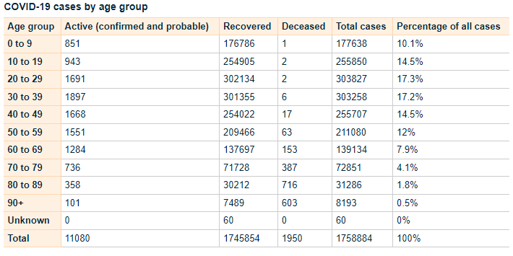

<https://www.health.govt.nz/covid-19-novel-coronavirus/covid-19-data-and-statistics/covid-19-case-demographics#all-cases>

Testing Guidance COVID-19

<https://www.health.govt.nz/system/files/documents/pages/testing_operational_guidance_for_general_practice_10_march_2022.pdf>

COVID Care in the Community Framework (2022)

<https://www.health.govt.nz/system/files/documents/pages/covid-19-care_in-the-community-framework-25aug22.pdf>

### 

HAWKE’S BAY COVID CO-ORDINATION SYSTEM

### 

Patient Management Pathway

|  |  |  |  |  |  |  |  |
| --- | --- | --- | --- | --- | --- | --- | --- |
| **Assessment and Definition** | **Severity** | **Mild** | | **Moderate** | | **Severe/Critical** | |
| **Clinical definition** | No symptoms | Any COVID symptoms **without** features of pneumonitis | A clinically stable patient with any evidence of COVID-19 pneumonitis:   * New onset (or worsening) shortness of breath **OR** * Infiltrates on plain chest radiograph **OR** * Hypoxaemia that is **EITHER:** | | Any of the following:   * Requiring CPAP or high-flow nasal oxygen to maintain saturation ≥ 92% **OR** * Acute respiratory distress e.g. RR >30 **OR** * Rapidly deteriorating clinical trajectory | Any of the following:   * Requiring mechanical ventilation to maintain saturation ≥ 92% **OR** * Requiring advanced circulatory support |
| ...mild (92-94%), transient, or exercise-induced only (i.e. not requiring continuous oxygen therapy **OR** | …sustained but able to maintain ≥ 92% (≥90% for patients with chronic lung disease) with up to 4L/minute oxygen via standard nasal cannula |
| **Stage of infection** | Almost all cases in the first 5 days; throughout in most vaccinated patients without risk factors | | Progression to moderate/severe disease most commonly develops ~ 5-7 days post onset of illness in patients with significant risk factors; the trajectory of deterioration can sometimes be rapid | | | |
| **Site of care** | **Community** | | **Individual decision** | **Hospital** | | |
|  | **Anti-viral therapy** | Paxlovid OR Remdesivir OR Molnupiravir If <5 days illness AND meets high risk criteria | | | Consider Remdesivir if <7days illness | | Nil |
| **Therapeutics** | **Respiratory support** | Nil | | | Oxygen via NP | CPAP (or HFNO) | Mechanical ventilation |
| **VTE prophylaxis** | Nil | Low dose Enoxaparin  *if hospitalised* | | Low dose Enoxaparin  (or consider therapeutic dose) | Low dose Enoxaparin | |
| **Corticosteroids** | Nil | Consider inhaled Budesonide *if meets high risk criteria* | | Dexamethasone | | |
| **Immune modulation** | Nil | | | Baricitinib or Tocilizumab | | Tocilizumab |
|  | **Antibody therapy** | Nil | | | | | |

ANTIVIRAL THERAPY

**Taking antiviral medicines to treat COVID-19**

COVID-19 antiviral medicines are available to treat eligible people with COVID-19 at home. COVID-19 medicines must be commenced within the first five days of onset of COVID-19 symptoms. When taken early in COVID-19 illness, these medicines have been proven to reduce hospitalisation and death.

These medicines are free for eligible people with COVID-19 within five days of their symptoms starting. If eligible, persons may get a prescription from their usual healthcare provider, or the medicine may be supplied without a prescription from some pharmacies.

**Eligibility for COVID-19 medicines**

People with a high risk of severe illness from COVID-19 are eligible for treatment with COVID-19 medicines.

To be eligible for COVID-19 antiviral medicine the consumer must:

* have symptoms and have tested positive for COVID-19 or
* have symptoms and be a household contact of a person with COVID-19

One of the following must also apply:

* severely weakened immune system
* Down syndrome
* sickle cell disease
* aged 75 years or older
* previously been admitted to an intensive care unit as a result of COVID-19 and have tested positive again

Persons may also be eligible if they meet two or more of the below criteria:

* [high-risk medical conditions](https://www.health.govt.nz/covid-19-novel-coronavirus/covid-19-information-specific-audiences/covid-19-higher-risk-people)
* over 50 years of age
* Māori or Pacific Island ethnicity
* not vaccinated for COVID-19, or are not up to date with your COVID-19 vaccinations

Please note: These medicines may not be suitable for everyone, even if they meet eligibility criteria.

More information about eligibility can be found on the [Pharmac](https://pharmac.govt.nz/news-and-resources/covid19/access-criteria-for-covid-19-medicines/covid-antivirals/access-criteria-assessment-tool/) website, including its [access criteria assessment tool](https://pharmac.govt.nz/news-and-resources/covid19/access-criteria-for-covid-19-medicines/covid-antivirals/).

Te Whatu Ora has developed an Eligibility Guide for COVID-19 antiviral medicines:

<https://www.health.govt.nz/system/files/documents/pages/eligibility-guide-for-covid-19-oral-antiviral-meds-12aug22.pdf>

Types of COVID-19 medicines available

Three COVID-19 antiviral medicines are available to treat eligible people with COVID-19 in the community:

Nirmatrelvir with ritonavir (branded as Paxlovid)

Molnupiravir (branded as Lagevrio)

Remdesivir, an infusion treatment (branded as Veklury).

For more information please see the following links

**Paxlovid**

<https://www.healthnavigator.org.nz/paxlovid/>

<https://www.medsafe.govt.nz/profs/Datasheet/p/paxlovidtab.pdf>

**Lagevrio**

<https://www.healthnavigator.org.nz/medicines/m/molnupiravir/>

<https://www.medsafe.govt.nz/profs/datasheet/l/lagevirocap.pdf>

**remdesivir**

<https://www.healthnavigator.org.nz/medicines/r/remdesivir/>

https://www.medsafe.govt.nz/COVID-19/treatment-applications.asp

<https://www.health.govt.nz/covid-19-novel-coronavirus/covid-19-health-advice-public/advice-people-covid-19/covid-19-medicines>

Return of Symptoms Following Paxlovid Treatment

For some people, symptoms may return after completing a course of Paxlovid. This is known as Paxlovid rebound.

People experiencing Paxlovid rebound do not appear to get severely ill. Symptoms are usually mild and typically resolve within three days.

It is normal for some people recovering from COVID-19 to have symptoms that come and go for some time, regardless of whether they have taken antiviral medicines.

Patients should stay home and recover until 24 hours after they no longer have symptoms if:

* their symptoms returned after finishing the five-day course of Paxlovid
* and it’s 28 days or less since their first symptoms appeared or they tested positive

There is no need to take another course of Paxlovid if symptoms return during this time.

COVID VARIANTS OF CONCERN

There is a high likelihood that a new COVID-19 Variant of Concern will emerge within weeks or months. The timeframe and clinical impacts of these variants is not clear, but it is important that we prepare for new, more severe variants that could emerge.

On 30 March 2022, the World Health Organization (WHO) released its Strategic Preparedness, Readiness and Response Plan to End the Global COVID-19 Emergency in 2022. It sets out key strategic adjustments that, if implemented rapidly and consistently at national, regional, and global levels, will enable the world to end the acute phase of the pandemic.

The capacity and adjustments necessary to end the acute phase of the COVID-19 pandemic can and should lay the foundations for a future in which the world is prepared to prevent, detect, and respond to pandemic threats.

To support Government preparedness and response efforts, the Ministry of Health (the Ministry) has developed Aotearoa New Zealand’s Strategic Framework for COVID-19 Variants of Concern (the Strategic Framework), which builds on the plans and enabling systems that have held the Ministry in good stead over the last two years. It identifies the contextual factors, range of indicators, and baseline and response measures required to ensure that we are prepared to respond to the emergence of a new variant of concern.

**Variant Scenarios**

Five scenarios have been developed to inform the potential range of responses that may be required. There may be particular viral characteristics that may change, and any decisions are likely to be made before a detailed evidence base is formed.

The scenarios are based on evidence on the likely characteristics of new variants and their characteristics, including research into similar scenarios that other countries have used, and have been externally reviewed by the COVID-19 Technical Advisory Group and the Strategic Public Health Advisory Group. They have also been considered by the COVID-19 Independent Continuous Review, Improvement and Advice Group as part of engagement.

The scenarios range from high clinical severity and high immune escape to low clinical severity and low immune escape, and a scenario that includes co-circulating diseases. All scenarios assume a variant that is able to out-compete Omicron BA2 because it is more transmissible.

**The variant scenarios are:**

1. High clinical severity, high immune evasion: similar to Omicron but with greater severity. Therapeutics, vaccines and/or prior infection may not work or protect well.
2. Low clinical severity high immune evasion: similar to Omicron. Therapeutics and vaccines may not be effective at controlling spread or symptoms, but hospitalisation rates remain manageable.
3. High clinical severity, low immune evasion: the virus is highly transmissible with high case numbers, but current effective immunity and vaccination is protective for most.
4. Low clinical severity, low immune evasion: the virus has enough transmissibility to create a high case load, but current effective immunity is protective and what disease there is, is milder than experienced in previous waves. Effective treatments are available for vulnerable populations.
5. Multiple co-circulating variants of concern with different levels of virulence and severity and different levels of cross-protection, as we see with influenza. This scenario potentially draws features from the other scenarios.

For reference, all the hypothetical scenarios are compared to the current Omicron planning scenario. For further information please click on the following link.

<https://www.health.govt.nz/system/files/documents/pages/220601_final_summary_of_voc_sf_for_cabinet_paper_21_june.pdf>

STAYING AT HOME, PATIENT INFORMATION

If you have been advised to stay at home after a test, you should do so until you receive a negative test result.

If someone in your household or bubble is a Close Contact and they develop symptoms, it is recommended that you (regardless of whether you are vaccinated or unvaccinated) stay at home until the Close Contact returns a negative test (taken after their symptoms started).

If you develop symptoms, you should get a test and stay at home (or in your current accommodation) until you receive a negative test result and until 24 hours after your symptoms resolve.

What it means to stay at home:

* If you have symptoms, stay away from your household members if possible.
* You should not go to work or school. If you are unable to work from home while awaiting COVID-19 test results, a short-term payment may be available to your employer (or you, if you are self-employed) to help support you. For more information visit the Work and Income website.
* It is important that you do not use public transport, taxis or similar transport methods.
* You should not have any visitors in your home (including tradespeople).
* Where possible, ask friends or family to shop for you. If this isn’t possible, order supplies online. Make sure any deliveries are left outside your home for you to collect. If you need assistance, the Ministry of Social Development has information about where you can go for services and support, what you can get help with, and contact information. Visit the Ministry of Social Development website.
* If you need medical assistance, call ahead to your health provider. Clean your hands with hand gel and put on a face mask before you enter any health care facility.

<https://www.health.govt.nz/covid-19-novel-coronavirus/covid-19-health-advice-public/covid-19-staying-home>

**HALCYON COVID-19 SCREENING TOOL (DOUBLE CLICK TO OPEN)**



**OTHER USEFUL LINKS MoH**

**Epidemic Notice and Orders**

<https://www.health.govt.nz/covid-19-novel-coronavirus/covid-19-response-planning/covid-19-epidemic-notice-and-orders>

**Community Response Framework**

<https://www.health.govt.nz/covid-19-novel-coronavirus/covid-19-response-planning/covid-19-community-response-framework>

**For more information see the MoH Website.**

**POST COVID CONDITION - LONG COVID**

Some people feel they do not fully recover or regain their previous health following infection from COVID-19. The World Health Organisation (March, 2021) published some UK national research on COVID-19 that indicated.

* 1 in 10 respondents testing positive for COVID-19 may exhibit symptoms for a period of 12 weeks or longer
* studies indicated around a third of people testing positive for SARS-CoV-2 had not returned to their usual state of health when interviewed 3-6 weeks post diagnosis
* Up to 30% of COVID-19 patients surveyed still had persistent symptoms after nine months, the majority of these (85% were outpatients with mild illness)

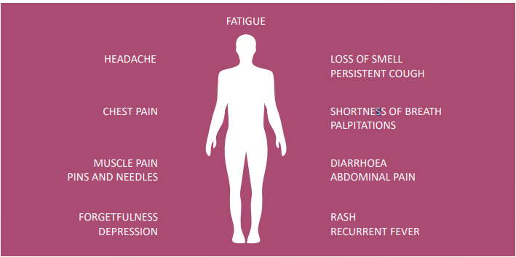

*This is not an exhaustive list; other symptoms are reported.*

[file:///G:/Downloads/Update54_clinical_long_term_effects.pdf](../../../../current/Downloads/Update54_clinical_long_term_effects.pdf)

Other Coronavirus infections such as SARS, MERS found significant impairment of exercise capacity and health status in survivors of SARS over 24 months. Another study revealed that 40% of people recovering from SARS still had chronic fatigue symptoms 3.5 years after being diagnosed.

More research is needed to examine the long-term consequences of COVID-19.

COVID-19 can result in prolonged illness, even in young adults and children without underlying chronic medical conditions. Much is still unknown about how COVID-19 affects people over time and more research and multi-year studies are needed to understand:

* long-term effects of COVID-19
* why symptoms persist or recur
* how these health problems affect patients
* clinical course and likelihood of full recovery
* Implication of long-term health effects on return to work
* How protective measures continue to be important in preventing COVID-19

Long COVID patients internationally have voiced the need to be heard and have their symptoms acknowledged and treated as real. The qualitative evidence suggests not doing so can have long term mental health implications.

**Public Gathering**

**SOP**

### Closure and re-opening of public places, events and gatherings

### Plan for pandemic influenza

# Introduction:

This plan is developed as part of a number of workstreams to enhance Hawke’s Bay pandemic preparedness.

## Definitions

Public place or event – any congregation of people at any premises or place, whether indoors or outdoors, public or private. This may include workplaces. There are a few exceptions - see Related legislation.

Public Health Order (92Z) – on an application by a Medical Officer of Health, the District Court may make a public health order in respect of an individual if the court is satisfied that the individual poses a public health risk.

## Abbreviations

CIMS – coordinated incident management structure

MOH – Medical Officer of Health

PHS – Public Health Service

PPE – personal protective equipment

## Related legislation

Epidemic Preparedness Act 2006 repeals and replaces some sections of the Health Act. This Act enables the Prime Minister on the advice of the Director-General of Health to enable use of special powers when there is an outbreak of a stated quarantinable disease. These powers include:

* The MOH would have powers to require premises to close and to forbid people to congregate. These premises and congregations of people may be public or private. “Premises” does not include private dwellings, parliament, courts or prisons. The MOH must publicise an order.
* Powers for police to assist the Medical Officer of Health. Police may consider (as a last resort) using the following statutory provisions to detain anyone who does not comply with MOH requests: Summary Offences Act (obstruction); Crimes Act (criminal nuisance). However the powers under the Epidemic Preparedness Act 2006 should be sufficient.

## Related plans of other agencies

New Zealand Influenza Pandemic Plan.

Ministry of Education: Pandemic Planning Kit for Schools and Early Childhood Education (ECE) Services.

<http://www.minedu.govt.nz/index.cfm?layout=document&documentid=10981&indexid=10898&indexparentid=6088>

<http://www.education.govt.nz/school/health-safety-and-wellbeing/emergencies-and-traumatic-incidents/pandemic-planning-kit/>

## Aims and general purpose

To describe the purpose and processes for closure and re-opening of public places and events during a pandemic.

## Assumptions

Closure of public places and events will achieve social distancing and this will reduce the opportunities for virus transmission.

Some degree of voluntary social distancing will occur spontaneously by the public during a pandemic. Most people will be happy to follow recommendations from the MOH.

Some people and groups will be reluctant or extremely opposed to social distancing which interferes with their planned activities. They will ignore public health recommendations for closure of public places or events. Some people will give cultural and lifestyle considerations priority over the need for social distancing.

Indoor events will be more likely to transmit infection than outdoor ones.

Closure of places and events involving children will have relatively more effectiveness than those involving adults only. Children shed more virus, for longer, and are less likely to be able to observe infection control recommendations.

Closure of places and events involving children will have significant flow-on effects on health and all economic activity because parents will have to cease work to care for children.

Closure of workplaces would lead to significant economic hardship for many people.

## Conditions under which the plan comes into force

From the earliest stage in the epidemic, during the “Stamp-it-out” phase focused closure of public places and events should be considered as part of the public health management for every case.

Widespread closure of public places and events should be considered during the epidemic as clusters of cases appear and when cases become widespread.

# Operational Structure:

The decision to close public events and places will be made by the Medical Officer of Health who has the necessary legal powers. This decision should be made with the Response Coordinator.

## Relationships with other levels of government

Use of MOH powers under s70 and s71 of the Health Act require a public health emergency to be declared by the Director-General of Health or a civil defence emergency to be declared. The MOH may also access these powers if authorized to do so by the Minister for the purpose of preventing the outbreak or spread of infectious disease (for example if no national emergency has been declared and the risk is limited to a certain region/s in the early stages).

Emergency powers of the MOH under the Epidemic Preparedness Act 2006 will only be available when a notice is placed in the Gazette by the Prime Minister.

# Communication Plan/Issues:

## Types of messages, how they will be distributed, obligations on receipt

Under the Epidemic Preparedness Act 2006, orders by the MOH *must* be communicated via newspaper *and* a TV channel or radio station that most people in the district can receive.

Orders by the MOH will also be communicated to people in the following ways:

#### General channels

* Te Whatu Ora 0800 number and website
* News media – local radio, TV and newspapers
* Local authority community development officers
* Primary healthcare providers, including Māori and Pacific Island NGO providers
* Through Iwi / taiwhenua to marae representatives

#### Specific to particular groups affected by the closures

* Letters, including to marae committees
* Email bulletins
* Telephone trees
* Text messages
* Websites
* Fax
* Notices at venues e.g. marae, churches, clubrooms etc

# Preparedness:

## Relationships required

Iwi

Police

Educational institutions

Organisations involved in social, business, tourism and leisure activities

Media

## Risk assessment

The public may be unprepared for the possibility of closures because insufficient public communication has been carried out.

People may ignore the closures and police enforcement may be necessary.

Closures may be perceived as unpopular and ineffective because the virus will spread despite closures.

The media may communicate the messages in a way which raises rather than lessens public alarm.

Groups and organisations may have no contingency plans for closures, with resulting confusion and poor implementation.

Public health and police personnel may have insufficient resources to enforce orders. Therefore orders should be realistic and carefully considered.

Some Māori will wish to use their marae as places to take their sick. They will expect treatment services to be there and to be able to leave or remain with their sick according to their preference. Not all Māori will take this course – some will stay away from the marae for fear of infection.

# Operational Procedures:

## Roles, relationships and tasks

|  |  |  |
| --- | --- | --- |
| **Agency** | **Role and task** | **Relationships** |
| MOH | Identify closures needed and make the orders  Communicate the details of the orders rapidly.  Revoke the closure orders | Response Coordinator  The police  The public  The media |
| Police | Support the MOH as requested to enforce orders | MOH |
| Response coordinator | Communicate with Incident Management Team about the orders | MOH |

## Action required at different alert phases

Closures will be made throughout the epidemic from the first cases or clusters until the epidemic has waned.

Revocation of closures should only be made after consultation with the Incident Management Team. Consideration should be given to the possibility that further epidemic waves might make the revocation premature.

## Resources e.g. designated sites, equipment required

Police for enforcement.

Contingency plans needed for all organisations and groups.

## Workforce issues

The closures will impact on workforce in industries, including health. If there is widespread civil disobedience of closures they will impact seriously on police and security workload.

## Reporting

Daily report on closures in place to Response Coordinator, Police, CACs, Outreach Services and the MoH.

This would form part of the daily PHS report to the Planning and Intelligence Manager.

## Names, addresses and contact numbers

Lists held by Te Whatu Ora Hawke’s Bay will be used to communicate closures.

# Implications

The CDEM workforce group should examine the issue of whether compensation will be paid for loss of business earnings if premises are closed.

Communication about the possibility of closures should begin before a Hawke’s Bay epidemic begins so that closure orders do not come as a surprise. Such communication should include the likelihood that closures will only reduce the rate of transmission, not prevent it entirely. This communication plan should include discussions with Hawke’s Bay media so that accurate information can be conveyed which minimises unnecessary alarm.

All groups and organisations need to be advised to develop contingency plans for closures.

Police should consider options for increased workload which may be involved in enforcing closures.

The IMT should be aware that Māori may be expecting treatment services at their marae.

If Māori intend to go to their marae when there is a closure order on public premises or gatherings, the MOH and response coordinator will need to decide:

* How the risk of increased transmission on marae can be clearly communicated to Māori
* How Te Whatu Ora Hawke’s Bay can best work with marae to make the marae gatherings as safe as possible